Reliance Foundry Co Ltd

#207-6450 148 St

Surrey, BC V3S 7G7

Phone: 604-547-0460

Phone: 1-877-789-3245

Fax: 604-590-8875

Email: info@reliance-foundry.com

Website: www.reliance-foundry.com

Reliance Foundry is an award-winning supplier of high quality stock and custom-designed site furnishings

for architectural, traffic management, and industrial applications. Reliance Foundry brings over 90 years of expertise to the design and manufacturing of our products.

Reliance Foundry bollards add architectural accents to your perimeter security, landscaping, traffic control, and streetscape projects. Use bollards as design features for new and existing buildings, for access control measures, traffic guidance, and as decorative covers over steel security posts. This section includes plastic post covers.

Specification Coordination: Edit this guide specification to meet project requirements. Coordinate with other specification sections as required. If using more than one bollard type, use the same designation in both drawings and specifications. Display hidden text to see or print notes to specifier.

Drawing Coordination: Show locations, sizes, layout, and spacing of each type of bollard or bollard cover required. Show footing and security post details, if required. Soft metric conversion is provided for all measurements.

**SECTION 34 71 13**

**VEHICLE BARRIERS**

PLASTIC SECURITY POST COVERS

1. GENERAL
   * + 1. SUMMARY
          1. Section Includes:

Accessories

Plastic bollard covers.

Edit following to coordinate with other specification sections in project.

* + - * 1. Related Requirements:

[Division 03 Sections: [Concrete] [Mortar] fill for security posts.]

[Division 32 Section "Bollards" for bollards other than plastic bollard covers specified herein.]

[_________________]

Delete below if no steel security posts.

* + - 1. REFERENCE STANDARDS
         1. ASTM A500 – Standard Specification for Cold-Formed Welded and Seamless Carbon Steel Structural Tubing in Rounds and Shapes.
      2. SUBMITTALS
         1. Comply with Section [01 33 00 – Submittal Procedures.] [_________.]
         2. Product Data: Provide for each type of bollard, component, finish, and accessory specified.
         3. Color Samples: [Submit manufacturer’s standard colors for selection.] [Submit sample of color specified.]

Delete below if no steel security posts or if security post installation is simple.

* + - * 1. Setting Drawings: For steel security posts, show foundations and cutouts required in work specified in other Sections.
        2. Maintenance Data: Submit manufacturer’s field touch-up, cleaning, and maintenance instructions.
        3. Warranty Documentation: Submit sample of manufacturer’s warranty.
      1. QUALITY ASSURANCE
         1. Comply with Section [01 43 00 – Quality Assurance.] [_________.]
      2. DELIVERY, STORAGE AND HANDLING
         1. Comply with Section [01 66 00 – Product Storage and Handling Requirements.] [_________.]
         2. Protect bollards and accessories during delivery, storage, and handling.
      3. WARRANTY
         1. Comply with Section [01 78 36 – Warranties.] [_________.]
         2. Provide manufacturer’s standard warranty against defects in materials and workmanship.

Warranty Period: Five years from date of invoice, except as otherwise indicated.

Plastic Bollards and Post Covers: One year.

1. PRODUCTS
   * + 1. MANUFACTURERS
          1. Manufacturer: Reliance Foundry Co. Ltd.

Phone: 604-547-0460 or 1-877-789-3245

Fax: 604-590-8875

Website: <http://www.reliance-foundry.com/bollard>

Email: [info@reliance-foundry.com](mailto:info@reliance-foundry.com)

* + - * 1. Substitutions: [Comply with provisions of [Section 01 25 00 "Substitution Procedures"] [_________] for substitution procedures.] [Not allowed.]
      1. ACCESSORIES:
         1. Self-adhesive foam strips.
         2. Self-adhesive neoprene tape.
         3. Reflective Tape: 2 strips of 3M Scotchlite Reflective Sheeting Series tape, recessed on bollard.

For installation over new security posts, include information below. Determine security post and footing requirements with security consultant and structural engineer. Verify that plastic bollard type(s) specified have sufficient inside diameter and height to fit over required security posts.

Steel posts are standard; galvanizing and powder coating are available upon request.

* + - * 1. Security Post:

Pipe: ASTM 500 B Structural Grade Steel

Manufacturer: Reliance Foundry Co. Ltd.

Country of Origin: United States.

Base Diameter: [4.5 inches] [6.25 inches] [8.625 inches] [10.75 inches]

Finish: [Red] [Grey] primer.

Installation:

Direct embed.

Footing and fill; Concrete or mortar, [3000 psi minimum.]

* + - 1. PLASTIC BOLLARD COVERS

See <http://www.reliance-foundry.com/bollard/post-covers-plastic> for assistance in selecting bollard covers.

* + - * 1. Materials:

Formolene HB5502B, High Density Polyethylene (HDPE); Hexene Copolyer for Blow Molding.

High molecular weight material. Designed for optimum balance of density, molecular weight and molecular weight distribution demonstrating maximum property advantages for large products that require high impact resistance.

Ultraviolet protection additive.

Anti-Static Package: Combined in manufacturing process of HDPE.

Abrasion Resistant.

Environmental Stress Cracks Resistant.

Flexural modulus: 200,000 psi.

Tensile Strength: 4,000 psi.

Low-density thermoplastic polyethylene (LDPE).

* + - * 1. Country of Origin: China.

Delete requirement below if bollard covers will not be installed on sloping substrates or if regularity of height is not a concern:

Add 1 to 3 inches to specified height, to allow for fitting, cutting, foam installation strips, and grade or slope condition.

If desired, height of bollard cover may substantially exceed height of pipe bollards, for added visibility. Specify a finished height, or show heights on Drawings if varying heights are used or if alignment with other elements is required.

* + - * 1. 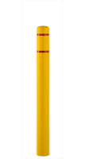Plastic Bollard Cover [Designer’s Designation]:

Model: Reliance Foundry; **R-7100**.

Height: 52 inches (132 cm)

Base Diameter: 5 inches (12.7 cm)

Weight: 4 lbs. (1.8 kg)

Maximum Interior Post Height: 51 inches (129.5 cm)

Maximum Interior Post Diameter: 4.5 inches (11.4 cm)

Material: High Density Polyethylene (HDPE)

Color: [Yellow] [White] [Blue] [Red] [Black] [Gray] [Green] [Orange]

[Brown] [Beige].

Tape Color: [Red] [White] [Blue].

Installation: Security post, self-adhesive foam strips.

* + - * 1. 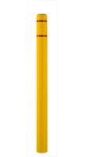Plastic Bollard Cover [Designer’s Designation]:

Model: Reliance Foundry; **R-7101**.

Height: 64 inches (162.5 cm)

Base Diameter: 5 inches (12.7 cm)

Weight: 5 lbs. (2.3 kg)

Maximum Interior Post Height: 63 inches (160 cm)

Maximum Interior Post Diameter: 4.5 inches (11.4 cm)

Material: High Density Polyethylene (HDPE)

Color: [Yellow] [White] [Blue] [Red] [Black] [Gray] [Green] [Orange]

[Brown] [Beige].

Tape Color: [Red] [White] [Blue].

Installation: Security post, self-adhesive foam strips.

* + - * 1. 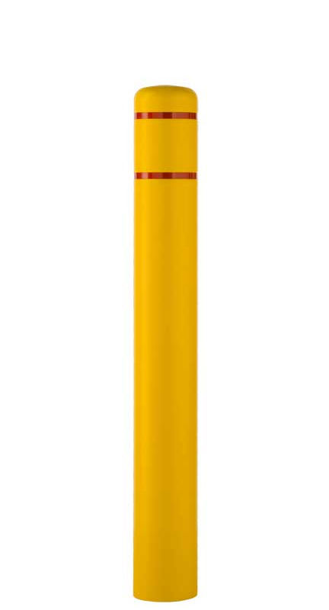Plastic Bollard Cover [Designer’s Designation]:

Model: Reliance Foundry; **R-7109**.

Height: 52 inches (132 cm)

Base Diameter: 7 3/8 inches (18.7 cm)

Weight: 6 lbs. (2.7 kg)

Maximum Interior Post Height: 50 inches (127 cm)

Maximum Interior Post Diameter: 6 5/8 inches (16.8 cm)

Material: High Density Polyethylene (HDPE)

Color: [Yellow] [White] [Blue] [Red] [Black] [Gray] [Green] [Orange] [Brown] [Beige].

Tape Color: [Red] [White] [Blue].

Installation: Security post, self-adhesive foam strips.

* + - * 1. 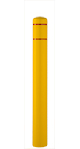Plastic Bollard Cover [Designer’s Designation]:

Model: Reliance Foundry; **R-7110**.

Height: 60 inches (152.4 cm)

Base Diameter: 7-3/8 inches (18.7 cm)

Weight: 7 lbs. (3.2 kg)

Maximum Interior Post Height: 59 inches (149.9 cm)

Maximum Interior Post Diameter: 6 5/8 inches (16.8 cm)

Material: High Density Polyethylene (HDPE)

Color: [Yellow] [White] [Blue] [Red] [Black] [Gray] [Green] [Orange]

[Brown] [Beige].

Tape Color: [Red] [White] [Blue].

Installation: Security post, self-adhesive foam strips.

* + - * 1. 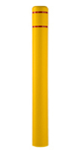Plastic Bollard Cover [Designer’s Designation]:

Model: Reliance Foundry; **R-7111**.

Height: 72 inches (182.9 cm)

Base Diameter: 7-3/8 inches (18.7 cm)

Weight: 8 lbs. (3.6 kg)

Maximum Interior Post Height: 71 inches (180.3 cm)

Maximum Interior Post Diameter: 6 5/8 inches (16.8 cm)

Material: High Density Polyethylene (HDPE)

Color: [Yellow] [White] [Blue] [Red] [Black] [Gray] [Green] [Orange]

[Brown] [Beige].

Tape Color: [Red] [White] [Blue].

Installation: Security post, self-adhesive foam strips.

* + - * 1. 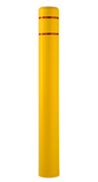Plastic Bollard Cover [Designer’s Designation]:

Model: Reliance Foundry; **R-7120**.

Height: 72 inches (182.9 cm)

Base Diameter: 9 3/8 inches (28.9 cm)

Weight: 10 lbs. (4.5 kg)

Maximum Interior Post Height: 70 inches (177.8 cm)

Maximum Interior Post Diameter: 8 5/8 inches (22.5 cm)

Material: [Low-density thermoplastic polyethylene (LDPE)] [High Density Polyethylene (HDPE)]

Color: [Yellow] [White] [Blue] [Red] [Black] [Gray] [Green] [Orange]

[Brown] [Beige].

Tape Color: [Red] [White] [Blue].

Installation: Security post, self-adhesive foam strips.

* + - * 1. 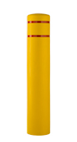Plastic Bollard Cover [Designer’s Designation]:

Model: Reliance Foundry; **R-7130**.

Height: 60 inches (152.4 cm)

Base Diameter: 11 3/8 inches (23.8)

Weight: 14 lbs. (6.4 kg)

Maximum Interior Post Height: 58 inches (147.3 cm)

Maximum Interior Post Diameter: 10 3/4 inches (27.3 cm)

Material: Low-density thermoplastic polyethylene (LDPE).

Color: [Yellow] [White] [Blue] [Red] [Black] [Gray] [Green] [Orange] [Brown] [Beige].

Tape Color: [Red] [White] [Blue].

Installation: Security post, self-adhesive foam strips.

* + - * 1. 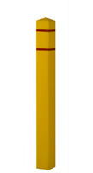Plastic Bollard Cover [Designer’s Designation]:

Model: Reliance Foundry; **R-7140**.

Height: 55 inches (139.7 cm)

Base Width: 5 inches (12.7 cm) x 5 inches (12.7 cm)

Weight: 6.7 lbs. (3 kg)

Maximum Interior Post Height: 54 inches (137.2 cm)

Maximum Interior Post Diameter: 4 1/2 inches (11.4 cm)

Material: Low-density thermoplastic polyethylene (LDPE).

Color: [Yellow] [White] [Blue] [Red] [Black] [Gray] [Green] [Orange] [Brown] [Beige].

Tape Color: [Red] [White] [Blue].

Installation: Security post, self-adhesive foam strips.

* + - * 1. 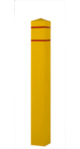Plastic Bollard Cover [Designer’s Designation]:

Model: Reliance Foundry; **R-7150**.

Height: 55 inches (139.7 cm)

Base Width: 7 3/8 inches (18.7 cm) x 7 3/8 inches (18.7 cm)

Weight: 10 lbs. (4.5 kg)

Maximum Interior Post Height: 54 inches (137.2 cm)

Maximum Interior Post Diameter: 61/2 inches (16.5 cm)

Material: Low-density thermoplastic polyethylene (LDPE).

Color: [Yellow] [White] [Blue] [Red] [Black] [Gray] [Green] [Orange]

[Brown] [Beige].

Tape Color: [Red] [White] [Blue].

Installation: Security post, self-adhesive foam strips.

* + - * 1. 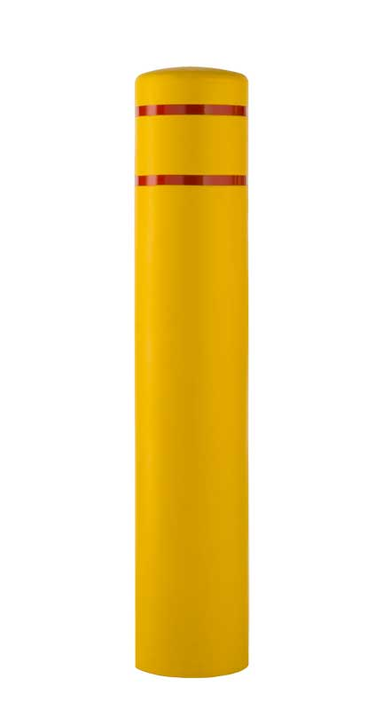Plastic Bollard Cover [Designer’s Designation]:

Model: Reliance Foundry; **R-7155**.

Height: 61 inches (155 cm)

Weight: 16 lbs. (7.3 kg)

Base Diameter: 13 inches (33 cm)

Maximum Interior Post Height: 58 inches (147.3 cm)

Maximum Interior Post Diameter: 12 3/4 inches (32.4 cm)

Material: Low-density thermoplastic polyethylene (LDPE).

Color: [Yellow] [White] [Blue] [Red] [Black] [Gray] [Green] [Orange]

[Brown] [Beige].

Tape Color: [Red] [White] [Blue].

Installation: Security post, self-adhesive foam strips.

* + - 1. DECORATIVE PLASTIC BOLLARD COVERS
         1. Material: High-density thermoplastic polyethylene (HDPE).

Nominal Wall Thickness: 0.25 inches (6.4 mm)

* + - * 1. Country of Origin: U.S.A.

[Add 1 to 3 inches to specified height, to allow for fitting, cutting, foam installation strips, and grade or slope condition.]

* + - * 1. 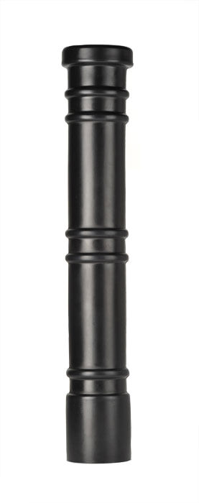Plastic Bollard Cover [Designer’s Designation]:

Model: Reliance Foundry; **R-7171.**

Design: Cylinder with rings and flat top.

Height: 51 inches (129.5 cm)

Base Diameter: 8-3/8 inches (21.3 cm)

Weight: 12 lbs. (5.4 kg)

Maximum Interior Post Height: 49 inches (124.5 cm)

Maximum Interior Post Diameter: 6 5/8 inches (16.8 cm)

Color: [Yellow] [White] [Dark Blue] [Red] [Black] [Grey] [Green] [Orange] [Brown] [Light Blue].

Installation: Security post, self-adhesive neoprene tape.

* + - * 1. 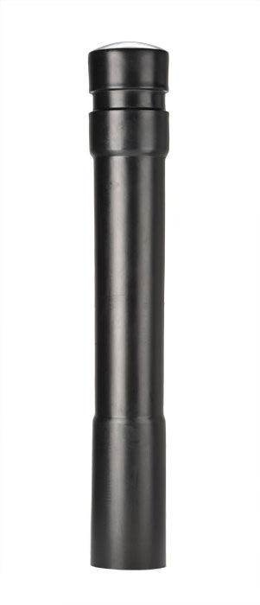Plastic Bollard Cover [Designer’s Designation]:

Model: Reliance Foundry; **R-7172.**

Design: Cylinder with wide rings.

Height: 53 inches (134.6 cm)

Base Diameter: 7 3/4 inches (19.7 cm)

Weight: 12 lbs. (5.4 kg)

Maximum Interior Post Height: 49 inches (124.5 cm)

Maximum Interior Post Diameter: 6 5/8 inches (16.8 cm)

Color: [Yellow] [White] [Dark Blue] [Red] [Black] [Grey] [Green] [Orange]

[Brown] [Light Blue].

Installation: Security post, self-adhesive neoprene tape.

* + - * 1. 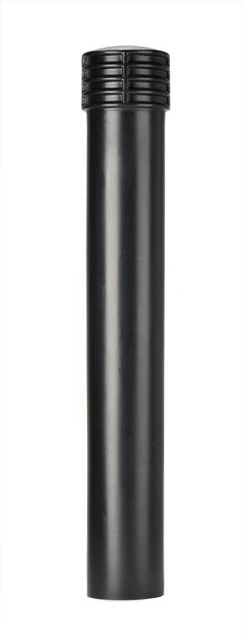Plastic Bollard Cover [Designer’s Designation]:

Model: Reliance Foundry; **R-7173.**

Design: Cylinder with banded top.

Height: 52 inches (132 cm)

Base Diameter: 7 1/2 inches (19 cm)

Weight: 12 lbs. (5.4 kg)

Maximum Interior Post Height: 49 inches (124.5 cm)

Maximum Interior Post Diameter: 6 5/8 inches (16.8 cm)

Color: [Yellow] [White] [Dark Blue] [Red] [Black] [Grey] [Green] [Orange] [Brown] [Light Blue].

Installation: Security post, self-adhesive neoprene tape.

* + - * 1. 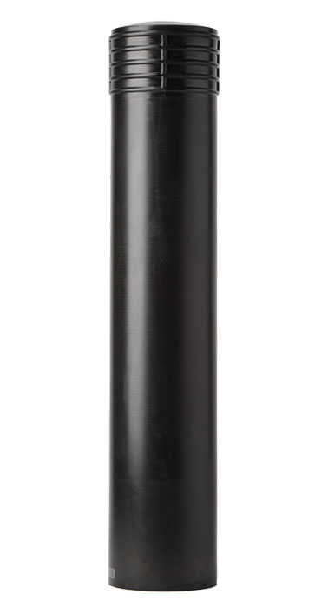Plastic Bollard Cover [Designer’s Designation]:

Model: Reliance Foundry; **R-7173-L.**

Design: Large cylinder with banded top.

Height: 59 1/2 inches (151.1 cm)

Base Diameter: 11 5/8 inches (29.5 cm)

Weight: 15 lbs. (6.8 kg)

Maximum Interior Post Height: 56 inches (142.2 cm)

Maximum Interior Post Diameter: 10 3/4 inches (27.3 cm)

Color: [Yellow] [White] [Dark Blue] [Red] [Black] [Grey] [Green] [Orange]

[Brown] [Light Blue].

Installation: Security post, self-adhesive neoprene tape.

* + - * 1. 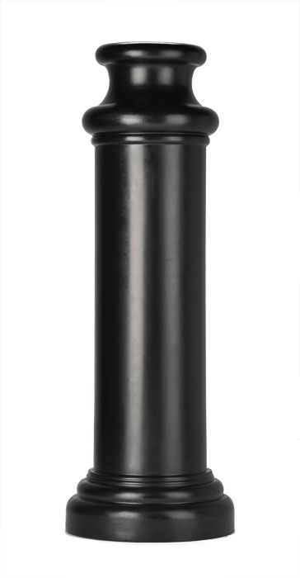Plastic Bollard Cover [Designer’s Designation]:

Model: Reliance Foundry; **R-7174.**

Design: Cylinder with tapered base and sculpted flat top.

Height: 48 1/2 inches (123.1 cm)

Base Diameter: 17 inches (43.2 cm)

Weight: 15 lbs. (6.8 kg)

Maximum Interior Post Height: 44 inches (111.8 cm)

Maximum Interior Post Diameter: 10 3/4 inches (27.3 cm)

Color: [Yellow] [White] [Dark Blue] [Red] [Black] [Grey] [Green] [Orange]

[Brown] [Light Blue].

Installation: Security post, self-adhesive neoprene tape.

* + - * 1. 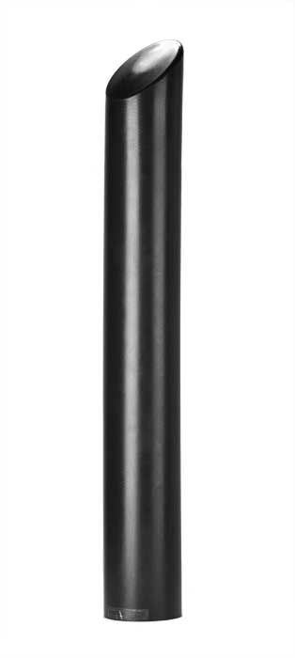Plastic Bollard Cover [Designer’s Designation]:

Model: Reliance Foundry; **R-7175.**

Design: Cylinder with angled top.

Height: 57 inches (144.8 cm)

Base Diameter: 7 1/4 inches (18.4 cm)

Weight: 12 lbs. (5.4 kg)

Maximum Interior Post Height: 46 inches (117 cm)

Maximum Interior Post Diameter: 6 5/8 inches (16.8 cm)

Color: [Yellow] [White] [Dark Blue] [Red] [Black] [Grey] [Green] [Orange] [Brown] [Light Blue].

Installation: Security post, self-adhesive neoprene tape.

* + - * 1. 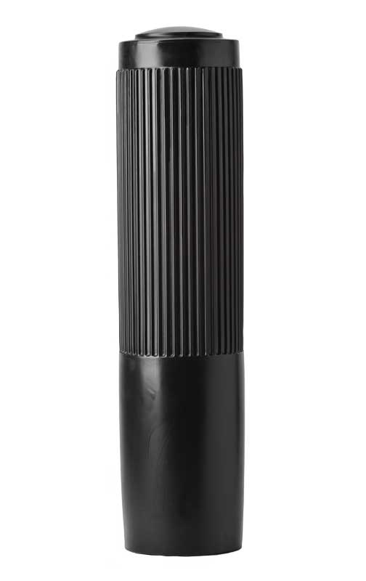Plastic Bollard Cover [Designer’s Designation]:

Model: Reliance Foundry; **R-7176.**

Design: Cylinder with ribbed exterior.

Height: 49 1/2 inches (125.7 cm)

Base Diameter: 12 1/4 inches (31.1 cm)

Weight: 15 lbs. (6.8 kg)

Maximum Interior Post Height: 44 inches (111.8 cm)

Maximum Interior Post Diameter: 10 5/8 inches (26.9 cm)

Color: [Yellow] [White] [Dark Blue] [Red] [Black] [Grey] [Green] [Orange]

[Brown] [Light Blue].

Installation: Security post, self-adhesive neoprene tape.

1. EXECUTION
   * + 1. EXAMINATION
          1. Examine paving or other substrates for compliance with manufacturer’s requirements for placement and location of embedded items, condition of substrate, and other conditions affecting installation of bollards.
          2. Proceed with installation only after unsatisfactory conditions have been corrected.
       2. INSTALLATION
          1. General: Comply with manufacturer’s installation instructions and setting drawings.
          2. Do not install damaged, cracked, chipped, deformed, or marred bollards. Field touch-up minor imperfections in accordance with manufacturer’s instructions. Replace bollards that cannot be field repaired.

Retain below and add project-specific detail, if new security posts are required. See http://www.reliance-foundry.com/bollard/steel-pipe for considerations for placing security posts.

* + - * 1. Security Posts:

Embed with grout in formed or cored holes in concrete.

Embed in concrete footings.

* + - * 1. Plastic Bollard Covers: Install over foam strips in pattern indicated in manufacturer's instructions.
        2. Decorative Bollard Covers: Install over neoprene adhesive tape as indicated in manufacturer's instructions.
      1. CLEANING & PROTECTION

Normal cleaning may be done with clean water and a soft cloth. Detailed cleaning and inspection instructions are available at http://www.reliance-foundry.com/bollard/maintenance-bollards

* + - * 1. Protect bollards against damage.
        2. Immediately prior to Substantial Completion, clean bollards in accordance with manufacturer’s instructions to remove dust, dirt, adhesives, and other foreign materials.
        3. Touch up damaged finishes according to manufacturer’s instructions.
      1. CLOSEOUT ACTIVITIES
         1. Provide executed warranty.

END OF SECTION

Copyright 2018 by Reliance Foundry Co. Ltd.; qualified design and construction professionals may copy for preparation of construction specifications and purchase orders for Reliance Foundry products. Issued April 2018. Subject to change.

Issued July 2016. Subject to change.