Reliance Foundry Co Ltd
#207-6450 148 St
Surrey, BC V3S 7G7
Phone: 604-547-0460
Phone: 1-877-789-3245
Fax: 604-590-8875
Email: info@reliance-foundry.com
Website: www.reliance-foundry.com

Reliance Foundry is an award-winning supplier of high-quality stock and custom-designed site furnishings
for architectural, traffic management, and industrial applications. Reliance Foundry brings over 90 years of expertise to the design and manufacturing of our products.
Reliance Foundry’s crash-rated bollards have exceptional stopping power and impact resistance. They are certified to ASTM ratings with the ability to stop vehicles from intruding into pedestrian zones. Very easy installation for a crash-rated bollard, with no assembly or specialty subgrade required—simply set the prefabricated bollard into the site and pour concrete.

Specification Coordination: Edit this guide specification to meet project requirements. Coordinate with other specification sections as required. If using more than one bollard type, use the same designation in both drawings and specifications. Display hidden text to see or print notes to specifier.

Drawing Coordination: Show locations, sizes, layout, and spacing of each type of bollard or bollard cover required. Show footing and security post details, if required. Soft metric conversion is provided for all measurements.

SECTION 34 71 13.16
VEHICLE BARRIER SYSTEMS
- GENERAL
      - SUMMARY
        - Section Includes:
          - Crash-rated bollards
          - [_________________]
        - Related Requirements:
          - [Section 03 30 00: Cast-in-Place Concrete]
          - [Section 28 13 63 - Access Control Vehicle Identification System]
          - [_________________]
      - REFERENCE STANDARDS
        - Department of Defense (DoD) approved and listed on Anti-Ram Vehicle Barrier List
      - SUBMITTALS
        - Manufacturer’s Product Data
          - Comply with Section [01 33 00 – Submittal Procedures.] [_________.]
          - Product Data: Provide for each type of bollard, component, finish, and accessory specified.
          - Maintenance Data: Submit manufacturer’s field touch-up, cleaning, and maintenance instructions.
          - Warranty Documentation: Submit sample of manufacturer’s warranty.
        - Setting Drawings: Show embedded items and cutouts required for work specified by other Sections.
      - QUALITY ASSURANCE
        - Comply with Section [01 43 00 – Quality Assurance.] [_________.]
      - DELIVERY, STORAGE AND HANDL-ING
        - Comply with Section [01 66 00 – Product Storage and Handling Requirements.] [_________.]
        - Protect bollards during delivery, storage, and handling.
      - WARRANTY
        - Comply with Section [01 78 36 – Warranties.] [_________.]
- PRODUCTS
      - MANUFACTURERS
        - Manufacturer: Reliance Foundry Co. Ltd.
          - Phone: 604-547-0460 or 1-877-789-3245
          - Fax: 604-590-8875
          - Website: http://www.reliance-foundry.com/bollard
          - Email: info@reliance-foundry.com
        - Substitutions: [Comply with provisions of [Section 01 25 00 "Substitution Procedures"] [_________] for substitution procedures.] [Not allowed.]
      - CRASH-RATED BOLLARDS
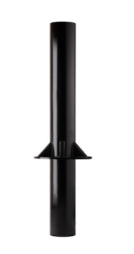
        - Crash-rated bollard [Designer’s Designation]:
          - Model: Reliance Foundry; R-1009-04.
          - Height: 72 inches (182.9 cm)
          - Height Above Grade: 38 1/2 inches (97.8 cm)
          - Diameter: 8 inches (20.3 cm)
          - Weight: 410 lbs. (186 kg)
          - Design: M30 ASTM crash-rated bollard.
          - Material: Steel.
          - Country of Origin: United States.
          - Finish: Paint coated.
          - Color Coating:
            - Type: Paint.
            - Color: [Black]
          - Installation:
            - Concrete Embedded
        - Crash-rated bollard [Designer’s Designation]:
          - Model: Reliance Foundry; R-1009-04-R.
          - Height: 72 inches (182.9 cm)
          - Height Above Grade: 39 1/2 inches (100.3 cm)
          - Diameter: 8 inches (20.3 cm)
          - Weight: 410 lbs. (186 kg)
          - Design: Removable M30 crash engineered bollard.
          - Material: Steel.
          - Country of Origin: United States.
          - Finish: Paint coated.
          - Color Coating:
            - Type: Paint.
            - Color: [Black]
          - Installation:
            - Concrete Embedded
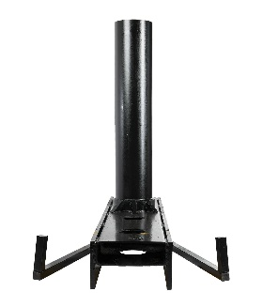
        - Crash-rated bollard [Designer’s Designation]:
          - Model: Reliance Foundry; R-1009-04-SM
          - Height: 50 inches (127 cm)
          - Height Above Grade: 39 1/2 inches (100.3 cm)
          - Diameter: 8 5/8 inches (18.73 cm)
          - Weight: 780 lbs. (353.8 kg)
          - Design: Shallow Mount M30 ASTM crash-rated bollard.
          - Material: Steel
          - Country of Origin: United States
          - Finish: Paint coated.
          - Color Coating:
            - Type: Paint
            - Color: [Black]
          - Installation:
            - Concrete Embedded
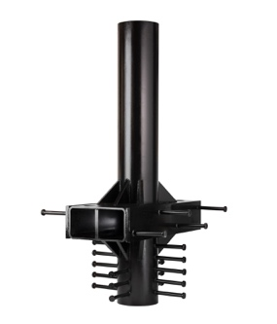
        - Crash-rated bollard [Designer’s Designation]:
          - Model: Reliance Foundry; R-1009-12.
          - Height: 75.5 inches (191.8 cm)
          - Height Above Grade: 39-1/2 inches (100.3 cm)
          - Diameter: 10 inches (25.4 cm)
          - Weight: 1257 lbs. (570.2 kg)
          - Design M50 ASTM crash-rated bollard.
          - Material: Steel.
          - Country of Origin: United States.
          - Finish: Paint coated.
          - Color Coating:
            - Type: Paint.
            - Color: [Black]
          - Installation:
            - Concrete Embedded
        - Crash-rated bollard [Designer’s Designation]:
          - Model: Reliance Foundry; R-1009-12-R.
          - Height: 75.5 inches (191.8 cm)
          - Height Above Grade: 39 1/2 inches (100.3 cm)
          - Diameter: 10 inches (25.4 cm)
          - Weight: 1257 lbs. (570.2 kg)
          - Design: Removable M50 crash engineered bollard
          - Material: Steel.
          - Country of Origin: United States.
          - Finish: Paint coated.
          - Color Coating:
            - Type: Paint.
            - Color: [Black]
          - Installation:
            - Concrete Embedded
        - Crash-rated bollard [Designer’s Designation]:
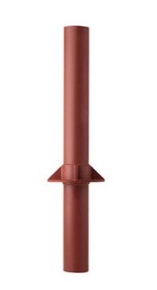
          - Model: Reliance Foundry; R-1009-40.
          - Height: 66 inches (182.9 cm)
          - Height Above Grade: 36 inches (91.4 cm)
          - Diameter: 6 5/8 inches (16.8 cm)
          - Weight: 190 lbs. (86.2 kg)
          - Design: C40 crash engineered bollard.
          - Material: Steel.
          - Country of Origin: United States.
          - Finish: Prime paint coated.
          - Color Coating:
            - Type: Prime paint.
            - Color: [Red]
          - Installation:
            - Concrete Embedded
        - Crash-rated bollard [Designer’s Designation]:
          - Model: Reliance Foundry; R-1009-40-R.
          - Height: 66 inches (182.9 cm)
          - Height Above Grade: 36 inches (91.4 cm)
          - Diameter: 6 5/8 inches (16.8 cm)
          - Bollard Weight: 126 lbs. (57.2 kg)
          - Total Weight: 155 lbs. (70.3 kg)
          - Design: Removable C40 crash engineered bollard.
          - Material: Steel.
          - Country of Origin: United States.
          - Finish: Prime paint coated.
          - Color Coating:
            - Type: Prime paint.
            - Color: [Red]
          - Installation:
            - Concrete Embedded
- EXECUTION
      - EXAMINATION
        - Examine paving or other substrates for compliance with manufacturer’s requirements for placement and location of embedded items, condition of substrate, and other conditions affecting installation of bollards.
        - Proceed with installation only after unsatisfactory conditions have been corrected.
      - INSTALLATION
        - General: Comply with manufacturer’s installation instructions and setting drawings.
        - Do not install damaged, cracked, chipped, deformed or marred bollards. Field touch-up minor imperfections in accordance with manufacturer’s instructions. Replace bollards that cannot be field repaired.
      - CLEANING & PROTECTION
Normal cleaning may be done with clean water and a soft cloth. Detailed cleaning and inspection instructions are available at www.reliance-foundry.com/bollard/maintenance-bollards.
        - Protect bollards against damage.
        - Immediately prior to Substantial Completion, clean bollards in accordance with manufacturer’s instructions to remove dust, dirt, adhesives, and other foreign materials.
        - Touch up damaged finishes according to manufacturer’s instructions.
      - CLOSEOUT ACTIVITIES
        - Provide executed warranty.

END OF SECTION
Copyright 2020 by Reliance Foundry Co. Ltd.; qualified design and construction professionals may copy for preparation of construction specifications and purchase orders for Reliance Foundry products. Issued March 2020. Subject to change.
Issued July 2016. Subject to change.

