Reliance Foundry Co Ltd

#207-6450 148 St

Surrey, BC V3S 7G7

Phone: 604-547-0460

Phone: 1-877-789-3245

Fax: 604-590-8875

Email: info@reliance-foundry.com

Website: www.reliance-foundry.com

Reliance Foundry is an award-winning supplier of high quality stock and custom-designed site furnishings

for architectural, traffic management, and industrial applications. Reliance Foundry brings over 90 years of expertise to the design and manufacturing of our products.

Reliance Foundry bollards add architectural accents to your perimeter security, landscaping, traffic control, and streetscape projects. Use bollards as design features for new and existing buildings, for access control measures, traffic guidance, and as decorative covers over steel security posts. This section includes access control bollards including collapsible, removable, and retractable bollards.

Specification Coordination: Edit this guide specification to meet project requirements. Coordinate with other specification sections as required. If using more than one bollard type, use the same designation in both drawings and specifications. Display hidden text to see or print notes to specifier.

Drawing Coordination: Show locations, sizes, layout, and spacing of each type of bollard or bollard cover required. Show footing and security post details, if required. Soft metric conversion is provided for all measurements.

**SECTION 32 39 13.15**

**METAL ACCESS CONTROL BOLLARDS**

1. GENERAL
   * + 1. SUMMARY
          1. Section Includes:

Removable bollards

Retractable bollard set

Collapsible bollards

Accessories

[_________________]

Edit following to coordinate with other specification sections in project.

* + - * 1. Related Requirements:

[Division 03 Sections: [Concrete] [Mortar] fill for security posts.]

[Division 08 Sections: Padlocks.]

[_________________]

Edit below to include only reference standards used in project.

* + - 1. REFERENCE STANDARDS
         1. ASTM A36 – Standard Specification for Carbon Structural Steel.
         2. ASTM A312 – Standard Specification for Seamless, Welded, and Heavily Cold Worked Austenitic Stainless Steel Pipes.
         3. ASTM A500 – Standard Specification for Cold-Formed Welded and Seamless Carbon Steel Structural Tubing in Rounds and Shapes.
         4. ASTM A536 – Standard Specification for Ductile Iron Castings.
         5. ASTM B26 – Standard Specification for Aluminum-Alloy Sand Castings.
      2. SUBMITTALS
         1. Comply with Section [01 33 00 – Submittal Procedures.] [_________.]
         2. Product Data: Provide for each type of bollard, component, finish, and accessory specified.
         3. Color Samples: [Submit manufacturer’s standard colors for selection.] [Submit sample of color specified.]
         4. Setting Drawings: Show embedded items and cutouts required for work specified in other Sections.
         5. Maintenance Data: Submit manufacturer’s field touch-up, cleaning, and maintenance instructions.
         6. Warranty Documentation: Submit sample of manufacturer’s warranty.
      3. QUALITY ASSURANCE
         1. Comply with Section [01 43 00 – Quality Assurance.] [_________.]
      4. DELIVERY, STORAGE AND HANDLING
         1. Comply with Section [01 66 00 – Product Storage and Handling Requirements.] [_________.]
         2. Protect bollards and accessories during delivery, storage, and handling.
      5. WARRANTY
         1. Comply with Section [01 78 36 – Warranties.] [_________.]
         2. Provide manufacturer’s standard warranty against defects in materials and workmanship.

Warranty Period: Five years from date of invoice, except as otherwise indicated.

Coatings: Two years, against peeling, cracking, or significant color change.

1. PRODUCTS
   * + 1. MANUFACTURERS
          1. Manufacturer: Reliance Foundry Co. Ltd.

Phone: 604-547-0460 or 1-877-789-3245

Fax: 604-590-8875

Website: <http://www.reliance-foundry.com/bollard>

Email: [info@reliance-foundry.com](mailto:info@reliance-foundry.com)

* + - * 1. Substitutions: [Comply with provisions of [Section 01 25 00 "Substitution Procedures"] [_________] for substitution procedures.] [Not allowed.]
      1. REMOVABLE BOLLARDS
         1. 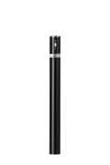Bollard [Designer’s Designation]:

If coating is required, retain “RA” below.

Model: Reliance Foundry; **R-7464**.

See Retractable Bollard Set for complementary retractable and embedded models.

Height: 35 5/8 inches (93.0 cm)

Diameter: 4 1/2 inches (11.4 cm) body; 6 1/2 inches (16.5 cm) base

Weight: 35 lbs. (15.9 kg) body; 13 lbs. (5.9 kg) receiver

Design: Fixed cylinder with flat top.

Material: [Coated] carbon Steel:

Grade Q235.

Country of Origin: China.

If coating is required, retain “Coated” above and Color Coating requirement below.

Color Coating:

Type: Polyester powder coat over epoxy primer.

Color: [Black textured semi gloss] [Dark green] [Statuary bronze] [Bengal silver] [Anodized silver] [Safety yellow].

Reflective Stripe: [White][Yellow][Blue][Red][None].

Installation:

Removable, new concrete, receiver with key

Removable, existing concrete, receiver with key

* + - * 1. 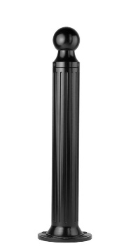Bollard [Designer’s Designation]:

Retain -AL for aluminum. Delete if not required.

Model: Reliance Foundry; **R-7530 [-AL]**.

See R-7530-B for complementary bike parking bollard: <http://www.reliance-foundry.com/bike-storage/bike-bollard-stands>

Height: 39 inches (99 cm)

Diameter: 5 inches (12.7 cm) body; 10 inches (25.4 cm) base

Design: Cylindrical and fluted, with tapered bottom and ball top.

Retain aluminum or cast iron to coordinate with model number.

Material:

Aluminum: ASTM B26; 20 percent recycled-material content.

Weight: 25 lbs. (11.3 kg)

Ductile Cast Iron: ASTM A536, Grade 65-45-12; 30 percent recycled-material content.

Weight: 62 lbs. (28.1 kg)

Country of Origin: China.

Color Coating:

Type: Polyester powder coat over epoxy primer.

Color: [Black textured semi gloss] [Dark green] [Statuary bronze] [Bengal silver] [Anodized silver] [Safety yellow].

Installation:

Fixed, new concrete, anchor.

Fixed, existing concrete, insert.

Fixed, existing concrete, adhesive.

Fixed, existing concrete, flange and insert.

Security post cover, new post

Security post cover, existing post, insert.

Security post cover, existing post, adhesive.

Security post cover, existing post, concrete anchor.

Removable, new concrete, anchor.

Removable, existing concrete, insert.

Removable, new concrete, retractable.

* + - * 1. 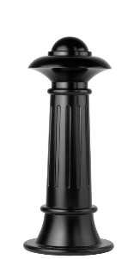Bollard [Designer’s Designation]:

Model: Reliance Foundry; **R-7538**.

Height: 35 inches (89 cm)

Diameter: 7 3/4 inches (19.7 cm) body; 15 inches (38 cm) base

Weight: 129 lbs. (58.5 kg)

Design: Tapered and fluted, with fluted base and nautical-styled top.

Material:

Ductile Cast Iron: ASTM A536, Grade 65-45-12; 30 percent recycled-material content.

Country of Origin: China.

Color Coating:

Type: Polyester powder coat over epoxy primer.

Color: [Black textured semi gloss] [Dark green] [Statuary bronze] [Bengal silver] [Anodized silver] [Safety yellow].

Installation:

Fixed, new concrete, anchor.

Fixed, existing concrete, insert.

Fixed, existing concrete, adhesive.

Fixed, anchor casting, concrete form.

Security post cover, new post

Security post cover, existing post, insert.

Security post cover, existing post, adhesive.

Security post cover, existing post, concrete anchor.

Removable, new concrete, anchor.

Removable, existing concrete, insert.

Removable, new concrete, retractable.

* + - * 1. 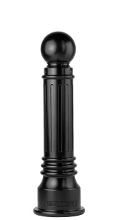Bollard [Designer’s Designation]:

Retain -AL for aluminum. Delete if not required.

Model: Reliance Foundry; **R-7539 [-AL]**.

See R-7539-B for complementary bike parking model: <http://www.reliance-foundry.com/bike-storage/bike-bollard-stands>

Height: 35 3/4 inches (90.8 cm)

Diameter: 5 7/8 inches (15 cm) body; 10 1/4 inches (26 cm) base

Design: Tapered and fluted, with round finial and ball top.

Retain aluminum or cast iron to coordinate with model number.

Material:

Aluminum: ASTM B26; 20 percent recycled-material content.

Weight: 31 lbs. (14 kg)

Ductile Cast Iron: ASTM A536, Grade 65-45-12; 30 percent recycled-material content.

Weight: 75 lbs. (34 kg)

Country of Origin: China.

Color Coating:

Type: Polyester powder coat over epoxy primer.

Color: [Black textured semi gloss] [Dark green] [Statuary bronze] [Bengal silver] [Anodized silver] [Safety yellow].

Installation:

Fixed, new concrete, anchor.

Fixed, existing concrete, insert.

Fixed, existing concrete, adhesive.

Fixed, anchor casting, concrete form.

Security post cover, new post

Security post cover, existing post, insert.

Security post cover, existing post, adhesive.

Security post cover, existing post, concrete anchor.

Removable, new concrete, anchor.

Removable, existing concrete, insert.

Removable, new concrete, retractable.

* + - * 1. Bollard [Designer’s Designation]:

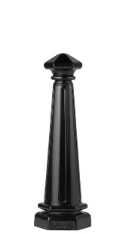Model: Reliance Foundry; **R-7542**.

Height: 30 inches (89 cm)

Diameter: 5 inches (12.7 cm) body; 10 inches (38 cm) base

Weight: 77 lbs. (35 kg)

Design: Tapered and fluted, with fluted base and nautical-styled top.

Material: Ductile Cast Iron: ASTM A536, Grade 65-45-12; 30 percent recycled-material content.

Country of Origin: China.

Color Coating:

Type: Polyester powder coat over epoxy primer.

Color: [Black textured semi gloss] [Dark green] [Statuary bronze] [Bengal silver] [Anodized silver] [Safety yellow].

Installation:

Fixed, new concrete, anchor.

Fixed, existing concrete, insert.

Fixed, existing concrete, adhesive.

Fixed, anchor casting, concrete form.

Security post cover, new post

Security post cover, existing post, insert.

Security post cover, existing post, adhesive.

Security post cover, existing post, concrete anchor.

Removable, new concrete, anchor.

Removable, existing concrete, insert.

Removable, new concrete, retractable.

* + - * 1. 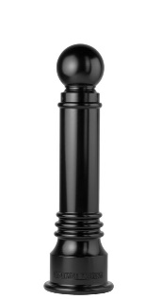Bollard [Designer’s Designation]:

Model: Reliance Foundry; **R-7551**.

See R-7551-B for complementary bike parking model: <http://www.reliance-foundry.com/bike-storage/bike-bollard-stands>

Height: 35.75 inches (90.8 cm)

Diameter: 6 inches (15.2 cm) body; 10 1/4 inches (26 cm) base

Weight: 79 lbs. (35.8 kg)

Design: Tapered with round finial and ball top.

Material: Ductile Cast Iron: ASTM A536, Grade 65-45-12; 30 percent recycled-material content.

Country of Origin: China.

Color Coating:

Type: Polyester powder coat over epoxy primer.

Color: [Black textured semi gloss] [Dark green] [Statuary bronze] [Bengal silver] [Anodized silver] [Safety yellow].

Installation:

Fixed, new concrete, anchor.

Fixed, existing concrete, insert.

Fixed, existing concrete, adhesive.

Fixed, anchor casting, concrete form.

Security post cover, new post

Security post cover, existing post, insert.

Security post cover, existing post, adhesive.

Security post cover, existing post, concrete anchor.

Removable, new concrete, anchor.

Removable, existing concrete, insert.

Removable, new concrete, retractable.

* + - * 1. 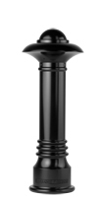Bollard [Designer’s Designation]:

Model: Reliance Foundry; **R-7552**.

Height: 36 inches (91.4 cm)

Diameter: 6 inches (15.2 cm) body; 10 1/4 inches (26 cm) base

Weight: 96 lbs. (43.5 kg)

Design: Tapered with round finial and contemporary-styled top.

Material: Ductile Cast Iron: ASTM A536, Grade 65-45-12; 30 percent recycled-material content.

Country of Origin: China.

Color Coating:

Type: Polyester powder coat over epoxy primer.

Color: [Black textured semi gloss] [Dark green] [Statuary bronze] [Bengal silver] [Anodized silver] [Safety yellow].

Installation:

Fixed, new concrete, anchor.

Fixed, existing concrete, insert.

Fixed, existing concrete, adhesive.

Fixed, anchor casting, concrete form.

Security post cover, new post

Security post cover, existing post, insert.

Security post cover, existing post, adhesive.

Security post cover, existing post, concrete anchor.

Removable, new concrete, anchor.

Removable, existing concrete, insert.

Removable, new concrete, retractable.

* + - * 1. Bollard [Designer’s Designation]:

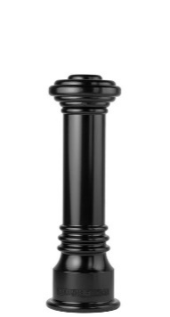Model: Reliance Foundry; **R-7553**.

See R-7553-B for complementary bike parking model: <http://www.reliance-foundry.com/bike-storage/bike-bollard-stands>

Height: 32 inches (81.3 cm)

Diameter: 6 inches (15.2 cm) body; 10 1/4 inches (26 cm) base

Weight: 81 lbs. (36.7 kg)

Design: Tapered with round finial and flat disc top.

Material: Ductile Cast Iron: ASTM A536, Grade 65-45-12; 30 percent recycled-material content.

Country of Origin: China.

Color Coating:

Type: Polyester powder coat over epoxy primer.

Color: [Black textured semi gloss] [Dark green] [Statuary bronze] [Bengal silver] [Anodized silver] [Safety yellow].

Installation:

Fixed, new concrete, anchor.

Fixed, existing concrete, insert.

Fixed, existing concrete, adhesive.

Fixed, anchor casting, concrete form.

Security post cover, new post

Security post cover, existing post, insert.

Security post cover, existing post, adhesive.

Security post cover, existing post, concrete anchor.

Removable, new concrete, anchor.

Removable, existing concrete, insert.

Removable, new concrete, retractable.

* + - * 1. 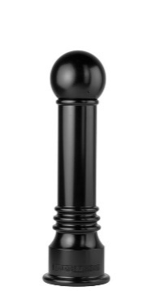Bollard [Designer’s Designation]:

Model: Reliance Foundry; **R-7555**.

Height: 35 inches (88.9 cm)

Diameter: 6 inches (15.2 cm) body; 10 1/4 inches (26 cm) base

Weight: 76 lbs. (34.5 kg)

Design: Tapered with round finial and large ball top.

Material: Ductile Cast Iron: ASTM A536, Grade 65-45-12; 30 percent recycled-material content.

Country of Origin: China.

Color Coating:

Type: Polyester powder coat over epoxy primer.

Color: [Black textured semi gloss] [Dark green] [Statuary bronze] [Bengal silver] [Anodized silver] [Safety yellow].

Installation:

Fixed, new concrete, anchor.

Fixed, existing concrete, insert.

Fixed, existing concrete, adhesive.

Fixed, anchor casting, concrete form.

Security post cover, new post

Security post cover, existing post, insert.

Security post cover, existing post, adhesive.

Security post cover, existing post, concrete anchor.

Removable, new concrete, anchor.

Removable, existing concrete, insert.

Removable, new concrete, retractable.

* + - * 1. Bollard [Designer’s Designation]:

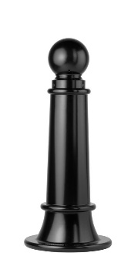Model: Reliance Foundry; **R-7561**.

Height: 35 inches (89 cm)

Diameter: 7 3/4 inches (19.7 cm) body; 15 inches (38 cm) base

Weight: 116 lbs. (52.6 kg)

Design: Tapered with round finial and ball top.

Material: Ductile Cast Iron: ASTM A536, Grade 65-45-12; 30 percent recycled-material content.

Country of Origin: China.

Color Coating:

Type: Polyester powder coat over epoxy primer.

Color: [Black textured semi gloss] [Dark green] [Statuary bronze] [Bengal silver] [Anodized silver] [Safety yellow].

Installation:

Fixed, new concrete, anchor.

Fixed, existing concrete, insert.

Fixed, existing concrete, adhesive.

Fixed, anchor casting, concrete form.

Security post cover, new post

Security post cover, existing post, insert.

Security post cover, existing post, adhesive.

Security post cover, existing post, concrete anchor.

Removable, new concrete, anchor.

Removable, existing concrete, insert.

Removable, new concrete, retractable.

* + - * 1. 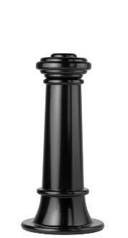Bollard [Designer’s Designation]:

Model: Reliance Foundry; **R-7563**.

Height: 31 inches (78.7 cm)

Diameter: 7 3/4 inches (19.7 cm) body; 15 inches (38 cm) base

Weight: 119 lbs. (54 kg)

Design: Tapered with round finial and flat disc top.

Material: Ductile Cast Iron: ASTM A536, Grade 65-45-12; 30 percent recycled-material content.

Country of Origin: China.

Color Coating:

Type: Polyester powder coat over epoxy primer.

Color: [Black textured semi gloss] [Dark green] [Statuary bronze] [Bengal silver] [Anodized silver] [Safety yellow].

Installation:

Fixed, new concrete, anchor.

Fixed, existing concrete, insert.

Fixed, existing concrete, adhesive.

Fixed, anchor casting, concrete form.

Security post cover, new post

Security post cover, existing post, insert.

Security post cover, existing post, adhesive.

Security post cover, existing post, concrete anchor.

Removable, new concrete, anchor.

Removable, existing concrete, insert.

Removable, new concrete, retractable.

* + - * 1. 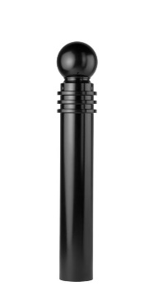Bollard [Designer’s Designation]:

Model: Reliance Foundry; **R-7571**.

See R-7571-B for complementary bike parking model: http://www.reliance-foundry.com/bike-storage/bike-bollard-stands

Height: 40 1/2 inches (102.9 cm)

Diameter: 5 3/4 inches (14.6 cm) body; 5 3/4 inches (14.6 cm) base

Weight: 64 lbs. (29 kg)

Design: Cylindrical with round finial and ball top.

Material: Ductile Cast Iron: ASTM A536, Grade 65-45-12; 30 percent recycled-material content.

Country of Origin: China.

Color Coating:

Type: Polyester powder coat over epoxy primer.

Color: [Black textured semi gloss] [Dark green] [Statuary bronze] [Bengal silver] [Anodized silver] [Safety yellow].

Installation:

Fixed, new concrete, anchor.

Fixed, existing concrete, insert.

Fixed, existing concrete, adhesive.

Fixed, anchor casting, concrete form.

Security post cover, new post

Security post cover, existing post, insert.

Security post cover, existing post, adhesive.

Security post cover, existing post, concrete anchor.

Removable, new concrete, anchor.

Removable, existing concrete, insert.

Removable, new concrete, retractable.

* + - * 1. Bollard [Designer’s Designation]:

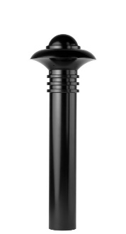Model: Reliance Foundry; **R-7572**.

Height: 40 1/2 inches (102.9 cm)

Diameter: 5 3/4 inches (14.6 cm) body; 5 3/4 inches (14.6 cm) base

Weight: 82 lbs. (37.2 kg)

Design: Cylindrical with round finial and contemporary-styled top.

Material: Ductile Cast Iron: ASTM A536, Grade 65-45-12; 30 percent recycled-material content.

Country of Origin: China.

Color Coating:

Type: Polyester powder coat over epoxy primer.

Color: [Black textured semi gloss] [Dark green] [Statuary bronze] [Bengal silver] [Anodized silver] [Safety yellow].

Installation:

Fixed, new concrete, anchor.

Fixed, existing concrete, insert.

Fixed, existing concrete, adhesive.

Fixed, anchor casting, concrete form.

Security post cover, new post

Security post cover, existing post, insert.

Security post cover, existing post, adhesive.

Security post cover, existing post, concrete anchor.

Removable, new concrete, anchor.

Removable, existing concrete, insert.

Removable, new concrete, retractable.

* + - * 1. 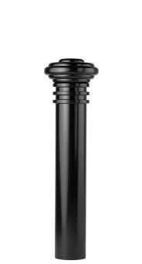Bollard [Designer’s Designation]:

Model: Reliance Foundry; **R-7573**.

Height: 36 1/2 inches (92.7 cm)

Diameter: 5 3/4 inches (14.6 cm) body; 5 3/4 inches (14.6 cm) base

Weight: 67 lbs. (30.4 kg)

Design: Cylindrical with round finial and flat disc top.

Material: Ductile Cast Iron: ASTM A536, Grade 65-45-12; 30 percent recycled-material content.

Country of Origin: China.

Color Coating:

Type: Polyester powder coat over epoxy primer.

Color: [Black textured semi gloss] [Dark green] [Statuary bronze] [Bengal silver] [Anodized silver] [Safety yellow].

Installation:

Fixed, new concrete, anchor.

Fixed, existing concrete, insert.

Fixed, existing concrete, adhesive.

Fixed, anchor casting, concrete form.

Security post cover, new post

Security post cover, existing post, insert.

Security post cover, existing post, adhesive.

Security post cover, existing post, concrete anchor.

Removable, new concrete, anchor.

Removable, existing concrete, insert.

Removable, new concrete, retractable.

* + - * 1. 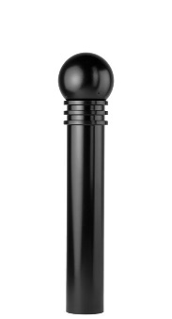Bollard [Designer’s Designation]:

Model: Reliance Foundry; **R-7575**.

Height: 39 3/8 inches (99.7 cm)

Diameter: 5 3/4 inches (14.6 cm) body; 5 3/4 inches (14.6 cm) base

Weight: 62 lbs. (28.1 kg)

Design: Cylindrical with round finial and large ball top.

Material: Ductile Cast Iron: ASTM A536, Grade 65-45-12; 30 percent recycled-material content.

Country of Origin: China.

Color Coating:

Type: Polyester powder coat over epoxy primer.

Color: [Black textured semi gloss] [Dark green] [Statuary bronze] [Bengal silver] [Anodized silver] [Safety yellow].

Installation:

Fixed, new concrete, anchor.

Fixed, existing concrete, insert.

Fixed, existing concrete, adhesive.

Fixed, anchor casting, concrete form.

Security post cover, new post

Security post cover, existing post, insert.

Security post cover, existing post, adhesive.

Security post cover, existing post, concrete anchor.

Removable, new concrete, anchor.

Removable, existing concrete, insert.

Removable, new concrete, retractable.

* + - * 1. 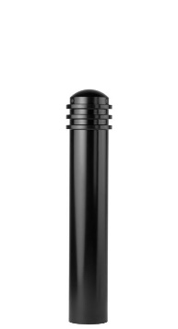Bollard [Designer’s Designation]:

Model: Reliance Foundry; **R-7576**.

See R-7576-B for complementary bike parking model: http://www.reliance-foundry.com/bike-storage/bike-bollard-stands

Height: 34 inches (86.4 cm)

Diameter: 5 3/4 inches (14.6 cm) body; 5 3/4 inches (14.6 cm) base

Weight: 51 lbs. (23.1 Kg)

Design: Cylindrical with round finial and rounded top.

Material: Ductile Cast Iron: ASTM A536, Grade 65-45-12; 30 percent recycled-material content.

Color Coating:

Type: Polyester powder coat over epoxy primer.

Color: [Black textured semi gloss] [Dark green] [Statuary bronze] [Bengal silver] [Anodized silver] [Safety yellow].

Installation:

Fixed, new concrete, anchor.

Fixed, existing concrete, insert.

Fixed, existing concrete, adhesive.

Fixed, anchor casting, concrete form.

Security post cover, new post

Security post cover, existing post, insert.

Security post cover, existing post, adhesive.

Security post cover, existing post, concrete anchor.

Removable, new concrete, anchor.

Removable, existing concrete, insert.

Removable, new concrete, retractable.

* + - * 1. 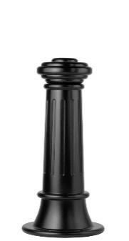Bollard [Designer’s Designation]:

Retain -AL for aluminum. Delete if not required.

Model: Reliance Foundry; **R-7581 [-AL]**.

Height: 31 inches (78.7 cm)

Diameter: 7 3/4 inches (19.7 cm) body; 15 inches (38 cm) base

Design: Tapered and fluted, with round finial and flat disc top.

Retain aluminum or cast iron to coordinate with model number.

Material:

Aluminum: ASTM B26; 20 percent recycled-material content.

Weight: 46 lbs. (20.8 kg)

Ductile Cast Iron: ASTM A536, Grade 65-45-12; 30 percent recycled-material content.

Weight: 114 lbs. (51.7 kg)

Country of Origin: China.

Color Coating:

Type: Polyester powder coat over epoxy primer.

Color: [Black textured semi gloss] [Dark green] [Statuary bronze] [Bengal silver] [Anodized silver] [Safety yellow].

Installation:

Fixed, new concrete, anchor.

Fixed, existing concrete, insert.

Fixed, existing concrete, adhesive.

Fixed, anchor casting, concrete form.

Security post cover, new post

Security post cover, existing post, insert.

Security post cover, existing post, adhesive.

Security post cover, existing post, concrete anchor.

Removable, new concrete, anchor.

Removable, existing concrete, insert.

Removable, new concrete, retractable.

* + - * 1. 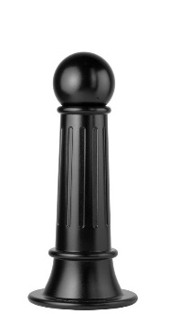Bollard [Designer’s Designation]:

Model: Reliance Foundry; **R-7582**.

Height: 34 inches (86.4 cm)

Diameter: 7 3/4 inches (19.7 cm) body; 15 inches (38 cm) base

Weight: 109 lbs. (49.5 kg)

Design: Tapered and fluted, with round finial and large ball top.

Material: Ductile Cast Iron: ASTM A536, Grade 65-45-12; 30 percent recycled-material content.

Country of Origin: China.

Color Coating:

Type: Polyester powder coat over epoxy primer.

Color: [Black textured semi gloss] [Dark green] [Statuary bronze] [Bengal silver] [Anodized silver] [Safety yellow].

Installation:

Fixed, new concrete, anchor.

Fixed, existing concrete, insert.

Fixed, existing concrete, adhesive.

Fixed, anchor casting, concrete form.

Security post cover, new post

Security post cover, existing post, insert.

Security post cover, existing post, adhesive.

Security post cover, existing post, concrete anchor.

Removable, new concrete, anchor.

Removable, existing concrete, insert.

Removable, new concrete, retractable.

* + - * 1. 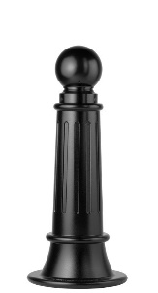Bollard [Designer’s Designation]:

Retain -AL for aluminum. Delete if not required.

Model: Reliance Foundry; **R-7589 [-AL]**.

Height: 35 inches (89 cm)

Diameter: 7 3/4 inches (19.7 cm) body; 15 inches (38 cm) base

Design: Tapered and fluted, with round finial and ball top.

Retain aluminum or cast iron to coordinate with model number.

Material:

Aluminum: ASTM B26; 20 percent recycled-material content.

Weight: 46 lbs. (20.8 kg)

Ductile Cast Iron: ASTM A536, Grade 65-45-12; 30 percent recycled-material content.

Weight: 111 lbs. (50.3 kg)

Country of Origin: China.

Color Coating:

Type: Polyester powder coat over epoxy primer.

Color: [Black textured semi gloss] [Dark green] [Statuary bronze] [Bengal silver] [Anodized silver] [Safety yellow].

Installation:

Fixed, new concrete, anchor.

Fixed, existing concrete, insert.

Fixed, existing concrete, adhesive.

Fixed, anchor casting, concrete form.

Security post cover, new post

Security post cover, existing post, insert.

Security post cover, existing post, adhesive.

Security post cover, existing post, concrete anchor.

Removable, new concrete, anchor.

Removable, existing concrete, insert.

Removable, new concrete, retractable.

* + - * 1. 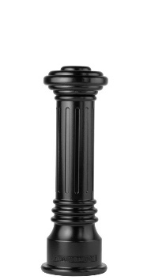Bollard [Designer’s Designation]:

Retain -AL for aluminum. Delete if not required.

Model: Reliance Foundry; **R-7591 [-AL]**.

See R-7591-B for complementary bike parking model: http://www.reliance-foundry.com/bike-storage/bike-bollard-stands

Height: 32 inches (81.3 cm)

Diameter: 6 inches (15.2 cm) body; 10 1/4 inches (26 cm) base

Design: Tapered and fluted, with round finial and flat disc top.

Retain aluminum or cast iron to coordinate with model number.

Material:

Aluminum: ASTM B26; 20 percent recycled-material content.

Weight: 31 lbs. (14 kg)

Ductile Cast Iron: ASTM A536, Grade 65-45-12; 30 percent recycled-material content.

Weight: 77 lbs. (35 kg)

Country of Origin: China.

Color Coating:

Type: Polyester powder coat over epoxy primer.

Color: [Black textured semi gloss] [Dark green] [Statuary bronze] [Bengal silver] [Anodized silver] [Safety yellow].

Installation:

Fixed, new concrete, anchor.

Fixed, existing concrete, insert.

Fixed, existing concrete, adhesive.

Fixed, anchor casting, concrete form.

Security post cover, new post

Security post cover, existing post, insert.

Security post cover, existing post, adhesive.

Security post cover, existing post, concrete anchor.

Removable, new concrete, anchor.

Removable, existing concrete, insert.

Removable, new concrete, retractable.

* + - * 1. 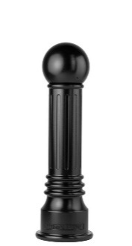Bollard [Designer’s Designation]:

Model: Reliance Foundry; **R-7592**.

Height: 35 inches (89 cm)

Diameter: 6 inches (15.2 cm) body; 10 1/4 inches (26 cm) base.

Weight: 73 lbs. (33 kg)

Design: Tapered and fluted, with round finial and large ball top.

Material: Ductile Cast Iron: ASTM A536, Grade 65-45-12; 30 percent recycled-material content.

Country of Origin: China.

Color Coating:

Type: Polyester powder coat over epoxy primer.

Color: [Black textured semi gloss] [Dark green] [Statuary bronze] [Bengal silver] [Anodized silver] [Safety yellow].

Installation:

Fixed, new concrete, anchor.

Fixed, existing concrete, insert.

Fixed, existing concrete, adhesive.

Fixed, anchor casting, concrete form.

Security post cover, new post

Security post cover, existing post, insert.

Security post cover, existing post, adhesive.

Security post cover, existing post, concrete anchor.

Removable, new concrete, anchor.

Removable, existing concrete, insert.

Removable, new concrete, retractable.

* + - * 1. 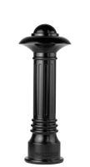Bollard [Designer’s Designation]:

Model: Reliance Foundry; **R-7598**.

Height: 36 inches (91.5 cm)

Diameter: 6 inches (15.2 cm) body; 10 1/4 inches (26 cm) base.

Weight: 93 lbs. (42.2 kg)

Design: Tapered and fluted, with fluted base and nautical-styled top.

Material: Ductile Cast Iron: ASTM A536, Grade 65-45-12; 30 percent recycled-material content.

Country of Origin: China.

Color Coating:

Type: Polyester powder coat over epoxy primer.

Color: [Black textured semi gloss] [Dark green] [Statuary bronze] [Bengal silver] [Anodized silver] [Safety yellow].

Installation:

Fixed, new concrete, anchor.

Fixed, existing concrete, insert.

Fixed, existing concrete, adhesive.

Fixed, anchor casting, concrete form.

Security post cover, new post

Security post cover, existing post, insert.

Security post cover, existing post, adhesive.

Security post cover, existing post, concrete anchor.

Removable, new concrete, anchor.

Removable, existing concrete, insert.

Removable, new concrete, retractable.

* + - * 1. 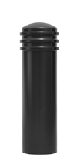Bollard [Designer’s Designation]:

Model: Reliance Foundry; **R-7835**.

See R-7835-B for complementary bike parking model: http://www.reliance-foundry.com/bike-storage/bike-bollard-stands

Height: 35 inches (88.9 cm)

Diameter: 9 1/2 inches (24.1 cm) body; 9 1/2 inches (24.1 cm) base

Weight: 80 lbs. (36.3 kg)

Design: Cylindrical with segmented rings and rounded top.

Material: Steel: ASTM A36; 25 percent recycled-material content.

Country of Origin: China.

Color Coating:

Type: Polyester powder coat over epoxy primer.

Color: [Black textured semi gloss] [Dark green] [Statuary bronze] [Bengal silver] [Anodized silver] [Safety yellow].

Installation:

Fixed, new concrete, anchor.

Fixed, existing concrete, insert.

Fixed, existing concrete, adhesive.

Fixed, anchor casting, concrete form.

Security post cover, new post

Security post cover, existing post, insert.

Security post cover, existing post, adhesive.

Security post cover, existing post, concrete anchor.

Removable, new concrete, anchor.

Removable, existing concrete, insert.

Removable, new concrete, retractable.

* + - * 1. Bollard [Designer’s Designation]:

If coating is required, retain “RA” below.

Model: Reliance Foundry; **R-8464**[**-RA**].

See Retractable Bollard Set for complementary retractable and embedded models.

Height: 35 1/2 inches (90.2 cm)

Diameter: 4 1/2 inches (11.4 cm) body; 6 1/2 inches (16.5 cm) base

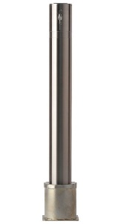Weight: 26 lbs. (11.8 kg)

Design: Fixed cylinder with flat top.

Material: [Coated] Stainless Steel:

Pipe: ASTM A312, Grade TP 316.

Plate: ASTM A959, Grade TP 316.

Country of Origin: China.

If coating is required, retain “Coated” above and Color Coating requirement below.

Color Coating:

Type: Polyester powder coat over epoxy primer.

Color: [Black textured semi gloss] [Dark green] [Statuary bronze] [Bengal silver] [Anodized silver] [Safety yellow].

Installation:

Removable, new concrete, receiver with key

Removable, existing concrete, receiver with key

* + - * 1. Bollard [Designer’s Designation]:

Model: Reliance Foundry; **R-8464-30**

Height: 30 1/8 inches (76.5 cm)

Diameter: 4 1/2 inches (11.4 cm) body; 6 1/2 inches (16.5 cm) base

Weight: 17 lbs (7.7 kg)

Design: Fixed cylinder with flat top

Material: [Coated] Stainless Steel:

Pipe: ASTM A312, Grade TP 316.

Plate: ASTM A959, Grade TP 316.

Country of Origin: China

Color Coating:

Type: Polyester powder coat over epoxy primer

Color: [Black textured semi gloss] [Dark green] [Statuary bronze] [Bengal silver] [Anodized silver] [Safety yellow]

Installation:

Removable, new concrete, receiver with key

Removable, existing concrete, receiver with key

* + - * 1. Bollard [Designer’s Designation]:

If coating is required, retain “RA” below.

Model: Reliance Foundry; **R-9464**.

See Retractable Bollard Set for complementary retractable and embedded models.

Height: 35 3/8 inches (90 cm)

Diameter: 4 1/2 inches (11.4 cm) body; 6 1/2 inches (16.5 cm) base

Weight: 28 lbs. (12.7 kg)

Design: Fixed cylinder with flat top.

Material: [Coated] Stainless Steel:

Pipe: ASTM A312, Grade TP 316.

Plate: ASTM A959, Grade TP 316.

Country of Origin: China.

If coating is required, retain “Coated” above and Color Coating requirement below.

Color Coating:

Type: Polyester powder coat over epoxy primer.

Color: [Black textured semi gloss] [Dark green] [Statuary bronze] [Bengal silver] [Anodized silver] [Safety yellow].

Installation:

Removable, new concrete, receiver with key

Removable, existing concrete, receiver with key

* + - 1. RETRACTABLE BOLLARD SET
         1. 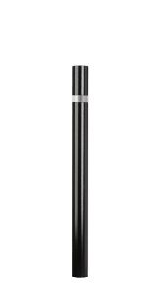Bollard [Designer’s Designation]:

If coating is required, retain “RA” below.

Model: Reliance Foundry; **R-7460**.

Height: 35 5/8 inches (93.0 cm)

Diameter: 4 1/2 inches (11.4 cm)

Weight: 22 lbs. (10.0 kg)

Design: Fixed cylinder with flat top.

Material: [Coated] Carbon Steel:

Grade Q235

Country of Origin: China.

If coating is required, retain “Coated” above and Color Coating requirement below.

Color Coating:

Type: Polyester powder coat over epoxy primer.

Color: [Black textured semi gloss] [Dark green] [Statuary bronze] [Bengal silver] [Anodized silver] [Safety yellow].

Reflective Stripe: [White][Yellow][Blue][Red][None].

Installation:

Fixed, New Concrete, Embedded.

* + - * 1. 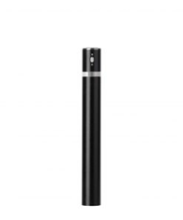Bollard [Designer’s Designation]:

See R-8460 and R-8464 for alternative mountings: http://www.reliance-foundry.com/bollard/retractable-bollards

If coating is required, retain “RA” below.

Model: Reliance Foundry; **R-7471**.

Height: 35 5/8 inches (93.0 cm)

Diameter: 4 1/2 inches (11.4 cm) body; 8 5/8 inches (21.9 cm) base.

Weight: 23lbs. (10.4 kg) bollard weight; 60 lbs. (27.2 kg) total weight.

Design: Retractable cylinder with flat top.

Lock: Extended Only

Material: [Coated] Carbon Steel:

Grade Q235.

Country of Origin: China.

If coating is required, retain “Coated” above and Color Coating requirement below.

Color Coating:

Type: Polyester powder coat over epoxy primer.

Color: [Black textured semi gloss] [Dark green] [Statuary bronze] [Bengal silver] [Anodized silver] [Safety yellow].

Reflective Stripe: [White][Yellow][Blue][Red][None].

Installation:

Retractable, New Concrete:

Receiver

Locking: In raised position.

Footing: [3000 psi minimum concrete or mortar.] [[Concrete] [Mortar] as specified in Section [__ __ __].]

Fill: [Aggregate.] [Aggregate as specified in Section [__ __ __].]

Retractable, Existing Concrete:

Receiver

Locking: In raised position.

Footing: [3000 psi minimum concrete or mortar.] [[Concrete] [Mortar] as specified in Section [__ __ __].]

Fill: [Aggregate.] [Aggregate as specified in Section [__ __ __].]

* + - * 1. 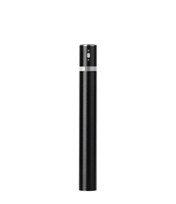Bollard [Designer’s Designation]:

See R-8460 and R-8464 for alternative mountings: http://www.reliance-foundry.com/bollard/retractable-bollards

If coating is required, retain “RA” below.

Model: Reliance Foundry; **R-7472**.

Height: 35 5/8 inches (93.0 cm)

Diameter: 4 1/2 inches (11.4 cm) body; 8 5/8 inches (21.9 cm) base.

Weight: 23lbs. (10.4 kg) bollard weight; 60 lbs. (27.2 kg) total weight.

Design: Retractable cylinder with flat top.

Lock: extended and lowered

Material: [Coated] Carbon Steel:

Grade Q235.

Country of Origin: China.

If coating is required, retain “Coated” above and Color Coating requirement below.

Color Coating:

Type: Polyester powder coat over epoxy primer.

Color: [Black textured semi gloss] [Dark green] [Statuary bronze] [Bengal silver] [Anodized silver] [Safety yellow].

Reflective Stripe: [White][Yellow][Blue][Red][None].

Installation:

Retractable, New Concrete:

Receiver

Locking: In raised position.

Footing: [3000 psi minimum concrete or mortar.] [[Concrete] [Mortar] as specified in Section [__ __ __].]

Fill: [Aggregate.] [Aggregate as specified in Section [__ __ __].]

Retractable, Existing Concrete:

Receiver

Locking: In raised position.

Footing: [3000 psi minimum concrete or mortar.] [[Concrete] [Mortar] as specified in Section [__ __ __].]

Fill: [Aggregate.] [Aggregate as specified in Section [__ __ __].]

* + - * 1. 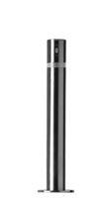Bollard [Designer’s Designation]:

See R-8460 and R-8464 for alternative mountings: http://www.reliance-foundry.com/bollard/retractable-bollards

If coating is required, retain “RA” below.

Model: Reliance Foundry; **R-8471**[**-RA**].

Height: 35 1/2 inches (90.2 cm)

Diameter: 4 1/2 inches (11.4 cm) body; 8 3/4 inches (22 cm) base

Weight: 25 lbs. (11.3 kg)

Design: Retractable cylinder with flat top.

Lock: Extended Only

Material: [Coated] Stainless Steel:

Pipe: ASTM A312, Grade TP 316.

Plate: ASTM A959, GradeTP 316.

Country of Origin: China.

If coating is required, retain “Coated” above and Color Coating requirement below.

Color Coating:

Type: Polyester powder coat over epoxy primer.

Color: [Black textured semi gloss] [Dark green] [Statuary bronze] [Bengal silver] [Anodized silver] [Safety yellow].

Installation:

Retractable, New Concrete:

Receiver

Locking: In raised position.

Footing: [3000 psi minimum concrete or mortar.] [[Concrete] [Mortar] as specified in Section [__ __ __].]

Fill: [Aggregate.] [Aggregate as specified in Section [__ __ __].]

Retractable, Existing Concrete:

Receiver

Locking: In raised position.

Footing: [3000 psi minimum concrete or mortar.] [[Concrete] [Mortar] as specified in Section [__ __ __].]

Fill: [Aggregate.] [Aggregate as specified in Section [__ __ __].]

* + - * 1. Bollard [Designer’s Designation]:

See R-8460 and R-8464 for alternative mountings: http://www.reliance-foundry.com/bollard/retractable-bollards

If coating is required, retain “RA” below.

Model: Reliance Foundry; **R-8472**[**-RA**].

Height: 35 1/2 inches (90.2 cm)

Diameter: 4 1/2 inches (11.4 cm) body; 8 3/4 inches (22 cm) base

Weight: 25 lbs. (11.3 kg)

Design: Retractable cylinder with flat top.

Lock: extended and lowered

Material: [Coated] Stainless Steel:

Pipe: ASTM A312, Grade TP 316.

Plate: ASTM A959, GradeTP 316.

Country of Origin: China.

If coating is required, retain “Coated” above and Color Coating requirement below.

Color Coating:

Type: Polyester powder coat over epoxy primer.

Color: [Black textured semi gloss] [Dark green] [Statuary bronze] [Bengal silver] [Anodized silver] [Safety yellow].

Installation:

Retractable, New Concrete:

Receiver

Locking: In raised position.

Footing: [3000 psi minimum concrete or mortar.] [[Concrete] [Mortar] as specified in Section [__ __ __].]

Fill: [Aggregate.] [Aggregate as specified in Section [__ __ __].]

Retractable, Existing Concrete:

Receiver

Locking: In raised position.

Footing: [3000 psi minimum concrete or mortar.] [[Concrete] [Mortar] as specified in Section [__ __ __].]

Fill: [Aggregate.] [Aggregate as specified in Section [__ __ __].]

* + - * 1. 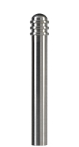Bollard [Designer’s Designation]:

See R-8903 for complementary bike parking bollard http://www.reliance-foundry.com/bollard/bike-parking-bollards

Model: Reliance Foundry; **R-8911**.

Height: 36 inches (91.4 cm)

Diameter: 6 1/2 inches (16.5 cm) body; 6 1/2 inches (16.5 cm) base

Weight: 58 lbs. (26.3 kg)

Design: Cylindrical with segmented rings and rounded top.

Material: Stainless steel, ASTM A312, Grade TP 316.

Country of Origin: China.

Color coating over stainless is available at additional cost for this bollard. Delete if not required.

Color Coating:

Type: Polyester powder coat over epoxy primer.

Color: [Black textured semi gloss.] [Dark green.] [Statuary bronze.] [Bengal silver.] [Anodized silver.] [Safety yellow.]

Reflective Stripe: [White][Yellow][Blue][None].

Installation:

Fixed, new concrete, embedded.

Fixed, existing concrete, flanged surface mount.

Removable, new concrete, removable mount with hinged lid, std.

Removable, new concrete, removable mount with hinged lid, premium.

* + - * 1. 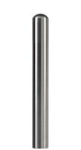Bollard [Designer’s Designation]:

See R-8904 for complementary bike parking bollard http://www.reliance-foundry.com/bollard/bike-parking-bollards

Model: Reliance Foundry; **R-8912**.

Height: 36 inches (91.4 cm)

Diameter: 6 1/2 inches (16.5 cm) body; 6 1/2 inches (16.5 cm) base

Weight: 52 lbs. (23.6 kg)

Design: Cylindrical with rounded top.

Material: Stainless steel, ASTM A312, Grade TP 316.

Country of Origin: China.

Color coating over stainless is available at additional cost for this bollard. Delete if not required.

Color Coating:

Type: Polyester powder coat over epoxy primer.

Color: [Black textured semi gloss.] [Dark green.] [Statuary bronze.] [Bengal silver.] [Anodized silver.] [Safety yellow.]

Reflective Stripe: [White][Yellow][Blue][None].

Installation:

Fixed, new concrete, embedded.

Fixed, existing concrete, flanged surface mount.

Removable, new concrete, removable mount with hinged lid, std.

Removable, new concrete, removable mount with hinged lid, premium.

* + - * 1. 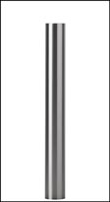Bollard [Designer’s Designation]:

See R-8904 for complementary bike parking bollard http://www.reliance-foundry.com/bollard/bike-parking-bollards

Model: Reliance Foundry; **R-8914**.

Height: 36 inches (91.4 cm)

Diameter: 6 1/2 inches (16.5 cm) body; 6 1/2 inches (16.5 cm) base

Weight: 58 lbs. (26.3 kg)

Design: Cylindrical with flat top.

Material: Stainless steel, ASTM A312, Grade TP 316.

Country of Origin: China.

Color coating over stainless is available at additional cost for this bollard. Delete if not required.

Color Coating:

Type: Polyester powder coat over epoxy primer.

Color: [Black textured semi gloss] [Dark green] [Statuary bronze] [Bengal silver] [Anodized silver] [Safety yellow].

Reflective Stripe: [White][Yellow][Blue][None].

Installation:

Fixed, new concrete, embedded.

Fixed, existing concrete, flanged surface mount.

Removable, new concrete, removable mount with hinged lid, std.

Removable, new concrete, removable mount with hinged lid, premium.

* + - * 1. Bollard [Designer’s Designation]:

See R-8460 and R-8464 for alternative mountings: http://www.reliance-foundry.com/bollard/retractable-bollards

If coating is required, retain “RA” below.

Model: Reliance Foundry; **R-9471**.

Height: 35 3/8 inches (90 cm)

Diameter: 4 1/2 inches (11.4 cm) body; 8 3/4 inches (22 cm) base

Weight: 27 lbs. (12.2 kg)

Design: Retractable cylinder with flat top.

Lock: Extended Only

Material: [Coated] Stainless Steel:

Pipe: ASTM A312, Grade TP 316.

Plate: ASTM A959, GradeTP 316.

Country of Origin: China.

If coating is required, retain “Coated” above and Color Coating requirement below.

Color Coating:

Type: Polyester powder coat over epoxy primer.

Color: [Black textured semi gloss] [Dark green] [Statuary bronze] [Bengal silver] [Anodized silver] [Safety yellow].

Installation:

Retractable, New Concrete:

Receiver

Locking: In raised position.

Footing: [3000 psi minimum concrete or mortar.] [[Concrete] [Mortar] as specified in Section [__ __ __].]

Fill: [Aggregate.] [Aggregate as specified in Section [__ __ __].]

Retractable, Existing Concrete:

Receiver

Locking: In raised position.

Footing: [3000 psi minimum concrete or mortar.] [[Concrete] [Mortar] as specified in Section [__ __ __].]

Fill: [Aggregate.] [Aggregate as specified in Section [__ __ __].]

* + - * 1. 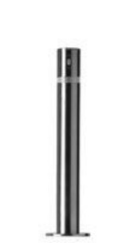Bollard [Designer’s Designation]:

See R-8460 and R-8464 for alternative mountings: http://www.reliance-foundry.com/bollard/retractable-bollards

If coating is required, retain “RA” below.

Model: Reliance Foundry; **R-9472**.

Height: 35 3/8 inches (90 cm)

Diameter: 4 1/2 inches (11.4 cm) body; 8 3/4 inches (22 cm) base

Weight: 27 lbs. (12.2 kg)

Design: Retractable cylinder with flat top.

Lock: extended and lowered

Material: [Coated] Stainless Steel:

Pipe: ASTM A312, Grade TP 316.

Plate: ASTM A959, GradeTP 316.

Country of Origin: China.

If coating is required, retain “Coated” above and Color Coating requirement below.

Color Coating:

Type: Polyester powder coat over epoxy primer.

Color: [Black textured semi gloss] [Dark green] [Statuary bronze] [Bengal silver] [Anodized silver] [Safety yellow].

Installation:

Retractable, New Concrete:

Receiver

Locking: In raised position.

Footing: [3000 psi minimum concrete or mortar.] [[Concrete] [Mortar] as specified in Section [__ __ __].]

Fill: [Aggregate.] [Aggregate as specified in Section [__ __ __].]

Retractable, Existing Concrete:

Receiver

Locking: In raised position.

Footing: [3000 psi minimum concrete or mortar.] [[Concrete] [Mortar] as specified in Section [__ __ __].]

Fill: [Aggregate.] [Aggregate as specified in Section [__ __ __].]

* + - * 1. 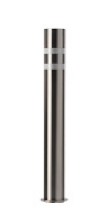Bollard [Designer’s Designation]:

If coating is required, retain “RA” below.

Model: Reliance Foundry; **R-8460** [**-RA**].

Height: 35 1/2 inches (90.2 cm)

Diameter: 4 1/2 inches (11.4 cm)

Weight: 20 lbs. (9 kg)

Design: Fixed cylinder with flat top.

Material: [Coated] Stainless Steel:

Pipe: ASTM A312, Grade TP 316.

Plate: ASTM A959, Grade TP 316.

Country of Origin: China.

If coating is required, retain “Coated” above and Color Coating requirement below.

Color Coating:

Type: Polyester powder coat over epoxy primer.

Color: [Black textured semi gloss] [Dark green] [Statuary bronze] [Bengal silver] [Anodized silver] [Safety yellow].

Installation:

Fixed, New Concrete, Embedded.

* + - * 1. 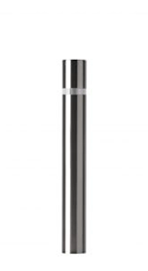Bollard [Designer’s Designation]:

If coating is required, retain “RA” below.

Model: Reliance Foundry; **R-8460 -30**[**-FL**].

Height: 30 inches (76.2 cm)

Diameter: 4 1/2 inches (11.4 cm)

Weight: 18 lbs. (8.2 kg)

Design: Fixed cylinder with flat top.

Material: Stainless Steel:

Pipe: ASTM A312, Grade TP 316.

Plate: ASTM A959, Grade TP 316.

Country of Origin: China.

If coating is required, retain “Coated” above and Color Coating requirement below.

Installation:

Fixed, New Concrete, Embedded.

b. Fixed, existing concrete, flanged surface mount.

* + - * 1. 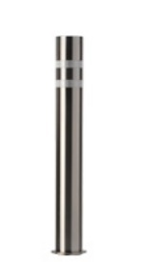Bollard [Designer’s Designation]:

If coating is required, retain “RA” below.

Model: Reliance Foundry; **R-9460**.

Height: 35 3/8 inches (90 cm)

Diameter: 4 1/2 inches (11.4 cm)

Weight: 24 lbs. (11 kg)

Design: Fixed cylinder with flat top.

Material: [Coated] Stainless Steel:

Pipe: ASTM A312, Grade TP 316.

Plate: ASTM A959, Grade TP 316.

Country of Origin: China.

If coating is required, retain “Coated” above and Color Coating requirement below.

Color Coating:

Type: Polyester powder coat over epoxy primer.

Color: [Black textured semi gloss] [Dark green] [Statuary bronze] [Bengal silver] [Anodized silver] [Safety yellow].

Installation:

Fixed, New Concrete, Embedded.

* + - 1. COLLAPSIBLE BOLLARDS

Most collapsible bollards are also available with fixed or removable mountings

* + - * 1. Bollard [Designer’s Designation]:

See R-7905, R-7903, and R-7903 RSA for complementary bike parking bollards http://www.reliance-foundry.com/bollard/bike-parking-bollards

Model: Reliance Foundry; **R-7901**.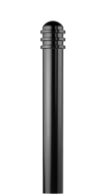

Height: 36 inches (91.4 cm)

Diameter: 4 1/3 inches (11 cm) body; 4 1/3 inches (11 cm) base

Weight: 38 lbs. (17.2 kg)

Design: Cylindrical with segmented rings and rounded top.

Material: Steel: ASTM A36; 25 percent recycled-material content.

Country of Origin: China.

Color Coating:

Type: Polyester powder coat over epoxy primer.

Color: [Black textured semi gloss] [Dark green] [Statuary bronze] [Bengal silver] [Anodized silver] [Safety yellow].

Reflective Stripe: [White] [Yellow] [Blue] [None].

Installation:

Fixed, new concrete, embedded.

Fixed, existing concrete, flange, surface mount.

Removable, new concrete, receiver.

[Steel] [Stainless Steel] receiver with lid.

[Steel] [Stainless Steel] receiver with chain.

Removable, existing concrete, receiver.

[Steel] [Stainless Steel] receiver with lid

[Steel] [Stainless Steel] receiver with chain

Collapsible, steel surface-mount with hinged receiver and padlock hasp.

* + - * 1. 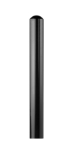Bollard [Designer’s Designation]:

See R-7906, R-7904, and R-7904-RSA for complementary bike parking bollards http://www.reliance-foundry.com/bollard/bike-parking-bollards

Model: Reliance Foundry; **R-7902**.

Height: 36 inches (91.4 cm)

Diameter: 4 3/8 inches (11.1 cm) body; 7 1/2 inches (19.1 cm) base

Weight: 29 lbs. (13.2 kg)

Design: Cylindrical with rounded top.

Material: Steel: ASTM A36; 25 percent recycled-material content.

Country of Origin: China.

Color Coating:

Type: Polyester powder coat over epoxy primer.

Color: [Black textured semi gloss] [Dark green] [Statuary bronze] [Bengal silver] [Anodized silver] [Safety yellow].

Reflective Stripe: [White][Yellow][Blue][None].

Installation:

Fixed, new concrete, embedded.

Fixed, existing concrete, flange, surface mount.

Removable, new concrete, receiver.

[Steel] [Stainless Steel] receiver with lid.

[Steel] [Stainless Steel] receiver with chain.

Removable, existing concrete, receiver.

[Steel] [Stainless Steel] receiver with lid

[Steel] [Stainless Steel] receiver with chain.

Collapsible, steel surface-mount with hinged receiver and padlock hasp.

* + - * 1. Bollard [Designer’s Designation]:

Model: Reliance Foundry; **R-7907**.

Height: 46 inches (116.8 cm)

Diameter: 4 3/9 inches (11 cm) body

Weight: 28 lbs. (12.7 kg)

Design: Cylindrical with flat top.

Material: Steel: ASTM A36; 95 percent recycled-material content.

Country of Origin: China

Color Coating:

Type: [Polyester powder coat over epoxy primer.] [IronArmor protective coating.]

Color: [Black textured semi gloss.] [Dark green.] [Statuary bronze.] [Bengal silver.] [Anodized silver.] [Safety yellow.]

Reflective Stripe: [White][Yellow][Blue][None].

Installation:

Fixed, new concrete, embedded.

Fixed, existing concrete, flange, surface mount.

Removable, new concrete, receiver.

[Steel] [Stainless Steel] receiver with lid.

[Steel] [Stainless Steel] receiver with chain.

Removable, existing concrete, receiver.

[Steel] [Stainless Steel] receiver with lid

[Steel] [Stainless Steel] receiver with chain.

Collapsible, steel surface-mount with hinged receiver and padlock hasp.

* + - * 1. 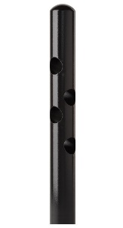Bollard [Designer’s Designation]:

See R-7906, R-7904, and R-7904-RSA for complementary bike parking bollards http://www.reliance-foundry.com/bollard/bike-parking-bollards

Model: Reliance Foundry; **R-7972**.

Height: 36 inches (91.4 cm)

Diameter: 4 5/16 inches (11 cm) body; 4 5/16 inches (11 cm) base

Weight: 32 lbs. (14.5 kg)

Design: Cylindrical with rounded top.

Material: Steel: ASTM A36; 25 percent recycled-material content.

Country of Origin: China.

Color Coating:

Type: Polyester powder coat over epoxy primer.

Color: [Black textured semi gloss] [Dark green] [Statuary bronze] [Bengal silver] [Anodized silver] [Safety yellow].

Reflective Stripe: [White][Yellow][Blue][None].

Installation:

Fixed, new concrete, embedded.

Fixed, existing concrete, flange, surface mount.

Removable, new concrete, receiver.

[Steel] [Stainless Steel] receiver with lid.

[Steel] [Stainless Steel] receiver with chain.

Removable, existing concrete, receiver.

[Steel] [Stainless Steel] receiver with lid

[Steel] [Stainless Steel] receiver with chain

Collapsible, steel surface-mount with hinged receiver and padlock hasp.

* + - * 1. 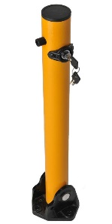Bollard [Designer’s Designation]:

Model: Reliance Foundry; **R-8430**.

Height: 24 1/2 inches (62.2 cm)

Diameter: 2 1/2 inches (6.3 cm) body; 5 7/8 inches (14.9 cm) base

Weight: 12 lbs. (5.4 kg)

Design: Cylindrical with built-in mounting hardware and internal locking mechanism.

Material: Steel: ASTM A36; 25 percent recycled-material content.

Country of Origin: China.

Powder Coating: Safety yellow

Installation: Collapsible, hinged surface mount.

* + - * 1. Text

           Description automatically generated with medium confidenceBollard [Designer’s Designation]:

If coating is required, retain “RA” below.

Model: Reliance Foundry; **R-8431**.

See Retractable Bollard Set for complementary retractable and embedded models.

Height: 32 inches (81.3 cm)

Diameter: 2 x 5 7/8 inches (5.1 x 14.9 cm) body; 8 x 8 inches (20.3 x 20.3 cm) base

Weight: 19 lbs. (8.5 kg)

Design: Rectangular bollard with square base.

Material: Steel: ASTM A36

Country of Origin: China.

Powder Coating: Safety yellow

Installation: Collapsible, hinged surface mount.

* + - * 1. Bollard [Designer’s Designation]:

See R-8903 for complementary bike parking bollard http://www.reliance-foundry.com/bollard/bike-parking-bollards

Model: Reliance Foundry; **R-8901**.

Height: 36 inches (91.4 cm)

Diameter: 4 1/3 inches (11 cm) body; 4 1/3 inches (11 cm) base

Weight: 36 lbs. (16.3 kg)

Design: Cylindrical with segmented rings and rounded top.

Material: Stainless steel, ASTM A312, Grade TP 316.

Country of Origin: China.

Color coating over stainless is available at additional cost for this bollard. Delete if not required.

Color Coating:

Type: Polyester powder coat over epoxy primer.

Color: [Black textured semi gloss] [Dark green] [Statuary bronze] [Bengal silver] [Anodized silver] [Safety yellow].

Reflective Stripe: [White][Yellow][Blue][None].

Installation:

Fixed, new concrete, anchor.

Fixed, existing concrete, insert.

Removable, new concrete, receiver.

[Steel] [Stainless Steel] receiver with lid.

[Steel] [Stainless Steel] receiver with chain.

Removable, existing concrete, receiver.

[Steel] [Stainless Steel] receiver with lid

[Steel] [Stainless Steel] receiver with chain

Collapsible, steel surface-mount with hinged receiver and padlock hasp.

* + - * 1. Bollard [Designer’s Designation]:

See R-8904 for complementary bike parking bollard http://www.reliance-foundry.com/bollard/bike-parking-bollards

Model: Reliance Foundry; **R-8902**.

Height: 36 inches (91.4 cm)

Diameter: 4 3/8 inches (11.1 cm) body; 7 1/2 inches (19.1 cm) base

Weight: 34 lbs. (15.4 kg)

Design: Cylindrical with rounded top.

Material: Stainless steel, ASTM A312, Grade TP 316.

Country of Origin: China.

Color coating over stainless is available at additional cost for this bollard. Delete if not required.

Color Coating:

Type: Polyester powder coat over epoxy primer.

Color: [Black textured semi gloss] [Dark green] [Statuary bronze] [Bengal silver] [Anodized silver] [Safety yellow].

Reflective Stripe: [White][Yellow][Blue][None].

Installation:

Fixed, new concrete, anchor.

Fixed, existing concrete, insert.

Removable, new concrete, receiver.

[Steel] [Stainless Steel] receiver with lid.

[Steel] [Stainless Steel] receiver with chain.

Removable, existing concrete, receiver.

[Steel] [Stainless Steel] receiver with lid

[Steel] [Stainless Steel] receiver with chain

Collapsible, steel surface-mount with hinged receiver and padlock hasp.

* + - * 1. Bollard [Designer’s Designation]:

See R-8904 for complementary bike parking bollard http://www.reliance-foundry.com/bollard/bike-parking-bollards

Model: Reliance Foundry; **R-8907**.

Height: 36 inches (91.4 cm)

Diameter: 4 3/8 inches (11.1 cm) body; 4 3/8 inches (11.1 cm) base

Weight: 32 lbs. (14.5 kg)

Design: Cylindrical with flat top.

Material: Stainless steel, ASTM A312, Grade TP 316.

Country of Origin: China.

Color coating over stainless is available at additional cost for this bollard. Delete if not required.

Color Coating:

Type: Polyester powder coat over epoxy primer.

Color: [Black textured semi gloss] [Dark green] [Statuary bronze] [Bengal silver] [Anodized silver] [Safety yellow].

Reflective Stripe: [White][Yellow][Blue][None].

Installation:

Fixed, new concrete, anchor.

Fixed, existing concrete, insert.

Removable, new concrete, receiver.

[Steel] [Stainless Steel] receiver with lid.

[Steel] [Stainless Steel] receiver with chain.

Removable, existing concrete, receiver.

[Steel] [Stainless Steel] receiver with lid

[Steel] [Stainless Steel] receiver with chain

Collapsible, steel surface-mount with hinged receiver and padlock hasp.

* + - * 1. 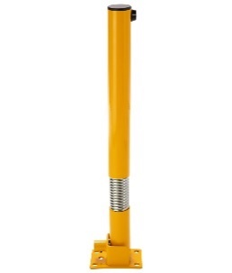Bollard [Designer’s Designation]:

If coating is required, retain “RA” below.

Model: Reliance Foundry; **R-8432**.

See Retractable Bollard Set for complementary retractable and embedded models.

Height: 35 5/8 inches (90.5 cm)

Diameter: 4 1/2 inches (11.4 cm)

Weight: 25 lbs. (11.3 kg)

Design: Round bollard with rectangular base and spring.

Bollard Material: Carbon Steel

Spring Material: 316 Stainless Steel

Country of Origin: China.

Powder Coating: Safety yellow

Installation: Collapsible, hinged surface mount.

* + - * 1. 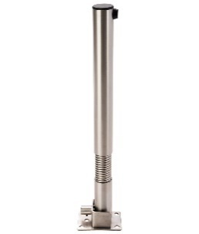Bollard [Designer’s Designation]:

If coating is required, retain “RA” below.

Model: Reliance Foundry; **R-8433**.

See Retractable Bollard Set for complementary retractable and embedded models.

Height: 35 5/8 inches (90.5 cm)

Diameter: 4 1/2 inches (11.4 cm)

Weight: 25 lbs. (11.3 kg)

Design: Round bollard with rectangular base and spring.

Bollard Material: 316 Stainless Steel

Spring Material: 316 Stainless Steel

Country of Origin: China.

Installation: Collapsible, hinged surface mount.

* + - * 1. 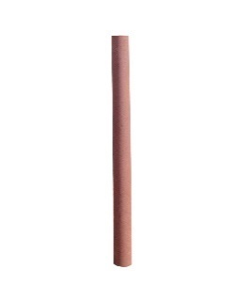Bollard [Designer’s Designation]:

If coating is required, retain “RA” below.

Model: Reliance Foundry; **R-1007-04**.

See Retractable Bollard Set for complementary retractable and embedded models.

Height: 84 inches (213.5 cm)

Diameter: 4 1/2 inches (11.4 cm)

Weight: 76 lbs. (34.5 kg)

Design: Steel pipe bollard.

Bollard Material: ASTM A500 B Structural Grade Steel

Country of Origin: China.

Finish: Primer coated.

Color Coating:

Type: Primer

Color: [Red]

Installation:

Fixed, new concrete.

Fixed, existing concrete.

* + - * 1. 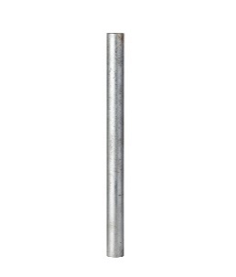Bollard [Designer’s Designation]:

If coating is required, retain “RA” below.

Model: Reliance Foundry; **R-1007-04G**.

See Retractable Bollard Set for complementary retractable and embedded models.

Height: 84 inches (213.5 cm)

Diameter: 4 1/2 inches (11.4 cm)

Weight: 76 lbs. (34.5 kg)

Design: Steel pipe bollard.

Bollard Material: ASTM A500 B Structural Grade Steel

Country of Origin: China.

Finish: Galvanized.

Installation:

Fixed, new concrete.

Fixed, existing concrete.

* + - * 1. 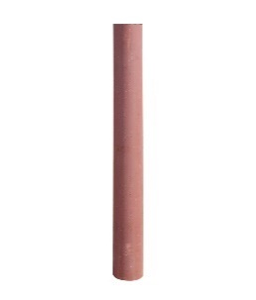Bollard [Designer’s Designation]:

If coating is required, retain “RA” below.

Model: Reliance Foundry; **R-1007-06[G]**.

See Retractable Bollard Set for complementary retractable and embedded models.

Height: 84 inches (213.5 cm)

Diameter: 6.63 inches (16.8 cm)

Weight: 133 lbs. (60.3 kg)

Design: Steel pipe bollard.

Bollard Material: ASTM A500 B Structural Grade Steel

Country of Origin: [United States] [China]

Finish: [Primer coated] [Galvanized]

Color Coating:

Type: Primer.

Color: [Red]

Installation:

Fixed, new concrete.

Fixed, existing concrete.

* + - * 1. 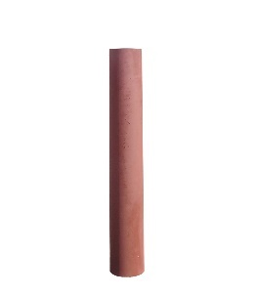Bollard [Designer’s Designation]:

If coating is required, retain “RA” below.

Model: Reliance Foundry; **R-1007-08[G]**.

See Retractable Bollard Set for complementary retractable and embedded models.

Height: 84 inches (213.5 cm)

Diameter: 8.63 inches (21.9 cm)

Weight: 200 lbs. (90.7 kg)

Design: Steel pipe bollard.

Bollard Material: ASTM A500 B Structural Grade Steel

Country of Origin: [United States] [China]

Finish: [Primer coated] [Galvanized]

Color Coating:

Type: Primer

Color: [Red]

Installation:

Fixed, new concrete.

Fixed, existing concrete.

* + - * 1. Bollard [Designer’s Designation]:

If coating is required, retain “RA” below.

Model: Reliance Foundry; **R-1007-10[G]**.

See Retractable Bollard Set for complementary retractable and embedded models.

Height: 84 inches (213.5 cm)

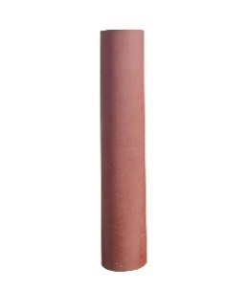Diameter: 10.75 inches (27.3 cm)

Weight: 284 lbs. (128.8 kg)

Design: Steel pipe bollard.

Bollard Material: ASTM A500 B Structural Grade Steel

Country of Origin: [United States] [China]

Finish: [Primer coated] [Galvanized]

Color Coating:

Type: Primer

Color: [Red]

Installation:

Fixed, new concrete.

Fixed, existing concrete.

* + - 1. ACCESSORIES

Retain following if specified bollards require security posts.

Retain padlock for removable bollards with padlock hasps and for chains with padlocks.

* + - * 1. Padlock: [Brass] [Marine Grade], supplied [supplied by bollard manufacturer] [as specified in Section [__ __ __]]. [Key alike.]
        2. Security Post: Steel pipe, ASTM A500, Grade B.

Manufacturer: Reliance Foundry Co. Ltd.

Country of Origin: United States.

Finish: [Red][Grey] primer.

Installation: Direct embed.

Footing and Fill: Concrete or mortar, [3000 psi minimum.]

1. EXECUTION
   * + 1. EXAMINATION
          1. Examine paving or other substrates for compliance with manufacturer’s requirements for placement and location of embedded items, condition of substrate, and other conditions affecting installation of bollards.
          2. Proceed with installation only after unsatisfactory conditions have been corrected.
       2. INSTALLATION
          1. General: Comply with manufacturer’s installation instructions and setting drawings.
          2. Do not install damaged, cracked, chipped, deformed or marred bollards. Field touch-up minor imperfections in accordance with manufacturer’s instructions. Replace bollards that cannot be field repaired.
       3. CLEANING & PROTECTION

Normal cleaning may be done with clean water and a soft cloth. Detailed cleaning and inspection instructions are available at [www.reliance-foundry.com/bollard/maintenance-bollards](http://www.reliance-foundry.com/bollard/maintenance-bollards).

* + - * 1. Protect bollards against damage.
        2. Immediately prior to Substantial Completion, clean bollards in accordance with manufacturer’s instructions to remove dust, dirt, adhesives, and other foreign materials.
        3. Touch up damaged finishes according to manufacturer’s instructions.
      1. CLOSEOUT ACTIVITIES
         1. Provide executed warranty

END OF SECTION

Copyright 2022 by Reliance Foundry Co. Ltd.; qualified design and construction professionals may copy for preparation of construction specifications and purchase orders for Reliance Foundry products. Issued January 2022. Subject to change.

Issued July 2016. Subject to change.