Reliance Foundry Co Ltd

#207-6450 148 St

Surrey, BC V3S 7G7

Phone: 604-547-0460

Phone: 1-877-789-3245

Fax: 604-590-8875

Email: info@reliance-foundry.com

Website: www.reliance-foundry.com

Reliance Foundry is an award-winning supplier of high quality stock and custom-designed site furnishings

for architectural, traffic management, and industrial applications. Reliance Foundry brings over 90 years of expertise to the design and manufacturing of our products.

Reliance Foundry bollards add architectural accents to your perimeter security, landscaping, traffic control, and streetscape projects. Use bollards as design features for new and existing buildings, for access control measures, traffic guidance, and as decorative covers over steel security posts. Reliance Foundry bike parking bollards increase cyclist access and security, prevent damage to trees and other streetscape features, and promote sustainable lifestyles in your community. This section includes metal bike parking bollards.

Specification Coordination: Edit this guide specification to meet project requirements. Coordinate with other specification sections as required. If using more than one bollard type, use the same designation in both drawings and specifications. Display hidden text to see or print notes to specifier.

Drawing Coordination: Show locations, sizes, layout, and spacing of each type of bollard or bollard cover required. Show footing and security post details, if required. Soft metric conversion is provided for all measurements.

**SECTION 32 39 13.13**

**METAL BIKE PARKING BOLLARDS**

1. GENERAL
   * + 1. SUMMARY
          1. Section Includes:

Metal Bicycle bollards.

Accessories.

[_________________]

Edit following to coordinate with other specification sections in project.

* + - * 1. Related Requirements:

Section 12 93 13 – Manufactured Bicycle Racks

[Division 03 Sections: [Concrete] [Mortar] fill for security posts.]

[Division 08 Sections: Padlocks.]

[_________________]

Edit below to include only reference standards used in project.

* + - 1. REFERENCE STANDARDS
         1. ASTM A36 – Standard Specification for Carbon Structural Steel.
         2. ASTM A312 – Standard Specification for Seamless, Welded, and Heavily Cold Worked Austenitic Stainless Steel Pipes.
         3. ASTM A500 – Standard Specification for Cold-Formed Welded and Seamless Carbon Steel Structural Tubing in Rounds and Shapes.
         4. ASTM A536 – Standard Specification for Ductile Iron Castings.
         5. ASTM B26 – Standard Specification for Aluminum-Alloy Sand Castings.
      2. SUBMITTALS
         1. Comply with Section [01 33 00 – Submittal Procedures.] [_________.]
         2. Product Data: Provide for each type of bollard, component, finish, and accessory specified.
         3. Color Samples: [Submit manufacturer’s standard colors for selection.] [Submit sample of color specified.]
         4. Setting Drawings: Show embedded items and cutouts required for work specified in other Sections.
         5. Maintenance Data: Submit manufacturer’s field touch-up, cleaning, and maintenance instructions.
         6. Warranty Documentation: Submit sample of manufacturer’s warranty.
      3. QUALITY ASSURANCE
         1. Comply with Section [01 43 00 – Quality Assurance.] [_________.]
      4. DELIVERY, STORAGE, AND HANDLING
         1. Comply with Section [01 66 00 – Product Storage and Handling Requirements.] [_________.]
         2. Protect bollards and accessories during delivery, storage, and handling.
      5. WARRANTY
         1. Comply with Section [01 78 36 – Warranties.] [_________.]
         2. Provide manufacturer’s standard warranty against defects in materials and workmanship.

Warranty Period: Five years from date of invoice, except as otherwise indicated.

Coatings: Two years, against peeling, cracking, or significant color change.

1. PRODUCTS
   * + 1. MANUFACTURERS
          1. Manufacturer: Reliance Foundry Co. Ltd.

Phone: 604-547-0460 or 1-877-789-3245

Fax: 604-590-8875

Website: <http://www.reliance-foundry.com/bike-parking/bike-bollards>

Email: [info@reliance-foundry.com](mailto:info@reliance-foundry.com)

* + - * 1. Substitutions: [Comply with provisions of [Section 01 25 00 "Substitution Procedures"] [_________] for substitution procedures.] [Not allowed.]
      1. 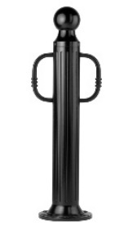METAL BICYCLE BOLLARDS

Bollard arms are available to factory customize bollards for lifting assistance or bicycle parking. Contact Reliance Foundry for more information.

* + - * 1. Bike Bollard [Designer’s Designation]:

Model: Reliance Foundry; **R-7530-B**.

Height: 39 inches (99 cm)

Diameter: 5 inches (12.7 cm) body; 10 inches (25.4 cm) base

Weight: 66 lbs. (30 kg)

Design: Cylindrical and fluted, with tapered bottom, ball top and bike arms.

Material:

Aluminum: ASTM B26; 20 percent recycled-material content.

Ductile Cast Iron: ASTM A536, Grade 65-45-12; 30 percent recycled-material content.

Country of Origin: China.

Arms: Match body.

Color Coating:

Type: Polyester powder coat over epoxy primer.

Color: [Black textured semi gloss] [Dark green] [Statuary bronze] [Bengal silver] [Anodized silver] [Safety yellow].

Installation:

Fixed, new concrete, anchor.

Fixed, existing concrete, insert.

Fixed, existing concrete, adhesive.

Fixed, existing concrete, flange and insert.

Fixed, new concrete, anchor with concrete form.

Security post cover, new post.

Security post cover, existing post, insert.

Security post cover, existing post, adhesive.

Removable, new concrete, anchor.

Removable, existing concrete, insert.

Removable, new concrete, premium removable mounting

* + - * 1. 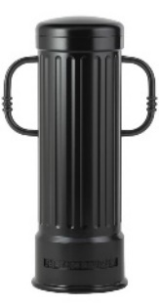Bike Bollard [Designer’s Designation]:

Model: Reliance Foundry; **R-7535-B**.

Height: 39 inches (99 cm)

Diameter: 12 inches (30.5 cm) body; 14 inches (35.5 cm) base

Weight: 216 lbs. (98 kg)

Design: Cylindrical and fluted, with a rounded top and bike arms.

Material: Ductile Cast Iron: ASTM A536, Grade 65-45-12; 30 percent recycled-material content.

Country of Origin: China.

Arms: Match body.

Color Coating:

Type: Polyester powder coat over epoxy primer.

Color: [Black textured semi gloss] [Dark green] [Statuary bronze] [Bengal silver] [Anodized silver] [Safety yellow].

Installation:

Fixed, new concrete, anchor.

Fixed, existing concrete, insert.

Fixed, existing concrete, adhesive.

Fixed, new concrete, anchor with concrete form.

Security post cover, new post.

Security post cover, existing post, insert.

Security post cover, existing post, adhesive.

* + - * 1. 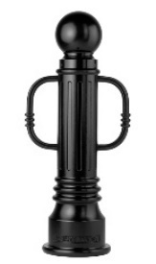Bike Bollard [Designer’s Designation]:

Model: Reliance Foundry; **R-7539-B**.

Height: 35 3/4 inches (90.8 cm)

Diameter: 5 7/8 inches (15.2 cm) body; 10 1/4 inches (26 cm) base

Weight: 80 lbs. (36.3 kg)

Design: Tapered and fluted, with round finial, ball top and bike arms.

Material:

Aluminum: ASTM B26; 20 percent recycled-material content.

Ductile Cast Iron: ASTM A536, Grade 65-45-12; 30 percent recycled-material content.

Country of Origin: China.

Arms: Match body.

Color Coating:

Type: Polyester powder coat over epoxy primer.

Color: [Black textured semi gloss] [Dark green] [Statuary bronze] [Bengal silver] [Anodized silver] [Safety yellow].

Installation:

Fixed, new concrete, anchor.

Fixed, existing concrete, insert.

Fixed, existing concrete, adhesive.

Fixed, new concrete, anchor with concrete form.

Security post cover, new post.

Security post cover, existing post, insert.

Security post cover, existing post, adhesive.

Removable, new concrete, anchor.

Removable, existing concrete, insert.

Removable, new concrete, premium removable mounting

* + - * 1. 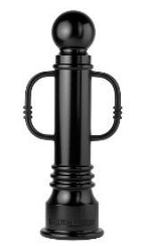Bike Bollard [Designer’s Designation]:

Model: Reliance Foundry; **R-7551-B**.

Height: 35 3/4 inches (90.8 cm)

Diameter: 6 inches (15.2 cm) body; 10 1/4 inches (26 cm) base

Weight: 87 lbs. (39.5 kg)

Design: Tapered with round finial, ball top and bike arms.

Material:

Aluminum: ASTM B26; 20 percent recycled-material content.

Ductile Cast Iron: ASTM A536, Grade 65-45-12; 30 percent recycled-material content.

Country of Origin: China.

Arms: Match body.

Color Coating:

Type: Polyester powder coat over epoxy primer.

Color: [Black textured semi gloss] [Dark green] [Statuary bronze] [Bengal silver] [Anodized silver] [Safety yellow].

Installation:

Fixed, new concrete, anchor.

Fixed, existing concrete, insert.

Fixed, existing concrete, adhesive.

Fixed, new concrete, anchor with concrete form.

Security post cover, new post.

Security post cover, existing post, insert.

Security post cover, existing post, adhesive.

Removable, new concrete, anchor.

Removable, existing concrete, insert.

Removable, new concrete, premium removable mounting

* + - * 1. 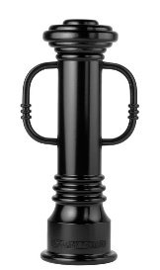Bollard [Designer’s Designation]:

Model: Reliance Foundry; **R-7553-B**

Height: 32 inches (81.3 cm)

Diameter: 6 inches (15.2 cm) body; 10 1/4 inches (26 cm) base

Weight: 86 lbs. (39 kg)

Design: Tapered with round finial and flat disc top and bike arms

Material: Ductile Cast Iron: ASTM A536, Grade 65-45-12; 30 percent recycled-material content.

Country of Origin: China.

Color Coating:

Type: Polyester powder coat over epoxy primer.

Color: [Black textured semi gloss] [Dark green] [Statuary bronze] [Bengal silver] [Anodized silver] [Safety yellow].

Installation:

Fixed, new concrete, anchor.

Fixed, existing concrete, insert.

Fixed, existing concrete, adhesive.

Fixed, new concrete, anchor with concrete form.

Security post cover, new post.

Security post cover, existing post, insert.

Security post cover, existing post, adhesive.

Removable, new concrete, anchor.

Removable, existing concrete, insert.

* + - * 1. 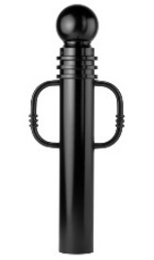Bike Bollard [Designer’s Designation]:

Model: Reliance Foundry; **R-7571-B**.

Height: 40 1/2 inches (102.9 cm)

Diameter: 5 3/4 inches (14.6 cm) body; 5 3/4 inches (14.6 cm) base

Weight: 67 lbs. (30.4 kg)

Design: Cylindrical with round finial, ball top and bike arms.

Material: Ductile Cast Iron: ASTM A536, Grade 65-45-12; 30 percent recycled-material content.

Country of Origin: China.

Arms: Match body.

Color Coating:

Type: Polyester powder coat over epoxy primer.

Color: [Black textured semi gloss] [Dark green] [Statuary bronze] [Bengal silver] [Anodized silver] [Safety yellow].

Installation:

Fixed, new concrete, anchor.

Fixed, existing concrete, insert.

Fixed, existing concrete, adhesive.

Fixed, new concrete, anchor with concrete form.

Security post cover, new post.

Security post cover, existing post, insert.

Security post cover, existing post, adhesive.

Removable, new concrete, anchor.

Removable, existing concrete, insert.

Removable, new concrete, premium removable mounting

* + - * 1. 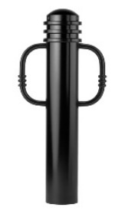Bike Bollard [Designer’s Designation]:

Model: Reliance Foundry; **R-7576-B**.

Height: 34 inches (86.4 cm)

Diameter: 5 3/4 inches (14.6 cm) body; 5 3/4 inches (14.6 cm) base

Weight: 56 lbs. (25.4 kg)

Design: Cylindrical with round finial, rounded top and bike arms.

Material: Ductile Cast Iron: ASTM A536, Grade 65-45-12; 30 percent recycled-material content.

Country of Origin: China.

Arms: Match body.

Color Coating:

Type: Polyester powder coat over epoxy primer.

Color: [Black textured semi gloss] [Dark green] [Statuary bronze] [Bengal silver] [Anodized silver] [Safety yellow].

Installation:

Fixed, new concrete, anchor.

Fixed, existing concrete, insert.

Fixed, existing concrete, adhesive.

Fixed, new concrete, anchor with concrete form.

Security post cover, new post.

Security post cover, existing post, insert.

Security post cover, existing post, adhesive.

Removable, new concrete, anchor.

Removable, existing concrete, insert.

Removable, new concrete, premium removable mounting

* + - * 1. 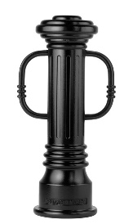Bollard [Designer’s Designation]:

Retain -AL for aluminum. Delete if not required.

Model: Reliance Foundry; **R-7591-B**

Height: 32 inches (81.3 cm)

Diameter: 6 inches (15.2 cm) body; 10 1/4 inches (26 cm) base

Weight: 82 lbs. (37.2 kg)

Design: Tapered and fluted, with round finial, flat disc top, and bike arms

Retain aluminum or cast iron to coordinate with model number.

Material: Ductile Cast Iron: ASTM A536, Grade 65-45-12; 30 percent recycled-material content.

Country of Origin: China.

Color Coating:

Type: Polyester powder coat over epoxy primer.

Color: [Black textured semi gloss] [Dark green] [Statuary bronze] [Bengal silver] [Anodized silver] [Safety yellow].

Installation:

Fixed, new concrete, anchor.

Fixed, existing concrete, insert.

Fixed, existing concrete, adhesive.

Fixed, new concrete, anchor with concrete form.

Security post cover, new post.

Security post cover, existing post, insert.

Security post cover, existing post, adhesive.

Removable, new concrete, anchor.

Removable, existing concrete, insert.

* + - * 1. 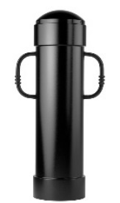Bike Bollard [Designer’s Designation]:

Model: Reliance Foundry; **R-7744-B**.

Height: 44 inches (111.8 cm)

Diameter: 13 inches (33 cm) body; 13 inches (33 cm) base

Weight: 156 lbs. (70.8 kg)

Design: Cylindrical with rounded top and bike arms.

Material:

Steel: ASTM A36; 25 percent recycled-material content.

Country of Origin: China.

Arms: Match body.

Color Coating:

Type: Polyester powder coat over epoxy primer.

Color: [Black textured semi gloss] [Dark green] [Statuary bronze] [Bengal silver] [Anodized silver] [Safety yellow].

Installation:

Fixed, new concrete, anchor.

Fixed, existing concrete, insert.

Fixed, existing concrete, adhesive.

Fixed, new concrete, anchor with concrete form.

Security post cover, new post.

Security post cover, existing post, insert.

Security post cover, existing post, adhesive.

* + - * 1. 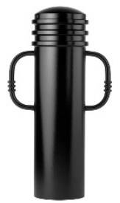Bike Bollard [Designer’s Designation]:

Model: Reliance Foundry; **R-7835-B**.

Height: 35 inches (88.9 cm)

Diameter: 9 1/2 inches (24.1 cm) body; 9 1/2 inches (24.1 cm) base

Weight: 96 lbs. (43.5 kg)

Design: Cylindrical with segmented rings, rounded top and bike arms.

Material:

Steel: ASTM A36; 25 percent recycled-material content.

Country of Origin: China.

Arms: Match body.

Color Coating:

Type: Polyester powder coat over epoxy primer.

Color: [Black textured semi gloss] [Dark green] [Statuary bronze] [Bengal silver] [Anodized silver] [Safety yellow].

Installation:

Fixed, new concrete, anchor.

Fixed, existing concrete, insert.

Fixed, existing concrete, adhesive.

Fixed, new concrete, anchor with concrete form.

Security post cover, new post.

Security post cover, existing post, insert.

Security post cover, existing post, adhesive.

Removable, new concrete, anchor.

Removable, existing concrete, insert.

Removable, new concrete, premium removable mounting

* + - * 1. 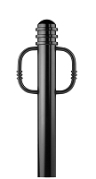Bike Bollard [Designer’s Designation]:

Model: Reliance Foundry; **R-7903**.

Height: 36 inches (91.4 cm)

Diameter: 4 1/3 inches (11 cm) body; 4 1/3 inches (11 cm) base

Weight: 44 lbs. (20 kg)

Design: Straight base with domed top, annular rings and bike arms.

Material:

Steel: ASTM A36; 25 percent recycled-material content.

Country of Origin: China.

Arms: Match body.

Color Coating:

Type: Polyester powder coat over epoxy primer.

Color: [Black textured semi gloss] [Dark green] [Statuary bronze] [Bengal silver] [Anodized silver] [Safety yellow].

Installation:

Fixed, new concrete, embedded.

Fixed, Existing Concrete, flanged surface mount.

Removable, new concrete, receiver:

[Steel] [Stainless steel]receiver with lid.

[Steel] [Stainless steel]receiver with chain.

Removable, existing concrete, receiver:

[Steel] [Stainless steel]receiver with lid.

[Steel] [Stainless steel]receiver with chain.

Collapsible, steel surface-mount with hinged receiver and padlock hasp.

* + - * 1. 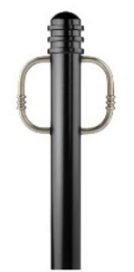Bike Bollard [Designer’s Designation]:

Model: Reliance Foundry; **R-7903-RSA**.

Height: 36 inches (91.4 cm)

Diameter: 4 1/3 inches (11 cm) body; 4 1/3 inches (11 cm) base

Weight: 45 lbs. (20.4 kg)

Design: Straight base with domed top, annular rings and bike arms.

Material:

Steel: ASTM A36; 25 percent recycled-material content.

Country of Origin: China.

Arms: Polished stainless steel.

Color Coating:

Type: Polyester powder coat over epoxy primer.

Color: [Black textured semi gloss] [Dark green] [Statuary bronze] [Bengal silver] [Anodized silver] [Safety yellow].

Installation:

Fixed, new concrete, embedded.

Fixed, Existing Concrete, flanged surface mount.

Removable, new concrete, receiver:

[Steel] [Stainless steel]receiver with lid.

[Steel] [Stainless steel]receiver with chain.

Removable, existing concrete, receiver:

[Steel] [Stainless steel]receiver with lid.

[Steel] [Stainless steel]receiver with chain.

Collapsible, steel surface-mount with hinged receiver and padlock hasp.

* + - * 1. Bike Bollard [Designer’s Designation]:

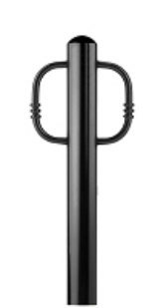Model: Reliance Foundry; **R-7904**.

Height: 36 inches (91.4 cm)

Diameter: 4 1/3 inches (11 cm) body; 4 1/3 inches (11 cm) base

Weight: 35 lbs. (16 kg)

Design: Straight base with domed top and bike arms.

Material:

Steel: ASTM A36; 25 percent recycled-material content.

Country of Origin: China.

Arms: Match body.

Color Coating:

Type: Polyester powder coat over epoxy primer.

Color: [Black textured semi gloss] [Dark green] [Statuary bronze] [Bengal silver] [Anodized silver] [Safety yellow].

Installation:

Fixed, new concrete, embedded.

Fixed, Existing Concrete, flanged surface mount.

Removable, new concrete, receiver:

[Steel] [Stainless steel]receiver with lid.

[Steel] [Stainless steel]receiver with chain.

Removable, existing concrete, receiver:

[Steel] [Stainless steel]receiver with lid.

[Steel] [Stainless steel]receiver with chain.

Collapsible, steel surface-mount with hinged receiver and padlock hasp.

* + - * 1. Bike Bollard [Designer’s Designation]:

Model: Reliance Foundry; **R-7904-RSA**.

Height: 36 inches (91.4 cm)

Diameter: 4 1/3 inches (11 cm) body; 4 1/3 inches (11 cm) base

Weight: 36 lbs. (16.3 kg)

Design: Straight base with domed top and bike arms.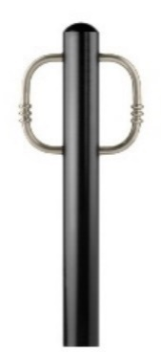

Material:

Steel: ASTM A36; 25 percent recycled-material content.

Country of Origin: China.

Arms: Uncoated stainless steel.

Color Coating:

Type: Polyester powder coat over epoxy primer.

Color: [Black textured semi gloss] [Dark green] [Statuary bronze] [Bengal silver] [Anodized silver] [Safety yellow].

Installation:

Fixed, new concrete, embedded.

Fixed, Existing Concrete, flanged surface mount.

Removable, new concrete, receiver:

[Steel] [Stainless steel]receiver with lid.

[Steel] [Stainless steel]receiver with chain.

Removable, existing concrete, receiver:

[Steel] [Stainless steel]receiver with lid.

[Steel] [Stainless steel]receiver with chain.

Collapsible, steel surface-mount with hinged receiver and padlock hasp.

* + - * 1. 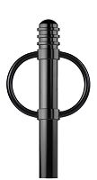Bike Bollard [Designer’s Designation]:

Model: Reliance Foundry; **R-7905**.

Height: 36 inches (91.4 cm)

Diameter: 4 1/3 inches (11 cm) body; 4 1/3 inches (11 cm) base

Weight: 51 lbs. (23.1 kg)

Design: Straight base with domed top, annular rings and round bike arms.

Material:

Steel: ASTM A36; 25 percent recycled-material content.

Country of Origin: China.

Arms: Match body.

Color Coating:

Type: Polyester powder coat over epoxy primer.

Color: [Black textured semi gloss] [Dark green] [Statuary bronze] [Bengal silver] [Anodized silver] [Safety yellow].

Installation:

Fixed, new concrete, embedded.

Fixed, Existing Concrete, flanged surface mount.

Removable, new concrete, receiver:

[Steel] [Stainless steel]receiver with lid.

[Steel] [Stainless steel]receiver with chain.

Removable, existing concrete, receiver:

[Steel] [Stainless steel]receiver with lid.

[Steel] [Stainless steel]receiver with chain.

Collapsible, steel surface-mount with hinged receiver and padlock hasp.

* + - * 1. 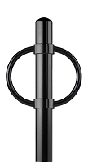Bike Bollard [Designer’s Designation]:

Model: Reliance Foundry; **R-7906**.

Height: 36 inches (91.4 cm)

Diameter: 4 1/3 inches (11 cm) body; 4 1/3 inches (11 cm) base

Weight: 42 lbs. (19 kg)

Design: Straight base with domed top and round bike arms.

Material:

Steel: ASTM A36; 25 percent recycled-material content.

Country of Origin: China.

Arms: Match body.

Color Coating:

Type: Polyester powder coat over epoxy primer.

Color: [Black textured semi gloss] [Dark green] [Statuary bronze] [Bengal silver] [Anodized silver] [Safety yellow].

Installation:

Fixed, new concrete, embedded.

Fixed, Existing Concrete, flanged surface mount.

Removable, new concrete, receiver:

[Steel] [Stainless steel]receiver with lid.

[Steel] [Stainless steel]receiver with chain.

Removable, existing concrete, receiver:

[Steel] [Stainless steel]receiver with lid.

[Steel] [Stainless steel]receiver with chain.

Collapsible, steel surface-mount with hinged receiver and padlock hasp.

* + - * 1. 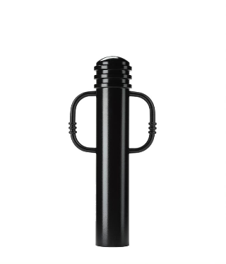Bike Bollard [Designer’s Designation]:

Model: Reliance Foundry; **R-7913**.

Height: 36 inches (91.4 cm)

Diameter: 6 1/2 inches (16.5 cm) body; 6 1/2 inches (16.5 cm) base

Weight: 63 lbs. (28.6 kg)

Design: Straight base with domed top, annular rings, and bike arms.

Material:

Steel: ASTM A36; 25 percent recycled-material content.

Country of Origin: China.

Arms: Match body.

Color Coating:

Type: Polyester powder coat over epoxy primer.

Color: [Black textured semi gloss] [Dark green] [Statuary bronze] [Bengal silver] [Anodized silver] [Safety yellow].

Installation:

Fixed, new concrete, embedded.

Fixed, Existing Concrete, flanged surface mount.

Removable, new concrete, receiver:

[Steel] [Stainless steel]receiver with lid.

[Steel] [Stainless steel]receiver with chain.

Removable, existing concrete, receiver:

[Steel] [Stainless steel]receiver with lid.

[Steel] [Stainless steel]receiver with chain.

Collapsible, steel surface-mount with hinged receiver and padlock hasp.

* + - * 1. 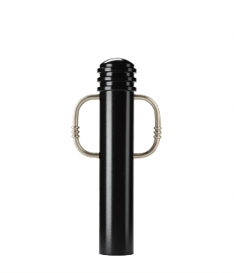Bike Bollard [Designer’s Designation]:

Model: Reliance Foundry; **R-7913-RSA**.

Height: 36 inches (91.4 cm)

Diameter: 6 1/2 inches (16.5 cm) body; 6 1/2 inches (16.5 cm) base

Weight: 63 lbs. (28.6 kg)

Design: Straight base with domed

Material:

Steel: ASTM A36; 25 percent recycled-material content.

Country of Origin: China.

Arms: Polished stainless steel.

Color Coating:

Type: Polyester powder coat over epoxy primer.

Color: [Black textured semi gloss] [Dark green] [Statuary bronze] [Bengal silver] [Anodized silver] [Safety yellow].

Installation:

Fixed, new concrete, embedded.

Fixed, Existing Concrete, flanged surface mount.

Removable, new concrete, receiver:

[Steel] [Stainless steel]receiver with lid.

[Steel] [Stainless steel]receiver with chain.

Removable, existing concrete, receiver:

[Steel] [Stainless steel]receiver with lid.

[Steel] [Stainless steel]receiver with chain.

Collapsible, steel surface-mount with hinged receiver and padlock hasp.

* + - * 1. 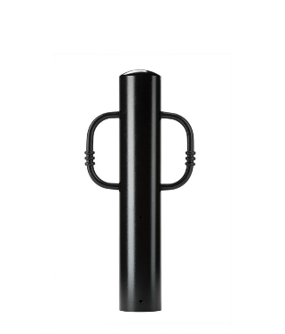Bike Bollard [Designer’s Designation]:

Model: Reliance Foundry; **R-7914**.

Height: 36 inches (91.4 cm)

Diameter: 6 1/2 inches (16.5 cm) body; 6 1/2 inches (16.5 cm) base

Weight: 57 lbs. (25.9 kg)

Design: Straight base with domed top and bike arms.

Material:

Steel: ASTM A36; 25 percent recycled-material content.

Country of Origin: China.

Arms: Match body.

Color Coating:

Type: Polyester powder coat over epoxy primer.

Color: [Black textured semi gloss] [Dark green] [Statuary bronze] [Bengal silver] [Anodized silver] [Safety yellow].

Installation:

Fixed, new concrete, embedded.

Fixed, Existing Concrete, flanged surface mount.

Removable, new concrete, receiver:

[Steel] [Stainless steel]receiver with lid.

[Steel] [Stainless steel]receiver with chain.

Removable, existing concrete, receiver:

[Steel] [Stainless steel]receiver with lid.

[Steel] [Stainless steel]receiver with chain.

Collapsible, steel surface-mount with hinged receiver and padlock hasp.

* + - * 1. 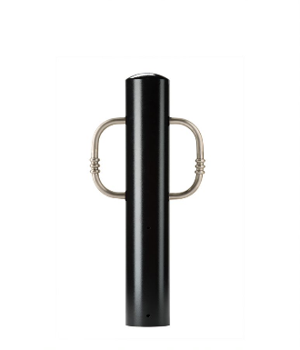Bike Bollard [Designer’s Designation]:

Model: Reliance Foundry; **R-7914-RSA**.

Height: 36 inches (91.4 cm)

Diameter: 6 1/2 inches (16.5 cm) body; 6 1/2 inches (16.5 cm) base

Weight: 57 lbs. (25.9 kg)

Design: Straight base with top and round bike arms.

Material:

Steel: ASTM A36; 25 percent recycled-material content.

Country of Origin: China.

Arms: Polished stainless steel.

Color Coating:

Type: Polyester powder coat over epoxy primer.

Color: [Black textured semi gloss] [Dark green] [Statuary bronze] [Bengal silver] [Anodized silver] [Safety yellow].

Installation:

Fixed, new concrete, embedded.

Fixed, Existing Concrete, flanged surface mount.

Removable, new concrete, receiver:

[Steel] [Stainless steel]receiver with lid.

[Steel] [Stainless steel]receiver with chain.

Removable, existing concrete, receiver:

[Steel] [Stainless steel]receiver with lid.

[Steel] [Stainless steel]receiver with chain.

Collapsible, steel surface-mount with hinged receiver and padlock hasp.

* + - * 1. 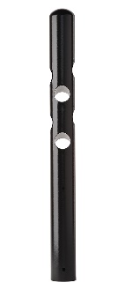Bike Bollard [Designer’s Designation]

Model: Reliance Foundry; **R-7972**.

Height: 36 inches (91.4 cm)

Diameter: 4 5/16 inches (11 cm) body; 4 5/16 inches (11 cm) base

Weight: 32 lbs. (14.5 kg)

Design: Straight base with domed top and cylindrical bike-locking cavities.

Material:

Steel: ASTM A36; 25 percent recycled-material content.

Country of Origin: China.

Color Coating:

Type: Polyester powder coat over epoxy primer.

Color: [Black textured semi gloss] [Dark green] [Statuary bronze] [Bengal silver] [Anodized silver] [Safety yellow].

Installation:

Fixed, new concrete, embedded.

Fixed, Existing Concrete, flanged surface mount.

Removable, new concrete, receiver:

[Steel] [Stainless steel]receiver with lid.

[Steel] [Stainless steel]receiver with chain.

Removable, existing concrete, receiver:

[Steel] [Stainless steel]receiver with lid.

[Steel] [Stainless steel]receiver with chain.

Collapsible, steel surface-mount with hinged receiver and padlock hasp.

* + - * 1. Bike Bollard [Designer’s Designation]:

Model: Reliance Foundry; **R-8903**.

Height: 36 inches (91.4 cm)

Diameter: 4 1/3 inches (11 cm) body; 4 1/3 inches (11 cm) base

Weight: 44 lbs. (20 kg)

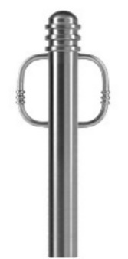Design: Straight base with domed top, annular rings and bike arms.

Material: Stainless steel, ASTM A312, Grade TP 316.

Country of Origin: China.

Arms: Match body.

Color Coating:

Type: Polyester powder coat over epoxy primer.

Color: [Black textured semi gloss] [Dark green] [Statuary bronze] [Bengal silver] [Anodized silver] [Safety yellow].

Installation:

Fixed, new concrete, embedded.

Fixed, Existing Concrete, flanged surface mount.

Removable, new concrete, receiver:

[Steel] [Stainless steel]receiver with lid.

[Steel] [Stainless steel]receiver with chain.

Removable, existing concrete, receiver:

[Steel] [Stainless steel]receiver with lid.

[Steel] [Stainless steel]receiver with chain.

Collapsible, steel surface-mount with hinged receiver and padlock hasp.

* + - * 1. Bike Bollard [Designer’s Designation]:

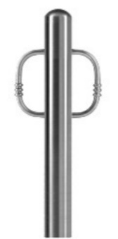Model: Reliance Foundry; **R-8904**.

Height: 36 inches (91.4 cm)

Diameter: 4 1/3 inches (11 cm) body; 4 1/3 inches (11 cm) base

Weight: 42 lbs. (19 kg)

Design: Straight base with domed top and bike arms.

Material: Stainless steel, ASTM A312, Grade TP 316.

Country of Origin: China.

Arms: Match body.

Color Coating:

Type: Polyester powder coat over epoxy primer.

Color: [Black textured semi gloss] [Dark green] [Statuary bronze] [Bengal silver] [Anodized silver] [Safety yellow].

Installation:

Fixed, new concrete, embedded.

Fixed, Existing Concrete, flange surface mount.

Removable, new concrete, receiver:

[Steel] [Stainless steel]receiver with lid.

[Steel] [Stainless steel]receiver with chain.

Removable, existing concrete, receiver:

[Steel] [Stainless steel]receiver with lid.

[Steel] [Stainless steel]receiver with chain.

Collapsible, steel surface-mount with hinged receiver and padlock hasp.

* + - * 1. Bike Bollard [Designer’s Designation]:

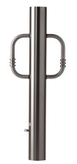Model: Reliance Foundry; **R-8908**.

Height: 36 inches (91.4 cm)

Diameter: 4 3/8 inches (11.1 cm) body; 4 3/8 inches (11.1 cm) base

Weight: 37 lbs. (16.8 kg)

Design: Straight base with domed top and bike arms.

Material: Stainless steel, ASTM A312, Grade TP 316.

Country of Origin: China.

Arms: Match body.

Color Coating:

Type: Polyester powder coat over epoxy primer.

Color: [Black textured semi gloss] [Dark green] [Statuary bronze] [Bengal silver] [Anodized silver] [Safety yellow].

Installation:

Fixed, new concrete, embedded.

Fixed, Existing Concrete, flange surface mount.

Removable, new concrete, receiver:

[Steel] [Stainless steel]receiver with lid.

[Steel] [Stainless steel]receiver with chain.

Removable, existing concrete, receiver:

[Steel] [Stainless steel]receiver with lid.

[Steel] [Stainless steel]receiver with chain.

Collapsible, steel surface-mount with hinged receiver and padlock hasp.

* + - 1. ACCESSORIES

Retain following if specified bollards require security posts.

* + - * 1. Security Post: Steel pipe, ASTM A500, Grade B.

Manufacturer: Reliance Foundry Co. Ltd.

Country of Origin: United States.

Finish: [Red][Grey] primer.

Installation:

Direct embed.

Footing and fill; Concrete or mortar, [3000 psi minimum.] [as specified in Section [__ __].]

Retain following if chains draped between metal bollards or bicycle bollards are required. In Drawings, show locations where chain is required, quick-release and padlock locations, and drape of chain.

* + - * 1. Chain:

5/16-inch galvanized steel chain, Grade 30, [quick-release connections.]

Provide sufficient lengths to provide drape [shown on Drawings.] [acceptable to Architect.]

Chain Eye: 5/16-inch diameter steel.

Quick Links: Powder coated chain links with barrel nut closures.

Finish: Powder coated to match bollard finish. [_______________.]

Retain padlock for removable bollards with padlock hasps and for chains with padlocks.

* + - * 1. Padlock:

[Brass] [Marine Grade], supplied [supplied by bollard manufacturer] [as specified in Section [__ __ __]]. [Key alike.]

* + - * 1. Bollard Arms:

Curved rods attach to bollard body.

Material: Stainless steel: ASTM A312, Grade TP 316

Finish: [Powder coated to match bollard [_______________.]] [Satin No. 6, buffed].

1. EXECUTION
   * + 1. EXAMINATION
          1. Examine paving or other substrates for compliance with manufacturer’s requirements for placement and location of embedded items, condition of substrate, and other conditions affecting installation of bollards.
          2. Proceed with installation only after unsatisfactory conditions have been corrected.
       2. INSTALLATION
          1. General: Comply with manufacturer’s installation instructions and setting drawings.
          2. Do not install damaged, cracked, chipped, deformed or marred bollards. Field touch-up minor imperfections in accordance with manufacturer’s instructions. Replace bollards that cannot be field repaired.
       3. CLEANING & PROTECTION

Normal cleaning may be done with clean water and a soft cloth. Detailed cleaning and inspection instructions are available at [www.reliance-foundry.com/bollard/maintenance-bollards](http://www.reliance-foundry.com/bollard/maintenance-bollards).

* + - * 1. Protect bollards against damage.
        2. Immediately prior to Substantial Completion, clean bollards in accordance with manufacturer’s instructions to remove dust, dirt, adhesives, and other foreign materials.
        3. Touch up damaged finishes according to manufacturer’s instructions.
      1. CLOSEOUT ACTIVITIES
         1. Provide executed warranty.

END OF SECTION

Copyright 2018 by Reliance Foundry Co. Ltd.; qualified design and construction professionals may copy for preparation of construction specifications and purchase orders for Reliance Foundry products.

Issued April 2018. Subject to change.