Reliance Foundry Co Ltd
#207-6450 148 St
Surrey, BC V3S 7G7
Phone: 604-547-0460
Phone: 1-877-789-3245
Fax: 604-590-8875
Email: info@reliance-foundry.com
Website: www.reliance-foundry.com

Reliance Foundry is an award-winning supplier of high-quality stock and custom-designed site furnishings
for architectural, traffic management, and industrial applications. Reliance Foundry brings over 90 years of expertise to the design and manufacturing of our products.

Reliance Foundry benches are the newest addition to our site furnishings product line. These customizable benches enhance various public spaces by introducing a social element. Add benches to create a comfortable, inviting atmosphere and complete the design of parks, sidewalks, and commercial sites. Made from high-quality materials, Reliance Foundry benches are durable and long lasting.

Specification Coordination: Edit this guide specification to meet project requirements. Coordinate with other specification sections as required. Display hidden text to see or print notes to specifier.

Drawing Coordination: Show locations, sizes, and layout of each type of bench required. Soft metric conversion is provided for all measurements.

SECTION 12 93 43.13
SITE SEATING
BENCHES

- GENERAL
      - SUMMARY
        - Section Includes:
          - Backless benches
          - [_________________]
Edit following to coordinate with other specification sections in project.
Edit below to include only reference standards used in project.
      - REFERENCE STANDARDS
        - ASTM 6061 – Standard Specification for Aluminum and Aluminum Alloy Extruded Pipes and Tubes
      - SUBMITTALS
        - Manufacturer’s Product Data
          - Comply with Section [01 33 00 – Submittal Procedures.] [_________.]
          - Product Data: Provide for each type of bench specified.
          - Color Samples: [Submit manufacturer’s standard colors for selection.] [Submit sample of color specified.]
          - Maintenance Data: Submit manufacturer’s field touch-up, cleaning, and maintenance instructions.
          - Warranty Documentation: Submit sample of manufacturer’s warranty.
        - Setting Drawings: Show items required for work specified by other Sections.
      - QUALITY ASSURANCE
        - Comply with Section [01 43 00 – Quality Assurance.] [_________.]
      - DELIVERY, STORAGE AND HANDLING
        - Comply with Section [01 66 00 – Product Storage and Handling Requirements.] [_________.]
        - Handle products in accordance with manufacturer’s instructions.
        - Product shall be delivered flat or fully assembled and ready for installation.
        - Products should be stored in a clean, dry environment and protected from impact.
      - WARRANTY
        - Comply with Section [01 78 36 – Warranties.] [_________.]
        - Provide manufacturer’s standard warranty against defects in materials and workmanship.
          - Metal Benches Warranty Period: Five years from date of invoice, except as otherwise indicated.
- PRODUCTS
      - MANUFACTURERS
        - Manufacturer: Reliance Foundry Co. Ltd.
          - Phone: 604-547-0460 or 1-877-789-3245
          - Fax: 604-590-8875
          - Website: https://www.reliance-foundry.com/site-furnishings/park-benches
          - Email: info@reliance-foundry.com
        - Substitutions: [Comply with provisions of [Section 01 25 00 "Substitution Procedures"] [_________] for substitution procedures.] [Not allowed.]

      - METAL BENCHES
        - Laser-Cut Metal Bench [Designer’s Designation]:
          - Model: Reliance Foundry; R-5504.
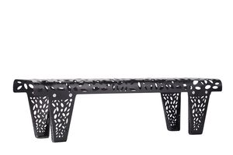
          - Height: 16 3/4 inches (42.5 cm)
          - Depth: 16 1/2 inches (41.9 cm)
          - Length: 59 inches (149.8cm)
          - Weight: 37.5 lbs. (16.6 kg)
          - Design: Backless vine design laser-cut bench.
          - Material: Aluminum: ASTM 6061.
          - Country of Origin: China.
          - Finish: Thermoplastic.
Color coating over stainless is available at additional cost for this bollard. Delete if not required.
          - Color Coating:
            - Type: [Polyester powder coat over epoxy primer.] [IronArmor protective coating.]
            - Color: [Traffic white.] [Black textured semi gloss.] [Dark green.]
[Statuary bronze.] [Bengal silver.] [Anodized silver.] [Safety yellow.]
          - Installation:
            - Surface mount, bolt and anchor.
        - Laser-Cut Metal Bench [Designer’s Designation]:
          - Model: Reliance Foundry; R-5505.
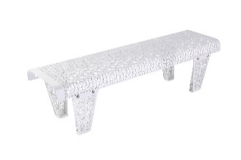
          - Height: 16 3/4 inches (42.5 cm)
          - Depth: 16 1/2 inches (41.9 cm)
          - Length: 59 inches (149.8cm)
          - Weight: 37.5 lbs. (16.6 kg)
          - Design: Backless floral design laser-cut bench.
          - Material: Aluminum: ASTM 6061.
          - Country of Origin: China.
          - Finish: Thermoplastic.
Color coating over stainless is available at additional cost for this bollard. Delete if not required.
          - Color Coating:
            - Type: [Polyester powder coat over epoxy primer.] [IronArmor protective coating.]
            - Color: [Traffic white.] [Black textured semi gloss.] [Dark green.]
[Statuary bronze.] [Bengal silver.] [Anodized silver.] [Safety yellow.]
          - Installation:
            - Surface mount, bolt and anchor.
      - WOOD BENCHES
        - Wood Bench [Designer’s Designation]:
          - Model: Reliance Foundry; R-5501.
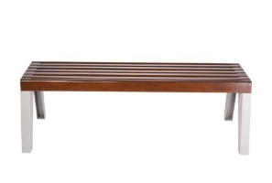
          - Height: 17 1/2 inches (44.5 cm)
          - Depth: 21 5/16 inches (54.1 cm)
          - Length: 59 1/8 inches (150.2 cm)
          - Weight: 75 lbs. (34 kg)
          - Design: Backless Balau wood slats bench.
          - Material: Galvanized Steel, Wood
          - Country of Origin: Malaysia.
          - Finish: Mahogany wood stain.
          - Color Coating:
            - Type: [Polyester powder coat over epoxy primer.] [IronArmor protective coating.]
            - Color: [Traffic white.] [Black textured semi gloss.] [Dark green.]
[Statuary bronze.] [Bengal silver.] [Anodized silver.] [Safety yellow.]
          - Installation:
            - Surface mount, bolt and anchor.
        - Wood Bench [Designer’s Designation]:
          - Model: Reliance Foundry; R-5506.
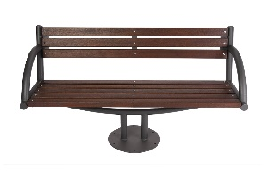
          - Height: 32 inches (81.3 cm)
          - Depth: 23 inches (58.4 cm)
          - Length: 59 inches (150 cm)
          - Weight: 95 lbs. (43.1 kg)
          - Design: Camphor wood slats bench with backrest.
          - Material: Mild Steel Q235, Wood
          - Country of Origin: China.
          - Finish: Oil brushed.
          - Color Coating:
            - Type: [Polyester powder coat over epoxy primer.] [IronArmor protective coating.]
            - Color: [Black textured semi gloss.]
          - Installation:
            - Surface mount, bolt and anchor.
        - Wood Bench [Designer’s Designation]:
          - Model: Reliance Foundry; R-5506-BL.
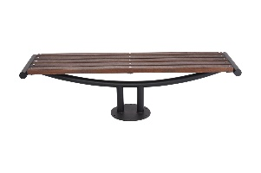
          - Height: 16 7/8 inches (42.9 cm)
          - Depth: 23 inches (58.4 cm)
          - Length: 59 inches (150 cm)
          - Weight: 59 lbs. (26.8 kg)
          - Design: Backless Camphor wood slats bench.
          - Material: Mild Steel Q235, Wood
          - Country of Origin: China.
          - Finish: Oil brushed.
          - Color Coating:
            - Type: [Polyester powder coat over epoxy primer.] [IronArmor protective coating.]
            - Color: [Black textured semi gloss.]
          - Installation:
            - Surface mount, bolt and anchor.
        - Wood Bench [Designer’s Designation]:
          - Model: Reliance Foundry; R-5514 / R-5516 / R-5518.
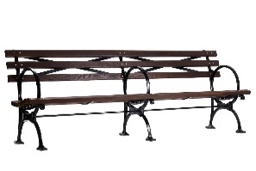
          - Height: 34 3/8 inches (87.3 cm)
          - Depth: 26 3/4 inches (67.9 cm)
          - Length: 48 inches (121.9 cm) / 60 inches (152.4 cm) / 72 inches (182.9 cm)
          - Weight: 120 – 125 lbs. (54.4 – 56.7 kg) / 140 – 150 lbs. (63.5 – 68 kg) / 200 – 220 lbs. (90.7 - 99.8 kg)
          - Design: Wood slats bench with backrest
          - Material: Cast Iron with steel brackets and stainless-steel hardware
          - Country of Origin: India (legs and brackets) / Canada / USA
          - Finish: [Thermo-ash] [Maple wood] [Recycled plastic lumber: Teak]
          - Color Coating:
            - Type: [Powder Coated.] [IronArmor protective coating.]
            - Color: [Black semi-gloss.]
          - Installation:
            - Surface mount, bolt and anchor.

        - Wood Bench [Designer’s Designation]:
          - Model: Reliance Foundry; R-5526.
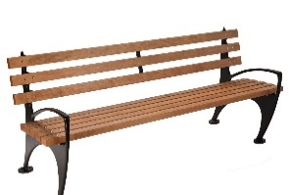
          - Height: 31 1/2 inches (80 cm)
          - Depth: 26 3/8 inches (67 cm)
          - Length: 48 inches (121.9 cm) / 72 inches (182.9 cm)
          - Weight: 140 – 145 lbs. (63.5 – 65.8 kg) / 160 – 165 lbs. (72.6 – 74.8 kg)
          - Design: Wood slats bench with backrest
          - Material: Cast Iron with steel brackets and stainless-steel hardware
          - Country of Origin: India (legs and brackets) / Canada / USA
          - Finish: [Thermo-ash] [Maple wood] [Recycled plastic lumber: Teak]
          - Color Coating:
            - Type: [Powder Coated.] [IronArmor protective coating.]
            - Color: [Black semi-gloss.]
          - Installation:
            - Surface mount, bolt and anchor.
        - Wood Bench [Designer’s Designation]:
          - Model: Reliance Foundry; R-5526-BL.
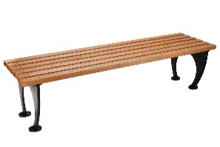
          - Height: 18 1/4 inches (46.4 cm)
          - Depth: 19 3/8 inches (49.2 cm)
          - Length: 48 inches (121.9 cm) / 72 inches (182.9 cm)
          - Weight: 110 – 115 lbs. (49.9 – 52.2 kg) / 125 – 130 lbs. (56.7 – 59 kg)
          - Design: Backless wood slats bench
          - Material: Cast Iron with steel brackets and stainless-steel hardware
          - Country of Origin: India (legs and brackets) / Canada / USA
          - Finish: [Thermo-ash] [Maple wood] [Recycled plastic lumber: Teak]
          - Color Coating:
            - Type: [Powder Coated.] [IronArmor protective coating.]
            - Color: [Black semi-gloss.]
          - Installation:
            - Surface mount, bolt and anchor.

- EXECUTION
      - EXAMINATION
        - Examine paving or other substrates for compliance with manufacturer’s requirements for placement and location.
        - Verify that the substrates are in stable condition and able to support the weight of the benches covered in this section.
        - Verify that the substrates have been effectively prepared to securely anchor benches that will be surface mounted.
        - Proceed with installation only after unsatisfactory conditions have been corrected.
      - INSTALLATION
        - General: Comply with manufacturer’s installation instructions and setting drawings.
        - For surface mounting, bolt and anchor benches securely in place.
        - Install in conformance to applicable regional accessibility guidelines and End User’s established accessibility policies.
      - CLEANING & PROTECTION
        - Clean in accordance with manufacturer's recommendations.
        - Protect installed products until completion of project.
        - Touch up damaged finishes in accordance with manufacturer's instructions before Substantial Completion.
      - CLOSEOUT ACTIVITIES
        - Provide executed warranty.

END OF SECTION
Copyright 2023 by Reliance Foundry Co. Ltd.; qualified design and construction professionals may copy for preparation of construction specifications and purchase orders for Reliance Foundry products. Issued January 2022. Subject to change.
Issued July 2016. Subject to change.

