Reliance Foundry Co Ltd
#207-6450 148 St
Surrey, BC V3S 7G7
Phone: 604-547-0460
Phone: 1-877-789-3245
Fax: 604 590-8875
Email: info@reliance-foundry.com
Website: www.reliance-foundry.com

Reliance Foundry is an award-winning supplier of high quality stock and custom-designed site furnishings
for architectural, traffic management, and industrial applications. Reliance Foundry brings over 90 years of expertise to the design and manufacturing of our products.

Reliance Foundry bicycle lockers offer security to both cyclists and building owners by enclosing bicycles and gear. The locker design supports a range of versatile configurations. Reliance Foundry bicycle racks and bike parking bollards increase cyclist access and security, prevent damage to trees and other streetscape features, and promote sustainable lifestyles in your community.

Specification Coordination: Edit this guide specification to meet project requirements. Coordinate with other specification sections as required. If using more than one bike rack or bike bollard type, use the same designation in both drawings and specifications. Display hidden text to see or print notes to specifier.

Drawing Coordination: Show locations, sizes, layout, and spacing of each type of bike locker, rack, or bollard required. Soft metric conversion is provided for all measurements.

SECTION 12 93 14
BICYCLE LOCKERS
- GENERAL
      - SUMMARY
        - Section Includes: Bicycle lockers
      - ACTION SUBMITTALS
        - Manufacturer's Product Data
Delete the paragraph below if specifying colors in this section or in Drawings.
Reliance's bicycle storage units may contribute to these and other LEED credits. Adjust the list below to reflect credits sought for the project.
Credits below are based on LEED 2009 New Construction, Core and Shell, and Schools rating systems.
        - LEED Submittals:
          - Credit SS 4.2, Alternative Transportation – Bicycle Storage and Changing Rooms: Provide product data indicating number of bicycles stored by each bicycle storage unit. Include statement indicating total number of bicycle storage units and total number of bicycles stored.
        - Setting Drawings: Show embedded items and cutouts required for work specified in other Sections.
      - CLOSEOUT SUBMITTALS
        - Manufacturer's Maintenance Instructions for field touch-up of finishes, cleaning, and maintenance.
        - Warranty Documentation: Submit sample of manufacturer’s warranty.
      - DELIVERY, STORAGE, AND HANDLING
        - Protect bicycle lockers and accessories during delivery, storage, and handling to comply with manufacturer’s instructions and prevent damage.
      - WARRANTY
See http://www.reliance-foundry.com/site/documents/warranty-bollards-and-bike-parking-products.pdf for warranty information.
        - Manufacturer's Warranty: One-year warranty from date of invoice.
- PRODUCTS
      - BICYCLE LOCKERS
        - Manufacturer: Reliance Foundry Co. Ltd.
          - Phone: 604-547-0460 or 1-877-789-3245
          - Fax: 604-590-8875
          - Website: http://www.reliance-foundry.com/bike-lockers
          - Email: info@reliance-foundry.com
        - Substitutions: [Comply with provisions of [Section 01 25 00 "Substitution Procedures"] [_________] for substitution procedures.] [Not allowed.]
        - Reliance Foundry Model R-8285:
- Size  - Height: 48 inches (121.9 cm)  - Length: 80 inches (203.2 cm)  - Width (front): 36 inches (91.4 cm)  - Width (rear): 11 inches (27.9 cm)  - Weight: 163 lbs. (73.9 kg)  - Installation: [Surface mounting using drop-in anchors with internal bolts]  - Color: [Charcoal Black]  - Door Hardware  - Two-point latching level of galvanize steel  - Solid door-locking mechanism using single padlock  - Stainless steel door stop plate | 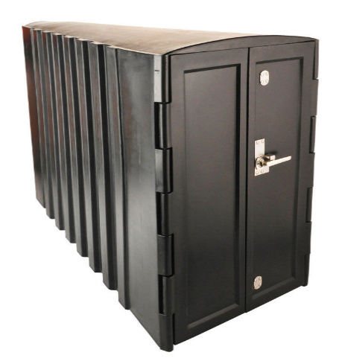
      - MATERIALS
        - Material: High Density Polyethylene (HPDE) and Medium Density Polyethylene (MPDE).
          - Doors: HDPE octene copolymer, with insulation foam.
            - Flexural Modulus: 119,500 psi minimum.
            - Tensile Strength: 4,250 psi minimum.
            - Insulation: Foamable polyethylene micropellets.
          - Body: MDPE hexane copolymer.
            - Flexural Modulus: 110,230 psi minimum.
            - Tensile Strength: 3,000 psi minimum.
      - ACCESSORIES
        - Mounting Accessories
          - Epoxy adhesive: As recommended in writing by adhesive manufacturer for outdoor use with concrete and galvanized steel.
Standard nuts are provided with bicycle lockers. Where lockers may be vulnerable to vandalism or theft, consider using optional security fasteners. With security fasteners, coordinate with Part 1 Maintenance Material Submittals.
          - Bolts and Washers: Galvanized steel
        - Locks: User-supplied.
- EXECUTION
      - EXAMINATION
        - Examine paving or other substrates for compliance with manufacturer’s requirements for placement and location of embedded items, condition of substrate, and other conditions affecting installation of bicycle lockers.
        - Proceed with installation only after unsatisfactory conditions have been corrected.
      - INSTALLATION
Drawing Coordination: Ensure that bicycle lockers, when in use, do not impede required paths of egress and accessible travel. Allow adequate clearance for bicycle storage and removal.
        - General: Comply with manufacturer’s installation requirements and setting drawings.
        - Install according to manufacturer's written instructions by concrete insert method.
        - Do not install damaged, cracked, chipped, deformed, or marred bicycle lockers. Field touch-up minor imperfections in accordance with manufacturer’s instructions. Replace bicycle lockers that cannot be field repaired.
      - CLEANING
        - Immediately prior to Substantial Completion, clean bicycle lockers in accordance with manufacturer’s instructions to remove dust, dirt, adhesives, and other foreign materials.
      - PROTECTION
        - Protect bicycle lockers against damage.

END OF SECTION
Copyright 2018 by Reliance Foundry Co. Ltd.; qualified design and construction professionals may copy for preparation of construction specifications and purchase orders for Reliance Foundry products.
Issued April 2018. Subject to change.

