Reliance Foundry Co Ltd

#207-6450 148 St

Surrey, BC V3S 7G7

Phone: 604-547-0460

Phone: 1-877-789-3245

Fax: 604-590-8875

Email: info@reliance-foundry.com

Website: www.reliance-foundry.com

Reliance Foundry is an award-winning supplier of high quality stock and custom-designed site furnishings

for architectural, traffic management, and industrial applications. Reliance Foundry brings over 90 years of expertise to the design and manufacturing of our products.

Reliance Foundry bollards add architectural accents to your perimeter security, landscaping, traffic control, and streetscape projects. Use bollards as design features for new and existing buildings, for access control measures, traffic guidance, and as decorative covers over steel security posts. This section includes precast concrete bollards, access control bollards including collapsible, removable, and retractable bollards, flexible bollards, surface mount metal bollards, decorative metal bollards, and bollard covers.

Specification Coordination: Edit this guide specification to meet project requirements. Coordinate with other specification sections as required. If using more than one bollard type, use the same designation in both drawings and specifications. Display hidden text to see or print notes to specifier.

Drawing Coordination: Show locations, sizes, layout, and spacing of each type of bollard or bollard cover required. Show footing and security post details, if required. Soft metric conversion is provided for all measurements.

**SECTION 03 48 13**

**PRECAST CONCRETE BOLLARDS**

1. GENERAL
   * + 1. SUMMARY
          1. Section Includes:

Precast concrete bollards.

Accessories

Edit following to coordinate with other specification sections in project.

* + - * 1. Related Requirements:

[Any Division 32 Section with "Bollards" in the title or Section 32 41 00 “Bollards” for bollards other than precast concrete bollards specified herein.]

* + - 1. REFERENCE STANDARDS
         1. ASTM C666 - Standard Test Method for Resistance of Concrete to Rapid Freezing and Thawing.
         2. ASTM C825 - Standard Specification for Precast Concrete Barriers.
         3. ASTM C979 - Standard Specification for Pigments for Integrally Colored Concrete.
      2. SUBMITTALS
         1. Comply with Section [01 33 00 – Submittal Procedures.] [_________.]
         2. Product Data: Provide for each type of bollard specified.
         3. Color Samples: [Submit manufacturer’s standard colors for selection.] [Submit sample of color specified.]
         4. Maintenance Data: Submit manufacturer’s field touch-up, cleaning, and maintenance instructions.
         5. Warranty Documentation: Submit sample of manufacturer’s warranty.
      3. QUALITY ASSURANCE
         1. Comply with Section [01 43 00 – Quality Assurance.] [_________.]
      4. DELIVERY, STORAGE AND HANDLING
         1. Comply with Section [01 66 00 – Product Storage and Handling Requirements.] [_________.]
         2. Protect bollards and accessories during delivery, storage, and handling.
      5. WARRANTY
         1. Comply with Section [01 78 36 – Warranties.] [_________.]
         2. Provide manufacturer’s standard warranty against defects in materials and workmanship.

Warranty Period: Five years from date of invoice.

1. PRODUCTS
   * + 1. MANUFACTURERS
          1. Manufacturer: Reliance Foundry Co. Ltd.

Phone: 604-547-0460 or 1-877-789-3245

Fax: 604-590-8875

Website: <http://www.reliance-foundry.com/bollard>

Email: [info@reliance-foundry.com](mailto:info@reliance-foundry.com)

* + - * 1. Substitutions: [Comply with provisions of [Section 01 25 00 "Substitution Procedures"] [_________] for substitution procedures.] [Not allowed.]
      1. PRECAST CONCRETE BOLLARDS

See http://www.reliance-foundry.com/bollard/ for assistance in selecting a bollard model.

Concrete bollards have variable weight. Actual weight may vary from listed weight.

* + - * 1. Material:

Concrete: Precast concrete with 5200-psi (36 MPa) minimum compressive strength.

Components: ASTM C150, Type I or III cement, with ASTM C33 aggregate.

Pigments: ASTM C979, natural mineral oxide pigments, temperature-stable and non-fading.

Reinforcing: ASTM A 615/A 615M, Grade 60 (Grade 420), deformed.

Steel Pipe: ASTM A 500, Grade B.

* + - * 1. Country of Origin: Canada.
        2. Installation: Direct Imbed.
        3. 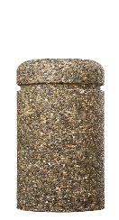Precast Concrete Bollard [Designer’s Designation]:

Model: Reliance Foundry; **R-9701**.

Height: 36 inches (91.5 cm)

Base Diameter: 18 inches (45.7 cm)

Weight: 815 lbs. (370 kg).

Color: Mixed/Granite.

Finish: Exposed Aggregate.

Optional Finish: High-Gloss Acrylic Sealer.

* + - * 1. 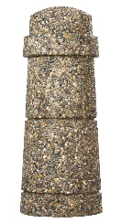Precast Concrete Bollard [Designer’s Designation]:

Model: Reliance Foundry; **R-9702**.

Height: 39.5 inches (100.4 cm)

Base Diameter: 15.75 inches (40 cm)

Weight: 510 lbs. (231 kg).

Color: Mixed/Granite.

Finish: Exposed Aggregate.

Optional Finish: High-Gloss Acrylic Sealer.

* + - * 1. 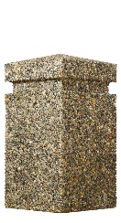Precast Concrete Bollard [Designer’s Designation]:

Model: Reliance Foundry; **R-9703**.

Height: 32 inches (81.3 cm)

Base Width: 24 inches (61 cm) by 24 inches (61 cm)

Weight: 1200 lbs. (544 kg).

Color: Mixed/Granite.

Finish: Exposed Aggregate.

Optional Finish: High-Gloss Acrylic Sealer.

* + - * 1. 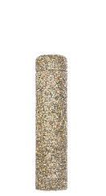Precast Concrete Bollard [Designer’s Designation]:

Model: Reliance Foundry **R-9704-36**

Height: 36 inches (91.4 cm)

Base Diameter: 11 inches (28 cm)

Weight: 310 lbs. (140 kg)

Color: Mixed/Granite.

Finish: Exposed Aggregate.

Optional Finish: High-Gloss Acrylic Sealer.

* + - * 1. 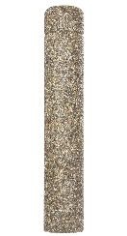Precast Concrete Bollard [Designer’s Designation]:

Model: Reliance Foundry; **R-9704-60**.

Height: 60 inches (152.5 cm)

Base Diameter: 11 inches (28 cm)

Weight: 510 lbs. (231 kg).

Color: Mixed/Granite.

Finish: Exposed Aggregate.

Optional Finish: High-Gloss Acrylic Sealer.

* + - * 1. 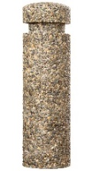Precast Concrete Bollard [Designer’s Designation]:

Model: Reliance Foundry; **R-9705**.

Height: 33 inches (83.8 cm)

Base Diameter: 10 inches (25.5 cm)

Weight: 220 lbs. (100 kg).

Color: Mixed/Granite.

Finish: Exposed Aggregate.

Optional Finish: High-Gloss Acrylic Sealer.

* + - 1. ACCESSORIES

Retain following if specified bollards require internal posts.

* + - * 1. Installation Materials:

Grout: Non-shrink, non-ferrous grout.

1. EXECUTION
   * + 1. EXAMINATION
          1. Examine paving or other substrates for compliance with manufacturer’s requirements for placement and location of embedded items, condition of substrate, and other conditions affecting installation of bollards.
          2. Proceed with installation only after unsatisfactory conditions have been corrected.
       2. INSTALLATION
          1. General: Comply with manufacturer’s installation instructions and setting drawings.
          2. Do not install damaged, cracked, chipped, deformed, or marred bollards. Field touch-up minor imperfections in accordance with manufacturer’s instructions. Replace bollards that cannot be field repaired.
          3. Direct Imbed: Support bollard during concrete placement and cure.
       3. CLEANING & PROTECTION

Normal cleaning may be done with clean water and a soft cloth. Detailed cleaning and inspection instructions are available at <http://www.reliance-foundry.com/site/documents/reliance-foundry-general-care-and-maintenance.pdf> .

* + - * 1. Protect bollards against damage.
        2. Immediately prior to Substantial Completion, clean bollards in accordance with manufacturer’s instructions to remove dust, dirt, adhesives, and other foreign materials.
        3. Touch up damaged finishes according to manufacturer’s instructions.
      1. CLOSEOUT ACTIVITIES
         1. Provide executed warranty.

**SECTION 32 39 13.15**

**METAL ACCESS CONTROL BOLLARDS**

1. GENERAL
   * + 1. SUMMARY
          1. Section Includes:

Removable bollards

Retractable bollard set

Collapsible bollards

Accessories

[_________________]

Edit following to coordinate with other specification sections in project.

* + - * 1. Related Requirements:

[Division 03 Sections: [Concrete] [Mortar] fill for security posts.]

[Division 08 Sections: Padlocks.]

[_________________]

Edit below to include only reference standards used in project.

* + - 1. REFERENCE STANDARDS
         1. ASTM A36 – Standard Specification for Carbon Structural Steel.
         2. ASTM A312 – Standard Specification for Seamless, Welded, and Heavily Cold Worked Austenitic Stainless Steel Pipes.
         3. ASTM A500 – Standard Specification for Cold-Formed Welded and Seamless Carbon Steel Structural Tubing in Rounds and Shapes.
         4. ASTM A536 – Standard Specification for Ductile Iron Castings.
         5. ASTM B26 – Standard Specification for Aluminum-Alloy Sand Castings.
      2. SUBMITTALS
         1. Comply with Section [01 33 00 – Submittal Procedures.] [_________.]
         2. Product Data: Provide for each type of bollard, component, finish, and accessory specified.
         3. Color Samples: [Submit manufacturer’s standard colors for selection.] [Submit sample of color specified.]
         4. Setting Drawings: Show embedded items and cutouts required for work specified in other Sections.
         5. Maintenance Data: Submit manufacturer’s field touch-up, cleaning, and maintenance instructions.
         6. Warranty Documentation: Submit sample of manufacturer’s warranty.
      3. QUALITY ASSURANCE
         1. Comply with Section [01 43 00 – Quality Assurance.] [_________.]
      4. DELIVERY, STORAGE AND HANDLING
         1. Comply with Section [01 66 00 – Product Storage and Handling Requirements.] [_________.]
         2. Protect bollards and accessories during delivery, storage, and handling.
      5. WARRANTY
         1. Comply with Section [01 78 36 – Warranties.] [_________.]
         2. Provide manufacturer’s standard warranty against defects in materials and workmanship.

Warranty Period: Five years from date of invoice, except as otherwise indicated.

Coatings: Two years, against peeling, cracking, or significant color change.

1. PRODUCTS
   * + 1. MANUFACTURERS
          1. Manufacturer: Reliance Foundry Co. Ltd.

Phone: 604-547-0460 or 1-877-789-3245

Fax: 604-590-8875

Website: <http://www.reliance-foundry.com/bollard>

Email: [info@reliance-foundry.com](mailto:info@reliance-foundry.com)

* + - * 1. Substitutions: [Comply with provisions of [Section 01 25 00 "Substitution Procedures"] [_________] for substitution procedures.] [Not allowed.]
      1. REMOVABLE BOLLARDS
         1. 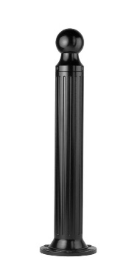Bollard [Designer’s Designation]:

Retain -AL for aluminum. Delete if not required.

Model: Reliance Foundry; **R-7530 [-AL]**.

See R-7530-B for complementary bike parking bollard: <http://www.reliance-foundry.com/bike-storage/bike-bollard-stands>

Height: 39 inches (99 cm)

Diameter: 5 inches (12.7 cm) body; 10 inches (25.4 cm) base

Design: Cylindrical and fluted, with tapered bottom and ball top.

Retain aluminum or cast iron to coordinate with model number.

Material:

Aluminum: ASTM B26; 20 percent recycled-material content.

Weight: 24 lbs. (10.9 kg)

Ductile Cast Iron: ASTM A536, Grade 65-45-12; 30 percent recycled-material content.

Weight: 62 lbs. (28.1 kg)

Country of Origin: China.

Color Coating:

Type: Polyester powder coat over epoxy primer.

Color: [Black textured semi gloss] [Dark green] [Statuary bronze] [Bengal silver] [Anodized silver] [Safety yellow].

Installation:

Fixed, new concrete, anchor.

Fixed, existing concrete, insert.

Fixed, existing concrete, adhesive.

Fixed, existing concrete, flange and insert.

Security post cover, new post

Security post cover, existing post, insert.

Security post cover, existing post, adhesive.

Security post cover, existing post, concrete anchor.

Removable, new concrete, anchor.

Removable, existing concrete, insert.

Removable, new concrete, retractable.

* + - * 1. 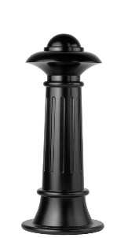Bollard [Designer’s Designation]:

Model: Reliance Foundry; **R-7538**.

Height: 35 inches (89 cm)

Diameter: 7.75 inches (19.7 cm) body; 15 inches (38 cm) base

Weight: 118 lbs. (53.5 kg)

Design: Tapered and fluted, with fluted base and nautical-styled top.

Material:

Ductile Cast Iron: ASTM A536, Grade 65-45-12; 30 percent recycled-material content.

Country of Origin: China.

Color Coating:

Type: Polyester powder coat over epoxy primer.

Color: [Black textured semi gloss] [Dark green] [Statuary bronze] [Bengal silver] [Anodized silver] [Safety yellow].

Installation:

Fixed, new concrete, anchor.

Fixed, existing concrete, insert.

Fixed, existing concrete, adhesive.

Fixed, anchor casting, concrete form.

Security post cover, new post

Security post cover, existing post, insert.

Security post cover, existing post, adhesive.

Security post cover, existing post, concrete anchor.

Removable, new concrete, anchor.

Removable, existing concrete, insert.

Removable, new concrete, retractable.

* + - * 1. 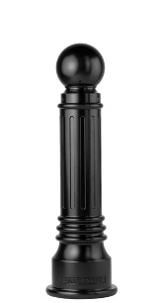Bollard [Designer’s Designation]:

Retain -AL for aluminum. Delete if not required.

Model: Reliance Foundry; **R-7539 [-AL]**.

See R-7539-B for complementary bike parking model: <http://www.reliance-foundry.com/bike-storage/bike-bollard-stands>

Height: 35.75 inches (90.8 cm)

Diameter: 6 inches (15.2 cm) body; 10.25 inches (26 cm) base

Design: Tapered and fluted, with round finial and ball top.

Retain aluminum or cast iron to coordinate with model number.

Material:

Aluminum: ASTM B26; 20 percent recycled-material content.

Weight: 31 lbs. (14 kg)

Ductile Cast Iron: ASTM A536, Grade 65-45-12; 30 percent recycled-material content.

Weight: 75 lbs. (34 kg)

Country of Origin: China.

Color Coating:

Type: Polyester powder coat over epoxy primer.

Color: [Black textured semi gloss] [Dark green] [Statuary bronze] [Bengal silver] [Anodized silver] [Safety yellow].

Installation:

Fixed, new concrete, anchor.

Fixed, existing concrete, insert.

Fixed, existing concrete, adhesive.

Fixed, anchor casting, concrete form.

Security post cover, new post

Security post cover, existing post, insert.

Security post cover, existing post, adhesive.

Security post cover, existing post, concrete anchor.

Removable, new concrete, anchor.

Removable, existing concrete, insert.

Removable, new concrete, retractable.

* + - * 1. Bollard [Designer’s Designation]:

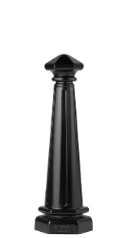Model: Reliance Foundry; **R-7542**.

Height: 30 inches (89 cm)

Diameter: 6.5 inches (16.5 cm) body; 10 inches (38 cm) base

Weight: 67 lbs. (30.4 kg)

Design: Tapered and fluted, with fluted base and nautical-styled top.

Material: Ductile Cast Iron: ASTM A536, Grade 65-45-12; 30 percent recycled-material content.

Country of Origin: China.

Color Coating:

Type: Polyester powder coat over epoxy primer.

Color: [Black textured semi gloss] [Dark green] [Statuary bronze] [Bengal silver] [Anodized silver] [Safety yellow].

Installation:

Fixed, new concrete, anchor.

Fixed, existing concrete, insert.

Fixed, existing concrete, adhesive.

Fixed, anchor casting, concrete form.

Security post cover, new post

Security post cover, existing post, insert.

Security post cover, existing post, adhesive.

Security post cover, existing post, concrete anchor.

Removable, new concrete, anchor.

Removable, existing concrete, insert.

Removable, new concrete, retractable.

* + - * 1. 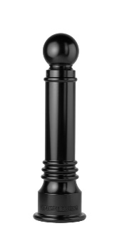Bollard [Designer’s Designation]:

Model: Reliance Foundry; **R-7551**.

See R-7551-B for complementary bike parking model: <http://www.reliance-foundry.com/bike-storage/bike-bollard-stands>

Height: 35.75 inches (90.8 cm)

Diameter: 6 inches (15.2 cm) body; 10.25 inches (26 cm) base

Weight: 78 lbs. (35 kg)

Design: Tapered with round finial and ball top.

Material: Ductile Cast Iron: ASTM A536, Grade 65-45-12; 30 percent recycled-material content.

Country of Origin: China.

Color Coating:

Type: Polyester powder coat over epoxy primer.

Color: [Black textured semi gloss] [Dark green] [Statuary bronze] [Bengal silver] [Anodized silver] [Safety yellow].

Installation:

Fixed, new concrete, anchor.

Fixed, existing concrete, insert.

Fixed, existing concrete, adhesive.

Fixed, anchor casting, concrete form.

Security post cover, new post

Security post cover, existing post, insert.

Security post cover, existing post, adhesive.

Security post cover, existing post, concrete anchor.

Removable, new concrete, anchor.

Removable, existing concrete, insert.

Removable, new concrete, retractable.

* + - * 1. 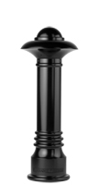Bollard [Designer’s Designation]:

Model: Reliance Foundry; **R-7552**.

Height: 35.75 inches (90.8 cm)

Diameter: 6 inches (15.2 cm) body; 10.25 inches (26 cm) base

Weight: 88 lbs. (40 kg)

Design: Tapered with round finial and contemporary-styled top.

Material: Ductile Cast Iron: ASTM A536, Grade 65-45-12; 30 percent recycled-material content.

Country of Origin: China.

Color Coating:

Type: Polyester powder coat over epoxy primer.

Color: [Black textured semi gloss] [Dark green] [Statuary bronze] [Bengal silver] [Anodized silver] [Safety yellow].

Installation:

Fixed, new concrete, anchor.

Fixed, existing concrete, insert.

Fixed, existing concrete, adhesive.

Fixed, anchor casting, concrete form.

Security post cover, new post

Security post cover, existing post, insert.

Security post cover, existing post, adhesive.

Security post cover, existing post, concrete anchor.

Removable, new concrete, anchor.

Removable, existing concrete, insert.

Removable, new concrete, retractable.

* + - * 1. Bollard [Designer’s Designation]:

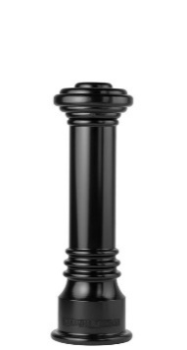Model: Reliance Foundry; **R-7553**.

See R-7553-B for complementary bike parking model: <http://www.reliance-foundry.com/bike-storage/bike-bollard-stands>

Height: 31.75 inches (90.8 cm)

Diameter: 6 inches (15.2 cm) body; 10.25 inches (26 cm) base

Weight: 82 lbs. (37 kg)

Design: Tapered with round finial and flat disc top.

Material: Ductile Cast Iron: ASTM A536, Grade 65-45-12; 30 percent recycled-material content.

Country of Origin: China.

Color Coating:

Type: Polyester powder coat over epoxy primer.

Color: [Black textured semi gloss] [Dark green] [Statuary bronze] [Bengal silver] [Anodized silver] [Safety yellow].

Installation:

Fixed, new concrete, anchor.

Fixed, existing concrete, insert.

Fixed, existing concrete, adhesive.

Fixed, anchor casting, concrete form.

Security post cover, new post

Security post cover, existing post, insert.

Security post cover, existing post, adhesive.

Security post cover, existing post, concrete anchor.

Removable, new concrete, anchor.

Removable, existing concrete, insert.

Removable, new concrete, retractable.

* + - * 1. 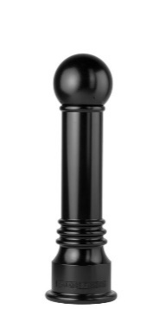Bollard [Designer’s Designation]:

Model: Reliance Foundry; **R-7555**.

Height: 34.5 inches (90.8 cm)

Diameter: 6 inches (15.2 cm) body; 10.25 inches (26 cm) base

Weight: 78 lbs. (35.4 kg)

Design: Tapered with round finial and large ball top.

Material: Ductile Cast Iron: ASTM A536, Grade 65-45-12; 30 percent recycled-material content.

Country of Origin: China.

Color Coating:

Type: Polyester powder coat over epoxy primer.

Color: [Black textured semi gloss] [Dark green] [Statuary bronze] [Bengal silver] [Anodized silver] [Safety yellow].

Installation:

Fixed, new concrete, anchor.

Fixed, existing concrete, insert.

Fixed, existing concrete, adhesive.

Fixed, anchor casting, concrete form.

Security post cover, new post

Security post cover, existing post, insert.

Security post cover, existing post, adhesive.

Security post cover, existing post, concrete anchor.

Removable, new concrete, anchor.

Removable, existing concrete, insert.

Removable, new concrete, retractable.

* + - * 1. Bollard [Designer’s Designation]:

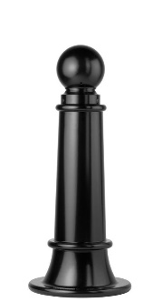Model: Reliance Foundry; **R-7561**.

Height: 35 inches (89 cm)

Diameter: 7.75 inches (19.7 cm) body; 15 inches (38 cm) base

Weight: 115 lbs. (52.2 kg)

Design: Tapered with round finial and ball top.

Material: Ductile Cast Iron: ASTM A536, Grade 65-45-12; 30 percent recycled-material content.

Country of Origin: China.

Color Coating:

Type: Polyester powder coat over epoxy primer.

Color: [Black textured semi gloss] [Dark green] [Statuary bronze] [Bengal silver] [Anodized silver] [Safety yellow].

Installation:

Fixed, new concrete, anchor.

Fixed, existing concrete, insert.

Fixed, existing concrete, adhesive.

Fixed, anchor casting, concrete form.

Security post cover, new post

Security post cover, existing post, insert.

Security post cover, existing post, adhesive.

Security post cover, existing post, concrete anchor.

Removable, new concrete, anchor.

Removable, existing concrete, insert.

Removable, new concrete, retractable.

* + - * 1. 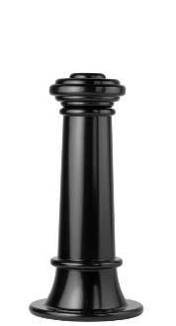Bollard [Designer’s Designation]:

Model: Reliance Foundry; **R-7563**.

Height: 31 inches (78.7 cm)

Diameter: 7.75 inches (19.7 cm) body; 15 inches (38 cm) base

Weight: 119 lbs. (54 kg)

Design: Tapered with round finial and flat disc top.

Material: Ductile Cast Iron: ASTM A536, Grade 65-45-12; 30 percent recycled-material content.

Country of Origin: China.

Color Coating:

Type: Polyester powder coat over epoxy primer.

Color: [Black textured semi gloss] [Dark green] [Statuary bronze] [Bengal silver] [Anodized silver] [Safety yellow].

Installation:

Fixed, new concrete, anchor.

Fixed, existing concrete, insert.

Fixed, existing concrete, adhesive.

Fixed, anchor casting, concrete form.

Security post cover, new post

Security post cover, existing post, insert.

Security post cover, existing post, adhesive.

Security post cover, existing post, concrete anchor.

Removable, new concrete, anchor.

Removable, existing concrete, insert.

Removable, new concrete, retractable.

* + - * 1. 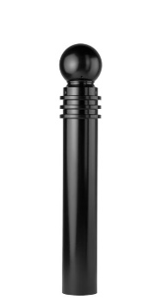Bollard [Designer’s Designation]:

Model: Reliance Foundry; **R-7571**.

See R-7571-B for complementary bike parking model: http://www.reliance-foundry.com/bike-storage/bike-bollard-stands

Height: 40.5 inches (102.9 cm)

Diameter: 5.75 inches (14.6 cm) body; 5.75 inches (14.6 cm) base

Weight: 62 lbs. (28.1 kg)

Design: Cylindrical with round finial and ball top.

Material: Ductile Cast Iron: ASTM A536, Grade 65-45-12; 30 percent recycled-material content.

Country of Origin: China.

Color Coating:

Type: Polyester powder coat over epoxy primer.

Color: [Black textured semi gloss] [Dark green] [Statuary bronze] [Bengal silver] [Anodized silver] [Safety yellow].

Installation:

Fixed, new concrete, anchor.

Fixed, existing concrete, insert.

Fixed, existing concrete, adhesive.

Fixed, anchor casting, concrete form.

Security post cover, new post

Security post cover, existing post, insert.

Security post cover, existing post, adhesive.

Security post cover, existing post, concrete anchor.

Removable, new concrete, anchor.

Removable, existing concrete, insert.

Removable, new concrete, retractable.

* + - * 1. Bollard [Designer’s Designation]:

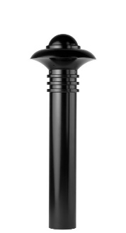Model: Reliance Foundry; **R-7572**.

Height: 40.5 inches (102.9 cm)

Diameter: 5.75 inches (14.6 cm) body; 5.75 inches (14.6 cm) base

Weight: 72 lbs. (32.7 kg)

Design: Cylindrical with round finial and contemporary-styled top.

Material: Ductile Cast Iron: ASTM A536, Grade 65-45-12; 30 percent recycled-material content.

Country of Origin: China.

Color Coating:

Type: Polyester powder coat over epoxy primer.

Color: [Black textured semi gloss] [Dark green] [Statuary bronze] [Bengal silver] [Anodized silver] [Safety yellow].

Installation:

Fixed, new concrete, anchor.

Fixed, existing concrete, insert.

Fixed, existing concrete, adhesive.

Fixed, anchor casting, concrete form.

Security post cover, new post

Security post cover, existing post, insert.

Security post cover, existing post, adhesive.

Security post cover, existing post, concrete anchor.

Removable, new concrete, anchor.

Removable, existing concrete, insert.

Removable, new concrete, retractable.

* + - * 1. 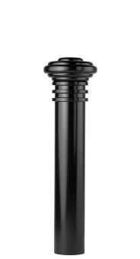Bollard [Designer’s Designation]:

Model: Reliance Foundry; **R-7573**.

Height: 36.5 inches (92.7 cm)

Diameter: 5.75 inches (14.6 cm) body; 5.75 inches (14.6 cm) base

Weight: 66 lbs. (30 kg)

Design: Cylindrical with round finial and flat disc top.

Material: Ductile Cast Iron: ASTM A536, Grade 65-45-12; 30 percent recycled-material content.

Country of Origin: China.

Color Coating:

Type: Polyester powder coat over epoxy primer.

Color: [Black textured semi gloss] [Dark green] [Statuary bronze] [Bengal silver] [Anodized silver] [Safety yellow].

Installation:

Fixed, new concrete, anchor.

Fixed, existing concrete, insert.

Fixed, existing concrete, adhesive.

Fixed, anchor casting, concrete form.

Security post cover, new post

Security post cover, existing post, insert.

Security post cover, existing post, adhesive.

Security post cover, existing post, concrete anchor.

Removable, new concrete, anchor.

Removable, existing concrete, insert.

Removable, new concrete, retractable.

* + - * 1. 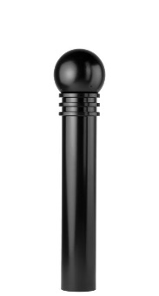Bollard [Designer’s Designation]:

Model: Reliance Foundry; **R-7575**.

Height: 39.25 inches (99.7 cm)

Diameter: 5.75 inches (14.6 cm) body; 5.75 inches (14.6 cm) base

Weight: 62 lbs. (28.1 kg)

Design: Cylindrical with round finial and large ball top.

Material: Ductile Cast Iron: ASTM A536, Grade 65-45-12; 30 percent recycled-material content.

Country of Origin: China.

Color Coating:

Type: Polyester powder coat over epoxy primer.

Color: [Black textured semi gloss] [Dark green] [Statuary bronze] [Bengal silver] [Anodized silver] [Safety yellow].

Installation:

Fixed, new concrete, anchor.

Fixed, existing concrete, insert.

Fixed, existing concrete, adhesive.

Fixed, anchor casting, concrete form.

Security post cover, new post

Security post cover, existing post, insert.

Security post cover, existing post, adhesive.

Security post cover, existing post, concrete anchor.

Removable, new concrete, anchor.

Removable, existing concrete, insert.

Removable, new concrete, retractable.

* + - * 1. 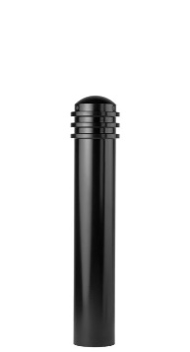Bollard [Designer’s Designation]:

Model: Reliance Foundry; **R-7576**.

See R-7576-B for complementary bike parking model: http://www.reliance-foundry.com/bike-storage/bike-bollard-stands

Height: 34.25 inches (87 cm)

Diameter: 5.75 inches (14.6 cm) body; 5.75 inches (14.6 cm) base

Weight: 51 lbs. (23.1 Kg)

Design: Cylindrical with round finial and rounded top.

Material: Ductile Cast Iron: ASTM A536, Grade 65-45-12; 30 percent recycled-material content.

Color Coating:

Type: Polyester powder coat over epoxy primer.

Color: [Black textured semi gloss] [Dark green] [Statuary bronze] [Bengal silver] [Anodized silver] [Safety yellow].

Installation:

Fixed, new concrete, anchor.

Fixed, existing concrete, insert.

Fixed, existing concrete, adhesive.

Fixed, anchor casting, concrete form.

Security post cover, new post

Security post cover, existing post, insert.

Security post cover, existing post, adhesive.

Security post cover, existing post, concrete anchor.

Removable, new concrete, anchor.

Removable, existing concrete, insert.

Removable, new concrete, retractable.

* + - * 1. 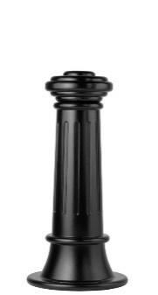Bollard [Designer’s Designation]:

Retain -AL for aluminum. Delete if not required.

Model: Reliance Foundry; **R-7581 [-AL]**.

Height: 31 inches (78.7 cm)

Diameter: 7.75 inches (19.7 cm) body; 15inches (38 cm) base

Design: Tapered and fluted, with round finial and flat disc top.

Retain aluminum or cast iron to coordinate with model number.

Material:

Aluminum: ASTM B26; 20 percent recycled-material content.

Weight: 46 lbs. (20.8 kg)

Ductile Cast Iron: ASTM A536, Grade 65-45-12; 30 percent recycled-material content.

Weight: 112 lbs. (50.8 kg)

Country of Origin: China.

Color Coating:

Type: Polyester powder coat over epoxy primer.

Color: [Black textured semi gloss] [Dark green] [Statuary bronze] [Bengal silver] [Anodized silver] [Safety yellow].

Installation:

Fixed, new concrete, anchor.

Fixed, existing concrete, insert.

Fixed, existing concrete, adhesive.

Fixed, anchor casting, concrete form.

Security post cover, new post

Security post cover, existing post, insert.

Security post cover, existing post, adhesive.

Security post cover, existing post, concrete anchor.

Removable, new concrete, anchor.

Removable, existing concrete, insert.

Removable, new concrete, retractable.

* + - * 1. 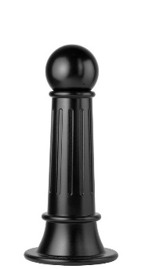Bollard [Designer’s Designation]:

Model: Reliance Foundry; **R-7582**.

Height: 33.75 inches (85.7 cm)

Diameter: 7.75 inches (19.7 cm) body; 15inches (38 cm) base

Weight: 108 lbs. (49 kg)

Design: Tapered and fluted, with round finial and large ball top.

Material: Ductile Cast Iron: ASTM A536, Grade 65-45-12; 30 percent recycled-material content.

Country of Origin: China.

Color Coating:

Type: Polyester powder coat over epoxy primer.

Color: [Black textured semi gloss] [Dark green] [Statuary bronze] [Bengal silver] [Anodized silver] [Safety yellow].

Installation:

Fixed, new concrete, anchor.

Fixed, existing concrete, insert.

Fixed, existing concrete, adhesive.

Fixed, anchor casting, concrete form.

Security post cover, new post

Security post cover, existing post, insert.

Security post cover, existing post, adhesive.

Security post cover, existing post, concrete anchor.

Removable, new concrete, anchor.

Removable, existing concrete, insert.

Removable, new concrete, retractable.

* + - * 1. 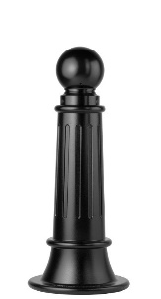Bollard [Designer’s Designation]:

Retain -AL for aluminum. Delete if not required.

Model: Reliance Foundry; **R-7589 [-AL]**.

Height: 35 inches (89 cm)

Diameter: 7.75 inches (19.7 cm) body; 15inches (38 cm) base

Design: Tapered and fluted, with round finial and ball top.

Retain aluminum or cast iron to coordinate with model number.

Material:

Aluminum: ASTM B26; 20 percent recycled-material content.

Weight: 46 lbs. (20.8 kg)

Ductile Cast Iron: ASTM A536, Grade 65-45-12; 30 percent recycled-material content.

Weight: 108 lbs. (50.8 kg)

Country of Origin: China.

Color Coating:

Type: Polyester powder coat over epoxy primer.

Color: [Black textured semi gloss] [Dark green] [Statuary bronze] [Bengal silver] [Anodized silver] [Safety yellow].

Installation:

Fixed, new concrete, anchor.

Fixed, existing concrete, insert.

Fixed, existing concrete, adhesive.

Fixed, anchor casting, concrete form.

Security post cover, new post

Security post cover, existing post, insert.

Security post cover, existing post, adhesive.

Security post cover, existing post, concrete anchor.

Removable, new concrete, anchor.

Removable, existing concrete, insert.

Removable, new concrete, retractable.

* + - * 1. 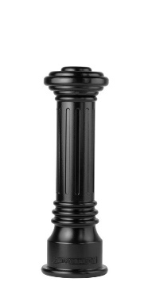Bollard [Designer’s Designation]:

Retain -AL for aluminum. Delete if not required.

Model: Reliance Foundry; **R-7591 [-AL]**.

See R-7591-B for complementary bike parking model: http://www.reliance-foundry.com/bike-storage/bike-bollard-stands

Height: 31.75 inches (80.6 cm)

Diameter: 6 inches (15.2 cm) body; 10.25 inches (26 cm) base

Design: Tapered and fluted, with round finial and flat disc top.

Retain aluminum or cast iron to coordinate with model number.

Material:

Aluminum: ASTM B26; 20 percent recycled-material content.

Weight: 31 lbs. (14 kg)

Ductile Cast Iron: ASTM A536, Grade 65-45-12; 30 percent recycled-material content.

Weight: 79 lbs. (35.8 kg)

Country of Origin: China.

Color Coating:

Type: Polyester powder coat over epoxy primer.

Color: [Black textured semi gloss] [Dark green] [Statuary bronze] [Bengal silver] [Anodized silver] [Safety yellow].

Installation:

Fixed, new concrete, anchor.

Fixed, existing concrete, insert.

Fixed, existing concrete, adhesive.

Fixed, anchor casting, concrete form.

Security post cover, new post

Security post cover, existing post, insert.

Security post cover, existing post, adhesive.

Security post cover, existing post, concrete anchor.

Removable, new concrete, anchor.

Removable, existing concrete, insert.

Removable, new concrete, retractable.

* + - * 1. 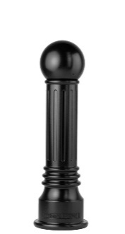Bollard [Designer’s Designation]:

Model: Reliance Foundry; **R-7592**.

Height: 34.5 inches (87.6 cm)

Diameter: 6 inches (15.2 cm) body; 10.25 inches (26 cm) base.

Weight: 75 lbs. (34 kg)

Design: Tapered and fluted, with round finial and large ball top.

Material: Ductile Cast Iron: ASTM A536, Grade 65-45-12; 30 percent recycled-material content.

Country of Origin: China.

Color Coating:

Type: Polyester powder coat over epoxy primer.

Color: [Black textured semi gloss] [Dark green] [Statuary bronze] [Bengal silver] [Anodized silver] [Safety yellow].

Installation:

Fixed, new concrete, anchor.

Fixed, existing concrete, insert.

Fixed, existing concrete, adhesive.

Fixed, anchor casting, concrete form.

Security post cover, new post

Security post cover, existing post, insert.

Security post cover, existing post, adhesive.

Security post cover, existing post, concrete anchor.

Removable, new concrete, anchor.

Removable, existing concrete, insert.

Removable, new concrete, retractable.

* + - * 1. 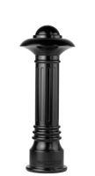Bollard [Designer’s Designation]:

Model: Reliance Foundry; **R-7598**.

Height: 35.75 inches (90.8 cm)

Diameter: 6 inches (15.2 cm) body; 10.25 inches (26 cm) base.

Weight: 85 lbs. (38.6 kg)

Design: Tapered and fluted, with fluted base and nautical-styled top.

Material: Ductile Cast Iron: ASTM A536, Grade 65-45-12; 30 percent recycled-material content.

Country of Origin: China.

Color Coating:

Type: Polyester powder coat over epoxy primer.

Color: [Black textured semi gloss] [Dark green] [Statuary bronze] [Bengal silver] [Anodized silver] [Safety yellow].

Installation:

Fixed, new concrete, anchor.

Fixed, existing concrete, insert.

Fixed, existing concrete, adhesive.

Fixed, anchor casting, concrete form.

Security post cover, new post

Security post cover, existing post, insert.

Security post cover, existing post, adhesive.

Security post cover, existing post, concrete anchor.

Removable, new concrete, anchor.

Removable, existing concrete, insert.

Removable, new concrete, retractable.

* + - * 1. 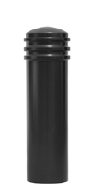Bollard [Designer’s Designation]:

Model: Reliance Foundry; **R-7835**.

See R-7835-B for complementary bike parking model: http://www.reliance-foundry.com/bike-storage/bike-bollard-stands

Height: 35 inches (88.9 cm)

Diameter: 9.5 inches (24.1 cm) body; 9.5 inches (24.1 cm) base

Weight: 80 lbs. (36.3 kg)

Design: Cylindrical with segmented rings and rounded top.

Material: Steel: ASTM A36; 25 percent recycled-material content.

Country of Origin: China.

Color Coating:

Type: Polyester powder coat over epoxy primer.

Color: [Black textured semi gloss] [Dark green] [Statuary bronze] [Bengal silver] [Anodized silver] [Safety yellow].

Installation:

Fixed, new concrete, anchor.

Fixed, existing concrete, insert.

Fixed, existing concrete, adhesive.

Fixed, anchor casting, concrete form.

Security post cover, new post

Security post cover, existing post, insert.

Security post cover, existing post, adhesive.

Security post cover, existing post, concrete anchor.

Removable, new concrete, anchor.

Removable, existing concrete, insert.

Removable, new concrete, retractable.

* + - * 1. Bollard [Designer’s Designation]:

If coating is required, retain “RA” below.

Model: Reliance Foundry; **R-8464**[**-RA**].

See Retractable Bollard Set for complementary retractable and embedded models.

Height: 35.5 inches (90.2 cm)

Diameter: 4.5 inches (11.4 cm) body; 6.5 inches (16.5 cm) base

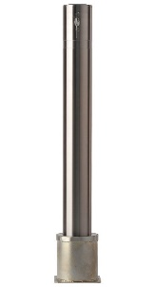Weight: 26 lbs. (11.8 kg)

Design: Fixed cylinder with flat top.

Material: [Coated] Stainless Steel:

Pipe: ASTM A312, Grade TP 316.

Plate: ASTM A959, Grade TP 316.

Country of Origin: China.

If coating is required, retain “Coated” above and Color Coating requirement below.

Color Coating:

Type: Polyester powder coat over epoxy primer.

Color: [Black textured semi gloss] [Dark green] [Statuary bronze] [Bengal silver] [Anodized silver] [Safety yellow].

Installation:

Removable, new concrete, receiver with key

Removable, existing concrete, receiver with key

* + - 1. RETRACTABLE BOLLARD SET
         1. 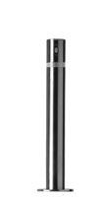Bollard [Designer’s Designation]:

See R-8460 and R-8464 for alternative mountings: http://www.reliance-foundry.com/bollard/retractable-bollards

If coating is required, retain “RA” below.

Model: Reliance Foundry; **R-8471**[**-RA**].

Height: 35.5 inches (90.2 cm)

Diameter: 4.5 inches (11.4 cm) body; 8.7 inches (22 cm) base

Weight: 25 lbs. (11.3 kg)

Design: Retractable cylinder with flat top.

Lock: Extended Only

Material: [Coated] Stainless Steel:

Pipe: ASTM A312, Grade TP 316.

Plate: ASTM A959, GradeTP 316.

Country of Origin: China.

If coating is required, retain “Coated” above and Color Coating requirement below.

Color Coating:

Type: Polyester powder coat over epoxy primer.

Color: [Black textured semi gloss] [Dark green] [Statuary bronze] [Bengal silver] [Anodized silver] [Safety yellow].

Installation:

Retractable, New Concrete:

Receiver

Locking: In raised position.

Footing: [3000 psi minimum concrete or mortar.] [[Concrete] [Mortar] as specified in Section [__ __ __].]

Fill: [Aggregate.] [Aggregate as specified in Section [__ __ __].]

Retractable, Existing Concrete:

Receiver

Locking: In raised position.

Footing: [3000 psi minimum concrete or mortar.] [[Concrete] [Mortar] as specified in Section [__ __ __].]

Fill: [Aggregate.] [Aggregate as specified in Section [__ __ __].]

* + - * 1. Bollard [Designer’s Designation]:

See R-8460 and R-8464 for alternative mountings: http://www.reliance-foundry.com/bollard/retractable-bollards

If coating is required, retain “RA” below.

Model: Reliance Foundry; **R-8472**[**-RA**].

Height: 35.5 inches (90.2 cm)

Diameter: 4.5 inches (11.4 cm) body; 8.7 inches (22 cm) base

Weight: 24 lbs. (10.9 kg)

Design: Retractable cylinder with flat top.

Lock: extended and lowered

Material: [Coated] Stainless Steel:

Pipe: ASTM A312, Grade TP 316.

Plate: ASTM A959, GradeTP 316.

Country of Origin: China.

If coating is required, retain “Coated” above and Color Coating requirement below.

Color Coating:

Type: Polyester powder coat over epoxy primer.

Color: [Black textured semi gloss] [Dark green] [Statuary bronze] [Bengal silver] [Anodized silver] [Safety yellow].

Installation:

Retractable, New Concrete:

Receiver

Locking: In raised position.

Footing: [3000 psi minimum concrete or mortar.] [[Concrete] [Mortar] as specified in Section [__ __ __].]

Fill: [Aggregate.] [Aggregate as specified in Section [__ __ __].]

Retractable, Existing Concrete:

Receiver

Locking: In raised position.

Footing: [3000 psi minimum concrete or mortar.] [[Concrete] [Mortar] as specified in Section [__ __ __].]

Fill: [Aggregate.] [Aggregate as specified in Section [__ __ __].]

* + - * 1. 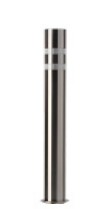Bollard [Designer’s Designation]:

If coating is required, retain “RA” below.

Model: Reliance Foundry; **R-8460** [**-RA**].

Height: 35.5 inches (90.2 cm)

Diameter: 4.5 inches (11.4 cm)

Weight: 21 lbs. (9.5 kg)

Design: Fixed cylinder with flat top.

Material: [Coated] Stainless Steel:

Pipe: ASTM A312, Grade TP 316.

Plate: ASTM A959, Grade TP 316.

Country of Origin: China.

If coating is required, retain “Coated” above and Color Coating requirement below.

Color Coating:

Type: Polyester powder coat over epoxy primer.

Color: [Black textured semi gloss] [Dark green] [Statuary bronze] [Bengal silver] [Anodized silver] [Safety yellow].

Installation:

Fixed, New Concrete, Embedded.

* + - 1. COLLAPSIBLE BOLLARDS

Most collapsible bollards are also available with fixed or removable mountings

* + - * 1. Bollard [Designer’s Designation]:

See R-7905, R-7903, and R-7903 RSA for complementary bike parking bollards http://www.reliance-foundry.com/bollard/bike-parking-bollards

Model: Reliance Foundry; **R-7901**.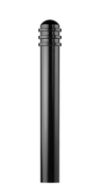

Height: 36 inches (91.4 cm)

Diameter: 4.33 inches (11 cm) body; 4.33 inches (11 cm) base

Weight: 33 lbs. (15 kg)

Design: Cylindrical with segmented rings and rounded top.

Material: Steel: ASTM A36; 25 percent recycled-material content.

Country of Origin: China.

Color Coating:

Type: Polyester powder coat over epoxy primer.

Color: [Black textured semi gloss] [Dark green] [Statuary bronze] [Bengal silver] [Anodized silver] [Safety yellow].

Reflective Stripe: [White] [Yellow] [Blue] [None].

Installation:

Fixed, new concrete, embedded.

Fixed, existing concrete, flange, surface mount.

Removable, new concrete, receiver.

[Steel] [Stainless Steel] receiver with lid.

[Steel] [Stainless Steel] receiver with chain.

Removable, existing concrete, receiver.

[Steel] [Stainless Steel] receiver with lid

[Steel] [Stainless Steel] receiver with chain

Collapsible, steel surface-mount with hinged receiver and padlock hasp.

* + - * 1. 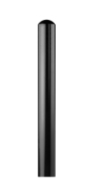Bollard [Designer’s Designation]:

See R-7906, R-7904, and R-7904-RSA for complementary bike parking bollards http://www.reliance-foundry.com/bollard/bike-parking-bollards

Model: Reliance Foundry; **R-7902**.

Height: 36 inches (91.4 cm)

Diameter: 4.33 inches (11 cm) body; 4.33 inches (11 cm) base

Weight: 31 lbs. (15 kg)

Design: Cylindrical with rounded top.

Material: Steel: ASTM A36; 25 percent recycled-material content.

Country of Origin: China.

Color Coating:

Type: Polyester powder coat over epoxy primer.

Color: [Black textured semi gloss] [Dark green] [Statuary bronze] [Bengal silver] [Anodized silver] [Safety yellow].

Reflective Stripe: [White][Yellow][Blue][None].

Installation:

Fixed, new concrete, embedded.

Fixed, existing concrete, flange, surface mount.

Removable, new concrete, receiver.

[Steel] [Stainless Steel] receiver with lid.

[Steel] [Stainless Steel] receiver with chain.

Removable, existing concrete, receiver.

[Steel] [Stainless Steel] receiver with lid

[Steel] [Stainless Steel] receiver with chain.

Collapsible, steel surface-mount with hinged receiver and padlock hasp.

* + - * 1. 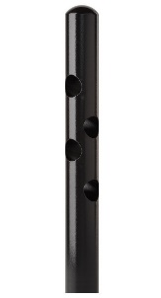Bollard [Designer’s Designation]:

See R-7906, R-7904, and R-7904-RSA for complementary bike parking bollards http://www.reliance-foundry.com/bollard/bike-parking-bollards

Model: Reliance Foundry; **R-7972**.

Height: 36 inches (91.4 cm)

Diameter: 4.33 inches (11 cm) body; 4.33 inches (11 cm) base

Weight: 32 lbs. (14.5 kg)

Design: Cylindrical with rounded top.

Material: Steel: ASTM A36; 25 percent recycled-material content.

Country of Origin: China.

Color Coating:

Type: Polyester powder coat over epoxy primer.

Color: [Black textured semi gloss] [Dark green] [Statuary bronze] [Bengal silver] [Anodized silver] [Safety yellow].

Reflective Stripe: [White][Yellow][Blue][None].

Installation:

Fixed, new concrete, embedded.

Fixed, existing concrete, flange, surface mount.

Removable, new concrete, receiver.

[Steel] [Stainless Steel] receiver with lid.

[Steel] [Stainless Steel] receiver with chain.

Removable, existing concrete, receiver.

[Steel] [Stainless Steel] receiver with lid

[Steel] [Stainless Steel] receiver with chain

Collapsible, steel surface-mount with hinged receiver and padlock hasp.

* + - * 1. 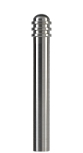Bollard [Designer’s Designation]:

See R-8903 for complementary bike parking bollard http://www.reliance-foundry.com/bollard/bike-parking-bollards

Model: Reliance Foundry; **R-8901**.

Height: 36 inches (91.4 cm)

Diameter: 4.33 inches (11 cm) body; 4.33 inches (11 cm) base

Weight: 34 lbs. (15.4 kg)

Design: Cylindrical with segmented rings and rounded top.

Material: Stainless steel, ASTM A312, Grade TP 316.

Country of Origin: China.

Color coating over stainless is available at additional cost for this bollard. Delete if not required.

Color Coating:

Type: Polyester powder coat over epoxy primer.

Color: [Black textured semi gloss] [Dark green] [Statuary bronze] [Bengal silver] [Anodized silver] [Safety yellow].

Reflective Stripe: [White][Yellow][Blue][None].

Installation:

Fixed, new concrete, anchor.

Fixed, existing concrete, insert.

Removable, new concrete, receiver.

[Steel] [Stainless Steel] receiver with lid.

[Steel] [Stainless Steel] receiver with chain.

Removable, existing concrete, receiver.

[Steel] [Stainless Steel] receiver with lid

[Steel] [Stainless Steel] receiver with chain

Collapsible, steel surface-mount with hinged receiver and padlock hasp.

* + - * 1. 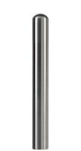Bollard [Designer’s Designation]:

See R-8904 for complementary bike parking bollard http://www.reliance-foundry.com/bollard/bike-parking-bollards

Model: Reliance Foundry; **R-8902**.

Height: 36 inches (91.4 cm)

Diameter: 4.33 inches (11 cm) body; 4.33 inches (11 cm) base

Weight: 32 lbs. (14.5 kg)

Design: Cylindrical with rounded top.

Material: Stainless steel, ASTM A312, Grade TP 316.

Country of Origin: China.

Color coating over stainless is available at additional cost for this bollard. Delete if not required.

Color Coating:

Type: Polyester powder coat over epoxy primer.

Color: [Black textured semi gloss] [Dark green] [Statuary bronze] [Bengal silver] [Anodized silver] [Safety yellow].

Reflective Stripe: [White][Yellow][Blue][None].

Installation:

Fixed, new concrete, anchor.

Fixed, existing concrete, insert.

Removable, new concrete, receiver.

[Steel] [Stainless Steel] receiver with lid.

[Steel] [Stainless Steel] receiver with chain.

Removable, existing concrete, receiver.

[Steel] [Stainless Steel] receiver with lid

[Steel] [Stainless Steel] receiver with chain

Collapsible, steel surface-mount with hinged receiver and padlock hasp.

* + - * 1. 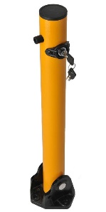Bollard [Designer’s Designation]:

Model: Reliance Foundry; **R-8430**.

Height: 24.5 inches (62.2 cm)

Diameter: 2.5 inches (6.3 cm) body; 5 inches (12.7 cm) base

Weight: 12 lbs. (5.4 kg)

Design: Cylindrical with built-in mounting hardware and internal locking mechanism.

Material: Steel: ASTM A36; 25 percent recycled-material content.

Country of Origin: China.

Powder Coating: Safety yellow

Installation: Collapsible, hinged surface mount.

* + - 1. ACCESSORIES

Retain following if specified bollards require security posts.

Retain padlock for removable bollards with padlock hasps and for chains with padlocks.

* + - * 1. Padlock: [Brass] [Marine Grade], supplied [supplied by bollard manufacturer] [as specified in Section [__ __ __]]. [Key alike.]
        2. Security Post: Steel pipe, ASTM A500, Grade B.

Manufacturer: Reliance Foundry Co. Ltd.

Country of Origin: United States.

Finish: [Red][Grey] primer.

Installation: Direct embed.

Footing and Fill: Concrete or mortar, [3000 psi minimum.]

1. EXECUTION
   * + 1. EXAMINATION
          1. Examine paving or other substrates for compliance with manufacturer’s requirements for placement and location of embedded items, condition of substrate, and other conditions affecting installation of bollards.
          2. Proceed with installation only after unsatisfactory conditions have been corrected.
       2. INSTALLATION
          1. General: Comply with manufacturer’s installation instructions and setting drawings.
          2. Do not install damaged, cracked, chipped, deformed or marred bollards. Field touch-up minor imperfections in accordance with manufacturer’s instructions. Replace bollards that cannot be field repaired.
       3. CLEANING & PROTECTION

Normal cleaning may be done with clean water and a soft cloth. Detailed cleaning and inspection instructions are available at [www.reliance-foundry.com/bollard/maintenance-bollards](http://www.reliance-foundry.com/bollard/maintenance-bollards).

* + - * 1. Protect bollards against damage.
        2. Immediately prior to Substantial Completion, clean bollards in accordance with manufacturer’s instructions to remove dust, dirt, adhesives, and other foreign materials.
        3. Touch up damaged finishes according to manufacturer’s instructions.
      1. CLOSEOUT ACTIVITIES
         1. Provide executed warranty

**SECTION 34 71 19.16**

**FLEXIBLE VEHICLE DELINEATORS**

FLEXIBLE BOLLARDS

1. GENERAL
   * + 1. SUMMARY
          1. Section Includes:

Flexible bollards.

Accessories.

[_________________]

Edit following to coordinate with other specification sections in project.

* + - * 1. Related Requirements:

[Division 03 Sections: [Concrete] [Mortar] fill for security posts.]

[Division 08 Sections: Padlocks.]

[_________________]

* + - 1. SUBMITTALS
         1. Comply with Section [01 33 00 – Submittal Procedures.] [_________.]
         2. Product Data: Provide for each type of bollard, component, finish, and accessory specified.
         3. Color Samples: [Submit manufacturer’s standard colors for selection.] [Submit sample of color specified.]
         4. Setting Drawings: Show embedded items and cutouts required for work specified in other Sections.
         5. Maintenance Data: Submit manufacturer’s field touch-up, cleaning, and maintenance instructions.
         6. Warranty Documentation: Submit sample of manufacturer’s warranty.
      2. QUALITY ASSURANCE
         1. Comply with Section [01 43 00 – Quality Assurance.] [_________.]
      3. DELIVERY, STORAGE AND HANDLING
         1. Comply with Section [01 66 00 – Product Storage and Handling Requirements.] [_________.]
         2. Protect bollards and accessories during delivery, storage, and handling.
      4. WARRANTY
         1. Comply with Section [01 78 36 – Warranties.] [_________.]
         2. Provide manufacturer’s standard warranty against defects in materials and workmanship.

Warranty Period: Five years from date of invoice, except as otherwise indicated.

1. PRODUCTS
   * + 1. MANUFACTURERS
          1. Manufacturer: Reliance Foundry Co. Ltd.

Phone: 604-547-0460 or 1-877-789-3245

Fax: 604-590-8875

Website: <http://www.reliance-foundry.com/bollard>

Email: [info@reliance-foundry.com](mailto:info@reliance-foundry.com)

* + - * 1. Substitutions: [Comply with provisions of [Section 01 25 00 "Substitution Procedures"] [_________] for substitution procedures.] [Not allowed.]
      1. FLEXIBLE BOLLARDS
         1. Flexible Bollards, General:

Material: Polyurethane.

Thermal stability: Good +/- 10 SHORE D.

Working Temperature: -40ºC / + 60 ºC.

Fire resistance: CLASS E. As per UNE-EN-ISO 11925-2:2002

Performance Requirements:

Impact resistance: Test of 50 impacts, bending the bollard through 90º, simulating a 1500kg vehicles at 15km/h.

Fatigue resistance: Test of 500 impacts, bending the bollard through 45º, at intervals of 30 seconds.

* + - * 1. 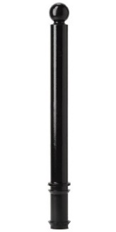Flexible Bollard [Designer’s Designation]:

Model: Reliance Foundry; **R-8301**

Height: 31.5 inches (80 cm)

Diameter: 3 inches (7.6 cm) body; 3 inches (7.6 cm) base

Weight: 8 lbs. (3.6 kg)

Design: Cylindrical with ball top.

Country of Origin: Spain.

Color: [Traffic Yellow] [Traffic Orange] [Traffic Red] [Night Blue] [Turquoise Green] [ Stone Gray] [Chocolate Brown] [Jet Black].

Reflective Tape: [Red] [White] [Yellow] [None].

Installation:

Fixed, new concrete, embedded.

Removable, 80 mm [light duty] [heavy duty] receiver.

* + - * 1. 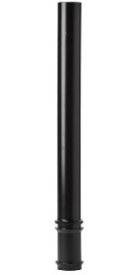Flexible Bollard [Designer’s Designation]:

Model: Reliance Foundry; **R-8302.**

Height: 35.4 inches (90 cm)

Diameter: 3.9 inches (10 cm) body; 3.9 inches (10 cm) base

Weight: 8 lbs. (3.6 kg)

Design: Cylindrical with flat top.

Country of Origin: Spain.

Color: [Traffic Yellow] [Traffic Orange] [Traffic Red] [Night Blue] [Turquoise Green] [ Stone Gray] [Chocolate Brown] [Jet Black].

Reflective Tape: [Red] [White] [Yellow] [None].

Installation:

Fixed, new concrete, embedded.

Removable, 100 mm [light duty] [heavy duty] receiver.

* + - * 1. Flexible Bollard [Designer’s Designation]:

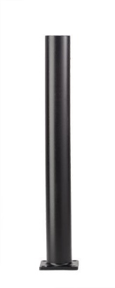Model: Reliance Foundry; **R-8302-FL**

Height: 35.8 inches (91 cm)

Diameter: 3.9 inches (10 cm) body; 3.9 inches (10 cm) base

Weight: 8 lbs. (3.6 kg)

Design: Cylindrical with flat top.

Country of Origin: Spain.

Color: [Traffic Yellow] [Traffic Orange] [Traffic Red] [Night Blue] [Turquoise Green] [ Stone Gray] [Chocolate Brown] [Jet Black].

Reflective Tape: [Red] [White] [Yellow] [None].

Installation:

Fixed, flanged surface mount.

* + - * 1. 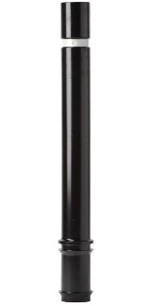Flexible Bollard [Designer’s Designation]:

Model: Reliance Foundry; **R-8303.**

Height: 31.5 inches (80 cm)

Diameter: 3.9 inches (10 cm) body; 3.9 inches (10 cm) base

Weight: 8 lbs. (3.6 kg)

Design: Cylindrical with flat top.

Country of Origin: Spain.

Color: [Traffic Yellow] [Traffic Orange] [Traffic Red] [Night Blue] [Turquoise Green] [ Stone Gray] [Chocolate Brown] [Jet Black].

Reflective Tape: [Red] [White] [Yellow] [None].

Installation:

Fixed, new concrete, embedded.

Removable, 100 mm [light duty] [heavy duty] receiver.

* + - * 1. 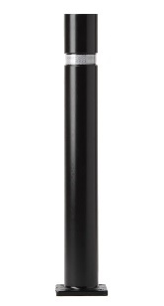Flexible Bollard [Designer’s Designation]:

Model: Reliance Foundry; **R-8303-FL**

Height: 31.5 inches (80 cm)

Diameter: 3.9 inches (10 cm) body; 3.9 inches (10 cm) base

Weight: 8 lbs. (3.6 kg)

Design: Cylindrical with flat top.

Country of Origin: Spain.

Color: [Traffic Yellow] [Traffic Orange] [Traffic Red] [Night Blue] [Turquoise Green] [ Stone Gray] [Chocolate Brown] [Jet Black].

Reflective Tape: [Red] [White] [Yellow] [None].

Installation:

Fixed, flanged surface mount.

* + - * 1. 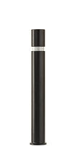Flexible Bollard [Designer’s Designation]:

Model: Reliance Foundry; **R-8303-EX.**

Height: 38.4 inches (97.5 cm)

Diameter: 3.9 inches (10 cm) body; 3.9 inches (10 cm) base

Weight: 10 lbs. (4.5 kg)

Design: Cylindrical with flat top.

Country of Origin: Spain.

Color: [Traffic Yellow] [Traffic Orange] [Traffic Red] [Night Blue] [Turquoise Green] [ Stone Gray] [Chocolate Brown] [Jet Black].

Reflective Tape: [Red] [White] [Yellow] [None].

Installation:

Fixed, new concrete, embedded.

Removable, 100 mm [light duty] [heavy duty] – EX receiver.

* + - 1. Accessories
         1. 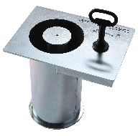Removable mounting receiver: 80 mm light duty

Parts: Receiver and key

Compatible Models: R-8301 flexible bollards

Material: AISI 304 Stainless Steel

Installation: Concrete embed.

* + - * 1. Removable mounting receiver: 80 mm heavy duty

Parts: Receiver and key

Compatible Models: R-8301 flexible bollards

Material: Galvanized Steel and AISI 304 Stainless Steel

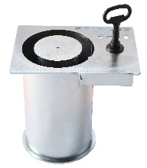Installation: Concrete embed.

* + - * 1. Removable mounting receiver: 100 mm light duty

Parts: Receiver and key

Compatible Models: R-8302 and R-8303 flexible bollards

Material: AISI 304 Stainless Steel

Installation: Concrete embed.

* + - * 1. Removable mounting receiver: 100 mm light duty – EX

Parts: Receiver and key

Compatible Models: R-8303-EX flexible bollards

Material: AISI 304 Stainless Steel

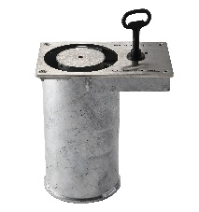Installation: Concrete embed.

* + - * 1. Removable mounting receiver: 100 mm heavy duty

Parts: Receiver and key

Compatible Models: R-8302 and R-8303 flexible bollards

Material: Galvanized Steel and AISI 304 Stainless Steel

Installation: Concrete embed.

* + - * 1. Removable mounting receiver: 100 mm heavy duty – EX

Parts: Receiver and key

Compatible Models: R-8303-EX flexible bollards

Material: Galvanized Steel and AISI 304 Stainless Steel

Installation: Concrete embed.

1. EXECUTION
   * + 1. EXAMINATION
          1. Examine paving or other substrates for compliance with manufacturer’s requirements for placement and location of embedded items, condition of substrate, and other conditions affecting installation of bollards.
          2. Proceed with installation only after unsatisfactory conditions have been corrected.
       2. INSTALLATION
          1. General: Comply with manufacturer’s installation instructions and setting drawings.
          2. Do not install damaged, cracked, chipped, deformed or marred bollards. Field touch-up minor imperfections in accordance with manufacturer’s instructions. Replace bollards that cannot be field repaired.
       3. CLEANING & PROTECTION

Normal cleaning may be done with clean water and a soft cloth. Detailed cleaning and inspection instructions are available at [www.reliance-foundry.com/bollard/maintenance-bollards](http://www.reliance-foundry.com/bollard/maintenance-bollards).

* + - * 1. Protect bollards against damage.
        2. Immediately prior to Substantial Completion, clean bollards in accordance with manufacturer’s instructions to remove dust, dirt, adhesives, and other foreign materials.
        3. Touch up damaged finishes according to manufacturer’s instructions.
      1. CLOSEOUT ACTIVITIES
         1. Provide executed warranty.

**SECTION 32 39 13.21**

**SURFACE MOUNT METAL BOLLARDS**

1. GENERAL
   * + 1. SUMMARY
          1. Section Includes:

Surface mount metal bollards.

Accessories

[_________________]

Edit following to coordinate with other specification sections in project.

* + - * 1. Related Requirements:

[Division 03 Sections: [Concrete] [Mortar] fill for security posts.]

[Division 08 Sections: Padlocks.]

[_________________]

Edit below to include only reference standards used in project.

* + - 1. REFERENCE STANDARDS
         1. ASTM A36 – Standard Specification for Carbon Structural Steel.
         2. ASTM A312 – Standard Specification for Seamless, Welded, and Heavily Cold Worked Austenitic Stainless Steel Pipes.
         3. ASTM A500 – Standard Specification for Cold-Formed Welded and Seamless Carbon Steel Structural Tubing in Rounds and Shapes.
         4. ASTM A536 – Standard Specification for Ductile Iron Castings.
         5. ASTM B26 – Standard Specification for Aluminum-Alloy Sand Castings.
      2. SUBMITTALS
         1. Comply with Section [01 33 00 – Submittal Procedures.] [_________.]
         2. Product Data: Provide for each type of bollard, component, finish, and accessory specified.
         3. Color Samples: [Submit manufacturer’s standard colors for selection.] [Submit sample of color specified.]
         4. Setting Drawings: Show embedded items and cutouts required for work specified in other Sections.
         5. Maintenance Data: Submit manufacturer’s field touch-up, cleaning, and maintenance instructions.
         6. Warranty Documentation: Submit sample of manufacturer’s warranty.
      3. QUALITY ASSURANCE
         1. Comply with Section [01 43 00 – Quality Assurance.] [_________.]
      4. DELIVERY, STORAGE AND HANDLING
         1. Comply with Section [01 66 00 – Product Storage and Handling Requirements.] [_________.]
         2. Protect bollards and accessories during delivery, storage, and handling.
      5. WARRANTY
         1. Comply with Section [01 78 36 – Warranties.] [_________.]
         2. Provide manufacturer’s standard warranty against defects in materials and workmanship.

Warranty Period: Five years from date of invoice, except as otherwise indicated.

Coatings: Two years, against peeling, cracking, or significant color change.

Solar-Powered Lighting System: Three years.

1. PRODUCTS
   * + 1. MANUFACTURERS
          1. Manufacturer: Reliance Foundry Co. Ltd.

Phone: 604-547-0460 or 1-877-789-3245

Fax: 604-590-8875

Website: <http://www.reliance-foundry.com/bollard>

Email: [info@reliance-foundry.com](mailto:info@reliance-foundry.com)

* + - * 1. Substitutions: [Comply with provisions of [Section 01 25 00 "Substitution Procedures"] [_________] for substitution procedures.] [Not allowed.]
      1. SURFACE MOUNT METAL BOLLARDS

Surface mount is also available for select solar powered light bollards and flexible polyurethane bollards

See <http://www.reliance-foundry.com/bollard/flexible-bendable> and <http://www.reliance-foundry.com/bollard/solar-lighting> to view models.

* + - * 1. 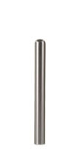Bollard [Designer’s Designation]:

Model: Reliance Foundry; **R-7180**.

Height: 24 inches (61 cm).

Diameter: 4 inches (10 cm) body; 4 inches (10 cm) base.

Weight: 14 lbs. (6.4 kg).

Design: Cylinder with rounded top.

Material: Stainless steel, ASTM A312, Grade TP 304.

Country of Origin: Vietnam.

Clear Coat: Water-resistant and anti-graffiti.

Installation: Fixed, 2-bolt threaded mount.

* + - * 1. 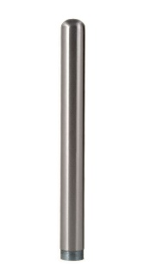Bollard [Designer’s Designation]:

Model: Reliance Foundry; **R-7181**.

Height: 32 inches (81.3 cm).

Diameter: 4 inches (10 cm) body; 4 inches (10 cm) base.

Weight: 17 lbs (7.7 kg).

Design: Cylinder with rounded top.

Material: Stainless steel, ASTM A312, Grade TP 304.

Country of Origin: Vietnam.

Clear Coat: Water-resistant and anti-graffiti.

Installation: Fixed, 2-bolt threaded mount.

* + - * 1. 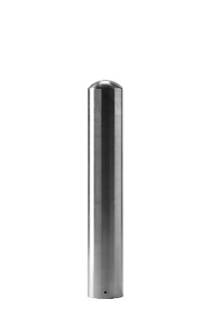Bollard [Designer’s Designation]:

Model: Reliance Foundry; **R-7182**.

Height: 24 inches (61 cm).

Diameter: 4 inches (10 cm) body; 4 inches (10 cm) base.

Weight: 12 lbs (5.4 kg).

Design: Cylinder with rounded top.

Material: Stainless steel AISI 316.

Country of Origin: China.

Clear Coat: Water-resistant and anti-graffiti.

Installation: drop-in anchor with bolt-down mounting collar

* + - * 1. 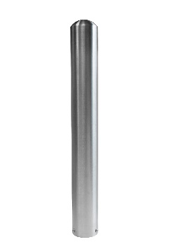Bollard [Designer’s Designation]:

Model: Reliance Foundry; **R-7183**.

Height: Height: 32 inches (81.3 cm).

Diameter: 4 inches (10 cm) body; 4 inches (10 cm) base.

Weight: 15 lbs (6.8 kg).

Design: Cylinder with rounded top.

Material: Stainless steel AISI 316.

Country of Origin: China.

Clear Coat: Water-resistant and anti-graffiti.

Installation: drop-in anchor with bolt-down mounting collar

* + - * 1. 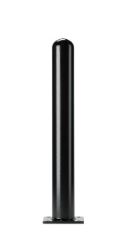 Bollard [Designer’s Designation]:

Model: Reliance Foundry; **R-7236**.

Height: 36 inches (91 cm)

Diameter: 4.5 inches (11.4 cm) body; 8 inches (20.3 cm) base.

Weight: 42 lbs. (19 kg).

Design: Cylinder with rounded top and square base flange.

Material: Steel, ASTM A36; 25 percent recycled-material content.

Country of Origin: China.

Color Coating:

Type: Polyester powder coat over epoxy primer.

Color: [Black textured semi gloss.] [Dark green.] [Statuary bronze.] [Bengal silver.] [Anodized silver.] [Safety yellow.]

Installation: Fixed, flanged surface mount.

* + - * 1. 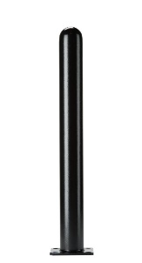Bollard [Designer’s Designation]:

Model: Reliance Foundry; **R-7242**.

Height: 42 inches (106.5 cm).

Diameter: 4.5 inches (11.4 cm) body; 8 inches (20.3 cm) base

Weight: 45 lbs. (20.4 kg).

Design: Cylinder with rounded top and square base flange.

Material: Steel, ASTM A36; 25 percent recycled-material content.

Country of Origin: China.

Color Coating:

Type: Polyester powder coat over epoxy primer.

Color: [Black textured semi gloss.] [Dark green.]

[Statuary bronze.] [Bengal silver.] [Anodized silver.] [Safety yellow.]

Installation: Fixed, flanged surface mount.

* + - * 1. 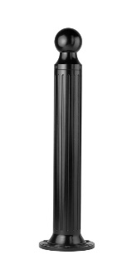Bollard [Designer’s Designation]:

Retain -AL for aluminum. Delete if not required.

Model: Reliance Foundry; **R-7530 [-AL]**.

Height: 39 inches (99 cm)

Diameter: 5 inches (12.7 cm) body; 10 inches (25.4 cm) base

Design: Cylindrical and fluted, with tapered bottom and ball top.

Retain aluminum or cast iron to coordinate with model number.

Material:

Aluminum: ASTM B26; 20 percent recycled-material content.

Weight: 24 lbs. (11 kg)

Ductile Cast Iron: ASTM A536, Grade 65-45-12; 30 percent recycled-material content.

Weight: 62 lbs. (28.1 kg)

Country of Origin: China.

Color Coating:

Type: Polyester powder coat over epoxy primer.

Color: [Black textured semi gloss.] [Dark green.] [Statuary bronze.] [Bengal silver.] [Anodized silver.] [Safety yellow.]

Installation:

Fixed, new concrete, anchor.

Fixed, existing concrete, insert.

Fixed, existing concrete, adhesive.

Fixed, flanged surface mount.

Security post cover, new post.

Security post cover, existing post, insert.

Security post cover, existing post, adhesive.

Security post cover, existing post, concrete anchor.

Removable, new concrete, anchor

Removable, existing concrete, insert.

* + - * 1. Bollard [Designer’s Designation]:

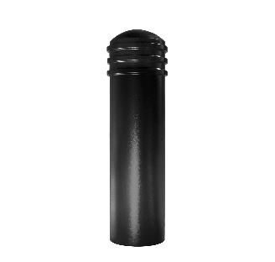Model: Reliance Foundry; **R-7743-FL**

Height: 44 inches (111.8 cm)

Diameter: 11.75 inches (29.8 cm) body; 17 inches (43 cm) base

Weight: 170 lbs. (77 kg)

Design: Cylindrical with segmented rings and rounded top

Material: Steel body with ductile iron cap

Country of Origin: China

Color Coating:

Type: Polyester powder coat over epoxy primer.

Color: [Black textured semi gloss.] [Dark green.] [Statuary bronze.] [Bengal silver.] [Anodized silver.] [Safety yellow.]

Installation:

Fixed, new concrete, anchor.

Fixed, existing concrete, insert.

Fixed, existing concrete, adhesive.

Fixed, new concrete, concrete form.

Bolt-down, flanged

Security post cover, new post.

Security post cover, existing post, insert.

Security post cover, existing post, adhesive

* + - * 1. Bollard [Designer’s Designation]:

See R-7905, R-7903, and R-7903 RSA for complementary bike parking bollards http://www.reliance-foundry.com/bollard/bike-parking-bollards

Model: Reliance Foundry; **R-7901**.

Height: 36 inches (91.4 cm)

Diameter: 4.33 inches (11 cm) body; 4.33 inches (11 cm) base

Weight: 33 lbs. (15 kg)

Design: Cylindrical with segmented rings and rounded top.

Material: Steel: ASTM A36; 25 percent recycled-material content.

Country of Origin: China.

Color Coating:

Type: Polyester powder coat over epoxy primer.

Color: [Black textured semi gloss.] [Dark green.] [Statuary bronze.] [Bengal silver.] [Anodized silver.] [Safety yellow.]

Reflective Stripe: [White][Yellow][Blue][None].

Installation:

Fixed, new concrete, embedded.

Fixed, existing concrete, flanged surface mount.

Removable, new concrete, removable mount with hinged lid, std.

Removable, new concrete, removable mount with hinged lid, premium.

Removable, new concrete, embedded receiver with chains, std.

Removable, new concrete, embedded receiver with chains, premium.

Fold down, powder coated.

Fold down, galvanized.

* + - * 1. Bollard [Designer’s Designation]:

See R-7906, R-7904, and R-7904-RSA for complementary bike parking bollards http://www.reliance-foundry.com/bollard/bike-parking-bollards

Model: Reliance Foundry; **R-7902**.

Height: 36 inches (91.4 cm)

Diameter: 4.33 inches (11 cm) body; 4.33 inches (11 cm) base

Weight: 31 lbs. (14 kg)

Design: Cylindrical with rounded top.

Material: Steel: ASTM A36; 25 percent recycled-material content.

Country of Origin: China.

Color Coating:

Type: Polyester powder coat over epoxy primer.

Color: [Black textured semi gloss.] [Dark green.] [Statuary bronze.] [Bengal silver.] [Anodized silver.] [Safety yellow.]

Reflective Stripe: [White][Yellow][Blue][None].

Installation:

Fixed, new concrete, embedded.

Fixed, existing concrete, flanged surface mount.

Removable, new concrete, removable mount with hinged lid, std.

Removable, new concrete, removable mount with hinged lid, premium.

Removable, new concrete, embedded receiver with chains, std.

Removable, new concrete, embedded receiver with chains, premium.

Fold down, powder coated.

Fold down, galvanized.

* + - * 1. Bollard [Designer’s Designation]:

See R-7906, R-7904, and R-7904-RSA for complementary bike parking bollards http://www.reliance-foundry.com/bollard/bike-parking-bollards

Model: Reliance Foundry; **R-7972**.

Height: 36 inches (91.4 cm)

Diameter: 4.33 inches (11 cm) body; 4.33 inches (11 cm) base

Weight: 32 lbs. (14.5 kg)

Design: Cylindrical with rounded top.

Material: Steel: ASTM A36; 25 percent recycled-material content.

Country of Origin: China.

Color Coating:

Type: Polyester powder coat over epoxy primer.

Color: [Black textured semi gloss.] [Dark green.] [Statuary bronze.] [Bengal silver.] [Anodized silver.] [Safety yellow.]

Reflective Stripe: [White][Yellow][Blue][None].

Installation:

Fixed, new concrete, embedded.

Fixed, existing concrete, flanged surface mount.

Removable, new concrete, removable mount with hinged lid, std.

Removable, new concrete, removable mount with hinged lid, premium.

Removable, new concrete, embedded receiver with chains, std.

Removable, new concrete, embedded receiver with chains, premium.

Fold down, powder coated.

Fold down, galvanized.

* + - * 1. Bollard [Designer’s Designation]:

Model: Reliance Foundry; **R-8430**.

Height: 24.5 inches (62.2 cm)

Diameter: 2.5 inches (6.3 cm) body; 5 inches (12.7 cm) base

Weight: 12 lbs. (5.4 kg)

Design: Cylindrical with built-in mounting hardware and internal locking mechanism.

Material: Steel: ASTM A36; 25 percent recycled-material content.

Country of Origin: China.

Powder Coating: [Safety yellow.]

Installation: Collapsible, hinged surface mount.

* + - * 1. Bollard [Designer’s Designation]:

See R-8903 for complementary bike parking bollard http://www.reliance-foundry.com/bollard/bike-parking-bollards

Model: Reliance Foundry; **R-8901**.

Height: 36 inches (91.4 cm)

Diameter: 4.33 inches (11 cm) body; 4.33 inches (11 cm) base

Weight: 34 lbs. (15.4 kg)

Design: Cylindrical with segmented rings and rounded top.

Material: Stainless steel, ASTM A312, Grade TP 316.

Country of Origin: China.

Color coating over stainless is available at additional cost for this bollard. Delete if not required.

Color Coating:

Type: Polyester powder coat over epoxy primer.

Color: [Black textured semi gloss.] [Dark green.] [Statuary bronze.] [Bengal silver.] [Anodized silver.] [Safety yellow.]

Reflective Stripe: [White][Yellow][Blue][None].

Installation:

Fixed, new concrete, embedded.

Fixed, existing concrete, flanged surface mount.

Removable, new concrete, removable mount with hinged lid, std.

Removable, new concrete, removable mount with hinged lid, premium.

Removable, new concrete, embedded receiver with chains, std.

Removable, new concrete, embedded receiver with chains, premium.

Fold down, powder coated.

Fold down, galvanized.

* + - * 1. Bollard [Designer’s Designation]:

See R-8904 for complementary bike parking bollard http://www.reliance-foundry.com/bollard/bike-parking-bollards

Model: Reliance Foundry; **R-8902**.

Height: 36 inches (91.4 cm)

Diameter: 4.33 inches (11 cm) body; 4.33 inches (11 cm) base

Weight: 32 lbs. (14.5 kg)

Design: Cylindrical with rounded top.

Material: Stainless steel, ASTM A312, Grade TP 316.

Country of Origin: China.

Color coating over stainless is available at additional cost for this bollard. Delete if not required.

Color Coating:

Type: Polyester powder coat over epoxy primer.

Color: [Black textured semi gloss.] [Dark green.] [Statuary bronze.] [Bengal silver.] [Anodized silver.] [Safety yellow.]

Reflective Stripe: [White][Yellow][Blue][None].

Installation:

Fixed, new concrete, embedded.

Fixed, existing concrete, flanged surface mount.

Removable, new concrete, removable mount with hinged lid, std.

Removable, new concrete, removable mount with hinged lid, premium.

Removable, new concrete, embedded receiver with chains, std.

Removable, new concrete, embedded receiver with chains, premium.

Fold down, powder coated.

Fold down, galvanized.

* + - 1. ACCESSORIES

Retain following if specified bollards require security posts.

* + - * 1. Security Post: Steel pipe, ASTM A500, Grade B.

Manufacturer: Reliance Foundry Co. Ltd.

Country of Origin: United States.

Finish: [Red][Grey] primer.

Installation:

Direct embed.

Footing and fill; Concrete or mortar, [3000 psi minimum.]

Retain the following for removable bollards with padlock hasps and for chains with padlocks

* + - * 1. Padlock:

[Brass] [Marine Grade], supplied [supplied by bollard manufacturer] [as specified in Section [__ __ __]]. [Key alike.]

Retain following if chains draped between bollards are required. In Drawings, show locations where chain is required, quick-release and padlock locations, and drape of chain.

* + - * 1. Chain:

5/16-inch galvanized steel chain, Grade 30, with quick-release type connections.] Provide sufficient lengths to provide drape [shown on Drawings.] [acceptable to Architect.]

Chain Eye: 5/16-inch diameter steel.

Quick Links: Powder coated chain links with barrel nut closures.

Finish: Powder coated to match bollard finish. [_______________.]

1. EXECUTION
   * + 1. EXAMINATION
          1. Examine paving or other substrates for compliance with manufacturer’s requirements for placement and location of embedded items, condition of substrate, and other conditions affecting installation of bollards.
          2. Proceed with installation only after unsatisfactory conditions have been corrected.
       2. INSTALLATION
          1. General: Comply with manufacturer’s installation instructions and setting drawings.
          2. Do not install damaged, cracked, chipped, deformed or marred bollards. Field touch-up minor imperfections in accordance with manufacturer’s instructions. Replace bollards that cannot be field repaired.
       3. CLEANING & PROTECTION

Normal cleaning may be done with clean water and a soft cloth. Detailed cleaning and inspection instructions are available at [www.reliance-foundry.com/bollard/maintenance-bollards](http://www.reliance-foundry.com/bollard/maintenance-bollards).

* + - * 1. Protect bollards against damage.
        2. Immediately prior to Substantial Completion, clean bollards in accordance with manufacturer’s instructions to remove dust, dirt, adhesives, and other foreign materials.
        3. Touch up damaged finishes according to manufacturer’s instructions.
      1. CLOSEOUT ACTIVITIES
         1. Provide executed warranty.

**SECTION 32 39 13.19**

**DECORATIVE METAL BOLLARDS**

1. GENERAL
   * + 1. SUMMARY
          1. Section Includes:

Metal bollard covers

Decorative metal bollards.

Accessories

[_________________]

Edit following to coordinate with other specification sections in project.

* + - * 1. Related Requirements:

[Division 03 Sections: [Concrete] [Mortar] fill for security posts.]

[Division 08 Sections: Padlocks.]

[_________________]

Edit below to include only reference standards used in project.

* + - 1. REFERENCE STANDARDS
         1. ASTM A36 – Standard Specification for Carbon Structural Steel.
         2. ASTM A312 – Standard Specification for Seamless, Welded, and Heavily Cold Worked Austenitic Stainless Steel Pipes.
         3. ASTM A500 – Standard Specification for Cold-Formed Welded and Seamless Carbon Steel Structural Tubing in Rounds and Shapes.
         4. ASTM A536 – Standard Specification for Ductile Iron Castings.
         5. ASTM B26 – Standard Specification for Aluminum-Alloy Sand Castings.
      2. SUBMITTALS
         1. Comply with Section [01 33 00 – Submittal Procedures.] [_________.]
         2. Product Data: Provide for each type of bollard, component, finish, and accessory specified.
         3. Color Samples: [Submit manufacturer’s standard colors for selection.] [Submit sample of color specified.]
         4. Setting Drawings: Show embedded items and cutouts required for work specified in other Sections.
         5. Maintenance Data: Submit manufacturer’s field touch-up, cleaning, and maintenance instructions.
         6. Warranty Documentation: Submit sample of manufacturer’s warranty.
      3. QUALITY ASSURANCE
         1. Comply with Section [01 43 00 – Quality Assurance.] [_________.]
      4. DELIVERY, STORAGE AND HANDLING
         1. Comply with Section [01 66 00 – Product Storage and Handling Requirements.] [_________.]
         2. Protect bollards and accessories during delivery, storage, and handling.
      5. WARRANTY
         1. Comply with Section [01 78 36 – Warranties.] [_________.]
         2. Provide manufacturer’s standard warranty against defects in materials and workmanship.

Warranty Period: Five years from date of invoice, except as otherwise indicated.

Coatings: Two years, against peeling, cracking, or significant color change.

1. PRODUCTS
   * + 1. MANUFACTURERS
          1. Manufacturer: Reliance Foundry Co. Ltd.

Phone: 604-547-0460 or 1-877-789-3245

Fax: 604-590-8875

Website: <http://www.reliance-foundry.com/bollard>

Email: [info@reliance-foundry.com](mailto:info@reliance-foundry.com)

* + - * 1. Substitutions: [Comply with provisions of [Section 01 25 00 "Substitution Procedures"] [_________] for substitution procedures.] [Not allowed.]
      1. METAL BOLLARD COVERS
         1. 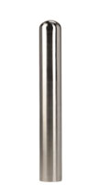Bollard Cover [Designer’s Designation]:

Model: Reliance Foundry; **R-7301**.

Height: 36 inches (91.5 cm)

Diameter: 6.25 inches (16 cm)

Weight: 25 lbs. (11.3 kg)

Max interior post size:

Height: 34 inches (86.4 cm)

Diameter: 4.5 inches (11.5 cm)

Design: Cylindrical bollard cover with rounded top.

Material: Stainless steel: ASTM A312, Grade TP 316.

Country of Origin: China.

Finish: Satin No. 6, buffed.

Color coating over stainless is available at additional cost for this bollard. Delete if not required.

Color Coating:

Type: Polyester powder coat over epoxy primer.

Color: [Black textured semi gloss.] [Dark green.]

[Statuary bronze.] [Bengal silver.] [Anodized silver.] [Safety yellow.]

Installation:

Security post cover, [new][existing] post, set screws

Security post cover, [new][existing] post, adhesive foam

Security post cover, [existing] post, top hangers with adhesive

Security post cover, [new] post, top “J” hangers for new concrete

* + - * 1. 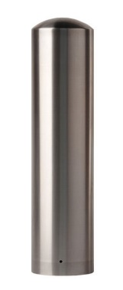Bollard Cover [Designer’s Designation]:

Model: Reliance Foundry; **R-7305**.

Height: 36 inches (91.5 cm)

Diameter: 8.625 inches (22 cm)

Weight: 46 lbs. (21 kg)

Max interior post size:

Height: 34 inches (86.4 cm)

Diameter: 6.625 inches (16.5 cm)

Design: Cylindrical bollard cover with rounded top.

Material: Stainless steel: ASTM A312, Grade TP 316.

Country of Origin: China.

Finish: Satin No. 6, buffed.

Color coating over stainless is available at additional cost for this bollard. Delete if not required.

Color Coating:

Type: Polyester powder coat over epoxy primer.

Color: [Black textured semi gloss.] [Dark green.] [Statuary bronze.]

[Bengal silver.] [Anodized silver.] [Safety yellow.]

Installation:

Security post cover, [new][existing] post, set screws

Security post cover, [new][existing] post, adhesive foam

Security post cover, [existing] post, top hangers with adhesive

Security post cover, [new] post, top “J” hangers for new concrete

* + - * 1. Bollard Cover [Designer’s Designation]:

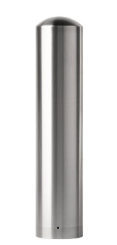Model: Reliance Foundry; **R-7305-EX**.

Height: 40 inches (101.6 cm)

Diameter: 8.625 inches (22 cm)

Weight: 47 lbs. (21.3 kg)

Max interior post size:

Height: 38 inches (96.5 cm)

Diameter: 6.625 inches (16.5 cm)

Design: Cylindrical bollard cover with rounded top.

Material: Stainless steel: ASTM A312, Grade TP 316.

Country of Origin: China.

Finish: Satin No. 6, buffed.

Color coating over stainless is available at additional cost for this bollard. Delete if not required.

Color Coating:

Type: Polyester powder coat over epoxy primer.

Optional Color: [Black textured semi gloss.] [Dark green.] [Statuary bronze.]

[Bengal silver.] [Anodized silver.] [Safety yellow.]

Installation:

Security post cover, [new][existing] post, set screws

Security post cover, [new][existing] post, adhesive foam

Security post cover, [existing] post, top hangers with adhesive

Security post cover, [new] post, top “J” hangers for new concrete

* + - 1. DECORATIVE METAL BOLLARDS

Some models are also available with bike arms. See Bike Parking Bollards: http://www.reliance-foundry.com/bollard/bike-parking-bollards

* + - * 1. 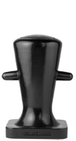Bollard [Designer’s Designation]:

Model: Reliance Foundry; **R-7510**.

Height: 30 inches (76.2 cm)

Diameter: 14.625 inches (37.1 cm) body; 18 inches (45.7 cm) base

Weight: 312 lbs. (141.5 kg)

Design: Marine style.

Material: Ductile Cast Iron: ASTM A536, Grade 65-45-12; 30 percent recycled-material content.

Country of Origin: China.

Color Coating:

Type: Polyester powder coat over epoxy primer.

Color: [Black textured semi gloss.] [Dark green.] [Statuary bronze.]

[Bengal silver.] [Anodized silver.] [Safety yellow.]

Installation:

Fixed, new concrete, anchor.

Fixed, existing concrete, insert.

Fixed, existing concrete, adhesive.

Fixed, new concrete, concrete form.

Security post cover, new post.

Security post cover, existing post, insert.

Security post cover, existing post, adhesive.

Security post cover, existing post, anchor.

* + - * 1. 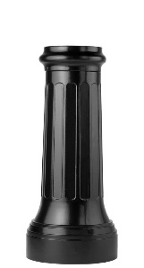Bollard [Designer’s Designation]:

Model: Reliance Foundry; **R-7520**.

Height: 35 inches (89 cm)

Diameter: 10.5 inches (26.7 cm) body; 15.5 inches (39.4 cm) base

Weight: 183 lbs. (83 kg)

Design: Tapered and fluted with a flat top.

Material: Ductile Cast Iron: ASTM A536, Grade 65-45-12; 30 percent recycled-material content.

Country of Origin: China.

Color Coating:

Type: Polyester powder coat over epoxy primer.

Color: [Black textured semi gloss.] [Dark green.] [Statuary bronze.]

[Bengal silver.] [Anodized silver.] [Safety yellow.]

Installation:

Fixed, new concrete, anchor.

Fixed, existing concrete, insert.

Fixed, existing concrete, adhesive.

Fixed, new concrete, concrete form.

Security post cover, new post.

Security post cover, existing post, insert.

Security post cover, existing post, adhesive.

Security post cover, existing post, anchor.

* + - * 1. Bollard [Designer’s Designation]:

Retain -AL for aluminum. Delete if not required.

Model: Reliance Foundry; **R-7530 [-AL]**.

Height: 39 inches (99 cm)

Diameter: 5 inches (12.7 cm) body; 10 inches (25.4 cm) base

Design: Cylindrical and fluted, with tapered bottom and ball top.

Retain aluminum or cast iron to coordinate with model number.

Material:

Aluminum: ASTM B26; 20 percent recycled-material content.

Weight: 24 lbs. (11 kg)

Ductile Cast Iron: ASTM A536, Grade 65-45-12; 30 percent recycled-material content.

Weight: 62 lbs. (28.1 kg)

Country of Origin: China.

Color Coating:

Type: Polyester powder coat over epoxy primer.

Color: [Black textured semi gloss.] [Dark green.] [Statuary bronze.] [Bengal silver.] [Anodized silver.] [Safety yellow.]

Installation:

Fixed, new concrete, anchor.

Fixed, existing concrete, insert.

Fixed, existing concrete, adhesive.

Fixed, new concrete, concrete form.

Fixed, existing concrete, flange and insert.

Security post cover, new post.

Security post cover, existing post, insert.

Security post cover, existing post, adhesive.

Security post cover, existing, anchor.

Removable, new concrete, anchor

Removable, existing concrete, insert.

Removable, new concrete, premium retractable.

* + - * 1. 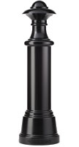Bollard [Designer’s Designation]:

Model: Reliance Foundry; **R-7532**.

Height: 53.75 inches (136.5 cm)

Diameter: 9.5 inches (24 cm) body; 16 inches (40.6 cm) base

Weight: 220 lbs. (99.8 kg)

Design: Cylindrical and non-fluted, with tapered bottom and nautical top.

Material: Ductile Cast Iron: ASTM A536, Grade 65-45-12; 30 percent recycled-material content.

Country of Origin: China.

Color Coating:

Type: Polyester powder coat over epoxy primer.

Color: [Black textured semi gloss.] [Dark green.] [Statuary bronze.] [Bengal silver.] [Anodized silver.] [Safety yellow.]

Installation:

Fixed, new concrete, anchor.

Fixed, existing concrete, insert.

Fixed, existing concrete, adhesive.

Fixed, new concrete, concrete form.

Security post cover, new post.

Security post cover, existing post, insert.

Security post cover, existing post, adhesive.

Security post cover, existing, anchor.

* + - * 1. 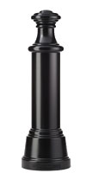Bollard [Designer’s Designation]:

Model: Reliance Foundry; **R-7533**.

Height: 49.75 inches (126.4 cm)

Diameter: 9.5 inches (24 cm) body; 16 inches (40.6 cm) base

Weight: 214 lbs. (97 kg)

Design: Cylindrical and non-fluted, with tapered bottom and flat top.

Material: Ductile Cast Iron: ASTM A536, Grade 65-45-12; 30 percent recycled-material content.

Country of Origin: China.

Color Coating:

Type: Polyester powder coat over epoxy primer.

Color: [Black textured semi gloss.] [Dark green.] [Statuary bronze.] [Bengal silver.] [Anodized silver.] [Safety yellow.]

Installation:

Fixed, new concrete, anchor.

Fixed, existing concrete, insert.

Fixed, existing concrete, adhesive.

Fixed, new concrete, concrete form.

Security post cover, new post.

Security post cover, existing post, insert.

Security post cover, existing post, adhesive.

Security post cover, existing, anchor.

* + - * 1. 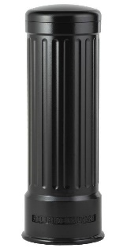 Bollard [Designer’s Designation]:

Model: Reliance Foundry; **R-7535**.

Height: 39 inches (99 cm)

Diameter: 12 inches (30.5 cm) body; 14 inches (35.5 cm) base

Weight: 187 lbs. (84.8 kg)

Design: Cylindrical and fluted, with a rounded top.

Material: Ductile Cast Iron: ASTM A536, Grade 65-45-12; 30 percent recycled-material content.

Country of Origin: China.

Color Coating:

Type: Polyester powder coat over epoxy primer.

Color: [Black textured semi gloss.] [Dark green.] [Statuary bronze.] [Bengal silver.] [Anodized silver.] [Safety yellow.]

Installation:

Fixed, new concrete, anchor.

Fixed, existing concrete, insert.

Fixed, existing concrete, adhesive.

Fixed, new concrete, concrete form.

Security post cover, new post.

Security post cover, existing post, insert.

Security post cover, existing post, adhesive.

Security post cover, existing, anchor.

* + - * 1. 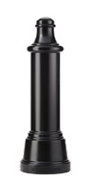Bollard [Designer’s Designation]:

Model: Reliance Foundry; **R-7536**.

Height: 47.5 inches (120.7 cm)

Diameter: 9.5 inches (24 cm) body; 16 inches (40.6 cm) base

Weight: 199 lbs. (90.2 kg)

Design: Cylindrical and non-fluted, with tapered bottom and rounded top.

Material: Ductile Cast Iron: ASTM A536, Grade 65-45-12; 30 percent recycled-material content.

Country of Origin: China.

Color Coating:

Type: Polyester powder coat over epoxy primer.

Color: [Black textured semi gloss.] [Dark green.] [Statuary bronze.] [Bengal silver.] [Anodized silver.] [Safety yellow.]

Installation:

Fixed, new concrete, anchor.

Fixed, existing concrete, insert.

Fixed, existing concrete, adhesive.

Fixed, new concrete, concrete form.

Security post cover, new post.

Security post cover, existing post, insert.

Security post cover, existing post, adhesive.

Security post cover, existing, anchor.

* + - * 1. Bollard [Designer’s Designation]:

Model: Reliance Foundry; **R-7538**.

Height: 35 inches (89 cm)

Diameter: 7.75 inches (19.7 cm) body; 15 inches (38 cm) base

Weight: 118 lbs. (53.5 kg)

Design: Tapered and fluted, with fluted base and nautical-styled top.

Material: Ductile Cast Iron: ASTM A536, Grade 65-45-12; 30 percent recycled-material content.

Country of Origin: China.

Color Coating:

Type: Polyester powder coat over epoxy primer.

Color: [Black textured semi gloss.] [Dark green.] [Statuary bronze.] [Bengal silver.] [Anodized silver.] [Safety yellow.]

Installation:

Fixed, new concrete, anchor.

Fixed, existing concrete, insert.

Fixed, existing concrete, adhesive.

Fixed, new concrete, concrete form.

Security post cover, new post.

Security post cover, existing post, insert.

Security post cover, existing post, adhesive.

Security post cover, existing, anchor.

Removable, new concrete, anchor.

Removable, existing concrete, insert.

Removable, new concrete, premium retractable.

* + - * 1. 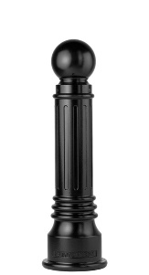Bollard [Designer’s Designation]:

Retain -AL for aluminum. Delete if not required.

Model: Reliance Foundry; **R-7539 [-AL]**.

Height: 35.75 inches (90.8 cm)

Diameter: 6 inches (15.2 cm) body; 10.25 inches (26 cm) base

Design: Tapered and fluted, with round finial and ball top.

Retain aluminum or cast iron to coordinate with model number.

Material:

Aluminum: ASTM B26; 20 percent recycled-material content.

Weight: 31 lbs. (14 kg)

Ductile Cast Iron: ASTM A536, Grade 65-45-12; 30 percent recycled-material content.

Weight: 75 lbs. (34 kg)

Country of Origin: China.

Color Coating:

Type: Polyester powder coat over epoxy primer.

Color: [Black textured semi gloss.] [Dark green.] [Statuary bronze.] [Bengal silver.] [Anodized silver.] [Safety yellow.]

Installation:

Fixed, new concrete, anchor.

Fixed, existing concrete, insert.

Fixed, existing concrete, adhesive.

Fixed, new concrete, concrete form.

Security post cover, new post.

Security post cover, existing post, insert.

Security post cover, existing post, adhesive.

Security post cover, existing, anchor.

Removable, new concrete, anchor.

Removable, existing concrete, insert.

Removable, new concrete, premium retractable.

* + - * 1. Bollard [Designer’s Designation]:

Model: Reliance Foundry; **R-7542**.

Height: 30 inches (89 cm)

Diameter: 5 inches (19.7 cm) body; 10 inches (38 cm) base

Weight: 67 lbs. (30 kg)

Design: Tapered and fluted, with fluted base and nautical-styled top.

Material: Ductile Cast Iron: ASTM A536, Grade 65-45-12; 30 percent recycled-material content.

Country of Origin: China.

Color Coating:

Type: Polyester powder coat over epoxy primer.

Color: [Black textured semi gloss.] [Dark green.] [Statuary bronze.] [Bengal silver.] [Anodized silver.] [Safety yellow.]

Installation:

Fixed, new concrete, anchor.

Fixed, existing concrete, insert.

Fixed, existing concrete, adhesive.

Fixed, new concrete, concrete form.

Security post cover, new post.

Security post cover, existing post, insert.

Security post cover, existing post, adhesive.

Security post cover, existing, anchor.

Removable, new concrete, anchor.

Removable, existing concrete, insert.

Removable, new concrete, premium retractable.

* + - * 1. 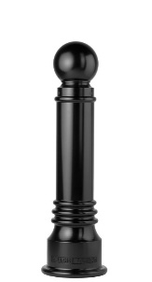Bollard [Designer’s Designation]:

Model: Reliance Foundry; **R-7551**.

Height: 35.75 inches (90.8 cm)

Diameter: 6 inches (15.2 cm) body; 10.25 inches (26 cm) base

Weight: 78 lbs. (35.4 kg)

Design: Tapered with round finial and ball top.

Material: Ductile Cast Iron: ASTM A536, Grade 65-45-12; 30 percent recycled-material content.

Country of Origin: China.

Color Coating:

Type: Polyester powder coat over epoxy primer.

Color: [Black textured semi gloss.] [Dark green.] [Statuary bronze.] [Bengal silver.] [Anodized silver.] [Safety yellow.]

Installation:

Fixed, new concrete, anchor.

Fixed, existing concrete, insert.

Fixed, existing concrete, adhesive.

Fixed, new concrete, concrete form.

Security post cover, new post.

Security post cover, existing post, insert.

Security post cover, existing post, adhesive.

Security post cover, existing, anchor.

Removable, new concrete, anchor.

Removable, existing concrete, insert.

Removable, new concrete, premium retractable.

* + - * 1. Bollard [Designer’s Designation]:

Model: Reliance Foundry; **R-7552**.

Height: 35.75 inches (90.8 cm)

Diameter: 6 inches (15.2 cm) body; 10.25 inches (26 cm) base

Weight: 88 lbs. (40 kg)

Design: Tapered with round finial and contemporary-styled top.

Material: Ductile Cast Iron: ASTM A536, Grade 65-45-12; 30 percent recycled-material content.

Country of Origin: China.

Color Coating:

Type: Polyester powder coat over epoxy primer.

Color: [Black textured semi gloss.] [Dark green.] [Statuary bronze.] [Bengal silver.] [Anodized silver.] [Safety yellow.]

Installation:

Fixed, new concrete, anchor.

Fixed, existing concrete, insert.

Fixed, existing concrete, adhesive.

Fixed, new concrete, concrete form.

Security post cover, new post.

Security post cover, existing post, insert.

Security post cover, existing post, adhesive.

Security post cover, existing, anchor.

Removable, new concrete, anchor.

Removable, existing concrete, insert.

Removable, new concrete, premium retractable.

* + - * 1. 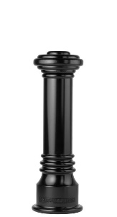Bollard [Designer’s Designation]:

Model: Reliance Foundry; **R-7553**.

Height: 31.75 inches (90.8 cm)

Diameter: 6 inches (15.2 cm) body; 10.25 inches (26 cm) base

Weight: 82 lbs. (37 kg)

Design: Tapered with round finial and flat disc top.

Material: Ductile Cast Iron: ASTM A536, Grade 65-45-12; 30 percent recycled-material content.

Country of Origin: China.

Color Coating:

Type: Polyester powder coat over epoxy primer.

Color: [Black textured semi gloss.] [Dark green.] [Statuary bronze.] [Bengal silver.] [Anodized silver.] [Safety yellow.]

Installation:

Fixed, new concrete, anchor.

Fixed, existing concrete, insert.

Fixed, existing concrete, adhesive.

Fixed, new concrete, concrete form.

Security post cover, new post.

Security post cover, existing post, insert.

Security post cover, existing post, adhesive.

Security post cover, existing, anchor.

Removable, new concrete, anchor.

Removable, existing concrete, insert.

Removable, new concrete, premium retractable.

* + - * 1. 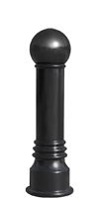Bollard [Designer’s Designation]:

Model: Reliance Foundry; **R-7555**.

Height: 34.5 inches (90.8 cm)

Diameter: 6 inches (15.2 cm) body; 10.25 inches (26 cm) base

Weight: 78 lbs. (35.4 kg)

Design: Tapered with round finial and large ball top.

Material: Ductile Cast Iron: ASTM A536, Grade 65-45-12; 30 percent recycled-material content.

Country of Origin: China.

Color Coating:

Type: Polyester powder coat over epoxy primer.

Color: [Black textured semi gloss.] [Dark green.] [Statuary bronze.] [Bengal silver.] [Anodized silver.] [Safety yellow.]

Installation:

Fixed, new concrete, anchor.

Fixed, existing concrete, insert.

Fixed, existing concrete, adhesive.

Fixed, new concrete, concrete form.

Security post cover, new post.

Security post cover, existing post, insert.

Security post cover, existing post, adhesive.

Security post cover, existing, anchor.

Removable, new concrete, anchor.

Removable, existing concrete, insert.

Removable, new concrete, premium retractable.

* + - * 1. 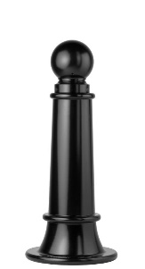Bollard [Designer’s Designation]:

Model: Reliance Foundry; **R-7561**.

Height: 35 inches (89 cm)

Diameter: 7.75 inches (19.7 cm) body; 15 inches (38 cm) base

Weight: 115 lbs. (52 kg)

Design: Tapered with round finial and ball top.

Material: Ductile Cast Iron: ASTM A536, Grade 65-45-12; 30 percent recycled-material content.

Country of Origin: China.

Color Coating:

Type: Polyester powder coat over epoxy primer.

Color: [Black textured semi gloss.] [Dark green.] [Statuary bronze.] [Bengal silver.] [Anodized silver.] [Safety yellow.]

Installation:

Fixed, new concrete, anchor.

Fixed, existing concrete, insert.

Fixed, existing concrete, adhesive.

Fixed, new concrete, concrete form.

Security post cover, new post.

Security post cover, existing post, insert.

Security post cover, existing post, adhesive.

Security post cover, existing, anchor.

Removable, new concrete, anchor.

Removable, existing concrete, insert.

Removable, new concrete, premium retractable.

* + - * 1. 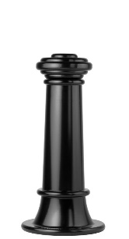Bollard [Designer’s Designation]:

Model: Reliance Foundry; **R-7563**.

Height: 31 inches (78.7 cm)

Diameter: 7.75 inches (19.7 cm) body; 15 inches (38 cm) base

Weight: 119 lbs. (54 kg)

Design: Tapered with round finial and flat disc top.

Material: Ductile Cast Iron: ASTM A536, Grade 65-45-12; 30 percent recycled-material content.

Country of Origin: China.

Color Coating:

Type: Polyester powder coat over epoxy primer.

Color: [Black textured semi gloss.] [Dark green.] [Statuary bronze.] [Bengal silver.] [Anodized silver.] [Safety yellow.]

Installation:

Fixed, new concrete, anchor.

Fixed, existing concrete, insert.

Fixed, existing concrete, adhesive.

Fixed, new concrete, concrete form.

Security post cover, new post.

Security post cover, existing post, insert.

Security post cover, existing post, adhesive.

Security post cover, existing, anchor.

Removable, new concrete, anchor.

Removable, existing concrete, insert.

Removable, new concrete, premium retractable.

* + - * 1. 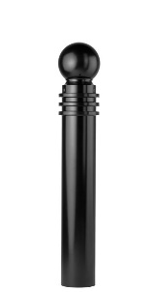Bollard [Designer’s Designation]:

Model: Reliance Foundry; **R-7571**.

Height: 40.5 inches (102.9 cm)

Diameter: 5.75 inches (14.6 cm) body; 5.75 inches (14.6 cm) base

Weight: 62 lbs. (28.1 kg)

Design: Cylindrical with round finial and ball top.

Material: Ductile Cast Iron: ASTM A536, Grade 65-45-12; 30 percent recycled-material content.

Color Coating:

Type: Polyester powder coat over epoxy primer.

Color: [Black textured semi gloss.] [Dark green.] [Statuary bronze.] [Bengal silver.] [Anodized silver.] [Safety yellow.]

Installation:

Fixed, new concrete, anchor.

Fixed, existing concrete, insert.

Fixed, existing concrete, adhesive.

Fixed, new concrete, concrete form.

Security post cover, new post.

Security post cover, existing post, insert.

Security post cover, existing post, adhesive.

Security post cover, existing, anchor.

Removable, new concrete, anchor.

Removable, existing concrete, insert.

Removable, new concrete, premium retractable.

* + - * 1. 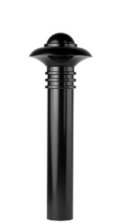Bollard [Designer’s Designation]:

Model: Reliance Foundry; **R-7572**.

Height: 40.5 inches (102.9 cm)

Diameter: 5.75 inches (14.6 cm) body; 5.75 inches (14.6 cm) base

Weight: 72 lbs. (32.7 kg)

Design: Cylindrical with round finial and contemporary-styled top.

Material: Ductile Cast Iron: ASTM A536, Grade 65-45-12; 30 percent recycled-material content.

Country of Origin: China.

Color Coating:

Type: Polyester powder coat over epoxy primer.

Color: [Black textured semi gloss.] [Dark green.] [Statuary bronze.] [Bengal silver.] [Anodized silver.] [Safety yellow.]

Installation:

Fixed, new concrete, anchor.

Fixed, existing concrete, insert.

Fixed, existing concrete, adhesive.

Fixed, new concrete, concrete form.

Security post cover, new post.

Security post cover, existing post, insert.

Security post cover, existing post, adhesive.

Security post cover, existing, anchor.

Removable, new concrete, anchor.

Removable, existing concrete, insert.

Removable, new concrete, premium retractable.

* + - * 1. 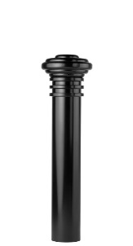Bollard [Designer’s Designation]:

Model: Reliance Foundry; **R-7573**.

Height: 36.5 inches (92.7 cm)

Diameter: 5.75 inches (14.6 cm) body; 5.75 inches (14.6 cm) base

Weight: 66 lbs. (30 kg)

Design: Cylindrical with round finial and flat disc top.

Material: Ductile Cast Iron: ASTM A536, Grade 65-45-12; 30 percent recycled-material content.

Country of Origin: China.

Color Coating:

Type: Polyester powder coat over epoxy primer.

Color: [Black textured semi gloss.] [Dark green.] [Statuary bronze.] [Bengal silver.] [Anodized silver.] [Safety yellow.]

Installation:

Fixed, new concrete, anchor.

Fixed, existing concrete, insert.

Fixed, existing concrete, adhesive.

Fixed, new concrete, concrete form.

Security post cover, new post.

Security post cover, existing post, insert.

Security post cover, existing post, adhesive.

Security post cover, existing, anchor.

Removable, new concrete, anchor.

Removable, existing concrete, insert.

Removable, new concrete, premium retractable.

* + - * 1. 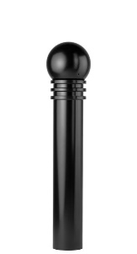Bollard [Designer’s Designation]:

Model: Reliance Foundry; **R-7575**.

Height: 39.25 inches (99.7 cm)

Diameter: 5.75 inches (14.6 cm) body; 5.75 inches (14.6 cm) base

Weight: 62 lbs. (28.1 kg)

Design: Cylindrical with round finial and large ball top.

Material: Ductile Cast Iron: ASTM A536, Grade 65-45-12; 30 percent recycled-material content.

Country of Origin: China.

Color Coating:

Type: Polyester powder coat over epoxy primer.

Color: [Black textured semi gloss.] [Dark green.] [Statuary bronze.] [Bengal silver.] [Anodized silver.] [Safety yellow.]

Installation:

Fixed, new concrete, anchor.

Fixed, existing concrete, insert.

Fixed, existing concrete, adhesive.

Fixed, new concrete, concrete form.

Security post cover, new post.

Security post cover, existing post, insert.

Security post cover, existing post, adhesive.

Security post cover, existing, anchor.

Removable, new concrete, anchor.

Removable, existing concrete, insert.

Removable, new concrete, premium retractable.

* + - * 1. 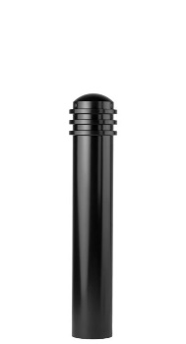Bollard [Designer’s Designation]:

Model: Reliance Foundry; **R-7576**.

Height: 34.25 inches (87 cm)

Diameter: 5.75 inches (14.6 cm) body; 5.75 inches (14.6 cm) base

Weight: 51 lbs. (23.1 lg)

Design: Cylindrical with round finial and rounded top.

Material: Ductile Cast Iron: ASTM A536, Grade 65-45-12; 30 percent recycled-material content.

Country of Origin: China.

Color Coating:

Type: Polyester powder coat over epoxy primer.

Color: [Black textured semi gloss.] [Dark green.] [Statuary bronze.] [Bengal silver.] [Anodized silver.] [Safety yellow.]

Installation:

Fixed, new concrete, anchor.

Fixed, existing concrete, insert.

Fixed, existing concrete, adhesive.

Fixed, new concrete, concrete form.

Security post cover, new post.

Security post cover, existing post, insert.

Security post cover, existing post, adhesive.

Security post cover, existing, anchor.

Removable, new concrete, anchor.

Removable, existing concrete, insert.

Removable, new concrete, premium retractable.

* + - * 1. 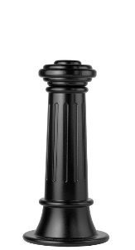Bollard [Designer’s Designation]:

Retain -AL for aluminum. Delete if not required.

Model: Reliance Foundry; **R-7581 [-AL]**.

Height: 31 inches (78.7 cm)

Diameter: 7.75 inches (19.7 cm) body; 15inches (38 cm) base

Design: Tapered and fluted, with round finial and flat disc top.

Retain aluminum or cast iron to coordinate with model number.

Material:

Aluminum: ASTM B26; 20 percent recycled-material content.

Weight: 46 lbs. (20.8 kg)

Ductile Cast Iron: ASTM A536, Grade 65-45-12; 30 percent recycled-material content.

Weight: 112 lbs. (50.8 kg)

Country of Origin: China.

Color Coating:

Type: Polyester powder coat over epoxy primer.

Color: [Black textured semi gloss.] [Dark green.] [Statuary bronze.] [Bengal silver.] [Anodized silver.] [Safety yellow.]

Installation:

Fixed, new concrete, anchor.

Fixed, existing concrete, insert.

Fixed, existing concrete, adhesive.

Fixed, new concrete, concrete form.

Security post cover, new post.

Security post cover, existing post, insert.

Security post cover, existing post, adhesive.

Security post cover, existing, anchor.

Removable, new concrete, anchor.

Removable, existing concrete, insert.

Removable, new concrete, premium retractable.

* + - * 1. 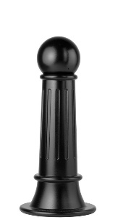Bollard [Designer’s Designation]:

Model: Reliance Foundry; **R-7582**.

Height: 33.75 inches (85.7 cm)

Diameter: 7.75 inches (19.7 cm) body; 15inches (38 cm) base

Weight: 108 lbs. (49 kg)

Design: Tapered and fluted, with round finial and large ball top.

Material: Ductile Cast Iron: ASTM A536, Grade 65-45-12; 30 percent recycled-material content.

Country of Origin: China.

Color Coating:

Type: Polyester powder coat over epoxy primer.

Color: [Black textured semi gloss.] [Dark green.] [Statuary bronze.] [Bengal silver.] [Anodized silver.] [Safety yellow.]

Installation:

Fixed, new concrete, anchor.

Fixed, existing concrete, insert.

Fixed, existing concrete, adhesive.

Fixed, new concrete, concrete form.

Security post cover, new post.

Security post cover, existing post, insert.

Security post cover, existing post, adhesive.

Security post cover, existing, anchor.

Removable, new concrete, anchor.

Removable, existing concrete, insert.

Removable, new concrete, premium retractable.

* + - * 1. 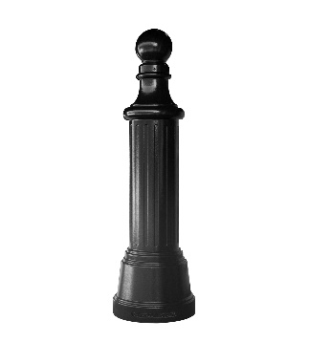Bollard [Designer’s Designation]:

Model: Reliance Foundry; **R-7585**.

Height: 52.5 inches (133.35 cm)

Diameter: 9.5 inches (24.13 cm) body; 16 inches (24.13 cm) base

Weight: 200 lbs. (90.72 kg)

Design: Cylindrical and fluted, with tapered bottom and small ball top.

Material: Ductile Cast Iron: ASTM A536, Grade 65-45-12

Country of Origin: China.

Color Coating:

Type: Polyester powder coat over epoxy primer.

Color: [Black textured semi gloss.] [Dark green.] [Statuary bronze.] [Bengal silver.] [Anodized silver.] [Safety yellow.]

Installation:

Fixed, new concrete, anchor.

Fixed, existing concrete, insert.

Fixed, existing concrete, adhesive.

Fixed, new concrete, concrete form.

Security post cover, new post.

Security post cover, existing post, insert.

Security post cover, existing post, adhesive.

Security post cover, existing, anchor.

* + - * 1. Bollard [Designer’s Designation]:

Retain -AL for aluminum. Delete if not required.

Model: Reliance Foundry; **R-7589 [-AL]**.

Height: 35 inches (89 cm)

Diameter: 7.75 inches (19.7 cm) body; 15inches (38 cm) base

Design: Tapered and fluted, with round finial and ball top.

Retain aluminum or cast iron to coordinate with model number.

Material:

Aluminum: ASTM B26; 20 percent recycled-material content.

Weight: 46 lbs. (20.8 kg)

Ductile Cast Iron: ASTM A536, Grade 65-45-12; 30 percent recycled-material content.

Weight: 108 lbs. (50.8 kg)

Country of Origin: China.

Color Coating:

Type: Polyester powder coat over epoxy primer.

Color: [Black textured semi gloss.] [Dark green.] [Statuary bronze.] [Bengal silver.] [Anodized silver.] [Safety yellow.]

Installation:

Fixed, new concrete, anchor.

Fixed, existing concrete, insert.

Fixed, existing concrete, adhesive.

Fixed, new concrete, concrete form.

Security post cover, new post.

Security post cover, existing post, insert.

Security post cover, existing post, adhesive.

Security post cover, existing, anchor.

Removable, new concrete, anchor.

Removable, existing concrete, insert.

Removable, new concrete, premium retractable.

* + - * 1. 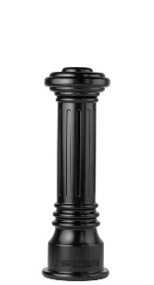Bollard [Designer’s Designation]:

Retain -AL for aluminum. Delete if not required.

Model: Reliance Foundry; **R-7591 [-AL]**.

Height: 31.75 inches (80.6 cm)

Diameter: 6 inches (15.2 cm) body; 10.25 inches (26 cm) base

Design: Tapered and fluted, with round finial and flat disc top.

Retain aluminum or cast iron to coordinate with model number.

Material:

Aluminum: ASTM B26; 20 percent recycled-material content.

Weight: 31 lbs. (14 kg)

Ductile Cast Iron: ASTM A536, Grade 65-45-12; 30 percent recycled-material content.

Weight: 79 lbs. (35.8 kg)

Country of Origin: China.

Color Coating:

Type: Polyester powder coat over epoxy primer.

Color: [Black textured semi gloss.] [Dark green.] [Statuary bronze.] [Bengal silver.] [Anodized silver.] [Safety yellow.]

Installation:

Fixed, new concrete, anchor.

Fixed, existing concrete, insert.

Fixed, existing concrete, adhesive.

Fixed, new concrete, concrete form.

Security post cover, new post.

Security post cover, existing post, insert.

Security post cover, existing post, adhesive.

Security post cover, existing, anchor.

Removable, new concrete, anchor.

Removable, existing concrete, insert.

Removable, new concrete, premium retractable.

* + - * 1. 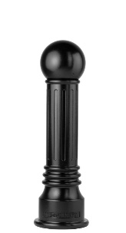Bollard [Designer’s Designation]:

Model: Reliance Foundry; **R-7592**.

Height: 34.5 inches (87.6 cm)

Diameter: 6 inches (15.2 cm) body; 10.25 inches (26 cm) base.

Weight: 75 lbs. (34 kg)

Design: Tapered and fluted, with round finial and large ball top.

Material: Ductile Cast Iron: ASTM A536, Grade 65-45-12; 30 percent recycled-material content.

Country of Origin: China.

Color Coating:

Type: Polyester powder coat over epoxy primer.

Color: [Black textured semi gloss.] [Dark green.] [Statuary bronze.] [Bengal silver.] [Anodized silver.] [Safety yellow.]

Installation:

Fixed, new concrete, anchor.

Fixed, existing concrete, insert.

Fixed, existing concrete, adhesive.

Fixed, new concrete, concrete form.

Security post cover, new post.

Security post cover, existing post, insert.

Security post cover, existing post, adhesive.

Security post cover, existing, anchor.

Removable, new concrete, anchor.

Removable, existing concrete, insert.

Removable, new concrete, premium retractable.

* + - * 1. 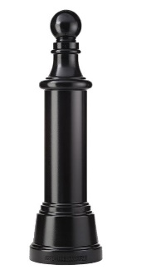Bollard [Designer’s Designation]:

Model: Reliance Foundry; **R-7593**.

Height: 53.75 inches (136.5 cm)

Weight: 210 lbs. (95.3 kg)

Diameter: 8.5 inches (21.6 cm) body; 16 inches (40.6 cm) base.

Design: Tapered cylindrical body with round finial and ball top.

Material: Ductile Cast Iron: ASTM A536, Grade 65-45-12; 30 percent recycled-material content.

Country of Origin: China.

Color Coating:

Type: Polyester powder coat over epoxy primer.

Color: [Black textured semi gloss.] [Dark green.] [Statuary bronze.] [Bengal silver.] [Anodized silver.] [Safety yellow.]

Installation:

Fixed, new concrete, anchor.

Fixed, existing concrete, insert.

Fixed, existing concrete, adhesive.

Fixed, new concrete, concrete form.

Security post cover, new post.

Security post cover, existing post, insert.

Security post cover, existing post, adhesive.

Security post cover, existing, anchor.

* + - * 1. 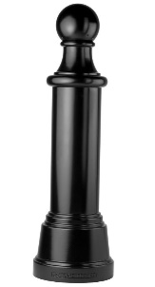Bollard [Designer’s Designation]:

Model: Reliance Foundry; **R-7595**.

Height: 52.5 inches (133.4 cm)

Diameter: 9.5 inches (24 cm) body; 16 inches (40.6 cm) base.

Weight: 210 lbs. (95.3 kg)

Design: Tapered cylindrical body with round finial and large ball top.

Material: Ductile Cast Iron: ASTM A536, Grade 65-45-12; 30 percent recycled-material content.

Country of Origin: China.

Color Coating:

Type: Polyester powder coat over epoxy primer.

Color: [Black textured semi gloss.] [Dark green.] [Statuary bronze.] [Bengal silver.] [Anodized silver.] [Safety yellow.]

Installation:

Fixed, new concrete, anchor.

Fixed, existing concrete, insert.

Fixed, existing concrete, adhesive.

Fixed, new concrete, concrete form.

Security post cover, new post.

Security post cover, existing post, insert.

Security post cover, existing post, adhesive.

Security post cover, existing, anchor.

* + - * 1. Bollard [Designer’s Designation]:

Model: Reliance Foundry; **R-7598**.

Height: 35.75 inches (90.8 cm)

Diameter: 6 inches (15.2 cm) body; 10.25 inches (26 cm) base.

Weight: 85 lbs. (38.6 kg)

Design: Tapered and fluted, with fluted base and nautical-styled top.

Material: Ductile Cast Iron: ASTM A536, Grade 65-45-12; 30 percent recycled-material content.

Country of Origin: China.

Color Coating:

Type: Polyester powder coat over epoxy primer.

Color: [Black textured semi gloss.] [Dark green.] [Statuary bronze.] [Bengal silver.] [Anodized silver.] [Safety yellow.]

Installation:

Fixed, new concrete, anchor.

Fixed, existing concrete, insert.

Fixed, existing concrete, adhesive.

Fixed, new concrete, concrete form.

Security post cover, new post.

Security post cover, existing post, insert.

Security post cover, existing post, adhesive.

Security post cover, existing, anchor.

Removable, new concrete, anchor.

Removable, existing concrete, insert.

Removable, new concrete, premium retractable.

* + - * 1. 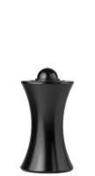Bollard [Designer’s Designation]:

Model: Reliance Foundry; **R-7611**.

Height: 22.5 inches (57 cm)

Diameter: 7.25 inches (18.4 cm) body; 11.75 inches (30 cm) base.

Weight: 65 lbs. (29.5 kg)

Design: Hourglass shape with rounded top.

Material: Ductile Cast Iron: ASTM A536, Grade 65-45-12; 30 percent recycled-material content.

Country of Origin: China.

Color Coating:

Type: Polyester powder coat over epoxy primer.

Color: [Black textured semi gloss.] [Dark green.] [Statuary bronze.] [Bengal silver.] [Anodized silver.] [Safety yellow.]

Installation:

Fixed, new concrete, anchor.

Fixed, existing concrete, insert.

Fixed, existing concrete, adhesive.

Fixed, new concrete, concrete form.

Security post cover, new post.

Security post cover, existing post, insert.

Security post cover, existing post, adhesive.

Security post cover, existing, anchor.

Removable, new concrete, anchor.

Removable, existing concrete, insert.

Removable, new concrete, premium retractable.

* + - * 1. 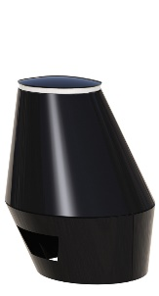Bollard [Designer’s Designation]:

Model: Reliance Foundry; **R-7651-EM**.

Height: 22.5 inches (57.2 cm)

Diameter:14 inches (35.6 cm) top; 25.5 inches (64.7 cm) base.

Weight: 180 lbs. (81.6 kg)

Design: Sloped-sided oval designed by Billings Jackson.

Material: Steel: ASTM A36; 25 percent recycled-material content.

Country of Origin: United States.

Color Coating:

Type: Polyester powder coat over epoxy primer.

Color: [Black textured semi gloss.] [Dark green.] [Statuary bronze.] [Bengal silver.] [Anodized silver.] [Safety yellow.]

Installation: Embedded, new concrete.

* + - * 1. 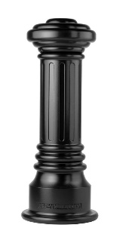Bollard [Designer’s Designation]:

Model: Reliance Foundry; **R-7691**.

Height: 38.75 inches (98.4 cm)

Diameter: 8.25 inches (21 cm) body; 15 inches (38 cm) base

Weight: 148 lbs. (67.1 kg)

Design: Tapered and fluted, with fluted base and flat disc top.

Material: Ductile Cast Iron: ASTM A536, Grade 65-45-12; 30 percent recycled-material content.

Country of Origin: China.

Color Coating:

Type: Polyester powder coat over epoxy primer.

Color: [Black textured semi gloss.] [Dark green.] [Statuary bronze.] [Bengal silver.] [Anodized silver.] [Safety yellow.]

Installation:

Fixed, new concrete, anchor.

Fixed, existing concrete, insert.

Fixed, existing concrete, adhesive.

Fixed, new concrete, concrete form.

Security post cover, new post.

Security post cover, existing post, insert.

Security post cover, existing post, adhesive.

Security post cover, existing, anchor.

* + - * 1. 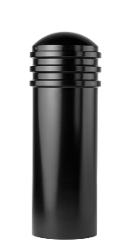Bollard [Designer’s Designation]:

Model: Reliance Foundry; **R-7736**.

Height: 36 inches (91.5 cm)

Diameter: 11.75 inches (29.8 cm) body; 11.75 inches (29.8 cm) base

Weight: 129 lbs. (58.5 kg)

Design: Cylindrical with segmented rings and rounded top.

Material: Steel: ASTM A36; 25 percent recycled-material content.

Country of Origin: China.

Color Coating:

Type: Polyester powder coat over epoxy primer.

Color: [Black textured semi gloss.] [Dark green.] [Statuary bronze.] [Bengal silver.] [Anodized silver.] [Safety yellow.]

Installation:

Fixed, new concrete, anchor.

Fixed, existing concrete, insert.

Fixed, existing concrete, adhesive.

Fixed, new concrete, concrete form.

Security post cover, new post.

Security post cover, existing post, insert.

Security post cover, existing post, adhesive.

Security post cover, existing, anchor.

Removable, new concrete, anchor.

Removable, existing concrete, insert.

Removable, new concrete, premium retractable.

* + - * 1. Bollard [Designer’s Designation]:

Model: Reliance Foundry; **R-7743**

Height: 44 inches (111.8 cm)

Diameter: 11.75 inches (29.8 cm) body; 11.75 inches (29.8 cm) base

Weight: 154 lbs. (69.9 kg)

Design: Cylindrical with segmented rings and rounded top

Material: Steel body with ductile iron cap

Country of Origin: China

Color Coating:

Type: Polyester powder coat over epoxy primer.

Color: [Black textured semi gloss.] [Dark green.] [Statuary bronze.] [Bengal silver.] [Anodized silver.] [Safety yellow.]

Installation:

Fixed, new concrete, anchor.

Fixed, existing concrete, insert.

Fixed, existing concrete, adhesive.

Fixed, new concrete, concrete form.

Security post cover, new post.

Security post cover, existing post, insert.

Security post cover, existing post, adhesive.

Security post cover, existing, anchor.

* + - * 1. 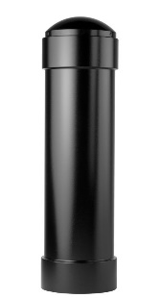Bollard [Designer’s Designation]:

Model: Reliance Foundry; **R-7744**.

Height: 44.5 inches (113 cm)

Diameter: 11.75 inches (29.8 cm) body; 12.625 inches (32 cm) base

Weight: 158 lbs. (71.7 kg)

Design: Cylindrical with rounded top.

Material: Steel: ASTM A36; 25 percent recycled-material content.

Country of Origin: China.

Color Coating:

Type: Polyester powder coat over epoxy primer.

Color: [Black textured semi gloss.] [Dark green.] [Statuary bronze.] [Bengal silver.] [Anodized silver.] [Safety yellow.]

Installation:

Fixed, new concrete, anchor.

Fixed, existing concrete, insert.

Fixed, existing concrete, adhesive.

Fixed, new concrete, concrete form.

Security post cover, new post.

Security post cover, existing post, insert.

Security post cover, existing post, adhesive.

Security post cover, existing, anchor.

* + - * 1. Bollard [Designer’s Designation]:

Model: Reliance Foundry; **R-7835**.

Height: 35 inches (88.9 cm)

Diameter: 9.5 inches (24.1 cm) body; 9.5 inches (24.1 cm) base

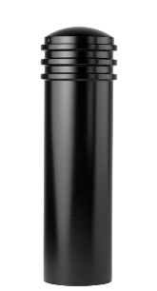Weight: 80 lbs. (36.3 kg)

Design: Cylindrical with segmented rings and rounded top.

Material: Steel: ASTM A36; 25 percent recycled-material content.

Country of Origin: China.

Color Coating:

Type: Polyester powder coat over epoxy primer.

Color: [Black textured semi gloss.] [Dark green.] [Statuary bronze.] [Bengal silver.] [Anodized silver.] [Safety yellow.]

Installation:

Fixed, new concrete, anchor.

Fixed, existing concrete, insert.

Fixed, existing concrete, adhesive.

Fixed, new concrete, concrete form.

Security post cover, new post.

Security post cover, existing post, insert.

Security post cover, existing post, adhesive.

Security post cover, existing, anchor.

Removable, new concrete, anchor.

Removable, existing concrete, insert.

Removable, new concrete, premium retractable.

* + - 1. ACCESSORIES

Retain following if specified bollards require security posts.

* + - * 1. Security Post:

Pipe: ASTM 500 B Structural Grade Steel

Manufacturer: Reliance Foundry Co. Ltd.

Country of Origin: United States.

Base Diameter: [4.5 inches] [6.25 inches] [8.625 inches] [10.75 inches]

Finish: [Red] [Grey] primer.

Installation:

Direct embed.

Footing and fill; Concrete or mortar, [3000 psi minimum.]

Retain the following for removable bollards with padlock hasps and for chains with padlocks

* + - * 1. Padlock:

[Brass] [Marine Grade], supplied [supplied by bollard manufacturer] [as specified in Section [__ __ __]]. [Key alike.]

Retain following if chains draped between bollards are required. In Drawings, show locations where chain is required, quick-release and padlock locations, and drape of chain.

* + - * 1. Chain:

5/16-inch galvanized steel chain, Grade 30, with quick-release type connections.] Provide sufficient lengths to provide drape [shown on Drawings.] [acceptable to Architect.]

Chain Eye: 5/16-inch diameter steel.

Quick Links: Powder coated chain links with barrel nut closures.

Finish: Powder coated to match bollard [_______________.]

See http://www.reliance-foundry.com/bike-storage/bike-bollard-stands

* + - * 1. Bollard Arms:

Curved rods attach to bollard body.

Material: Stainless steel: ASTM A312, Grade TP 316

Finish: [Powder coated to match bollard [_______________.]] [Satin No. 6, buffed].

1. EXECUTION
   * + 1. EXAMINATION
          1. Examine paving or other substrates for compliance with manufacturer’s requirements for placement and location of embedded items, condition of substrate, and other conditions affecting installation of bollards.
          2. Proceed with installation only after unsatisfactory conditions have been corrected.
       2. INSTALLATION
          1. General: Comply with manufacturer’s installation instructions and setting drawings.
          2. Do not install damaged, cracked, chipped, deformed or marred bollards. Field touch-up minor imperfections in accordance with manufacturer’s instructions. Replace bollards that cannot be field repaired.
       3. CLEANING & PROTECTION

Normal cleaning may be done with clean water and a soft cloth. Detailed cleaning and inspection instructions are available at [www.reliance-foundry.com/bollard/maintenance-bollards](http://www.reliance-foundry.com/bollard/maintenance-bollards).

* + - * 1. Protect bollards against damage.
        2. Immediately prior to Substantial Completion, clean bollards in accordance with manufacturer’s instructions to remove dust, dirt, adhesives, and other foreign materials.
        3. Touch up damaged finishes according to manufacturer’s instructions.
      1. CLOSEOUT ACTIVITIES
         1. Provide executed warranty.

**SECTION 34 71 13**

**VEHICLE BARRIERS**

PLASTIC SECURITY POST COVERS

1. GENERAL
   * + 1. SUMMARY
          1. Section Includes:

Accessories

Plastic bollard covers.

Edit following to coordinate with other specification sections in project.

* + - * 1. Related Requirements:

[Division 03 Sections: [Concrete] [Mortar] fill for security posts.]

[Division 32 Section "Bollards" for bollards other than plastic bollard covers specified herein.]

[_________________]

Delete below if no steel security posts.

* + - 1. REFERENCE STANDARDS
         1. ASTM A500 – Standard Specification for Cold-Formed Welded and Seamless Carbon Steel Structural Tubing in Rounds and Shapes.
      2. SUBMITTALS
         1. Comply with Section [01 33 00 – Submittal Procedures.] [_________.]
         2. Product Data: Provide for each type of bollard, component, finish, and accessory specified.
         3. Color Samples: [Submit manufacturer’s standard colors for selection.] [Submit sample of color specified.]

Delete below if no steel security posts or if security post installation is simple.

* + - * 1. Setting Drawings: For steel security posts, show foundations and cutouts required in work specified in other Sections.
        2. Maintenance Data: Submit manufacturer’s field touch-up, cleaning, and maintenance instructions.
        3. Warranty Documentation: Submit sample of manufacturer’s warranty.
      1. QUALITY ASSURANCE
         1. Comply with Section [01 43 00 – Quality Assurance.] [_________.]
      2. DELIVERY, STORAGE AND HANDLING
         1. Comply with Section [01 66 00 – Product Storage and Handling Requirements.] [_________.]
         2. Protect bollards and accessories during delivery, storage, and handling.
      3. WARRANTY
         1. Comply with Section [01 78 36 – Warranties.] [_________.]
         2. Provide manufacturer’s standard warranty against defects in materials and workmanship.

Warranty Period: Five years from date of invoice, except as otherwise indicated.

Plastic Bollards and Post Covers: One year.

1. PRODUCTS
   * + 1. MANUFACTURERS
          1. Manufacturer: Reliance Foundry Co. Ltd.

Phone: 604-547-0460 or 1-877-789-3245

Fax: 604-590-8875

Website: <http://www.reliance-foundry.com/bollard>

Email: [info@reliance-foundry.com](mailto:info@reliance-foundry.com)

* + - * 1. Substitutions: [Comply with provisions of [Section 01 25 00 "Substitution Procedures"] [_________] for substitution procedures.] [Not allowed.]
      1. ACCESSORIES:
         1. Self-adhesive foam strips.
         2. Self-adhesive neoprene tape.
         3. Reflective Tape: 2 strips of 3M Scotchlite Reflective Sheeting Series tape, recessed on bollard.

For installation over new security posts, include information below. Determine security post and footing requirements with security consultant and structural engineer. Verify that plastic bollard type(s) specified have sufficient inside diameter and height to fit over required security posts.

Steel posts are standard; galvanizing and powder coating are available upon request.

* + - * 1. Security Post:

Pipe: ASTM 500 B Structural Grade Steel

Manufacturer: Reliance Foundry Co. Ltd.

Country of Origin: United States.

Base Diameter: [4.5 inches] [6.25 inches] [8.625 inches] [10.75 inches]

Finish: [Red] [Grey] primer.

Installation:

Direct embed.

Footing and fill; Concrete or mortar, [3000 psi minimum.]

* + - 1. PLASTIC BOLLARD COVERS

See <http://www.reliance-foundry.com/bollard/post-covers-plastic> for assistance in selecting bollard covers.

* + - * 1. Materials:

Formolene HB5502B, High Density Polyethylene (HDPE); Hexene Copolyer for Blow Molding.

High molecular weight material. Designed for optimum balance of density, molecular weight and molecular weight distribution demonstrating maximum property advantages for large products that require high impact resistance.

Ultraviolet protection additive.

Anti-Static Package: Combined in manufacturing process of HDPE.

Abrasion Resistant.

Environmental Stress Cracks Resistant.

Flexural modulus: 200,000 psi.

Tensile Strength: 4,000 psi.

Low-density thermoplastic polyethylene (LDPE).

* + - * 1. Country of Origin: China.

Delete requirement below if bollard covers will not be installed on sloping substrates or if regularity of height is not a concern:

Add 1 to 3 inches to specified height, to allow for fitting, cutting, foam installation strips, and grade or slope condition.

If desired, height of bollard cover may substantially exceed height of pipe bollards, for added visibility. Specify a finished height, or show heights on Drawings if varying heights are used or if alignment with other elements is required.

* + - * 1. 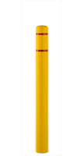Plastic Bollard Cover [Designer’s Designation]:

Model: Reliance Foundry; **R-7100**.

Height: 52 inches (132 cm)

Base Diameter: 5 inches (12.7 cm)

Weight: 4 lbs. (1.8 kg)

Maximum Interior Post Height: 51 inches (129.5 cm)

Maximum Interior Post Diameter: 4.5 inches (11.4 cm)

Material: High Density Polyethylene (HDPE)

Color: [Yellow] [White] [Blue] [Red] [Black] [Gray] [Green] [Orange]

[Brown] [Beige].

Tape Color: [Red] [White] [Blue].

Installation: Security post, self-adhesive foam strips.

* + - * 1. 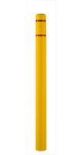Plastic Bollard Cover [Designer’s Designation]:

Model: Reliance Foundry; **R-7101**.

Height: 64 inches (162.5 cm)

Base Diameter: 5 inches (12.7 cm)

Weight: 5 lbs. (2.3 kg)

Maximum Interior Post Height: 63 inches (160 cm)

Maximum Interior Post Diameter: 4.5 inches (11.4 cm)

Material: High Density Polyethylene (HDPE)

Color: [Yellow] [White] [Blue] [Red] [Black] [Gray] [Green] [Orange]

[Brown] [Beige].

Tape Color: [Red] [White] [Blue].

Installation: Security post, self-adhesive foam strips.

* + - * 1. 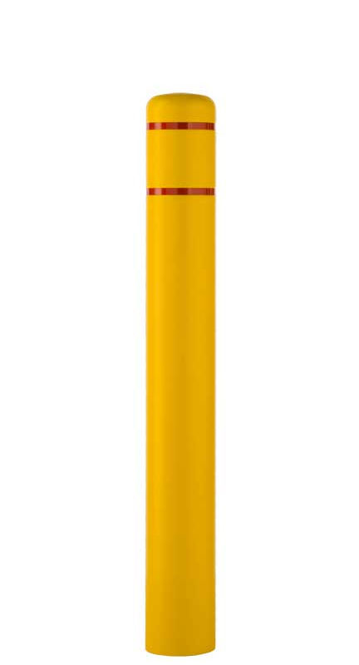Plastic Bollard Cover [Designer’s Designation]:

Model: Reliance Foundry; **R-7109**.

Height: 52 inches (132 cm)

Base Diameter: 7.4 inches (18.7 cm)

Weight: 5 lbs. (2.3 kg)

Maximum Interior Post Height: 51 inches (129.5 cm)

Maximum Interior Post Diameter: 6.6 inches (16.8 cm)

Material: High Density Polyethylene (HDPE)

Color: [Yellow] [White] [Blue] [Red] [Black] [Gray] [Green] [Orange] [Brown] [Beige].

Tape Color: [Red] [White] [Blue].

Installation: Security post, self-adhesive foam strips.

* + - * 1. 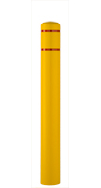Plastic Bollard Cover [Designer’s Designation]:

Model: Reliance Foundry; **R-7110**.

Height: 60 inches (152.4 cm)

Base Diameter: 7.4 inches (18.7 cm)

Weight: 6 lbs. (2.7 kg)

Maximum Interior Post Height: 59 inches (149.9 cm)

Maximum Interior Post Diameter: 6.6 inches (16.8 cm)

Material: High Density Polyethylene (HDPE)

Color: [Yellow] [White] [Blue] [Red] [Black] [Gray] [Green] [Orange]

[Brown] [Beige].

Tape Color: [Red] [White] [Blue].

Installation: Security post, self-adhesive foam strips.

* + - * 1. 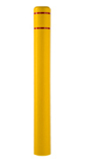Plastic Bollard Cover [Designer’s Designation]:

Model: Reliance Foundry; **R-7111**.

Height: 72 inches (182.9 cm)

Base Diameter: 7.4 inches (18.7 cm)

Weight: 8 lbs. (3.6 kg)

Maximum Interior Post Height: 71 inches (180.3 cm)

Maximum Interior Post Diameter: 6.6 inches (16.8 cm)

Material: High Density Polyethylene (HDPE)

Color: [Yellow] [White] [Blue] [Red] [Black] [Gray] [Green] [Orange]

[Brown] [Beige].

Tape Color: [Red] [White] [Blue].

Installation: Security post, self-adhesive foam strips.

* + - * 1. 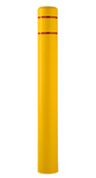Plastic Bollard Cover [Designer’s Designation]:

Model: Reliance Foundry; **R-7120**.

Height: 72 inches (182.9 cm)

Base Diameter: 9.4 inches (28.9 cm)

Weight: 10 lbs. (4.5 kg)

Maximum Interior Post Height: 71 inches (180.3 cm)

Maximum Interior Post Diameter: 8.9 inches (22.5 cm)

Material: [Low-density thermoplastic polyethylene (LDPE)] [High Density Polyethylene (HDPE)]

Color: [Yellow] [White] [Blue] [Red] [Black] [Gray] [Green] [Orange]

[Brown] [Beige].

Tape Color: [Red] [White] [Blue].

Installation: Security post, self-adhesive foam strips.

* + - * 1. 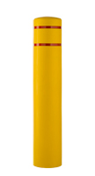Plastic Bollard Cover [Designer’s Designation]:

Model: Reliance Foundry; **R-7130**.

Height: 60 inches (152.4 cm)

Base Diameter: 11.4 inches (23.8)

Weight: 14 lbs. (6.4 kg)

Maximum Interior Post Height: 59 inches (149.9 cm)

Maximum Interior Post Diameter: 10.9 inches (27.7 cm)

Material: Low-density thermoplastic polyethylene (LDPE).

Color: [Yellow] [White] [Blue] [Red] [Black] [Gray] [Green] [Orange] [Brown] [Beige].

Tape Color: [Red] [White] [Blue].

Installation: Security post, self-adhesive foam strips.

* + - * 1. 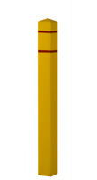Plastic Bollard Cover [Designer’s Designation]:

Model: Reliance Foundry; **R-7140**.

Height: 55 inches (139.7 cm)

Base Width: 5 inches (12.7 cm) x 5 inches (12.7 cm)

Weight: 6.7 lbs. (3 kg)

Maximum Interior Post Height: 54 inches (137.2 cm)

Maximum Interior Post Diameter: 4.5 inches (11.4 cm)

Material: Low-density thermoplastic polyethylene (LDPE).

Color: [Yellow] [White] [Blue] [Red] [Black] [Gray] [Green] [Orange] [Brown] [Beige].

Tape Color: [Red] [White] [Blue].

Installation: Security post, self-adhesive foam strips.

* + - * 1. 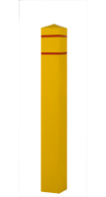Plastic Bollard Cover [Designer’s Designation]:

Model: Reliance Foundry; **R-7150**.

Height: 55 inches (139.7 cm)

Base Width: 7.4 inches (18.7 cm) x 7.4 inches (18.7 cm)

Weight: 10 lbs. (4.5 kg)

Maximum Interior Post Height: 54 inches (137.2 cm)

Maximum Interior Post Diameter: 6.5 inches (16.5 cm)

Material: Low-density thermoplastic polyethylene (LDPE).

Color: [Yellow] [White] [Blue] [Red] [Black] [Gray] [Green] [Orange]

[Brown] [Beige].

Tape Color: [Red] [White] [Blue].

Installation: Security post, self-adhesive foam strips.

* + - * 1. 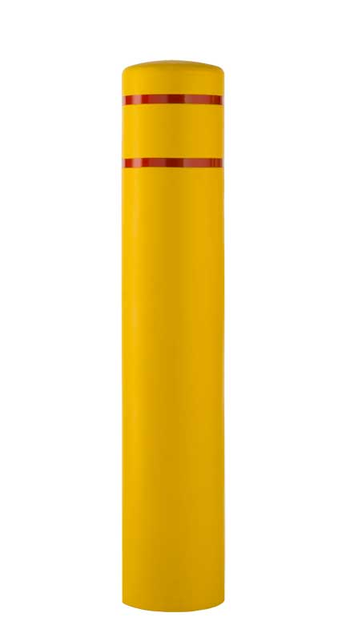Plastic Bollard Cover [Designer’s Designation]:

Model: Reliance Foundry; **R-7155**.

Height: 60 inches (152.4 cm)

Weight: 16 lbs. (7.3 kg)

Base Diameter: 13 inches (33 cm)

Maximum Interior Post Height: 59 inches (149.9 cm)

Maximum Interior Post Diameter: 12.8 inches (32.4 cm)

Material: Low-density thermoplastic polyethylene (LDPE).

Color: [Yellow] [White] [Blue] [Red] [Black] [Gray] [Green] [Orange]

[Brown] [Beige].

Tape Color: [Red] [White] [Blue].

Installation: Security post, self-adhesive foam strips.

* + - 1. DECORATIVE PLASTIC BOLLARD COVERS
         1. Material: High-density thermoplastic polyethylene (HDPE).

Nominal Wall Thickness: 0.25 inches (6.4 mm)

* + - * 1. Country of Origin: U.S.A.

[Add 1 to 3 inches to specified height, to allow for fitting, cutting, foam installation strips, and grade or slope condition.]

* + - * 1. 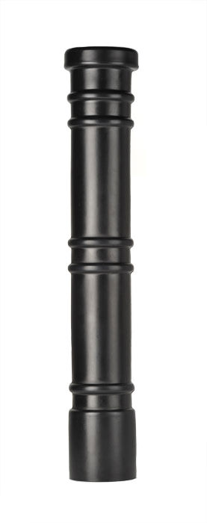Plastic Bollard Cover [Designer’s Designation]:

Model: Reliance Foundry; **R-7171.**

Design: Cylinder with rings and flat top.

Height: 52 inches (132cm)

Base Diameter: 8.4 inches (21.3 cm)

Weight: 12 lbs. (5.4 kg)

Maximum Interior Post Height: 50 inches (127 cm)

Maximum Interior Post Diameter: 6.6 inches (16.8 cm)

Color: [Yellow] [White] [Dark Blue] [Red] [Black] [Grey] [Green] [Orange] [Brown] [Light Blue].

Installation: Security post, self-adhesive neoprene tape.

* + - * 1. 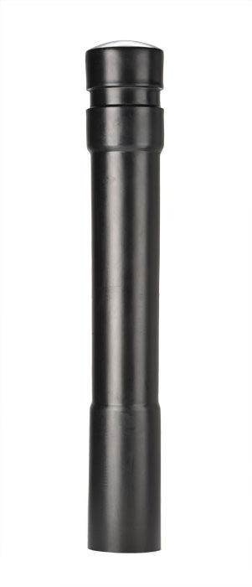Plastic Bollard Cover [Designer’s Designation]:

Model: Reliance Foundry; **R-7172.**

Design: Cylinder with wide rings.

Height: 53 inches (134.6 cm)

Base Diameter: 7.8 inches (19.7 cm)

Weight: 12 lbs. (5.4 kg)

Maximum Interior Post Height: 50 inches (127 cm)

Maximum Interior Post Diameter: 6.6 inches (16.8 cm)

Color: [Yellow] [White] [Dark Blue] [Red] [Black] [Grey] [Green] [Orange]

[Brown] [Light Blue].

Installation: Security post, self-adhesive neoprene tape.

* + - * 1. 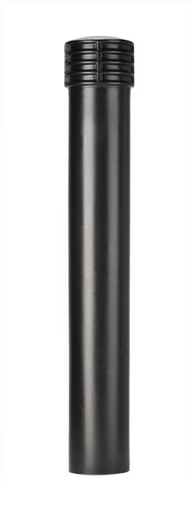Plastic Bollard Cover [Designer’s Designation]:

Model: Reliance Foundry; **R-7173.**

Design: Cylinder with banded top.

Height: 52 inches (132 cm)

Base Diameter: 7.5 inches (19 cm)

Weight: 12 lbs. (5.4 kg)

Maximum Interior Post Height: 50 inches (127 cm)

Maximum Interior Post Diameter: 6.6 inches (16.8 cm)

Color: [Yellow] [White] [Dark Blue] [Red] [Black] [Grey] [Green] [Orange] [Brown] [Light Blue].

Installation: Security post, self-adhesive neoprene tape.

* + - * 1. 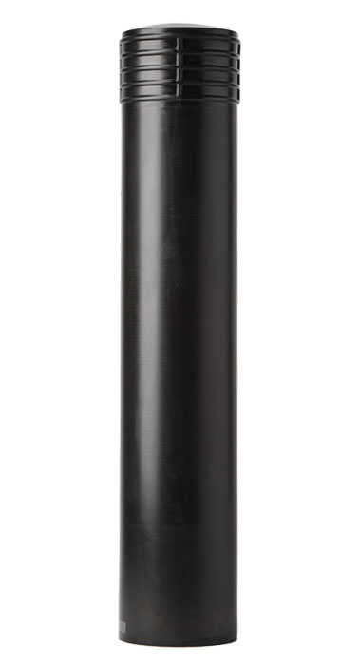Plastic Bollard Cover [Designer’s Designation]:

Model: Reliance Foundry; **R-7173-L.**

Design: Large cylinder with banded top.

Height: 59.5 inches (151.1 cm)

Base Diameter: 11.6 inches (29.5 cm)

Weight: 15 lbs. (6.8 kg)

Maximum Interior Post Height: 57 inches (144.8 cm)

Maximum Interior Post Diameter: 10.7 inches (27.3 cm)

Color: [Yellow] [White] [Dark Blue] [Red] [Black] [Grey] [Green] [Orange]

[Brown] [Light Blue].

Installation: Security post, self-adhesive neoprene tape.

* + - * 1. 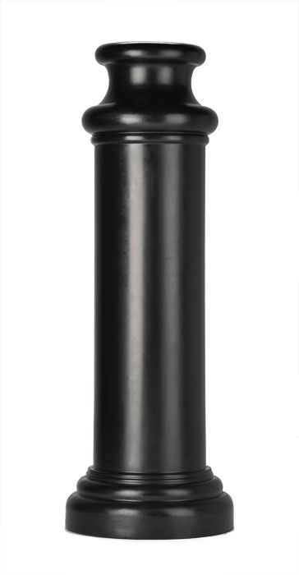Plastic Bollard Cover [Designer’s Designation]:

Model: Reliance Foundry; **R-7174.**

Design: Cylinder with tapered base and sculpted flat top.

Height: 48.5 inches (123.1 cm)

Base Diameter: 17 inches (43.2 cm)

Weight: 15 lbs. (6.8 kg)

Maximum Interior Post Height: 45 inches (114.3 cm)

Maximum Interior Post Diameter: 10.7 inches (27.3 cm)

Color: [Yellow] [White] [Dark Blue] [Red] [Black] [Grey] [Green] [Orange]

[Brown] [Light Blue].

Installation: Security post, self-adhesive neoprene tape.

* + - * 1. 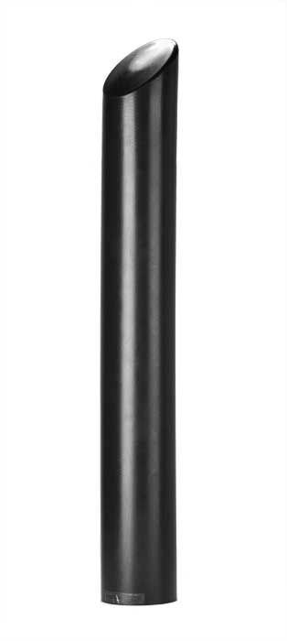Plastic Bollard Cover [Designer’s Designation]:

Model: Reliance Foundry; **R-7175.**

Design: Cylinder with angled top.

Height: 57 inches (144.8 cm)

Base Diameter: 7.3 inches (18.4 cm)

Weight: 12 lbs. (5.4 kg)

Maximum Interior Post Height: 47 inches (119.4 cm)

Maximum Interior Post Diameter: 6.6 inches (16.8 cm)

Color: [Yellow] [White] [Dark Blue] [Red] [Black] [Grey] [Green] [Orange] [Brown] [Light Blue].

Installation: Security post, self-adhesive neoprene tape.

* + - * 1. 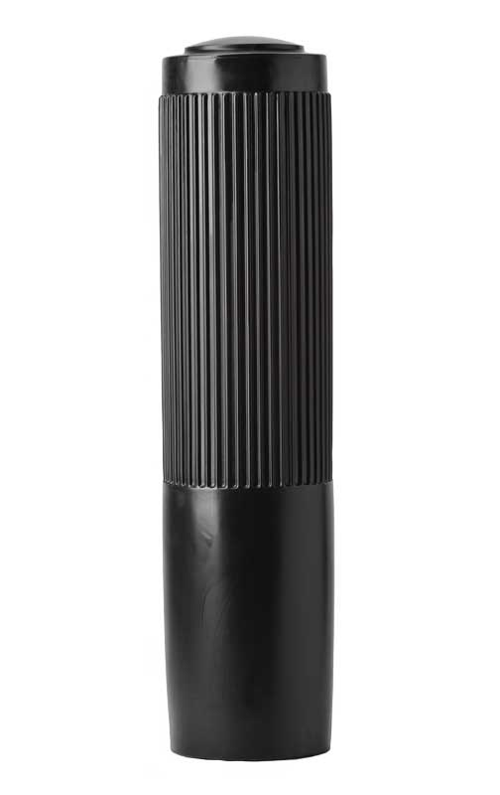Plastic Bollard Cover [Designer’s Designation]:

Model: Reliance Foundry; **R-7176.**

Design: Cylinder with ribbed exterior.

Height: 48 inches (121.9 cm)

Base Diameter: 12.3 inches (31.1 cm)

Weight: 15 lbs. (6.8 kg)

Maximum Interior Post Height: 45 inches (114.3 cm)

Maximum Interior Post Diameter: 10.6 inches (26.9 cm)

Color: [Yellow] [White] [Dark Blue] [Red] [Black] [Grey] [Green] [Orange]

[Brown] [Light Blue].

Installation: Security post, self-adhesive neoprene tape.

1. EXECUTION
   * + 1. EXAMINATION
          1. Examine paving or other substrates for compliance with manufacturer’s requirements for placement and location of embedded items, condition of substrate, and other conditions affecting installation of bollards.
          2. Proceed with installation only after unsatisfactory conditions have been corrected.
       2. INSTALLATION
          1. General: Comply with manufacturer’s installation instructions and setting drawings.
          2. Do not install damaged, cracked, chipped, deformed, or marred bollards. Field touch-up minor imperfections in accordance with manufacturer’s instructions. Replace bollards that cannot be field repaired.

Retain below and add project-specific detail, if new security posts are required. See http://www.reliance-foundry.com/bollard/steel-pipe for considerations for placing security posts.

* + - * 1. Security Posts:

Embed with grout in formed or cored holes in concrete.

Embed in concrete footings.

* + - * 1. Plastic Bollard Covers: Install over foam strips in pattern indicated in manufacturer's instructions.
        2. Decorative Bollard Covers: Install over neoprene adhesive tape as indicated in manufacturer's instructions.
      1. CLEANING & PROTECTION

Normal cleaning may be done with clean water and a soft cloth. Detailed cleaning and inspection instructions are available at http://www.reliance-foundry.com/bollard/maintenance-bollards

* + - * 1. Protect bollards against damage.
        2. Immediately prior to Substantial Completion, clean bollards in accordance with manufacturer’s instructions to remove dust, dirt, adhesives, and other foreign materials.
        3. Touch up damaged finishes according to manufacturer’s instructions.
      1. CLOSEOUT ACTIVITIES
         1. Provide executed warranty.

END OF SECTION

Copyright 2018 by Reliance Foundry Co. Ltd.; qualified design and construction professionals may copy for preparation of construction specifications and purchase orders for Reliance Foundry products. Issued April 2018. Subject to change.

Issued July 2016. Subject to change.