Reliance Foundry Co Ltd

#207-6450 148 St

Surrey, BC V3S 7G7

Phone: 604-547-0460

Phone: 1-877-789-3245

Fax: 604 590-8875

Email: info@reliance-foundry.com

Website: www.reliance-foundry.com

Reliance Foundry is an award-winning supplier of high quality stock and custom-designed site furnishings

for architectural, traffic management, and industrial applications. Reliance Foundry brings over 90 years of expertise to the design and manufacturing of our products.

Reliance Foundry bicycle lockers offer security to both cyclists and building owners by enclosing bicycles and gear. The locker design supports a range of versatile configurations. Reliance Foundry bicycle racks and bike parking bollards increase cyclist access and security, prevent damage to trees and other streetscape features, and promote sustainable lifestyles in your community.

Specification Coordination: Edit this guide specification to meet project requirements. Coordinate with other specification sections as required. If using more than one bike rack or bike bollard type, use the same designation in both drawings and specifications. Display hidden text to see or print notes to specifier.

Drawing Coordination: Show locations, sizes, layout, and spacing of each type of bike locker, rack, or bollard required. Soft metric conversion is provided for all measurements.

**SECTION 12 93 14**

**BICYCLE LOCKERS**

1. GENERAL
   * + 1. SUMMARY
          1. Section Includes: Bicycle lockers
       2. ACTION SUBMITTALS
          1. Manufacturer's Product Data

Delete the paragraph below if specifying colors in this section or in Drawings.

Reliance's bicycle storage units may contribute to these and other LEED credits. Adjust the list below to reflect credits sought for the project.

Credits below are based on LEED 2009 New Construction, Core and Shell, and Schools rating systems.

* + - * 1. LEED Submittals:

Credit SS 4.2, Alternative Transportation – Bicycle Storage and Changing Rooms: Provide product data indicating number of bicycles stored by each bicycle storage unit. Include statement indicating total number of bicycle storage units and total number of bicycles stored.

* + - * 1. Setting Drawings: Show embedded items and cutouts required for work specified in other Sections.
      1. CLOSEOUT SUBMITTALS
         1. Manufacturer's Maintenance Instructions for field touch-up of finishes, cleaning, and maintenance.
         2. Warranty Documentation: Submit sample of manufacturer’s warranty.
      2. DELIVERY, STORAGE, AND HANDLING
         1. Protect bicycle lockers and accessories during delivery, storage, and handling to comply with manufacturer’s instructions and prevent damage.
      3. WARRANTY

See http://www.reliance-foundry.com/site/documents/warranty-bollards-and-bike-parking-products.pdf for warranty information.

* + - * 1. Manufacturer's Warranty: One-year warranty from date of invoice.

1. PRODUCTS
   * + 1. BICYCLE LOCKERS
          1. Manufacturer: Reliance Foundry Co. Ltd.

Phone: 604-547-0460 or 1-877-789-3245

Fax: 604-590-8875

Website: <http://www.reliance-foundry.com/bike-lockers>

Email: [info@reliance-foundry.com](mailto:info@reliance-foundry.com)

* + - * 1. Substitutions: [Comply with provisions of [Section 01 25 00 "Substitution Procedures"] [_________] for substitution procedures.] [Not allowed.]
        2. Reliance Foundry Model R-8285:

|  |  |
| --- | --- |
| Size  Height: 48 inches (121.9 cm)  Length: 80 inches (203.2 cm)  Width (front): 36 inches (91.4 cm)  Width (rear): 11 inches (27.9 cm)  Weight: 163 lbs. (73.9 kg)  Installation: [Surface mounting using drop-in anchors with internal bolts]  Color: [Charcoal Black]  Door Hardware  Two-point latching level of galvanize steel  Solid door-locking mechanism using single padlock  Stainless steel door stop plate |  |

* + - 1. MATERIALS
         1. Material: High Density Polyethylene (HPDE) and Medium Density Polyethylene (MPDE).

Doors: HDPE octene copolymer, with insulation foam.

Flexural Modulus: 119,500 psi minimum.

Tensile Strength: 4,250 psi minimum.

Insulation: Foamable polyethylene micropellets.

Body: MDPE hexane copolymer.

Flexural Modulus: 110,230 psi minimum.

Tensile Strength: 3,000 psi minimum.

* + - 1. ACCESSORIES
         1. Mounting Accessories

Epoxy adhesive: As recommended in writing by adhesive manufacturer for outdoor use with concrete and galvanized steel.

Standard nuts are provided with bicycle lockers. Where lockers may be vulnerable to vandalism or theft, consider using optional security fasteners. With security fasteners, coordinate with Part 1 Maintenance Material Submittals.

Bolts and Washers: Galvanized steel

* + - * 1. Locks: User-supplied.

1. EXECUTION
   * + 1. EXAMINATION
          1. Examine paving or other substrates for compliance with manufacturer’s requirements for placement and location of embedded items, condition of substrate, and other conditions affecting installation of bicycle lockers.
          2. Proceed with installation only after unsatisfactory conditions have been corrected.
       2. INSTALLATION

Drawing Coordination: Ensure that bicycle lockers, when in use, do not impede required paths of egress and accessible travel. Allow adequate clearance for bicycle storage and removal.

* + - * 1. General: Comply with manufacturer’s installation requirements and setting drawings.
        2. Install according to manufacturer's written instructions by concrete insert method.
        3. Do not install damaged, cracked, chipped, deformed, or marred bicycle lockers. Field touch-up minor imperfections in accordance with manufacturer’s instructions. Replace bicycle lockers that cannot be field repaired.
      1. CLEANING
         1. Immediately prior to Substantial Completion, clean bicycle lockers in accordance with manufacturer’s instructions to remove dust, dirt, adhesives, and other foreign materials.
      2. PROTECTION
         1. Protect bicycle lockers against damage.

**SECTION 12 93 13**

**BICYCLE RACKS**

1. GENERAL
   * + 1. SUMMARY
          1. Section Includes: Bicycle racks.
          2. Related Requirements:

Section 32 39 13.13 – Metal Bike Parking Bollards

See http://www.reliance-foundry.com/bike-storage for metal bike parking bollard specifications.

* + - 1. REFERENCES
         1. Reference Standards:

AAMA 2603 – Pigmented Organic Coatings on Aluminum Extrusions and Panels.

ASTM A36 – Carbon Structural Steel.

ASTM A53 – Pipe, Steel, Black and Hot-Dipped, Zinc-Coated, Welded, and Seamless.

ASTM A312 – Seamless, Welded, and Heavily Cold Worked Austenitic Stainless Steel Pipes.

ASTM A959 – Harmonized Standard Grade Compositions for Wrought Stainless Steels.

* + - 1. ACTION SUBMITTALS
         1. Manufacturer's Product Data.

Delete paragraph below if specifying colors in this section or in Drawings.

* + - * 1. Samples for Initial Selection: Color card of manufacturer's standard colors.
        2. Samples for Verification: Specified finish.

Reliance's bicycle storage units may contribute to these and other LEED credits. Adjust list below to reflect credits sought for the project.

Credits below are based on LEED 2009 New Construction, Core and Shell, and Schools rating systems.

* + - * 1. LEED Submittals:

Credit SS 4.2, Alternative Transportation – Bicycle Storage and Changing Rooms: Provide Product Data indicating number of bicycles stored by each bicycle storage unit. Include statement indicating total number of bicycle storage units and total number of bicycles stored.

Credit MR 4, Recycled Content: For products having recycled content, provide Product Data indicating percentages by weight of post-consumer and pre-consumer recycled content. Include statement indicating cost for each product having recycled content.

* + - * 1. Setting Drawings: Show embedded items and cutouts required for work specified in other Sections.
      1. CLOSEOUT SUBMITTALS
         1. Manufacturer's Maintenance Instructions for field touch-up of finishes, cleaning, and maintenance.
         2. Warranty Documentation: Submit sample of manufacturer’s warranty.
      2. MAINTENANCE MATERIAL SUBMITTALS

Retain this article if security nuts are required in Part 2 and Owner anticipates a need to remove bicycle racks.

* + - * 1. Security Nut Tools: Tools provided or recommended by security nut manufacturer for operating security nuts (not provided by manufacturer)

Type: [Bit for drill or power screwdriver] [Hand driver with handle]

Quantity: [2] [Other number of tools required]

Delivery: Submit tools directly to [Owner] [Owner's Representative].

* + - 1. DELIVERY, STORAGE, AND HANDLING

See http://www.reliance-foundry.com/bike-storage/maintenance-bike-parking for maintenance instructions.

* + - * 1. Protect racks and accessories during delivery, storage, and handling to comply with manufacturer’s instructions and prevent damage.
      1. WARRANTY

See http://www.reliance-foundry.com/site/documents/warranty-bollards-and-bike-parking-products.pdf for warranty information.

* + - * 1. Manufacturer's Warranty: agreeing to repair, replace, or refund the purchase price of bike parking products found defective, within the following time periods.

Material and workmanship: Five-year metal components warranty.

Coatings: Two-year warranty against peeling, cracking, and significant color change.

1. PRODUCTS
   1. BICYCLE RACKS
      * + 1. Manufacturer: Reliance Foundry Co. Ltd.

Phone: 604-592-4333 or 888-735-5680

Fax: 604-590-8875

Website: <http://www.reliance-foundry.com/bike-storage>

Email: [info@reliance-foundry.com](mailto:info@reliance-foundry.com).

* + - * 1. Substitutions: [Comply with provisions of [Section 01 25 00 "Substitution Procedures"] [_________] for substitution procedures.] [Not allowed.]
        2. Bicycle Racks:

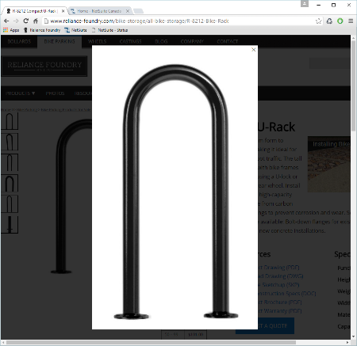Reliance Foundry Model **R-8212**[-SS]

Height: 35.5 inches (90.2 cm)

Width: 14.5 inches (36.8 cm)

Weight: 22 lbs. (9.9 kg)

Design: Inverted U.

Metal: [Steel] [Stainless Steel].

Installation: [Concrete Insert, Surface/Flange Mount]

[Concrete Embedded, In-ground Mount]

Color: [Textured black] [Dark green] [Statuary bronze]

[Bengal silver] [Anodized silver] [Safety yellow]

Reliance Foundry Model **R-8224**[-SS]

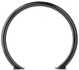Height: 31.5 inches (80 cm)

Width: 35.5 inches (90.2 cm)

Weight: 33 lbs. (15 kg)

Design: Circle.

Metal: [Steel] [Stainless Steel].

Installation: [Concrete Insert, Surface/Flange Mount] [Concrete Embedded, In-ground Mount]

Color: [Textured black] [Dark green] [Statuary bronze]

[Bengal silver] [Anodized silver] [Safety yellow]

Reliance Foundry Model **R-8234**

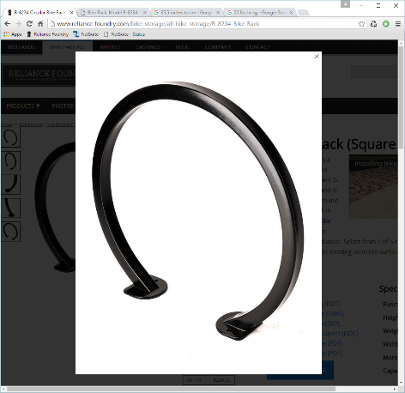Height: 31.5 inches (80 cm)

Width: 35.5 inches (90.2 cm)

Weight: 31 lbs. (14 kg)

Design: Circle of square tubing.

Metal: [Steel]

Installation: [Concrete Insert, Surface/Flange Mount]

[Concrete Embedded, In-ground Mount]

Color: [Textured black] [Dark green] [Statuary bronze]

[Bengal silver] [Anodized silver] [Safety yellow]

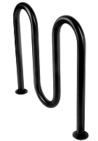Reliance Foundry Model **R-8239[-SS]**

Height: 36 inches (91.4 cm)

Width: 39 inches (99 cm)

Weight: 49 lbs. (22.2 kg)

Design: Multi-Curve wave racks (3 curve).

Metal: [Steel] [Stainless Steel].

Installation: [Concrete Insert, Surface/Flange Mount] [Concrete Embedded, In-ground Mount]

Color: [Textured black] [Dark green] [Statuary bronze]

[Bengal silver] [Anodized silver] [Safety yellow]

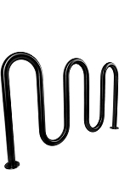Reliance Foundry Model **R-8240[-SS]**

Height: 36 inches (91.4 cm)

Width: 63.5 inches (161.3 cm)

Weight: 54 lbs. (24.5 kg)

Design: Multi-Curve wave racks (5 curve).

Metal: [Steel] [Stainless Steel].

Installation: [Concrete Insert, Surface/Flange Mount] [Concrete Embedded, In-ground Mount]

Color: [Textured black] [Dark green] [Statuary bronze]

[Bengal silver] [Anodized silver] [Safety yellow]

Reliance Foundry Model **R-8246[-SS]**

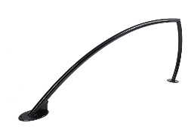Height: 33 inches (83.8 cm)

Width: 59 inches (149.9 cm)

Weight: 31 lbs. (14 kg)

Design: Shark fin.

Metal: [Steel] [Stainless Steel].

Installation: [Surface/Flange Mount] [Concrete Embedded, In-ground Mount]

Color: [Textured black] [Dark green] [Statuary bronze]   
[Bengal silver] [Anodized silver] [Safety yellow]

* + - 1. METALS
         1. Steel:

Pipe: ASTM A53, Type F or Type S, Grade A.

Plate, Shapes and Bars: ASTM A36.

Recycled Content of Steel Products: Postconsumer recycled content plus one-half of preconsumer recycled content not less than 25 percent.

Powder-Coat Finish: AAMA 2603 except with a minimum dry film thickness of 1.5 mils. Comply with coating manufacturer's written instructions.

* + - * 1. Stainless Steel: AISI Grade 316.

Pipe: ASTM A312.

Sheet, Strip, and Plate: ASTM A959.

Finish: Buffed Satin Finish No. 6.

* + - 1. ACCESSORIES
         1. Mounting Accessories

Epoxy adhesive: As recommended in writing by adhesive manufacturer for outdoor use with concrete and steel.

Fasteners

[Standard: 1/2 inch UNC Button Head Bolts, c/w SS Washer.] [As specified.]

Drop in place concrete anchors, for 1/2 inch UNC bolts.

Sealant: Silicone elastomeric sealant recommended for outdoor use.

* + - 1. FABRICATION
         1. Fabricate units with welded connections.
         2. Fabricate connections that will be exposed to weather in a manner to exclude water. Provide weep holes where water may accumulate.
         3. Provide inserts and other anchorage devices for connecting bicycle racks to substrate.
         4. Protect finishes from damage before shipping.
         5. Provide exposed [fasteners] [accessories] with stainless materials.

1. EXECUTION
   * + 1. EXAMINATION
          1. Examine paving or other substrates for compliance with manufacturer’s requirements for placement and location of embedded items, condition of substrate, and other conditions affecting installation of bicycle racks.
          2. Proceed with installation only after unsatisfactory conditions have been corrected.
       2. INSTALLATION
          1. General: Comply with manufacturer’s installation requirements and setting drawings.
          2. Install according to manufacturer's written instructions for specified setting method.
          3. Do not install damaged, cracked, chipped, deformed or marred bicycle racks. Field touch-up minor imperfections in accordance with manufacturer’s instructions. Replace bicycle racks that cannot be field repaired.
       3. CLEANING
          1. Immediately prior to Substantial Completion, clean racks in accordance with manufacturer’s instructions to remove dust, dirt, adhesives, and other foreign materials.
       4. PROTECTION
          1. Protect bicycle racks against damage.

**SECTION 32 39 13.13**

**METAL BIKE PARKING BOLLARDS**

1. GENERAL
   * + 1. SUMMARY
          1. Section Includes:

Metal Bicycle bollards.

Accessories.

[_________________]

Edit following to coordinate with other specification sections in project.

* + - * 1. Related Requirements:

Section 12 93 13 – Manufactured Bicycle Racks

[Division 03 Sections: [Concrete] [Mortar] fill for security posts.]

[Division 08 Sections: Padlocks.]

[_________________]

Edit below to include only reference standards used in project.

* + - 1. REFERENCE STANDARDS
         1. ASTM A36 – Standard Specification for Carbon Structural Steel.
         2. ASTM A312 – Standard Specification for Seamless, Welded, and Heavily Cold Worked Austenitic Stainless Steel Pipes.
         3. ASTM A500 – Standard Specification for Cold-Formed Welded and Seamless Carbon Steel Structural Tubing in Rounds and Shapes.
         4. ASTM A536 – Standard Specification for Ductile Iron Castings.
         5. ASTM B26 – Standard Specification for Aluminum-Alloy Sand Castings.
      2. SUBMITTALS
         1. Comply with Section [01 33 00 – Submittal Procedures.] [_________.]
         2. Product Data: Provide for each type of bollard, component, finish, and accessory specified.
         3. Color Samples: [Submit manufacturer’s standard colors for selection.] [Submit sample of color specified.]
         4. Setting Drawings: Show embedded items and cutouts required for work specified in other Sections.
         5. Maintenance Data: Submit manufacturer’s field touch-up, cleaning, and maintenance instructions.
         6. Warranty Documentation: Submit sample of manufacturer’s warranty.
      3. QUALITY ASSURANCE
         1. Comply with Section [01 43 00 – Quality Assurance.] [_________.]
      4. DELIVERY, STORAGE, AND HANDLING
         1. Comply with Section [01 66 00 – Product Storage and Handling Requirements.] [_________.]
         2. Protect bollards and accessories during delivery, storage, and handling.
      5. WARRANTY
         1. Comply with Section [01 78 36 – Warranties.] [_________.]
         2. Provide manufacturer’s standard warranty against defects in materials and workmanship.

Warranty Period: Five years from date of invoice, except as otherwise indicated.

Coatings: Two years, against peeling, cracking, or significant color change.

1. PRODUCTS
   * + 1. MANUFACTURERS
          1. Manufacturer: Reliance Foundry Co. Ltd.

Phone: 604-547-0460 or 1-877-789-3245

Fax: 604-590-8875

Website: <http://www.reliance-foundry.com/bike-parking/bike-bollards>

Email: [info@reliance-foundry.com](mailto:info@reliance-foundry.com)

* + - * 1. Substitutions: [Comply with provisions of [Section 01 25 00 "Substitution Procedures"] [_________] for substitution procedures.] [Not allowed.]
      1. 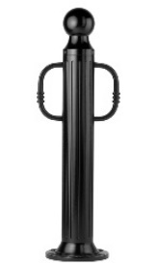METAL BICYCLE BOLLARDS

Bollard arms are available to factory customize bollards for lifting assistance or bicycle parking. Contact Reliance Foundry for more information.

* + - * 1. Bike Bollard [Designer’s Designation]:

Model: Reliance Foundry; **R-7530-B**.

Height: 39 inches (99 cm)

Diameter: 5 inches (12.7 cm) body; 10 inches (25.4 cm) base

Weight: 67 lbs. (30.4 kg)

Design: Cylindrical and fluted, with tapered bottom, ball top and bike arms.

Material:

Aluminum: ASTM B26; 20 percent recycled-material content.

Ductile Cast Iron: ASTM A536, Grade 65-45-12; 30 percent recycled-material content.

Country of Origin: China.

Arms: Match body.

Color Coating:

Type: Polyester powder coat over epoxy primer.

Color: [Black textured semi gloss] [Dark green] [Statuary bronze] [Bengal silver] [Anodized silver] [Safety yellow].

Installation:

Fixed, new concrete, anchor.

Fixed, existing concrete, insert.

Fixed, existing concrete, adhesive.

Fixed, existing concrete, flange and insert.

Fixed, new concrete, anchor with concrete form.

Security post cover, new post.

Security post cover, existing post, insert.

Security post cover, existing post, adhesive.

Removable, new concrete, anchor.

Removable, existing concrete, insert.

Removable, new concrete, premium removable mounting

* + - * 1. 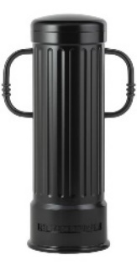Bike Bollard [Designer’s Designation]:

Model: Reliance Foundry; **R-7535-B**.

Height: 39 inches (99 cm)

Diameter: 12 inches (30.5 cm) body; 14 inches (35.5 cm) base

Weight: 216 lbs. (98 kg)

Design: Cylindrical and fluted, with a rounded top and bike arms.

Material: Ductile Cast Iron: ASTM A536, Grade 65-45-12; 30 percent recycled-material content.

Country of Origin: China.

Arms: Match body.

Color Coating:

Type: Polyester powder coat over epoxy primer.

Color: [Black textured semi gloss] [Dark green] [Statuary bronze] [Bengal silver] [Anodized silver] [Safety yellow].

Installation:

Fixed, new concrete, anchor.

Fixed, existing concrete, insert.

Fixed, existing concrete, adhesive.

Fixed, new concrete, anchor with concrete form.

Security post cover, new post.

Security post cover, existing post, insert.

Security post cover, existing post, adhesive.

* + - * 1. 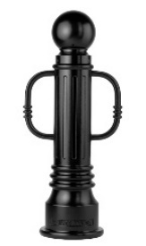Bike Bollard [Designer’s Designation]:

Model: Reliance Foundry; **R-7539-B**.

Height: 35.75 inches (90.8 cm)

Diameter: 6 inches (15.2 cm) body; 10.25 inches (26 cm) base

Weight: 80 lbs. (36.3 kg)

Design: Tapered and fluted, with round finial, ball top and bike arms.

Material:

Aluminum: ASTM B26; 20 percent recycled-material content.

Ductile Cast Iron: ASTM A536, Grade 65-45-12; 30 percent recycled-material content.

Country of Origin: China.

Arms: Match body.

Color Coating:

Type: Polyester powder coat over epoxy primer.

Color: [Black textured semi gloss] [Dark green] [Statuary bronze] [Bengal silver] [Anodized silver] [Safety yellow].

Installation:

Fixed, new concrete, anchor.

Fixed, existing concrete, insert.

Fixed, existing concrete, adhesive.

Fixed, new concrete, anchor with concrete form.

Security post cover, new post.

Security post cover, existing post, insert.

Security post cover, existing post, adhesive.

Removable, new concrete, anchor.

Removable, existing concrete, insert.

Removable, new concrete, premium removable mounting

* + - * 1. 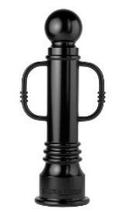Bike Bollard [Designer’s Designation]:

Model: Reliance Foundry; **R-7551-B**.

Height: 35.75 inches (90.8 cm)

Diameter: 6 inches (15.2 cm) body; 10.25 inches (26 cm) base

Weight: 87 lbs. (39.5 kg)

Design: Tapered with round finial, ball top and bike arms.

Material:

Aluminum: ASTM B26; 20 percent recycled-material content.

Ductile Cast Iron: ASTM A536, Grade 65-45-12; 30 percent recycled-material content.

Country of Origin: China.

Arms: Match body.

Color Coating:

Type: Polyester powder coat over epoxy primer.

Color: [Black textured semi gloss] [Dark green] [Statuary bronze] [Bengal silver] [Anodized silver] [Safety yellow].

Installation:

Fixed, new concrete, anchor.

Fixed, existing concrete, insert.

Fixed, existing concrete, adhesive.

Fixed, new concrete, anchor with concrete form.

Security post cover, new post.

Security post cover, existing post, insert.

Security post cover, existing post, adhesive.

Removable, new concrete, anchor.

Removable, existing concrete, insert.

Removable, new concrete, premium removable mounting

* + - * 1. 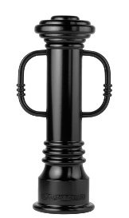Bollard [Designer’s Designation]:

Model: Reliance Foundry; **R-7553-B**

Height: 31.75 inches (90.8 cm)

Diameter: 6 inches (15.2 cm) body; 10.25 inches (26 cm) base

Weight: 86 lbs. (39 kg)

Design: Tapered with round finial and flat disc top and bike arms

Material: Ductile Cast Iron: ASTM A536, Grade 65-45-12; 30 percent recycled-material content.

Country of Origin: China.

Color Coating:

Type: Polyester powder coat over epoxy primer.

Color: [Black textured semi gloss] [Dark green] [Statuary bronze] [Bengal silver] [Anodized silver] [Safety yellow].

Installation:

Fixed, new concrete, anchor.

Fixed, existing concrete, insert.

Fixed, existing concrete, adhesive.

Fixed, new concrete, anchor with concrete form.

Security post cover, new post.

Security post cover, existing post, insert.

Security post cover, existing post, adhesive.

Removable, new concrete, anchor.

Removable, existing concrete, insert.

* + - * 1. 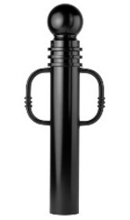Bike Bollard [Designer’s Designation]:

Model: Reliance Foundry; **R-7571-B**.

Height: 40.5 inches (102.9 cm)

Diameter: 5.75 inches (14.6 cm) body; 5.75 inches (14.6 cm) base

Weight: 67 lbs. (30.4 kg)

Design: Cylindrical with round finial, ball top and bike arms.

Material: Ductile Cast Iron: ASTM A536, Grade 65-45-12; 30 percent recycled-material content.

Country of Origin: China.

Arms: Match body.

Color Coating:

Type: Polyester powder coat over epoxy primer.

Color: [Black textured semi gloss] [Dark green] [Statuary bronze] [Bengal silver] [Anodized silver] [Safety yellow].

Installation:

Fixed, new concrete, anchor.

Fixed, existing concrete, insert.

Fixed, existing concrete, adhesive.

Fixed, new concrete, anchor with concrete form.

Security post cover, new post.

Security post cover, existing post, insert.

Security post cover, existing post, adhesive.

Removable, new concrete, anchor.

Removable, existing concrete, insert.

Removable, new concrete, premium removable mounting

* + - * 1. 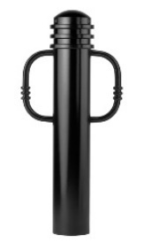Bike Bollard [Designer’s Designation]:

Model: Reliance Foundry; **R-7576-B**.

Height: 34.25 inches (87 cm)

Diameter: 5.75 inches (14.6 cm) body; 5.75 inches (14.6 cm) base

Weight: 56 lbs. (25.4 kg)

Design: Cylindrical with round finial, rounded top and bike arms.

Material: Ductile Cast Iron: ASTM A536, Grade 65-45-12; 30 percent recycled-material content.

Country of Origin: China.

Arms: Match body.

Color Coating:

Type: Polyester powder coat over epoxy primer.

Color: [Black textured semi gloss] [Dark green] [Statuary bronze] [Bengal silver] [Anodized silver] [Safety yellow].

Installation:

Fixed, new concrete, anchor.

Fixed, existing concrete, insert.

Fixed, existing concrete, adhesive.

Fixed, new concrete, anchor with concrete form.

Security post cover, new post.

Security post cover, existing post, insert.

Security post cover, existing post, adhesive.

Removable, new concrete, anchor.

Removable, existing concrete, insert.

Removable, new concrete, premium removable mounting

* + - * 1. 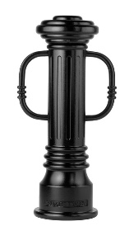Bollard [Designer’s Designation]:

Retain -AL for aluminum. Delete if not required.

Model: Reliance Foundry; **R-7591-B**

Height: 31.75 inches (80.6 cm)

Diameter: 6 inches (15.2 cm) body; 10.25 inches (26 cm) base

Weight: 82 lbs. (37.2 kg)

Design: Tapered and fluted, with round finial, flat disc top, and bike arms

Retain aluminum or cast iron to coordinate with model number.

Material: Ductile Cast Iron: ASTM A536, Grade 65-45-12; 30 percent recycled-material content.

Country of Origin: China.

Color Coating:

Type: Polyester powder coat over epoxy primer.

Color: [Black textured semi gloss] [Dark green] [Statuary bronze] [Bengal silver] [Anodized silver] [Safety yellow].

Installation:

Fixed, new concrete, anchor.

Fixed, existing concrete, insert.

Fixed, existing concrete, adhesive.

Fixed, new concrete, anchor with concrete form.

Security post cover, new post.

Security post cover, existing post, insert.

Security post cover, existing post, adhesive.

Removable, new concrete, anchor.

Removable, existing concrete, insert.

* + - * 1. 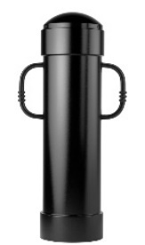Bike Bollard [Designer’s Designation]:

Model: Reliance Foundry; **R-7744-B**.

Height: 44.5 inches (113 cm)

Diameter: 11.75 inches (29.8 cm) body; 12.63 inches (32 cm) base

Weight: 163 lbs. (74 kg)

Design: Cylindrical with rounded top and bike arms.

Material:

Steel: ASTM A36; 25 percent recycled-material content.

Country of Origin: China.

Arms: Match body.

Color Coating:

Type: Polyester powder coat over epoxy primer.

Color: [Black textured semi gloss] [Dark green] [Statuary bronze] [Bengal silver] [Anodized silver] [Safety yellow].

Installation:

Fixed, new concrete, anchor.

Fixed, existing concrete, insert.

Fixed, existing concrete, adhesive.

Fixed, new concrete, anchor with concrete form.

Security post cover, new post.

Security post cover, existing post, insert.

Security post cover, existing post, adhesive.

* + - * 1. 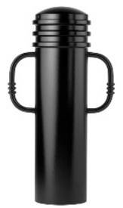Bike Bollard [Designer’s Designation]:

Model: Reliance Foundry; **R-7835-B**.

Height: 35 inches (88.9 cm)

Diameter: 9.5 inches (24.1 cm) body; 9.5 inches (24.1 cm) base

Weight: 96 lbs. (43.5 kg)

Design: Cylindrical with segmented rings, rounded top and bike arms.

Material:

Steel: ASTM A36; 25 percent recycled-material content.

Country of Origin: China.

Arms: Match body.

Color Coating:

Type: Polyester powder coat over epoxy primer.

Color: [Black textured semi gloss] [Dark green] [Statuary bronze] [Bengal silver] [Anodized silver] [Safety yellow].

Installation:

Fixed, new concrete, anchor.

Fixed, existing concrete, insert.

Fixed, existing concrete, adhesive.

Fixed, new concrete, anchor with concrete form.

Security post cover, new post.

Security post cover, existing post, insert.

Security post cover, existing post, adhesive.

Removable, new concrete, anchor.

Removable, existing concrete, insert.

Removable, new concrete, premium removable mounting

* + - * 1. 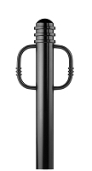Bike Bollard [Designer’s Designation]:

Model: Reliance Foundry; **R-7903**.

Height: 36 inches (91.4 cm)

Diameter: 4.33 inches (11 cm) body; 4.33 inches (11 cm) base

Weight: 44 lbs. (20 kg)

Design: Straight base with domed top, annular rings and bike arms.

Material:

Steel: ASTM A36; 25 percent recycled-material content.

Country of Origin: China.

Arms: Match body.

Color Coating:

Type: Polyester powder coat over epoxy primer.

Color: [Black textured semi gloss] [Dark green] [Statuary bronze] [Bengal silver] [Anodized silver] [Safety yellow].

Installation:

Fixed, new concrete, embedded.

Fixed, Existing Concrete, flanged surface mount.

Removable, new concrete, receiver:

[Steel] [Stainless steel]receiver with lid.

[Steel] [Stainless steel]receiver with chain.

Removable, existing concrete, receiver:

[Steel] [Stainless steel]receiver with lid.

[Steel] [Stainless steel]receiver with chain.

Collapsible, steel surface-mount with hinged receiver and padlock hasp.

* + - * 1. 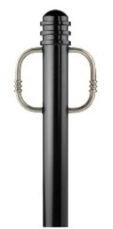Bike Bollard [Designer’s Designation]:

Model: Reliance Foundry; **R-7903-RSA**.

Height: 36 inches (91.4 cm)

Diameter: 4.33 inches (11 cm) body; 4.33 inches (11 cm) base

Weight: 45 lbs. (20.4 kg)

Design: Straight base with domed top, annular rings and bike arms.

Material:

Steel: ASTM A36; 25 percent recycled-material content.

Country of Origin: China.

Arms: Polished stainless steel.

Color Coating:

Type: Polyester powder coat over epoxy primer.

Color: [Black textured semi gloss] [Dark green] [Statuary bronze] [Bengal silver] [Anodized silver] [Safety yellow].

Installation:

Fixed, new concrete, embedded.

Fixed, Existing Concrete, flanged surface mount.

Removable, new concrete, receiver:

[Steel] [Stainless steel]receiver with lid.

[Steel] [Stainless steel]receiver with chain.

Removable, existing concrete, receiver:

[Steel] [Stainless steel]receiver with lid.

[Steel] [Stainless steel]receiver with chain.

Collapsible, steel surface-mount with hinged receiver and padlock hasp.

* + - * 1. Bike Bollard [Designer’s Designation]:

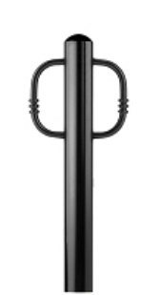Model: Reliance Foundry; **R-7904**.

Height: 36 inches (91.4 cm)

Diameter: 4.33 inches (11 cm) body; 4.33 inches (11 cm) base

Weight: 36 lbs. (16.4 kg)

Design: Straight base with domed top and bike arms.

Material:

Steel: ASTM A36; 25 percent recycled-material content.

Country of Origin: China.

Arms: Match body.

Color Coating:

Type: Polyester powder coat over epoxy primer.

Color: [Black textured semi gloss] [Dark green] [Statuary bronze] [Bengal silver] [Anodized silver] [Safety yellow].

Installation:

Fixed, new concrete, embedded.

Fixed, Existing Concrete, flanged surface mount.

Removable, new concrete, receiver:

[Steel] [Stainless steel]receiver with lid.

[Steel] [Stainless steel]receiver with chain.

Removable, existing concrete, receiver:

[Steel] [Stainless steel]receiver with lid.

[Steel] [Stainless steel]receiver with chain.

Collapsible, steel surface-mount with hinged receiver and padlock hasp.

* + - * 1. Bike Bollard [Designer’s Designation]:

Model: Reliance Foundry; **R-7904-RSA**.

Height: 36 inches (91.4 cm)

Diameter: 4.33 inches (11 cm) body; 4.33 inches (11 cm) base

Weight: 36 lbs. (16.3 kg)

Design: Straight base with domed top and bike arms.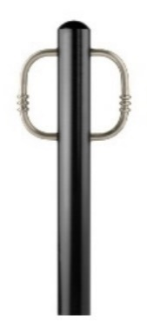

Material:

Steel: ASTM A36; 25 percent recycled-material content.

Country of Origin: China.

Arms: Uncoated stainless steel.

Color Coating:

Type: Polyester powder coat over epoxy primer.

Color: [Black textured semi gloss] [Dark green] [Statuary bronze] [Bengal silver] [Anodized silver] [Safety yellow].

Installation:

Fixed, new concrete, embedded.

Fixed, Existing Concrete, flanged surface mount.

Removable, new concrete, receiver:

[Steel] [Stainless steel]receiver with lid.

[Steel] [Stainless steel]receiver with chain.

Removable, existing concrete, receiver:

[Steel] [Stainless steel]receiver with lid.

[Steel] [Stainless steel]receiver with chain.

Collapsible, steel surface-mount with hinged receiver and padlock hasp.

* + - * 1. 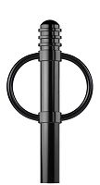Bike Bollard [Designer’s Designation]:

Model: Reliance Foundry; **R-7905**.

Height: 36 inches (91.4 cm)

Diameter: 4.33 inches (11 cm) body; 4.33 inches (11 cm) base

Weight: 42 lbs. (19 kg)

Design: Straight base with domed top, annular rings and round bike arms.

Material:

Steel: ASTM A36; 25 percent recycled-material content.

Country of Origin: China.

Arms: Match body.

Color Coating:

Type: Polyester powder coat over epoxy primer.

Color: [Black textured semi gloss] [Dark green] [Statuary bronze] [Bengal silver] [Anodized silver] [Safety yellow].

Installation:

Fixed, new concrete, embedded.

Fixed, Existing Concrete, flanged surface mount.

Removable, new concrete, receiver:

[Steel] [Stainless steel]receiver with lid.

[Steel] [Stainless steel]receiver with chain.

Removable, existing concrete, receiver:

[Steel] [Stainless steel]receiver with lid.

[Steel] [Stainless steel]receiver with chain.

Collapsible, steel surface-mount with hinged receiver and padlock hasp.

* + - * 1. 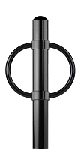Bike Bollard [Designer’s Designation]:

Model: Reliance Foundry; **R-7906**.

Height: 36 inches (91.4 cm)

Diameter: 4.33 inches (11 cm) body; 4.33 inches (11 cm) base

Weight: 40 lbs. (18 kg)

Design: Straight base with domed top and round bike arms.

Material:

Steel: ASTM A36; 25 percent recycled-material content.

Country of Origin: China.

Arms: Match body.

Color Coating:

Type: Polyester powder coat over epoxy primer.

Color: [Black textured semi gloss] [Dark green] [Statuary bronze] [Bengal silver] [Anodized silver] [Safety yellow].

Installation:

Fixed, new concrete, embedded.

Fixed, Existing Concrete, flanged surface mount.

Removable, new concrete, receiver:

[Steel] [Stainless steel]receiver with lid.

[Steel] [Stainless steel]receiver with chain.

Removable, existing concrete, receiver:

[Steel] [Stainless steel]receiver with lid.

[Steel] [Stainless steel]receiver with chain.

Collapsible, steel surface-mount with hinged receiver and padlock hasp.

* + - * 1. 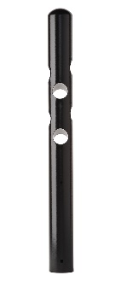Bike Bollard [Designer’s Designation]

Model: Reliance Foundry; **R-7972**.

Height: 36 inches (91.4 cm)

Diameter: 4.33 inches (11 cm) body; 4.33 inches (11 cm) base

Weight: 32 lbs. (14.5 kg)

Design: Straight base with domed top and cylindrical bike-locking cavities.

Material:

Steel: ASTM A36; 25 percent recycled-material content.

Country of Origin: China.

Color Coating:

Type: Polyester powder coat over epoxy primer.

Color: [Black textured semi gloss] [Dark green] [Statuary bronze] [Bengal silver] [Anodized silver] [Safety yellow].

Installation:

Fixed, new concrete, embedded.

Fixed, Existing Concrete, flanged surface mount.

Removable, new concrete, receiver:

[Steel] [Stainless steel]receiver with lid.

[Steel] [Stainless steel]receiver with chain.

Removable, existing concrete, receiver:

[Steel] [Stainless steel]receiver with lid.

[Steel] [Stainless steel]receiver with chain.

Collapsible, steel surface-mount with hinged receiver and padlock hasp.

* + - * 1. Bike Bollard [Designer’s Designation]:

Model: Reliance Foundry; **R-8903**.

Height: 36 inches (91.4 cm)

Diameter: 4.33 inches (11 cm) body; 4.33 inches (11 cm) base

Weight: 44 lbs. (20 kg)

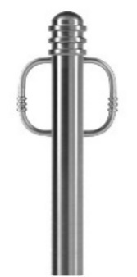Design: Straight base with domed top, annular rings and bike arms.

Material: Stainless steel, ASTM A312, Grade TP 316.

Country of Origin: China.

Arms: Match body.

Color Coating:

Type: Polyester powder coat over epoxy primer.

Color: [Black textured semi gloss] [Dark green] [Statuary bronze] [Bengal silver] [Anodized silver] [Safety yellow].

Installation:

Fixed, new concrete, embedded.

Fixed, Existing Concrete, flanged surface mount.

Removable, new concrete, receiver:

[Steel] [Stainless steel]receiver with lid.

[Steel] [Stainless steel]receiver with chain.

Removable, existing concrete, receiver:

[Steel] [Stainless steel]receiver with lid.

[Steel] [Stainless steel]receiver with chain.

Collapsible, steel surface-mount with hinged receiver and padlock hasp.

* + - * 1. Bike Bollard [Designer’s Designation]:

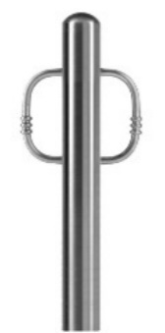Model: Reliance Foundry; **R-8904**.

Height: 36 inches (91.4 cm)

Diameter: 4.33 inches (11 cm) body; 4.33 inches (11 cm) base

Weight: 42 lbs. (19 kg)

Design: Straight base with domed top and bike arms.

Material: Stainless steel, ASTM A312, Grade TP 316.

Country of Origin: China.

Arms: Match body.

Color Coating:

Type: Polyester powder coat over epoxy primer.

Color: [Black textured semi gloss] [Dark green] [Statuary bronze] [Bengal silver] [Anodized silver] [Safety yellow].

Installation:

Fixed, new concrete, embedded.

Fixed, Existing Concrete, flange surface mount.

Removable, new concrete, receiver:

[Steel] [Stainless steel]receiver with lid.

[Steel] [Stainless steel]receiver with chain.

Removable, existing concrete, receiver:

[Steel] [Stainless steel]receiver with lid.

[Steel] [Stainless steel]receiver with chain.

Collapsible, steel surface-mount with hinged receiver and padlock hasp.

* + - 1. ACCESSORIES

Retain following if specified bollards require security posts.

* + - * 1. Security Post: Steel pipe, ASTM A500, Grade B.

Manufacturer: Reliance Foundry Co. Ltd.

Country of Origin: United States.

Finish: [Red][Grey] primer.

Installation:

Direct embed.

Footing and fill; Concrete or mortar, [3000 psi minimum.] [as specified in Section [__ __].]

Retain following if chains draped between metal bollards or bicycle bollards are required. In Drawings, show locations where chain is required, quick-release and padlock locations, and drape of chain.

* + - * 1. Chain:

5/16-inch galvanized steel chain, Grade 30, [quick-release connections.]

Provide sufficient lengths to provide drape [shown on Drawings.] [acceptable to Architect.]

Chain Eye: 5/16-inch diameter steel.

Quick Links: Powder coated chain links with barrel nut closures.

Finish: Powder coated to match bollard finish. [_______________.]

Retain padlock for removable bollards with padlock hasps and for chains with padlocks.

* + - * 1. Padlock:

[Brass] [Marine Grade], supplied [supplied by bollard manufacturer] [as specified in Section [__ __ __]]. [Key alike.]

* + - * 1. Bollard Arms:

Curved rods attach to bollard body.

Material: Stainless steel: ASTM A312, Grade TP 316

Finish: [Powder coated to match bollard [_______________.]] [Satin No. 6, buffed].

1. EXECUTION
   * + 1. EXAMINATION
          1. Examine paving or other substrates for compliance with manufacturer’s requirements for placement and location of embedded items, condition of substrate, and other conditions affecting installation of bollards.
          2. Proceed with installation only after unsatisfactory conditions have been corrected.
       2. INSTALLATION
          1. General: Comply with manufacturer’s installation instructions and setting drawings.
          2. Do not install damaged, cracked, chipped, deformed or marred bollards. Field touch-up minor imperfections in accordance with manufacturer’s instructions. Replace bollards that cannot be field repaired.
       3. CLEANING & PROTECTION

Normal cleaning may be done with clean water and a soft cloth. Detailed cleaning and inspection instructions are available at [www.reliance-foundry.com/bollard/maintenance-bollards](http://www.reliance-foundry.com/bollard/maintenance-bollards).

* + - * 1. Protect bollards against damage.
        2. Immediately prior to Substantial Completion, clean bollards in accordance with manufacturer’s instructions to remove dust, dirt, adhesives, and other foreign materials.
        3. Touch up damaged finishes according to manufacturer’s instructions.
      1. CLOSEOUT ACTIVITIES
         1. Provide executed warranty.

END OF SECTION

Copyright 2018 by Reliance Foundry Co. Ltd.; qualified design and construction professionals may copy for preparation of construction specifications and purchase orders for Reliance Foundry products.

Issued April 2018. Subject to change.