Reliance Foundry Co Ltd

#207-6450 148 St

Surrey, BC V3S 7G7

Phone: 604-547-0460

Phone: 1-877-789-3245

Fax: 604-590-8875

Email: info@reliance-foundry.com

Website: www.reliance-foundry.com

Reliance Foundry is an award-winning supplier of high quality stock and custom-designed site furnishings

for architectural, traffic management, and industrial applications. Reliance Foundry brings over 90 years of expertise to the design and manufacturing of our products.

Reliance Foundry bollards add architectural accents to your perimeter security, landscaping, traffic control, and streetscape projects. Use bollards as design features for new and existing buildings, for access control measures, traffic guidance, and as decorative covers over steel security posts. This section includes flexible bollards.

Specification Coordination: Edit this guide specification to meet project requirements. Coordinate with other specification sections as required. If using more than one bollard type, use the same designation in both drawings and specifications. Display hidden text to see or print notes to specifier.

Drawing Coordination: Show locations, sizes, layout, and spacing of each type of bollard or bollard cover required. Show footing and security post details, if required. Soft metric conversion is provided for all measurements.

**SECTION 34 71 19.16**

**FLEXIBLE VEHICLE DELINEATORS**

FLEXIBLE BOLLARDS

1. GENERAL
   * + 1. SUMMARY
          1. Section Includes:

Flexible bollards.

Accessories.

[_________________]

Edit following to coordinate with other specification sections in project.

* + - * 1. Related Requirements:

[Division 03 Sections: [Concrete] [Mortar] fill for security posts.]

[Division 08 Sections: Padlocks.]

[_________________]

* + - 1. SUBMITTALS
         1. Comply with Section [01 33 00 – Submittal Procedures.] [_________.]
         2. Product Data: Provide for each type of bollard, component, finish, and accessory specified.
         3. Color Samples: [Submit manufacturer’s standard colors for selection.] [Submit sample of color specified.]
         4. Setting Drawings: Show embedded items and cutouts required for work specified in other Sections.
         5. Maintenance Data: Submit manufacturer’s field touch-up, cleaning, and maintenance instructions.
         6. Warranty Documentation: Submit sample of manufacturer’s warranty.
      2. QUALITY ASSURANCE
         1. Comply with Section [01 43 00 – Quality Assurance.] [_________.]
      3. DELIVERY, STORAGE AND HANDLING
         1. Comply with Section [01 66 00 – Product Storage and Handling Requirements.] [_________.]
         2. Protect bollards and accessories during delivery, storage, and handling.
      4. WARRANTY
         1. Comply with Section [01 78 36 – Warranties.] [_________.]
         2. Provide manufacturer’s standard warranty against defects in materials and workmanship.

Warranty Period: Five years from date of invoice, except as otherwise indicated.

1. PRODUCTS
   * + 1. MANUFACTURERS
          1. Manufacturer: Reliance Foundry Co. Ltd.

Phone: 604-547-0460 or 1-877-789-3245

Fax: 604-590-8875

Website: <http://www.reliance-foundry.com/bollard>

Email: [info@reliance-foundry.com](mailto:info@reliance-foundry.com)

* + - * 1. Substitutions: [Comply with provisions of [Section 01 25 00 "Substitution Procedures"] [_________] for substitution procedures.] [Not allowed.]
      1. FLEXIBLE BOLLARDS
         1. Flexible Bollards, General:

Material: Polyurethane.

Thermal stability: Good +/- 10 SHORE D.

Working Temperature: -40ºC / + 60 ºC.

Fire resistance: CLASS E. As per UNE-EN-ISO 11925-2:2002

Performance Requirements:

Impact resistance: Test of 50 impacts, bending the bollard through 90º, simulating a 1500kg vehicles at 15km/h.

Fatigue resistance: Test of 500 impacts, bending the bollard through 45º, at intervals of 30 seconds.

* + - * 1. 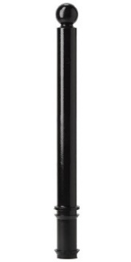Flexible Bollard [Designer’s Designation]:

Model: Reliance Foundry; **R-8301**

Height: 31 1/2 inches (80 cm)

Diameter: 3 inches (7.6 cm) body; 3 inches (7.6 cm) base

Weight: 8 lbs. (3.6 kg)

Design: Cylindrical with ball top.

Country of Origin: Spain.

Color: [Traffic Yellow] [Traffic Orange] [Traffic Red] [Night Blue] [Turquoise Green] [ Stone Gray] [Chocolate Brown] [Jet Black].

Reflective Tape: [Red] [White] [Yellow] [None].

Installation:

Fixed, new concrete, embedded.

Removable, 80 mm [light duty] [heavy duty] receiver.

* + - * 1. 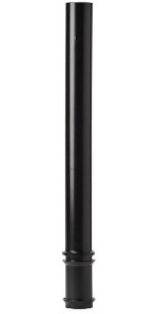Flexible Bollard [Designer’s Designation]:

Model: Reliance Foundry; **R-8302.**

Height: 35 2/5 inches (90 cm)

Diameter: 4 inches (10 cm) body; 4 inches (10 cm) base

Weight: 8 lbs. (3.6 kg)

Design: Cylindrical with flat top.

Country of Origin: Spain.

Color: [Traffic Yellow] [Traffic Orange] [Traffic Red] [Night Blue] [Turquoise Green] [ Stone Gray] [Chocolate Brown] [Jet Black].

Reflective Tape: [Red] [White] [Yellow] [None].

Installation:

Fixed, new concrete, embedded.

Removable, 100 mm [light duty] [heavy duty] receiver.

* + - * 1. Flexible Bollard [Designer’s Designation]:

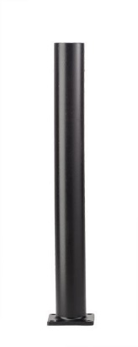Model: Reliance Foundry; **R-8302-FL**

Height: 35 4/5 inches (91 cm)

Diameter: 4 inches (10 cm) body; 4 inches (10 cm) base

Weight: 8 lbs. (3.6 kg)

Design: Cylindrical with flat top.

Country of Origin: Spain.

Color: [Traffic Yellow] [Traffic Orange] [Traffic Red] [Night Blue] [Turquoise Green] [ Stone Gray] [Chocolate Brown] [Jet Black].

Reflective Tape: [Red] [White] [Yellow] [None].

Installation:

Fixed, flanged surface mount.

* + - * 1. 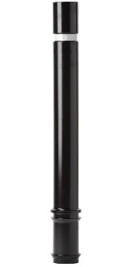Flexible Bollard [Designer’s Designation]:

Model: Reliance Foundry; **R-8303.**

Height: 31 1/2 inches (80 cm)

Diameter: 4 inches (10 cm) body; 4 inches (10 cm) base

Weight: 8 lbs. (3.6 kg)

Design: Cylindrical with flat top.

Country of Origin: Spain.

Color: [Traffic Yellow] [Traffic Orange] [Traffic Red] [Night Blue] [Turquoise Green] [ Stone Gray] [Chocolate Brown] [Jet Black].

Reflective Tape: [Red] [White] [Yellow] [None].

Installation:

Fixed, new concrete, embedded.

Removable, 100 mm [light duty] [heavy duty] receiver.

* + - * 1. 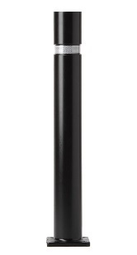Flexible Bollard [Designer’s Designation]:

Model: Reliance Foundry; **R-8303-FL**

Height: 31 1/2 inches (80 cm)

Diameter: 4 inches (10 cm) body; 4 inches (10 cm) base

Weight: 8 lbs. (3.6 kg)

Design: Cylindrical with flat top.

Country of Origin: Spain.

Color: [Traffic Yellow] [Traffic Orange] [Traffic Red] [Night Blue] [Turquoise Green] [ Stone Gray] [Chocolate Brown] [Jet Black].

Reflective Tape: [Red] [White] [Yellow] [None].

Installation:

Fixed, flanged surface mount.

* + - * 1. 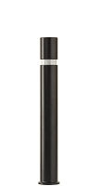Flexible Bollard [Designer’s Designation]:

Model: Reliance Foundry; **R-8303-EX.**

Height: 38 2/5 inches (97.5 cm)

Diameter: 4 inches (10 cm) body; 4 inches (10 cm) base

Weight: 10 lbs. (4.5 kg)

Design: Cylindrical with flat top.

Country of Origin: Spain.

Color: [Traffic Yellow] [Traffic Orange] [Traffic Red] [Night Blue] [Turquoise Green] [ Stone Gray] [Chocolate Brown] [Jet Black].

Reflective Tape: [Red] [White] [Yellow] [None].

Installation:

Fixed, new concrete, embedded.

Removable, 100 mm [light duty] [heavy duty] – EX receiver.

* + - * 1. 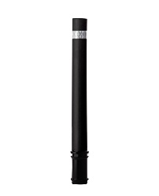Flexible Bollard [Designer’s Designation]:

Model: Reliance Foundry; **R-8323.**

Height: 34 inches (86.4 cm)

Diameter: 3.88 inches (9.86 cm) body

Weight: 6 lbs. (2.7 kg)

Design: Cylindrical with flat top.

Country of Origin: Spain.

Color: [Traffic Red] [Turquoise Green] [Jet Black].

Reflective Tape: [Red] [White] [Yellow] [None].

Installation:

Fixed, new concrete, embedded.

Removable, R-8320-R receiver

* + - 1. Accessories
         1. 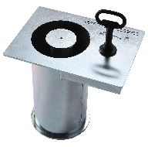Removable mounting receiver: 80 mm light duty

Parts: Receiver and key

Compatible Models: R-8301 flexible bollards

Material: AISI 304 Stainless Steel

Installation: Concrete embed.

* + - * 1. Removable mounting receiver: 80 mm heavy duty

Parts: Receiver and key

Compatible Models: R-8301 flexible bollards

Material: Galvanized Steel and AISI 304 Stainless Steel

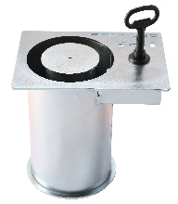Installation: Concrete embed.

* + - * 1. Removable mounting receiver: 100 mm light duty

Parts: Receiver and key

Compatible Models: R-8302 and R-8303 flexible bollards

Material: AISI 304 Stainless Steel

Installation: Concrete embed.

* + - * 1. Removable mounting receiver: 100 mm light duty – EX

Parts: Receiver and key

Compatible Models: R-8303-EX flexible bollards

Material: AISI 304 Stainless Steel

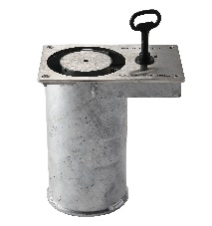Installation: Concrete embed.

* + - * 1. Removable mounting receiver: 100 mm heavy duty

Parts: Receiver and key

Compatible Models: R-8302 and R-8303 flexible bollards

Material: Galvanized Steel and AISI 304 Stainless Steel

Installation: Concrete embed.

* + - * 1. Removable mounting receiver: 100 mm heavy duty – EX

Parts: Receiver and key

Compatible Models: R-8303-EX flexible bollards

Material: Galvanized Steel and AISI 304 Stainless Steel

Installation: Concrete embed.

* + - * 1. Removable mounting receiver: R-8320-R receiver

Parts: Receiver and key

Compatible Models: R-8323 flexible bollards

Material: Polyurethane

Installation: Concrete embed.

1. EXECUTION
   * + 1. EXAMINATION
          1. Examine paving or other substrates for compliance with manufacturer’s requirements for placement and location of embedded items, condition of substrate, and other conditions affecting installation of bollards.
          2. Proceed with installation only after unsatisfactory conditions have been corrected.
       2. INSTALLATION
          1. General: Comply with manufacturer’s installation instructions and setting drawings.
          2. Do not install damaged, cracked, chipped, deformed or marred bollards. Field touch-up minor imperfections in accordance with manufacturer’s instructions. Replace bollards that cannot be field repaired.
       3. CLEANING & PROTECTION

Normal cleaning may be done with clean water and a soft cloth. Detailed cleaning and inspection instructions are available at [www.reliance-foundry.com/bollard/maintenance-bollards](http://www.reliance-foundry.com/bollard/maintenance-bollards).

* + - * 1. Protect bollards against damage.
        2. Immediately prior to Substantial Completion, clean bollards in accordance with manufacturer’s instructions to remove dust, dirt, adhesives, and other foreign materials.
        3. Touch up damaged finishes according to manufacturer’s instructions.
      1. CLOSEOUT ACTIVITIES
         1. Provide executed warranty.

END OF SECTION

Copyright 2018 by Reliance Foundry Co. Ltd.; qualified design and construction professionals may copy for preparation of construction specifications and purchase orders for Reliance Foundry products. Issued April 2018. Subject to change.

Issued July 2016. Subject to change.