Reliance Foundry Co Ltd

#207-6450 148 St

Surrey, BC V3S 7G7

Phone: 604-547-0460

Phone: 1-877-789-3245

Fax: 604-590-8875

Email: info@reliance-foundry.com

Website: www.reliance-foundry.com

Reliance Foundry is an award-winning supplier of high quality stock and custom-designed site furnishings

for architectural, traffic management, and industrial applications. Reliance Foundry brings over 90 years of expertise to the design and manufacturing of our products.

Reliance Foundry bollards add architectural accents to your perimeter security, landscaping, traffic control, and streetscape projects. Use bollards as design features for new and existing buildings, for access control measures, traffic guidance, and as decorative covers over steel security posts. This section includes decorative metal bollards and bollard covers.

Specification Coordination: Edit this guide specification to meet project requirements. Coordinate with other specification sections as required. If using more than one bollard type, use the same designation in both drawings and specifications. Display hidden text to see or print notes to specifier.

Drawing Coordination: Show locations, sizes, layout, and spacing of each type of bollard or bollard cover required. Show footing and security post details, if required. Soft metric conversion is provided for all measurements.

**SECTION 32 39 13.19**

**DECORATIVE METAL BOLLARDS**

1. GENERAL
   * + 1. SUMMARY
          1. Section Includes:

Metal bollard covers

Decorative metal bollards.

Accessories

[_________________]

Edit following to coordinate with other specification sections in project.

* + - * 1. Related Requirements:

[Division 03 Sections: [Concrete] [Mortar] fill for security posts.]

[Division 08 Sections: Padlocks.]

[_________________]

Edit below to include only reference standards used in project.

* + - 1. REFERENCE STANDARDS
         1. ASTM A36 – Standard Specification for Carbon Structural Steel.
         2. ASTM A312 – Standard Specification for Seamless, Welded, and Heavily Cold Worked Austenitic Stainless Steel Pipes.
         3. ASTM A500 – Standard Specification for Cold-Formed Welded and Seamless Carbon Steel Structural Tubing in Rounds and Shapes.
         4. ASTM A536 – Standard Specification for Ductile Iron Castings.
         5. ASTM B26 – Standard Specification for Aluminum-Alloy Sand Castings.
      2. SUBMITTALS
         1. Manufacturer’s Product Data

Comply with Section [01 33 00 – Submittal Procedures.] [_________.]

Product Data: Provide for each type of bollard, component, finish, and accessory specified.

Color Samples: [Submit manufacturer’s standard colors for selection.] [Submit sample of color specified.]

Maintenance Data: Submit manufacturer’s field touch-up, cleaning, and maintenance instructions.

Warranty Documentation: Submit sample of manufacturer’s warranty.

* + - * 1. LEED Submittals

Credit MR 4, Recycled Content: For products having recycled content, provide Product Data indicating percentages by weight of post-consumer and pre-consumer recycled content. Include statement indicating cost for each product having recycled content.

* + - * 1. Setting Drawings: Show embedded items and cutouts required for work specified by other Sections.
      1. QUALITY ASSURANCE
         1. Comply with Section [01 43 00 – Quality Assurance.] [_________.]
      2. DELIVERY, STORAGE AND HANDLING
         1. Comply with Section [01 66 00 – Product Storage and Handling Requirements.] [_________.]
         2. Protect bollards and accessories during delivery, storage, and handling.
      3. WARRANTY
         1. Comply with Section [01 78 36 – Warranties.] [_________.]
         2. Provide manufacturer’s standard warranty against defects in materials and workmanship.

Warranty Period: Five years from date of invoice, except as otherwise indicated.

Coatings: Two years, against peeling, cracking, or significant color change.

1. PRODUCTS
   * + 1. MANUFACTURERS
          1. Manufacturer: Reliance Foundry Co. Ltd.

Phone: 604-547-0460 or 1-877-789-3245

Fax: 604-590-8875

Website: <http://www.reliance-foundry.com/bollard>

Email: [info@reliance-foundry.com](mailto:info@reliance-foundry.com)

* + - * 1. Substitutions: [Comply with provisions of [Section 01 25 00 "Substitution Procedures"] [_________] for substitution procedures.] [Not allowed.]
      1. METAL BOLLARD COVERS
         1. 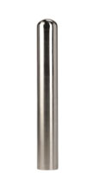Bollard Cover [Designer’s Designation]:

Model: Reliance Foundry; **R-7301**.

Height: 36 inches (91.5 cm)

Diameter: 6 1/4 inches (16 cm)

Weight: 25 lbs. (11.3 kg)

Max interior post size:

Height: 34 inches (86.4 cm)

Diameter: 4 1/2 inches (11.5 cm)

Design: Cylindrical bollard cover with rounded top.

Material: Stainless steel: ASTM A312, Grade TP 316.

Country of Origin: China.

Finish: Satin No. 6, buffed.

Color coating over stainless is available at additional cost for this bollard. Delete if not required.

Color Coating:

Type: [Polyester powder coat over epoxy primer.] [IronArmor protective coating.]

Color: [Black textured semi gloss.] [Dark green.]

[Statuary bronze.] [Bengal silver.] [Anodized silver.] [Safety yellow.]

Installation:

Security post cover, [new][existing] post, set screws

Security post cover, [new][existing] post, adhesive foam

Security post cover, [existing] post, top hangers with adhesive

Security post cover, [new] post, top “J” hangers for new concrete

* + - * 1. 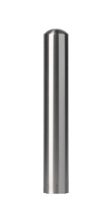Bollard Cover [Designer’s Designation]:

Model: Reliance Foundry; **R-7301EX**.

Height: 42 inches (106.7 cm)

Diameter: 6 1/4 inches (16 cm)

Weight: 29 lbs. (13.2 kg)

Max interior post size:

Height: 40 inches (101.6 cm)

Diameter: 4 1/2 inches (11.5 cm)

Design: Cylindrical bollard cover with rounded top.

Material: Stainless steel: ASTM A312, Grade TP 316.

Country of Origin: China.

Finish: Satin No. 6, buffed.

Color coating over stainless is available at additional cost for this bollard. Delete if not required.

Color Coating:

Type: [Polyester powder coat over epoxy primer.] [IronArmor protective coating.]

Color: [Black textured semi gloss.] [Dark green.]

[Statuary bronze.] [Bengal silver.] [Anodized silver.] [Safety yellow.]

Installation:

Security post cover, [new][existing] post, set screws

Security post cover, [new][existing] post, adhesive foam

Security post cover, [existing] post, top hangers with adhesive

Security post cover, [new] post, top “J” hangers for new concrete

* + - * 1. 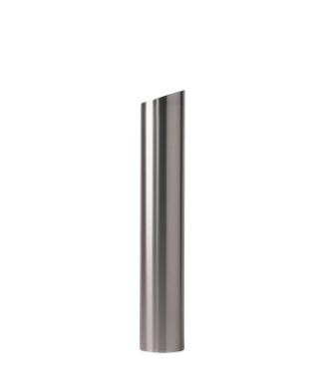Bollard Cover [Designer’s Designation]:

Model: Reliance Foundry; **R-7302**.

Height: 38 inches (96.5 cm)

Diameter: 6 1/4 inches (16 cm)

Weight: 26 lbs. (11.8 kg)

Max interior post size:

Height: 34 inches (86.4 cm)

Diameter: 4 1/2 inches (11.5 cm)

Design: Cylindrical bollard cover with slanted top.

Material: Stainless steel: ASTM A312, Grade TP 316.

Country of Origin: China.

Finish: Satin No. 6, buffed.

Color coating over stainless is available at additional cost for this bollard. Delete if not required.

Color Coating:

Type: [Polyester powder coat over epoxy primer.] [IronArmor protective coating.]

Color: [Black textured semi gloss.] [Dark green.]

[Statuary bronze.] [Bengal silver.] [Anodized silver.] [Safety yellow.]

Installation:

Security post cover, [new][existing] post, set screws

Security post cover, [new][existing] post, adhesive foam

Security post cover, [existing] post, top hangers with adhesive

Security post cover, [new] post, top “J” hangers for new concrete

* + - * 1. 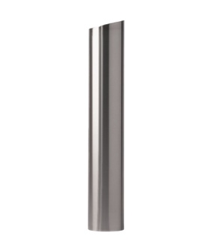Bollard Cover [Designer’s Designation]:

Model: Reliance Foundry; **R-7302-EX**.

Height: 44 inches (111.8 cm)

Diameter: 6 1/4 inches (16 cm)

Weight: 30 lbs. (13.6 kg)

Max interior post size:

Height: 40 inches (101.6 cm)

Diameter: 4 1/2 inches (11.5 cm)

Design: Cylindrical bollard cover with slanted top.

Material: Stainless steel: ASTM A312, Grade TP 316.

Country of Origin: China.

Finish: Satin No. 6, buffed.

Color coating over stainless is available at additional cost for this bollard. Delete if not required.

Color Coating:

Type: [Polyester powder coat over epoxy primer.] [IronArmor protective coating.]

Color: [Black textured semi gloss.] [Dark green.]

[Statuary bronze.] [Bengal silver.] [Anodized silver.] [Safety yellow.]

Installation:

Security post cover, [new][existing] post, set screws

Security post cover, [new][existing] post, adhesive foam

Security post cover, [existing] post, top hangers with adhesive

Security post cover, [new] post, top “J” hangers for new concrete

* + - * 1. 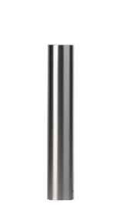Bollard Cover [Designer’s Designation]:

Model: Reliance Foundry; **R-7303**.

Height: 36 inches (91.5 cm)

Diameter: 6 1/4 inches (16 cm)

Weight: 26 lbs. (11.8 kg)

Max interior post size:

Height: 34 inches (86.4 cm)

Diameter: 4 1/2 inches (11.5 cm)

Design: Cylindrical bollard cover with flat top.

Material: Stainless steel: ASTM A312, Grade TP 316.

Country of Origin: China.

Finish: Satin No. 6, buffed.

Color coating over stainless is available at additional cost for this bollard. Delete if not required.

Color Coating:

Type: [Polyester powder coat over epoxy primer.] [IronArmor protective coating.]

Color: [Black textured semi gloss.] [Dark green.]

[Statuary bronze.] [Bengal silver.] [Anodized silver.] [Safety yellow.]

Installation:

Security post cover, [new][existing] post, set screws

Security post cover, [new][existing] post, adhesive foam

Security post cover, [existing] post, top hangers with adhesive

Security post cover, [new] post, top “J” hangers for new concrete

* + - * 1. Bollard Cover [Designer’s Designation]:

Model: Reliance Foundry; **R-7303EX**.

Height: 42 inches (106.7 cm)

Diameter: 6 1/4 inches (16 cm)

Weight: 30 lbs. (13.6 kg)

Max interior post size:

Height: 40 inches (101.6 cm)

Diameter: 4 1/2 inches (11.5 cm)

Design: Cylindrical bollard cover with flat top.

Material: Stainless steel: ASTM A312, Grade TP 316.

Country of Origin: China.

Finish: Satin No. 6, buffed.

Color coating over stainless is available at additional cost for this bollard. Delete if not required.

Color Coating:

Type: [Polyester powder coat over epoxy primer.] [IronArmor protective coating.]

Color: [Black textured semi gloss.] [Dark green.]

[Statuary bronze.] [Bengal silver.] [Anodized silver.] [Safety yellow.]

Installation:

Security post cover, [new][existing] post, set screws

Security post cover, [new][existing] post, adhesive foam

Security post cover, [existing] post, top hangers with adhesive

Security post cover, [new] post, top “J” hangers for new concrete

* + - * 1. 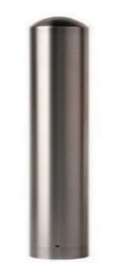Bollard Cover [Designer’s Designation]:

Model: Reliance Foundry; **R-7305**.

Height: 36 inches (91.5 cm)

Diameter: 8 5/8 inches (22 cm)

Weight: 46 lbs. (21 kg)

Max interior post size:

Height: 34 inches (86.4 cm)

Diameter: 6 5/8 inches (16.5 cm)

Design: Cylindrical bollard cover with rounded top.

Material: Stainless steel: ASTM A312, Grade TP 316.

Country of Origin: China.

Finish: Satin No. 6, buffed.

Color coating over stainless is available at additional cost for this bollard. Delete if not required.

Color Coating:

Type: [Polyester powder coat over epoxy primer.] [IronArmor protective coating.]

Color: [Black textured semi gloss.] [Dark green.] [Statuary bronze.]

[Bengal silver.] [Anodized silver.] [Safety yellow.]

Installation:

Security post cover, [new][existing] post, set screws

Security post cover, [new][existing] post, adhesive foam

Security post cover, [existing] post, top hangers with adhesive

Security post cover, [new] post, top “J” hangers for new concrete

* + - * 1. 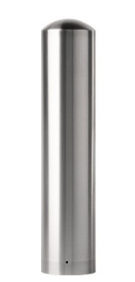Bollard Cover [Designer’s Designation]:

Model: Reliance Foundry; **R-7305-EX**.

Height: 40 inches (101.6 cm)

Diameter: 8 5/8 inches (22 cm)

Weight: 53 lbs. (24 kg)

Max interior post size:

Height: 38 inches (96.5 cm)

Diameter: 6 5/8 inches (16.5 cm)

Design: Cylindrical bollard cover with rounded top.

Material: Stainless steel: ASTM A312, Grade TP 316.

Country of Origin: China.

Finish: Satin No. 6, buffed.

Color coating over stainless is available at additional cost for this bollard. Delete if not required.

Color Coating:

Type: [Polyester powder coat over epoxy primer.] [IronArmor protective coating.]

Optional Color: [Black textured semi gloss.] [Dark green.] [Statuary bronze.]

[Bengal silver.] [Anodized silver.] [Safety yellow.]

Installation:

Security post cover, [new][existing] post, set screws

Security post cover, [new][existing] post, adhesive foam

Security post cover, [existing] post, top hangers with adhesive

Security post cover, [new] post, top “J” hangers for new concrete

* + - * 1. 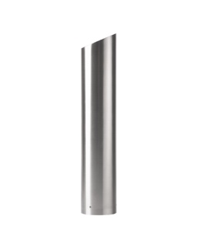Bollard Cover [Designer’s Designation]:

Model: Reliance Foundry; **R-7306**.

Height: 38 inches (96.5 cm)

Diameter: 8 5/8 inches (22cm)

Weight: 48 lbs. (21.8 kg)

Max interior post size:

Height: 34 inches (86.4 cm)

Diameter: 6 5/8 inches (11.5 cm)

Design: Cylindrical bollard cover with slanted top.

Material: Stainless steel: ASTM A312, Grade TP 316.

Country of Origin: China.

Finish: Satin No. 6, buffed.

Color coating over stainless is available at additional cost for this bollard. Delete if not required.

Color Coating:

Type: [Polyester powder coat over epoxy primer.] [IronArmor protective coating.]

Color: [Black textured semi gloss.] [Dark green.]

[Statuary bronze.] [Bengal silver.] [Anodized silver.] [Safety yellow.]

Installation:

Security post cover, [new][existing] post, set screws

Security post cover, [new][existing] post, adhesive foam

Security post cover, [existing] post, top hangers with adhesive

Security post cover, [new] post, top “J” hangers for new concrete

* + - * 1. Bollard Cover [Designer’s Designation]:

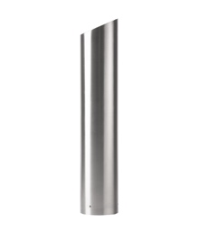Model: Reliance Foundry; **R-7306-EX**.

Height: 44 inches (111.8 cm)

Diameter: 8 5/8inches (22 cm)

Weight: 54 lbs. (24.5 kg)

Max interior post size:

Height: 40 inches (101.6 cm)

Diameter: 6 5/8 inches (16.5 cm)

Design: Cylindrical bollard cover with slanted top.

Material: Stainless steel: ASTM A312, Grade TP 316.

Country of Origin: China.

Finish: Satin No. 6, buffed.

Color coating over stainless is available at additional cost for this bollard. Delete if not required.

Color Coating:

Type: [Polyester powder coat over epoxy primer.] [IronArmor protective coating.]

Color: [Black textured semi gloss.] [Dark green.]

[Statuary bronze.] [Bengal silver.] [Anodized silver.] [Safety yellow.]

Installation:

Security post cover, [new][existing] post, set screws

Security post cover, [new][existing] post, adhesive foam

Security post cover, [existing] post, top hangers with adhesive

Security post cover, [new] post, top “J” hangers for new concrete

* + - * 1. 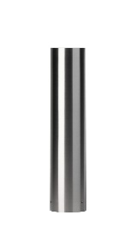Bollard Cover [Designer’s Designation]:

Model: Reliance Foundry; **R-7307**.

Height: 36 inches (91.5 cm)

Diameter: 8 5/8 inches (22 cm)

Weight: 47 lbs. (21.3 kg)

Max interior post size:

Height: 34 inches (86.4 cm)

Diameter: 6 5/8 inches (16.8 cm)

Design: Cylindrical bollard cover with flat top.

Material: Stainless steel: ASTM A312, Grade TP 316.

Country of Origin: China.

Finish: Satin No. 6, buffed.

Color coating over stainless is available at additional cost for this bollard. Delete if not required.

Color Coating:

Type: [Polyester powder coat over epoxy primer.] [IronArmor protective coating.]

Color: [Black textured semi gloss.] [Dark green.]

[Statuary bronze.] [Bengal silver.] [Anodized silver.] [Safety yellow.]

Installation:

Security post cover, [new][existing] post, set screws

Security post cover, [new][existing] post, adhesive foam

Security post cover, [existing] post, top hangers with adhesive

Security post cover, [new] post, top “J” hangers for new concrete

* + - * 1. Bollard Cover [Designer’s Designation]:

Model: Reliance Foundry; **R-7307-EX**.

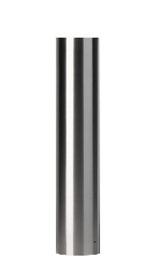Height: 42 inches (106.7 cm)

Diameter: 8 5/8 inches (22 cm)

Weight: 54 lbs. (24.5 kg)

Max interior post size:

Height: 40 inches (101.6 cm)

Diameter: 6 5/8 inches (16.5 cm)

Design: Cylindrical bollard cover with flat top.

Material: Stainless steel: ASTM A312, Grade TP 316.

Country of Origin: China.

Finish: Satin No. 6, buffed.

Color coating over stainless is available at additional cost for this bollard. Delete if not required.

Color Coating:

Type: [Polyester powder coat over epoxy primer.] [IronArmor protective coating.]

Optional Color: [Black textured semi gloss.] [Dark green.] [Statuary bronze.]

[Bengal silver.] [Anodized silver.] [Safety yellow.]

Installation:

Security post cover, [new][existing] post, set screws

Security post cover, [new][existing] post, adhesive foam

Security post cover, [existing] post, top hangers with adhesive

Security post cover, [new] post, top “J” hangers for new concrete

* + - * 1. 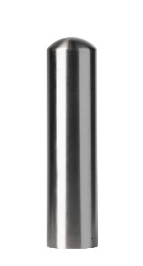Bollard Cover [Designer’s Designation]:

Model: Reliance Foundry; **R-7309**.

Height: 42 inches (106.7 cm)

Diameter: 10 3/4 inches (27.3 cm)

Weight: 67 lbs. (30.4 kg)

Max interior post size:

Height: 40 inches (101.6 cm)

Diameter: 8 5/8 inches (22 cm)

Design: Cylindrical bollard cover with rounded top.

Material: Stainless steel: ASTM A312, Grade TP 316.

Country of Origin: China.

Finish: Satin No. 6, buffed.

Color coating over stainless is available at additional cost for this bollard. Delete if not required.

Color Coating:

Type: [Polyester powder coat over epoxy primer.] [IronArmor protective coating.]

Color: [Black textured semi gloss.] [Dark green.]

[Statuary bronze.] [Bengal silver.] [Anodized silver.] [Safety yellow.]

Installation:

Security post cover, [new][existing] post, set screws

Security post cover, [new][existing] post, adhesive foam

Security post cover, [existing] post, top hangers with adhesive

Security post cover, [new] post, top “J” hangers for new concrete

* + - * 1. 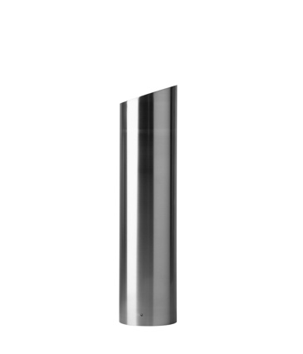Bollard Cover [Designer’s Designation]:

Model: Reliance Foundry; **R-7310**.

Height: 44 inches (111.8 cm)

Diameter: 10 3/4 inches (27.3 cm)

Weight: 69 lbs. (31.3 kg)

Max interior post size:

Height: 40 inches (101.6 cm)

Diameter: 8 5/8 inches (22 cm)

Design: Cylindrical bollard cover with slanted top.

Material: Stainless steel: ASTM A312, Grade TP 316.

Country of Origin: China.

Finish: Satin No. 6, buffed.

Color coating over stainless is available at additional cost for this bollard. Delete if not required.

Color Coating:

Type: [Polyester powder coat over epoxy primer.] [IronArmor protective coating.]

Color: [Black textured semi gloss.] [Dark green.]

[Statuary bronze.] [Bengal silver.] [Anodized silver.] [Safety yellow.]

Installation:

Security post cover, [new][existing] post, set screws

Security post cover, [new][existing] post, adhesive foam

Security post cover, [existing] post, top hangers with adhesive

Security post cover, [new] post, top “J” hangers for new concrete

* + - * 1. 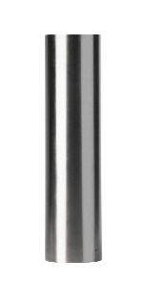Bollard Cover [Designer’s Designation]:

Model: Reliance Foundry; **R-7311**.

Height: 42 inches (106.7 cm)

Diameter: 10 3/4 inches (27.3 cm)

Weight: 69 lbs. (31.3 kg)

Max interior post size:

Height: 40 inches (101.6 cm)

Diameter: 8 5/8 inches (22 cm)

Design: Cylindrical bollard cover with flat top.

Material: Stainless steel: ASTM A312, Grade TP 316.

Country of Origin: China.

Finish: Satin No. 6, buffed.

Color coating over stainless is available at additional cost for this bollard. Delete if not required.

Color Coating:

Type: [Polyester powder coat over epoxy primer.] [IronArmor protective coating.]

Color: [Black textured semi gloss.] [Dark green.]

[Statuary bronze.] [Bengal silver.] [Anodized silver.] [Safety yellow.]

Installation:

Security post cover, [new][existing] post, set screws

Security post cover, [new][existing] post, adhesive foam

Security post cover, [existing] post, top hangers with adhesive

Security post cover, [new] post, top “J” hangers for new concrete

* + - * 1. Bollard Cover [Designer’s Designation]:

Model: Reliance Foundry; **R-7313**.

Height: 42 inches (106.7 cm)

Diameter: 12 3/4 inches (32.4 cm)

Weight: 80 lbs. (36.3 kg)

Max interior post size:

Height: 40 inches (101.6 cm)

Diameter: 10 3/4 inches (22 cm)

Design: Cylindrical bollard cover with rounded top.

Material: Stainless steel: ASTM A312, Grade TP 316.

Country of Origin: China.

Finish: Satin No. 6, buffed.

Color coating over stainless is available at additional cost for this bollard. Delete if not required.

Color Coating:

Type: [Polyester powder coat over epoxy primer.] [IronArmor protective coating.]

Color: [Black textured semi gloss.] [Dark green.]

[Statuary bronze.] [Bengal silver.] [Anodized silver.] [Safety yellow.]

Installation:

Security post cover, [new][existing] post, set screws

Security post cover, [new][existing] post, adhesive foam

Security post cover, [existing] post, top hangers with adhesive

Security post cover, [new] post, top “J” hangers for new concrete

* + - * 1. Bollard Cover [Designer’s Designation]:

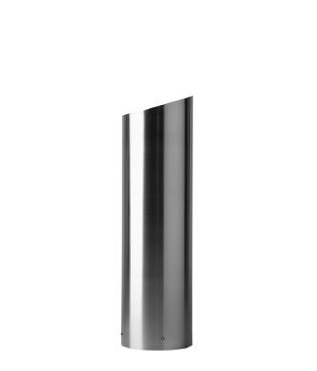Model: Reliance Foundry; **R-7314**.

Height: 44 inches (111.8 cm)

Diameter: 12 13/16 inches (32.5 cm)

Weight: 83 lbs. (37.6 kg)

Max interior post size:

Height: 40 inches (101.6 cm)

Diameter: 10 3/4 inches (27.3 cm)

Design: Cylindrical bollard cover with slanted top.

Material: Stainless steel: ASTM A312, Grade TP 316.

Country of Origin: China.

Finish: Satin No. 6, buffed.

Color coating over stainless is available at additional cost for this bollard. Delete if not required.

Color Coating:

Type: [Polyester powder coat over epoxy primer.] [IronArmor protective coating.]

Color: [Black textured semi gloss.] [Dark green.]

[Statuary bronze.] [Bengal silver.] [Anodized silver.] [Safety yellow.]

Installation:

Security post cover, [new][existing] post, set screws

Security post cover, [new][existing] post, adhesive foam

Security post cover, [existing] post, top hangers with adhesive

Security post cover, [new] post, top “J” hangers for new concrete

* + - * 1. 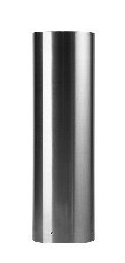Bollard Cover [Designer’s Designation]:

Model: Reliance Foundry; **R-7315**.

Height: 42 inches (106.7 cm)

Diameter: 12 3/4 inches (32.4 cm)

Weight: 83 lbs. (37.6 kg)

Max interior post size:

Height: 40 inches (101.6 cm)

Diameter: 10 3/4 inches (22 cm)

Design: Cylindrical bollard cover with flat top.

Material: Stainless steel: ASTM A312, Grade TP 316.

Country of Origin: China.

Finish: Satin No. 6, buffed.

Color coating over stainless is available at additional cost for this bollard. Delete if not required.

Color Coating:

Type: [Polyester powder coat over epoxy primer.] [IronArmor protective coating.]

Color: [Black textured semi gloss.] [Dark green.]

[Statuary bronze.] [Bengal silver.] [Anodized silver.] [Safety yellow.]

Installation:

Security post cover, [new][existing] post, set screws

Security post cover, [new][existing] post, adhesive foam

Security post cover, [existing] post, top hangers with adhesive

Security post cover, [new] post, top “J” hangers for new concrete

* + - * 1. Bollard Cover [Designer’s Designation]:

Model: Reliance Foundry; **R-7317**.

Height: 42 inches (106.7 cm)

Diameter: 14 7/8 inches (37.8 cm)

Weight: 94 lbs. (42.6 kg)

Max interior post size:

Height: 40 inches (101.6 cm)

Diameter: 12 3/4 inches (32.4 cm)

Design: Cylindrical bollard cover with rounded top.

Material: Stainless steel: ASTM A312, Grade TP 316.

Country of Origin: China.

Finish: Satin No. 6, buffed.

Color coating over stainless is available at additional cost for this bollard. Delete if not required.

Color Coating:

Type: [Polyester powder coat over epoxy primer.] [IronArmor protective coating.]

Color: [Black textured semi gloss.] [Dark green.]

[Statuary bronze.] [Bengal silver.] [Anodized silver.] [Safety yellow.]

Installation:

Security post cover, [new][existing] post, set screws

Security post cover, [new][existing] post, adhesive foam

Security post cover, [existing] post, top hangers with adhesive

Security post cover, [new] post, top “J” hangers for new concrete

* + - * 1. Bollard Cover [Designer’s Designation]:

Model: Reliance Foundry; **R-7318**.

Height: 44 inches (91.5 cm)

Diameter: 14 13/16 inches (37.6 cm)

Weight: 97 lbs. (11.8 kg)

Max interior post size:

Height: 40 inches (101.6 cm)

Diameter: 12 3/4 inches (32.4 cm)

Design: Cylindrical bollard cover with slanted top.

Material: Stainless steel: ASTM A312, Grade TP 316.

Country of Origin: China.

Finish: Satin No. 6, buffed.

Color coating over stainless is available at additional cost for this bollard. Delete if not required.

Color Coating:

Type: [Polyester powder coat over epoxy primer.] [IronArmor protective coating.]

Color: [Black textured semi gloss.] [Dark green.]

[Statuary bronze.] [Bengal silver.] [Anodized silver.] [Safety yellow.]

Installation:

Security post cover, [new][existing] post, set screws

Security post cover, [new][existing] post, adhesive foam

Security post cover, [existing] post, top hangers with adhesive

Security post cover, [new] post, top “J” hangers for new concrete

* + - * 1. 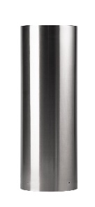Bollard Cover [Designer’s Designation]:

Model: Reliance Foundry; **R-7319**.

Height: 42 inches (106.7 cm)

Diameter: 14 7/8 inches (37.8 cm)

Weight: 97 lbs. (44 kg)

Max interior post size:

Height: 40 inches (101.6 cm)

Diameter: 12 3/4 inches (32.4 cm)

Design: Cylindrical bollard cover with flat top.

Material: Stainless steel: ASTM A312, Grade TP 316.

Country of Origin: China.

Finish: Satin No. 6, buffed.

Color coating over stainless is available at additional cost for this bollard. Delete if not required.

Color Coating:

Type: [Polyester powder coat over epoxy primer.] [IronArmor protective coating.]

Color: [Black textured semi gloss.] [Dark green.]

[Statuary bronze.] [Bengal silver.] [Anodized silver.] [Safety yellow.]

Installation:

Security post cover, [new][existing] post, set screws

Security post cover, [new][existing] post, adhesive foam

Security post cover, [existing] post, top hangers with adhesive

Security post cover, [new] post, top “J” hangers for new concrete

* + - * 1. Bollard Cover [Designer’s Designation]:

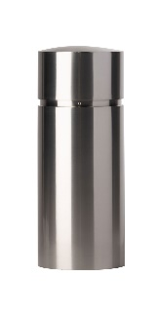Model: Reliance Foundry; **R-7341**.

Height: 31 7/8 inches (81 cm)

Diameter: 12 13/16 inches (32.5 cm)

Weight: 85 lbs. (38.5 kg)

Max interior post size:

Height: 30 inches (76.2 cm)

Diameter: 10 3/4 inches (27.3 cm)

Design: Cylindrical bollard cover with rounded top.

Material: Stainless steel: ASTM A312, Grade TP 316.

Country of Origin: China.

Finish: Satin No. 6, buffed.

Color coating over stainless is available at additional cost for this bollard. Delete if not required.

Color Coating:

Type: [Polyester powder coat over epoxy primer.] [IronArmor protective coating.]

Color: [Black textured semi gloss.] [Dark green.] [Statuary bronze.]

[Bengal silver.] [Anodized silver.] [Safety yellow.]

Installation:

Security post cover, [new][existing] post, set screws

* + - * 1. Bollard Cover [Designer’s Designation]:

Model: Reliance Foundry; **R-7342-SS**.

Height: 47 1/4 inches (120.02 cm)

Diameter: 11 13/16 inches (30 cm)

Weight: 40 lbs. (18.14 kg)

Max interior post size:

Height: 45 inches (114.3 cm)

Diameter: 10 3/4 inches (27.3 cm)

Design: Cylindrical bollard cover with flat top.

Material: Stainless steel: ASTM A312, Grade TP 316.

Country of Origin: China.

Finish: Satin No. 6, buffed.

Color coating over stainless is available at additional cost for this bollard. Delete if not required.

Color Coating:

Type: [Polyester powder coat over epoxy primer.] [IronArmor protective coating.]

Color: [Black textured semi gloss.] [Dark green.] [Statuary bronze.]

[Bengal silver.] [Anodized silver.] [Safety yellow.]

Installation:

Security post cover, [new][existing] post, set screws

Security post cover, [new][existing] post, adhesive foam

* + - 1. DECORATIVE METAL BOLLARDS

Some models are also available with bike arms. See Bike Parking Bollards: http://www.reliance-foundry.com/bollard/bike-parking-bollards

* + - * 1. 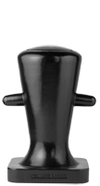Bollard [Designer’s Designation]:

Model: Reliance Foundry; **R-7510**.

Height: 30 inches (76.2 cm)

Diameter: 14 5/8 inches (37.1 cm) body; 18 inches (45.7 cm) base

Weight: 337 lbs. (153 kg)

Design: Marine style.

Material: Ductile Cast Iron: ASTM A536, Grade 65-45-12; 30 percent recycled-material content.

Country of Origin: China.

Color Coating:

Type: [Polyester powder coat over epoxy primer.] [IronArmor protective coating.]

Color: [Black textured semi gloss.] [Dark green.] [Statuary bronze.]

[Bengal silver.] [Anodized silver.] [Safety yellow.]

Installation:

Fixed, new concrete, anchor.

Fixed, existing concrete, insert.

Fixed, existing concrete, adhesive.

Fixed, new concrete, concrete form.

Security post cover, new post.

Security post cover, existing post, insert.

Security post cover, existing post, adhesive.

Security post cover, existing post, anchor.

* + - * 1. 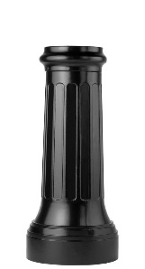Bollard [Designer’s Designation]:

Model: Reliance Foundry; **R-7520**.

Height: 35 inches (89 cm)

Diameter: 10 1/2 inches (26.7 cm) body; 15 1/2 inches (39.4 cm) base

Weight: 183 lbs. (83 kg)

Design: Tapered and fluted with a flat top.

Material: Ductile Cast Iron: ASTM A536, Grade 65-45-12; 30 percent recycled-material content.

Country of Origin: China.

Color Coating:

Type: [Polyester powder coat over epoxy primer.] [IronArmor protective coating.]

Color: [Black textured semi gloss.] [Dark green.] [Statuary bronze.]

[Bengal silver.] [Anodized silver.] [Safety yellow.]

Installation:

Fixed, new concrete, anchor.

Fixed, existing concrete, insert.

Fixed, existing concrete, adhesive.

Fixed, new concrete, concrete form.

Security post cover, new post.

Security post cover, existing post, insert.

Security post cover, existing post, adhesive.

Security post cover, existing post, anchor.

* + - * 1. 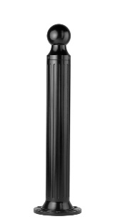Bollard [Designer’s Designation]:

Retain -AL for aluminum. Delete if not required.

Model: Reliance Foundry; **R-7530 [-AL]**.

Height: 39 inches (99 cm)

Diameter: 5 1/4 inches (13.3 cm) body; 10 inches (25.4 cm) base

Design: Cylindrical and fluted, with tapered bottom and ball top.

Retain aluminum or cast iron to coordinate with model number.

Material:

Aluminum: ASTM B26; 20 percent recycled-material content.

Weight: 24 lbs. (11 kg)

Ductile Cast Iron: ASTM A536, Grade 65-45-12; 30 percent recycled-material content.

Weight: 61 lbs. (27.7 kg)

Country of Origin: China.

Color Coating:

Type: [Polyester powder coat over epoxy primer.] [IronArmor protective coating.]

Color: [Black textured semi gloss.] [Dark green.] [Statuary bronze.] [Bengal silver.] [Anodized silver.] [Safety yellow.]

Installation:

Fixed, new concrete, anchor.

Fixed, existing concrete, insert.

Fixed, existing concrete, adhesive.

Fixed, new concrete, concrete form.

Fixed, existing concrete, flange and insert.

Security post cover, new post.

Security post cover, existing post, insert.

Security post cover, existing post, adhesive.

Security post cover, existing, anchor.

Removable, new concrete, anchor

Removable, existing concrete, insert.

Removable, new concrete, premium retractable.

* + - * 1. 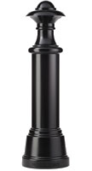Bollard [Designer’s Designation]:

Model: Reliance Foundry; **R-7532**.

Height: 53 3/4 inches (136.5 cm)

Diameter: 9 1/2 inches (24 cm) body; 16 inches (40.6 cm) base

Weight: 270 lbs. (122.5 kg)

Design: Cylindrical and non-fluted, with tapered bottom and nautical top.

Material: Ductile Cast Iron: ASTM A536, Grade 65-45-12; 30 percent recycled-material content.

Country of Origin: China.

Color Coating:

Type: [Polyester powder coat over epoxy primer.] [IronArmor protective coating.]

Color: [Black textured semi gloss.] [Dark green.] [Statuary bronze.] [Bengal silver.] [Anodized silver.] [Safety yellow.]

Installation:

Fixed, new concrete, anchor.

Fixed, existing concrete, insert.

Fixed, existing concrete, adhesive.

Fixed, new concrete, concrete form.

Security post cover, new post.

Security post cover, existing post, insert.

Security post cover, existing post, adhesive.

Security post cover, existing, anchor.

* + - * 1. 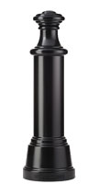Bollard [Designer’s Designation]:

Model: Reliance Foundry; **R-7533**.

Height: 49 3/4 inches (126.4 cm)

Diameter: 9 1/2 inches (24 cm) body; 16 inches (40.6 cm) base

Weight: 254 lbs. (115.2 kg)

Design: Cylindrical and non-fluted, with tapered bottom and flat top.

Material: Ductile Cast Iron: ASTM A536, Grade 65-45-12; 30 percent recycled-material content.

Country of Origin: China.

Color Coating:

Type: [Polyester powder coat over epoxy primer.] [IronArmor protective coating.]

Color: [Black textured semi gloss.] [Dark green.] [Statuary bronze.] [Bengal silver.] [Anodized silver.] [Safety yellow.]

Installation:

Fixed, new concrete, anchor.

Fixed, existing concrete, insert.

Fixed, existing concrete, adhesive.

Fixed, new concrete, concrete form.

Security post cover, new post.

Security post cover, existing post, insert.

Security post cover, existing post, adhesive.

Security post cover, existing, anchor.

* + - * 1. 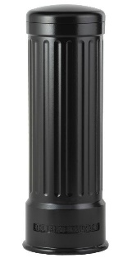 Bollard [Designer’s Designation]:

Model: Reliance Foundry; **R-7535**.

Height: 39 inches (99 cm)

Diameter: 12 inches (30.5 cm) body; 14 inches (35.5 cm) base

Weight: 211 lbs. (95.7 kg)

Design: Cylindrical and fluted, with a rounded top.

Material: Ductile Cast Iron: ASTM A536, Grade 65-45-12; 30 percent recycled-material content.

Country of Origin: China.

Color Coating:

Type: [Polyester powder coat over epoxy primer.] [IronArmor protective coating.]

Color: [Black textured semi gloss.] [Dark green.] [Statuary bronze.] [Bengal silver.] [Anodized silver.] [Safety yellow.]

Installation:

Fixed, new concrete, anchor.

Fixed, existing concrete, insert.

Fixed, existing concrete, adhesive.

Fixed, new concrete, concrete form.

Security post cover, new post.

Security post cover, existing post, insert.

Security post cover, existing post, adhesive.

Security post cover, existing, anchor.

* + - * 1. 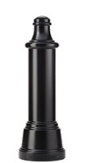Bollard [Designer’s Designation]:

Model: Reliance Foundry; **R-7536**.

Height: 47 1/2 inches (120.7 cm)

Diameter: 9 1/2 inches (24 cm) body; 16 inches (40.6 cm) base

Weight: 248 lbs. (112.5 kg)

Design: Cylindrical and non-fluted, with tapered bottom and rounded top.

Material: Ductile Cast Iron: ASTM A536, Grade 65-45-12; 30 percent recycled-material content.

Country of Origin: China.

Color Coating:

Type: [Polyester powder coat over epoxy primer.] [IronArmor protective coating.]

Color: [Black textured semi gloss.] [Dark green.] [Statuary bronze.] [Bengal silver.] [Anodized silver.] [Safety yellow.]

Installation:

Fixed, new concrete, anchor.

Fixed, existing concrete, insert.

Fixed, existing concrete, adhesive.

Fixed, new concrete, concrete form.

Security post cover, new post.

Security post cover, existing post, insert.

Security post cover, existing post, adhesive.

Security post cover, existing, anchor.

* + - * 1. 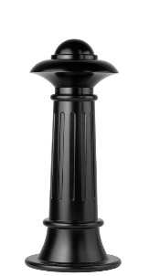Bollard [Designer’s Designation]:

Model: Reliance Foundry; **R-7538**.

Height: 35 inches (89 cm)

Diameter: 7 3/4 inches (19.7 cm) body; 15 inches (38 cm) base

Weight: 129 lbs. (58.5 kg)

Design: Tapered and fluted, with fluted base and nautical-styled top.

Material: Ductile Cast Iron: ASTM A536, Grade 65-45-12; 30 percent recycled-material content.

Country of Origin: China.

Color Coating:

Type: [Polyester powder coat over epoxy primer.] [IronArmor protective coating.]

Color: [Black textured semi gloss.] [Dark green.] [Statuary bronze.] [Bengal silver.] [Anodized silver.] [Safety yellow.]

Installation:

Fixed, new concrete, anchor.

Fixed, existing concrete, insert.

Fixed, existing concrete, adhesive.

Fixed, new concrete, concrete form.

Security post cover, new post.

Security post cover, existing post, insert.

Security post cover, existing post, adhesive.

Security post cover, existing, anchor.

Removable, new concrete, anchor.

Removable, existing concrete, insert.

Removable, new concrete, premium retractable.

* + - * 1. 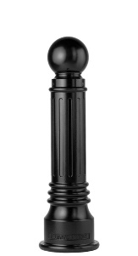Bollard [Designer’s Designation]:

Retain -AL for aluminum. Delete if not required.

Model: Reliance Foundry; **R-7539 [-AL]**.

Height: 35 3/4 inches (90.8 cm)

Diameter: 6 inches (15.2 cm) body; 10 1/4 inches (26 cm) base

Design: Tapered and fluted, with round finial and ball top.

Retain aluminum or cast iron to coordinate with model number.

Material:

Aluminum: ASTM B26; 20 percent recycled-material content.

Weight: 31 lbs. (14 kg)

Ductile Cast Iron: ASTM A536, Grade 65-45-12; 30 percent recycled-material content.

Weight: 75 lbs. (34 kg)

Country of Origin: China.

Color Coating:

Type: [Polyester powder coat over epoxy primer.] [IronArmor protective coating.]

Color: [Black textured semi gloss.] [Dark green.] [Statuary bronze.] [Bengal silver.] [Anodized silver.] [Safety yellow.]

Installation:

Fixed, new concrete, anchor.

Fixed, existing concrete, insert.

Fixed, existing concrete, adhesive.

Fixed, new concrete, concrete form.

Security post cover, new post.

Security post cover, existing post, insert.

Security post cover, existing post, adhesive.

Security post cover, existing, anchor.

Removable, new concrete, anchor.

Removable, existing concrete, insert.

Removable, new concrete, premium retractable.

* + - * 1. Bollard [Designer’s Designation]:

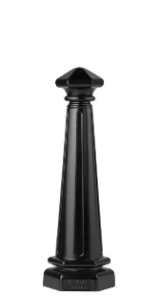Model: Reliance Foundry; **R-7542**.

Height: 30 inches (89 cm)

Diameter: 5 inches (19.7 cm) body; 10 inches (38 cm) base

Weight: 77 lbs. (35 kg)

Design: Tapered and fluted, with fluted base and nautical-styled top.

Material: Ductile Cast Iron: ASTM A536, Grade 65-45-12; 30 percent recycled-material content.

Country of Origin: China.

Color Coating:

Type: Polyester powder coat over epoxy primer.

Color: [Black textured semi gloss.] [Dark green.] [Statuary bronze.] [Bengal silver.] [Anodized silver.] [Safety yellow.]

Installation:

Fixed, new concrete, anchor.

Fixed, existing concrete, insert.

Fixed, existing concrete, adhesive.

Fixed, new concrete, concrete form.

Security post cover, new post.

Security post cover, existing post, insert.

Security post cover, existing post, adhesive.

Security post cover, existing, anchor.

Removable, new concrete, anchor.

Removable, existing concrete, insert.

Removable, new concrete, premium retractable.

* + - * 1. 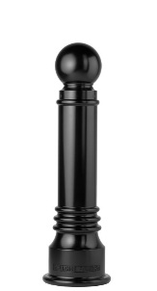Bollard [Designer’s Designation]:

Model: Reliance Foundry; **R-7551**.

Height: 35 3/4 inches (90.8 cm)

Diameter: 6 inches (15.2 cm) body; 10 1/4 inches (26 cm) base

Weight: 79 lbs. (35.8 kg)

Design: Tapered with round finial and ball top.

Material: Ductile Cast Iron: ASTM A536, Grade 65-45-12; 30 percent recycled-material content.

Country of Origin: China.

Color Coating:

Type: [Polyester powder coat over epoxy primer.] [IronArmor protective coating.]

Color: [Black textured semi gloss.] [Dark green.] [Statuary bronze.] [Bengal silver.] [Anodized silver.] [Safety yellow.]

Installation:

Fixed, new concrete, anchor.

Fixed, existing concrete, insert.

Fixed, existing concrete, adhesive.

Fixed, new concrete, concrete form.

Security post cover, new post.

Security post cover, existing post, insert.

Security post cover, existing post, adhesive.

Security post cover, existing, anchor.

Removable, new concrete, anchor.

Removable, existing concrete, insert.

Removable, new concrete, premium retractable.

* + - * 1. Bollard [Designer’s Designation]:

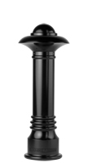Model: Reliance Foundry; **R-7552**.

Height: 36 inches (91.4 cm)

Diameter: 6 inches (15.2 cm) body; 10 1/4 inches (26 cm) base

Weight: 96 lbs. (43.5 kg)

Design: Tapered with round finial and contemporary-styled top.

Material: Ductile Cast Iron: ASTM A536, Grade 65-45-12; 30 percent recycled-material content.

Country of Origin: China.

Color Coating:

Type: [Polyester powder coat over epoxy primer.] [IronArmor protective coating.]

Color: [Black textured semi gloss.] [Dark green.] [Statuary bronze.] [Bengal silver.] [Anodized silver.] [Safety yellow.]

Installation:

Fixed, new concrete, anchor.

Fixed, existing concrete, insert.

Fixed, existing concrete, adhesive.

Fixed, new concrete, concrete form.

Security post cover, new post.

Security post cover, existing post, insert.

Security post cover, existing post, adhesive.

Security post cover, existing, anchor.

Removable, new concrete, anchor.

Removable, existing concrete, insert.

Removable, new concrete, premium retractable.

* + - * 1. 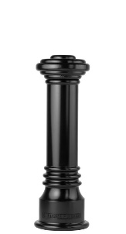Bollard [Designer’s Designation]:

Model: Reliance Foundry; **R-7553**.

Height: 32 inches (81.3 cm)

Diameter: 6 inches (15.2 cm) body; 10 1/4 inches (26 cm) base

Weight: 81 lbs. (36.7 kg)

Design: Tapered with round finial and flat disc top.

Material: Ductile Cast Iron: ASTM A536, Grade 65-45-12; 30 percent recycled-material content.

Country of Origin: China.

Color Coating:

Type: [Polyester powder coat over epoxy primer.] [IronArmor protective coating.]

Color: [Black textured semi gloss.] [Dark green.] [Statuary bronze.] [Bengal silver.] [Anodized silver.] [Safety yellow.]

Installation:

Fixed, new concrete, anchor.

Fixed, existing concrete, insert.

Fixed, existing concrete, adhesive.

Fixed, new concrete, concrete form.

Security post cover, new post.

Security post cover, existing post, insert.

Security post cover, existing post, adhesive.

Security post cover, existing, anchor.

Removable, new concrete, anchor.

Removable, existing concrete, insert.

Removable, new concrete, premium retractable.

* + - * 1. 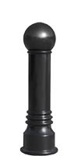Bollard [Designer’s Designation]:

Model: Reliance Foundry; **R-7555**.

Height: 35 inches (88.9 cm)

Diameter: 6 inches (15.2 cm) body; 10 1/4 inches (26 cm) base

Weight: 76 lbs. (34.5 kg)

Design: Tapered with round finial and large ball top.

Material: Ductile Cast Iron: ASTM A536, Grade 65-45-12; 30 percent recycled-material content.

Country of Origin: China.

Color Coating:

Type: [Polyester powder coat over epoxy primer.] [IronArmor protective coating.]

Color: [Black textured semi gloss.] [Dark green.] [Statuary bronze.] [Bengal silver.] [Anodized silver.] [Safety yellow.]

Installation:

Fixed, new concrete, anchor.

Fixed, existing concrete, insert.

Fixed, existing concrete, adhesive.

Fixed, new concrete, concrete form.

Security post cover, new post.

Security post cover, existing post, insert.

Security post cover, existing post, adhesive.

Security post cover, existing, anchor.

Removable, new concrete, anchor.

Removable, existing concrete, insert.

Removable, new concrete, premium retractable.

* + - * 1. 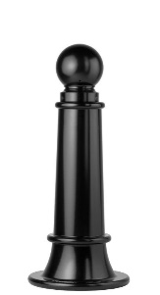Bollard [Designer’s Designation]:

Model: Reliance Foundry; **R-7561**.

Height: 35 inches (89 cm)

Diameter: 7 3/4 inches (19.7 cm) body; 15 inches (38 cm) base

Weight: 116 lbs. (52.6 kg)

Design: Tapered with round finial and ball top.

Material: Ductile Cast Iron: ASTM A536, Grade 65-45-12; 30 percent recycled-material content.

Country of Origin: China.

Color Coating:

Type: [Polyester powder coat over epoxy primer.] [IronArmor protective coating.]

Color: [Black textured semi gloss.] [Dark green.] [Statuary bronze.] [Bengal silver.] [Anodized silver.] [Safety yellow.]

Installation:

Fixed, new concrete, anchor.

Fixed, existing concrete, insert.

Fixed, existing concrete, adhesive.

Fixed, new concrete, concrete form.

Security post cover, new post.

Security post cover, existing post, insert.

Security post cover, existing post, adhesive.

Security post cover, existing, anchor.

Removable, new concrete, anchor.

Removable, existing concrete, insert.

Removable, new concrete, premium retractable.

* + - * 1. 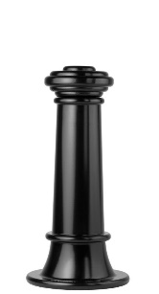Bollard [Designer’s Designation]:

Model: Reliance Foundry; **R-7563**.

Height: 31 inches (78.7 cm)

Diameter: 7 3/4 inches (19.7 cm) body; 15 inches (38 cm) base

Weight: 119 lbs. (54 kg)

Design: Tapered with round finial and flat disc top.

Material: Ductile Cast Iron: ASTM A536, Grade 65-45-12; 30 percent recycled-material content.

Country of Origin: China.

Color Coating:

Type: [Polyester powder coat over epoxy primer.] [IronArmor protective coating.]

Color: [Black textured semi gloss.] [Dark green.] [Statuary bronze.] [Bengal silver.] [Anodized silver.] [Safety yellow.]

Installation:

Fixed, new concrete, anchor.

Fixed, existing concrete, insert.

Fixed, existing concrete, adhesive.

Fixed, new concrete, concrete form.

Security post cover, new post.

Security post cover, existing post, insert.

Security post cover, existing post, adhesive.

Security post cover, existing, anchor.

Removable, new concrete, anchor.

Removable, existing concrete, insert.

Removable, new concrete, premium retractable.

* + - * 1. 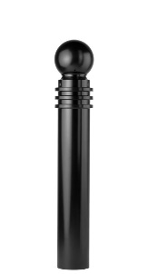Bollard [Designer’s Designation]:

Model: Reliance Foundry; **R-7571**.

Height: 40 1/2 inches (102.9 cm)

Diameter: 5 3/4 inches (14.6 cm) body; 5 3/4 inches (14.6 cm) base

Weight: 64 lbs. (29 kg)

Design: Cylindrical with round finial and ball top.

Material: Ductile Cast Iron: ASTM A536, Grade 65-45-12; 30 percent recycled-material content.

Color Coating:

Type: [Polyester powder coat over epoxy primer.] [IronArmor protective coating.]

Color: [Black textured semi gloss.] [Dark green.] [Statuary bronze.] [Bengal silver.] [Anodized silver.] [Safety yellow.]

Installation:

Fixed, new concrete, anchor.

Fixed, existing concrete, insert.

Fixed, existing concrete, adhesive.

Fixed, new concrete, concrete form.

Security post cover, new post.

Security post cover, existing post, insert.

Security post cover, existing post, adhesive.

Security post cover, existing, anchor.

Removable, new concrete, anchor.

Removable, existing concrete, insert.

Removable, new concrete, premium retractable.

* + - * 1. 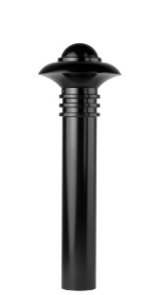Bollard [Designer’s Designation]:

Model: Reliance Foundry; **R-7572**.

Height: 40 1/2 inches (102.9 cm)

Diameter: 5 3/4 inches (14.6 cm) body; 5 3/4 inches (14.6 cm) base

Weight: 82 lbs. (37.2 kg)

Design: Cylindrical with round finial and contemporary-styled top.

Material: Ductile Cast Iron: ASTM A536, Grade 65-45-12; 30 percent recycled-material content.

Country of Origin: China.

Color Coating:

Type: [Polyester powder coat over epoxy primer.] [IronArmor protective coating.]

Color: [Black textured semi gloss.] [Dark green.] [Statuary bronze.] [Bengal silver.] [Anodized silver.] [Safety yellow.]

Installation:

Fixed, new concrete, anchor.

Fixed, existing concrete, insert.

Fixed, existing concrete, adhesive.

Fixed, new concrete, concrete form.

Security post cover, new post.

Security post cover, existing post, insert.

Security post cover, existing post, adhesive.

Security post cover, existing, anchor.

Removable, new concrete, anchor.

Removable, existing concrete, insert.

Removable, new concrete, premium retractable.

* + - * 1. 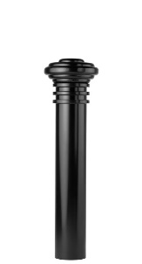Bollard [Designer’s Designation]:

Model: Reliance Foundry; **R-7573**.

Height: 36 1/2 inches (92.7 cm)

Diameter: 5 3/4 inches (14.6 cm) body; 5 3/4 inches (14.6 cm) base

Weight: 67 lbs. (30.4 kg)

Design: Cylindrical with round finial and flat disc top.

Material: Ductile Cast Iron: ASTM A536, Grade 65-45-12; 30 percent recycled-material content.

Country of Origin: China.

Color Coating:

Type: [Polyester powder coat over epoxy primer.] [IronArmor protective coating.]

Color: [Black textured semi gloss.] [Dark green.] [Statuary bronze.] [Bengal silver.] [Anodized silver.] [Safety yellow.]

Installation:

Fixed, new concrete, anchor.

Fixed, existing concrete, insert.

Fixed, existing concrete, adhesive.

Fixed, new concrete, concrete form.

Security post cover, new post.

Security post cover, existing post, insert.

Security post cover, existing post, adhesive.

Security post cover, existing, anchor.

Removable, new concrete, anchor.

Removable, existing concrete, insert.

Removable, new concrete, premium retractable.

* + - * 1. 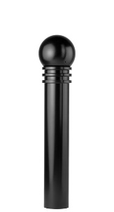Bollard [Designer’s Designation]:

Model: Reliance Foundry; **R-7575**.

Height: 39 3/8 inches (99.7 cm)

Diameter: 5 3/4 inches (14.6 cm) body; 5 3/4 inches (14.6 cm) base

Weight: 62 lbs. (28.1 kg)

Design: Cylindrical with round finial and large ball top.

Material: Ductile Cast Iron: ASTM A536, Grade 65-45-12; 30 percent recycled-material content.

Country of Origin: China.

Color Coating:

Type: [Polyester powder coat over epoxy primer.] [IronArmor protective coating.]

Color: [Black textured semi gloss.] [Dark green.] [Statuary bronze.] [Bengal silver.] [Anodized silver.] [Safety yellow.]

Installation:

Fixed, new concrete, anchor.

Fixed, existing concrete, insert.

Fixed, existing concrete, adhesive.

Fixed, new concrete, concrete form.

Security post cover, new post.

Security post cover, existing post, insert.

Security post cover, existing post, adhesive.

Security post cover, existing, anchor.

Removable, new concrete, anchor.

Removable, existing concrete, insert.

Removable, new concrete, premium retractable.

* + - * 1. 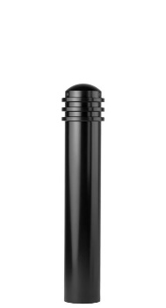Bollard [Designer’s Designation]:

Model: Reliance Foundry; **R-7576**.

Height: 34 inches (86.4 cm)

Diameter: 5 3/4 inches (14.6 cm) body; 5 3/4 inches (14.6 cm) base

Weight: 51 lbs. (23.1 lg)

Design: Cylindrical with round finial and rounded top.

Material: Ductile Cast Iron: ASTM A536, Grade 65-45-12; 30 percent recycled-material content.

Country of Origin: China.

Color Coating:

Type: [Polyester powder coat over epoxy primer.] [IronArmor protective coating.]

Color: [Black textured semi gloss.] [Dark green.] [Statuary bronze.] [Bengal silver.] [Anodized silver.] [Safety yellow.]

Installation:

Fixed, new concrete, anchor.

Fixed, existing concrete, insert.

Fixed, existing concrete, adhesive.

Fixed, new concrete, concrete form.

Security post cover, new post.

Security post cover, existing post, insert.

Security post cover, existing post, adhesive.

Security post cover, existing, anchor.

Removable, new concrete, anchor.

Removable, existing concrete, insert.

Removable, new concrete, premium retractable.

* + - * 1. 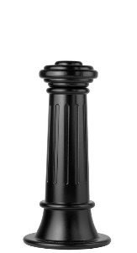Bollard [Designer’s Designation]:

Retain -AL for aluminum. Delete if not required.

Model: Reliance Foundry; **R-7581 [-AL]**.

Height: 31 inches (78.7 cm)

Diameter: 7 3/4 inches (19.7 cm) body; 15 inches (38 cm) base

Design: Tapered and fluted, with round finial and flat disc top.

Retain aluminum or cast iron to coordinate with model number.

Material:

Aluminum: ASTM B26; 20 percent recycled-material content.

Weight: 46 lbs. (20.8 kg)

Ductile Cast Iron: ASTM A536, Grade 65-45-12; 30 percent recycled-material content.

Weight: 114 lbs. (51.7 kg)

Country of Origin: China.

Color Coating:

Type: [Polyester powder coat over epoxy primer.] [IronArmor protective coating.]

Color: [Black textured semi gloss.] [Dark green.] [Statuary bronze.] [Bengal silver.] [Anodized silver.] [Safety yellow.]

Installation:

Fixed, new concrete, anchor.

Fixed, existing concrete, insert.

Fixed, existing concrete, adhesive.

Fixed, new concrete, concrete form.

Security post cover, new post.

Security post cover, existing post, insert.

Security post cover, existing post, adhesive.

Security post cover, existing, anchor.

Removable, new concrete, anchor.

Removable, existing concrete, insert.

Removable, new concrete, premium retractable.

* + - * 1. 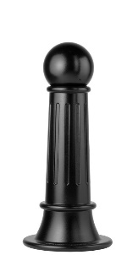Bollard [Designer’s Designation]:

Model: Reliance Foundry; **R-7582**.

Height: 34 inches (86.4 cm)

Diameter: 7 3/4 inches (19.7 cm) body; 15 inches (38 cm) base

Weight: 109 lbs. (49.5 kg)

Design: Tapered and fluted, with round finial and large ball top.

Material: Ductile Cast Iron: ASTM A536, Grade 65-45-12; 30 percent recycled-material content.

Country of Origin: China.

Color Coating:

Type: [Polyester powder coat over epoxy primer.] [IronArmor protective coating.]

Color: [Black textured semi gloss.] [Dark green.] [Statuary bronze.] [Bengal silver.] [Anodized silver.] [Safety yellow.]

Installation:

Fixed, new concrete, anchor.

Fixed, existing concrete, insert.

Fixed, existing concrete, adhesive.

Fixed, new concrete, concrete form.

Security post cover, new post.

Security post cover, existing post, insert.

Security post cover, existing post, adhesive.

Security post cover, existing, anchor.

Removable, new concrete, anchor.

Removable, existing concrete, insert.

Removable, new concrete, premium retractable.

* + - * 1. Bollard [Designer’s Designation]:

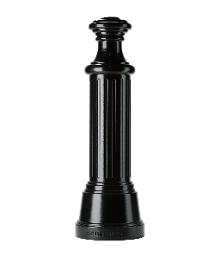Model: Reliance Foundry; **R-7583**.

Height: 49 3/4 inches (126.4 cm)

Diameter: 9 1/2 inches (24 cm) body; 16 inches (40.6 cm) base

Weight: 200 lbs. (90.7 kg)

Design: Tapered and fluted, with wide banded finials.

Material: Ductile Cast Iron: ASTM A536, Grade 65-45-12; 30 percent recycled-material content.

Country of Origin: China.

Color Coating:

Type: [Polyester powder coat over epoxy primer.] [IronArmor protective coating.]

Color: [Black textured semi gloss.] [Dark green.] [Statuary bronze.] [Bengal silver.] [Anodized silver.] [Safety yellow.]

Installation:

Fixed, new concrete, anchor.

Fixed, existing concrete, insert.

Fixed, existing concrete, adhesive.

Fixed, new concrete, concrete form.

Security post cover, new post.

Security post cover, existing post, insert.

Security post cover, existing post, adhesive.

Security post cover, existing, anchor.

Removable, new concrete, anchor.

Removable, existing concrete, insert.

Removable, new concrete, premium retractable.

* + - * 1. Bollard [Designer’s Designation]:

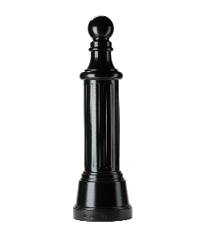Model: Reliance Foundry; **R-7584**.

Height: 53 3/4 inches (136.5 cm)

Diameter: 9 1/2 inches (24 cm) body; 16 inches (40.6 cm) base

Weight: 200 lbs. (90.7 kg)

Design: Tapered and fluted, with round finial and large ball top.

Material: Ductile Cast Iron: ASTM A536, Grade 65-45-12; 30 percent recycled-material content.

Country of Origin: China.

Color Coating:

Type: [Polyester powder coat over epoxy primer.] [IronArmor protective coating.]

Color: [Black textured semi gloss.] [Dark green.] [Statuary bronze.] [Bengal silver.] [Anodized silver.] [Safety yellow.]

Installation:

Fixed, new concrete, anchor.

Fixed, existing concrete, insert.

Fixed, existing concrete, adhesive.

Fixed, new concrete, concrete form.

Security post cover, new post.

Security post cover, existing post, insert.

Security post cover, existing post, adhesive.

Security post cover, existing, anchor.

Removable, new concrete, anchor.

Removable, existing concrete, insert.

Removable, new concrete, premium retractable.

* + - * 1. 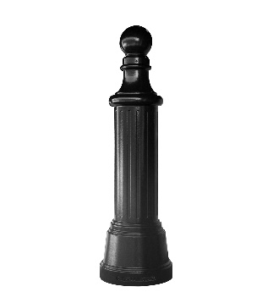Bollard [Designer’s Designation]:

Model: Reliance Foundry; **R-7585**.

Height: 52 1/2 inches (133.35 cm)

Diameter: 9 1/2 inches (24 cm) body; 16 inches (24.13 cm) base

Weight: 200 lbs. (90.72 kg)

Design: Cylindrical and fluted, with tapered bottom and small ball top.

Material: Ductile Cast Iron: ASTM A536, Grade 65-45-12

Country of Origin: China.

Color Coating:

Type: [Polyester powder coat over epoxy primer.] [IronArmor protective coating.]

Color: [Black textured semi gloss.] [Dark green.] [Statuary bronze.] [Bengal silver.] [Anodized silver.] [Safety yellow.]

Installation:

Fixed, new concrete, anchor.

Fixed, existing concrete, insert.

Fixed, existing concrete, adhesive.

Fixed, new concrete, concrete form.

Security post cover, new post.

Security post cover, existing post, insert.

Security post cover, existing post, adhesive.

Security post cover, existing, anchor.

* + - * 1. Bollard [Designer’s Designation]:

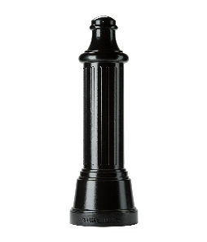Model: Reliance Foundry; **R-7586**.

Height: 47 1/2 inches (120.7 cm)

Diameter: 9 1/2 inches (24 cm) body; 16 inches (40.6 cm) base

Weight: 189 lbs. (85.7 kg)

Design: Tapered and fluted, with finial and rounded top.

Material: Ductile Cast Iron: ASTM A536, Grade 65-45-12; 30 percent recycled-material content.

Country of Origin: China.

Color Coating:

Type: [Polyester powder coat over epoxy primer.] [IronArmor protective coating.]

Color: [Black textured semi gloss.] [Dark green.] [Statuary bronze.] [Bengal silver.] [Anodized silver.] [Safety yellow.]

Installation:

Fixed, new concrete, anchor.

Fixed, existing concrete, insert.

Fixed, existing concrete, adhesive.

Fixed, new concrete, concrete form.

Security post cover, new post.

Security post cover, existing post, insert.

Security post cover, existing post, adhesive.

Security post cover, existing, anchor.

Removable, new concrete, anchor.

Removable, existing concrete, insert.

Removable, new concrete, premium retractable.

* + - * 1. Bollard [Designer’s Designation]:

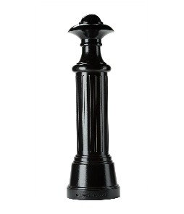Model: Reliance Foundry; **R-7587**.

Height: 53 3/4 inches (136.5 cm)

Diameter: 9 1/2 inches (24 cm) body; 16 inches (40.6 cm) base

Weight: 210 lbs. (95.3 kg)

Design: Tapered and fluted, with wide banded finials.

Material: Ductile Cast Iron: ASTM A536, Grade 65-45-12; 30 percent recycled-material content.

Country of Origin: China.

Color Coating:

Type: [Polyester powder coat over epoxy primer.] [IronArmor protective coating.]

Color: [Black textured semi gloss.] [Dark green.] [Statuary bronze.] [Bengal silver.] [Anodized silver.] [Safety yellow.]

Installation:

Fixed, new concrete, anchor.

Fixed, existing concrete, insert.

Fixed, existing concrete, adhesive.

Fixed, new concrete, concrete form.

Security post cover, new post.

Security post cover, existing post, insert.

Security post cover, existing post, adhesive.

Security post cover, existing, anchor.

Removable, new concrete, anchor.

Removable, existing concrete, insert.

Removable, new concrete, premium retractable.

* + - * 1. 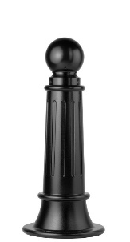Bollard [Designer’s Designation]:

Retain -AL for aluminum. Delete if not required.

Model: Reliance Foundry; **R-7589 [-AL]**.

Height: 35 inches (89 cm)

Diameter: 7 3/4 inches (19.7 cm) body; 15 inches (38 cm) base

Design: Tapered and fluted, with round finial and ball top.

Retain aluminum or cast iron to coordinate with model number.

Material:

Aluminum: ASTM B26; 20 percent recycled-material content.

Weight: 46 lbs. (20.8 kg)

Ductile Cast Iron: ASTM A536, Grade 65-45-12; 30 percent recycled-material content.

Weight: 111 lbs. (50.3 kg)

Country of Origin: China.

Color Coating:

Type: [Polyester powder coat over epoxy primer.] [IronArmor protective coating.]

Color: [Black textured semi gloss.] [Dark green.] [Statuary bronze.] [Bengal silver.] [Anodized silver.] [Safety yellow.]

Installation:

Fixed, new concrete, anchor.

Fixed, existing concrete, insert.

Fixed, existing concrete, adhesive.

Fixed, new concrete, concrete form.

Security post cover, new post.

Security post cover, existing post, insert.

Security post cover, existing post, adhesive.

Security post cover, existing, anchor.

Removable, new concrete, anchor.

Removable, existing concrete, insert.

Removable, new concrete, premium retractable.

* + - * 1. 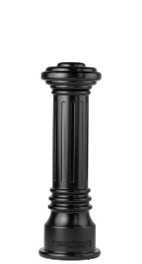Bollard [Designer’s Designation]:

Retain -AL for aluminum. Delete if not required.

Model: Reliance Foundry; **R-7591 [-AL]**.

Height: 32 inches (81.3 cm)

Diameter: 6 inches (15.2 cm) body; 10 1/4 inches (26 cm) base

Design: Tapered and fluted, with round finial and flat disc top.

Retain aluminum or cast iron to coordinate with model number.

Material:

Aluminum: ASTM B26; 20 percent recycled-material content.

Weight: 31 lbs. (14 kg)

Ductile Cast Iron: ASTM A536, Grade 65-45-12; 30 percent recycled-material content.

Weight: 77 lbs. (35 kg)

Country of Origin: China.

Color Coating:

Type: [Polyester powder coat over epoxy primer.] [IronArmor protective coating.]

Color: [Black textured semi gloss.] [Dark green.] [Statuary bronze.] [Bengal silver.] [Anodized silver.] [Safety yellow.]

Installation:

Fixed, new concrete, anchor.

Fixed, existing concrete, insert.

Fixed, existing concrete, adhesive.

Fixed, new concrete, concrete form.

Security post cover, new post.

Security post cover, existing post, insert.

Security post cover, existing post, adhesive.

Security post cover, existing, anchor.

Removable, new concrete, anchor.

Removable, existing concrete, insert.

Removable, new concrete, premium retractable.

* + - * 1. 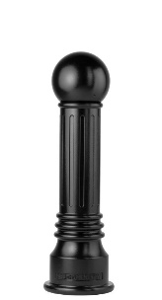Bollard [Designer’s Designation]:

Model: Reliance Foundry; **R-7592**.

Height: 35 inches (89 cm)

Diameter: 6 inches (15.2 cm) body; 10 1/4 inches (26 cm) base.

Weight: 73 lbs. (33 kg)

Design: Tapered and fluted, with round finial and large ball top.

Material: Ductile Cast Iron: ASTM A536, Grade 65-45-12; 30 percent recycled-material content.

Country of Origin: China.

Color Coating:

Type: [Polyester powder coat over epoxy primer.] [IronArmor protective coating.]

Color: [Black textured semi gloss.] [Dark green.] [Statuary bronze.] [Bengal silver.] [Anodized silver.] [Safety yellow.]

Installation:

Fixed, new concrete, anchor.

Fixed, existing concrete, insert.

Fixed, existing concrete, adhesive.

Fixed, new concrete, concrete form.

Security post cover, new post.

Security post cover, existing post, insert.

Security post cover, existing post, adhesive.

Security post cover, existing, anchor.

Removable, new concrete, anchor.

Removable, existing concrete, insert.

Removable, new concrete, premium retractable.

* + - * 1. 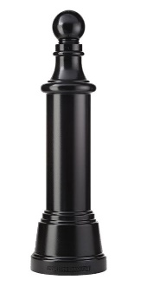Bollard [Designer’s Designation]:

Model: Reliance Foundry; **R-7593**.

Height: 53 3/4 inches (136.5 cm)

Weight: 259 lbs. (117.5 kg)

Diameter: 9 1/2 inches (24 cm) body; 16 inches (40.6 cm) base.

Design: Tapered cylindrical body with round finial and ball top.

Material: Ductile Cast Iron: ASTM A536, Grade 65-45-12; 30 percent recycled-material content.

Country of Origin: China.

Color Coating:

Type: [Polyester powder coat over epoxy primer.] [IronArmor protective coating.]

Color: [Black textured semi gloss.] [Dark green.] [Statuary bronze.] [Bengal silver.] [Anodized silver.] [Safety yellow.]

Installation:

Fixed, new concrete, anchor.

Fixed, existing concrete, insert.

Fixed, existing concrete, adhesive.

Fixed, new concrete, concrete form.

Security post cover, new post.

Security post cover, existing post, insert.

Security post cover, existing post, adhesive.

Security post cover, existing, anchor.

* + - * 1. 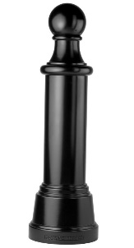Bollard [Designer’s Designation]:

Model: Reliance Foundry; **R-7595**.

Height: 52 1/2 inches (133.4 cm)

Diameter: 9 1/2 inches (24 cm) body; 16 inches (40.6 cm) base.

Weight: 256 lbs. (116 kg)

Design: Tapered cylindrical body with round finial and large ball top.

Material: Ductile Cast Iron: ASTM A536, Grade 65-45-12; 30 percent recycled-material content.

Country of Origin: China.

Color Coating:

Type: [Polyester powder coat over epoxy primer.] [IronArmor protective coating.]

Color: [Black textured semi gloss.] [Dark green.] [Statuary bronze.] [Bengal silver.] [Anodized silver.] [Safety yellow.]

Installation:

Fixed, new concrete, anchor.

Fixed, existing concrete, insert.

Fixed, existing concrete, adhesive.

Fixed, new concrete, concrete form.

Security post cover, new post.

Security post cover, existing post, insert.

Security post cover, existing post, adhesive.

Security post cover, existing, anchor.

* + - * 1. 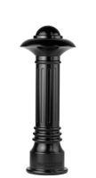Bollard [Designer’s Designation]:

Model: Reliance Foundry; **R-7598**.

Height: 36 inches (91.4 cm)

Diameter: 6 inches (15.2 cm) body; 10 1/4 inches (26 cm) base.

Weight: 93 lbs. (42.2 kg)

Design: Tapered and fluted, with fluted base and nautical-styled top.

Material: Ductile Cast Iron: ASTM A536, Grade 65-45-12; 30 percent recycled-material content.

Country of Origin: China.

Color Coating:

Type: [Polyester powder coat over epoxy primer.] [IronArmor protective coating.]

Color: [Black textured semi gloss.] [Dark green.] [Statuary bronze.] [Bengal silver.] [Anodized silver.] [Safety yellow.]

Installation:

Fixed, new concrete, anchor.

Fixed, existing concrete, insert.

Fixed, existing concrete, adhesive.

Fixed, new concrete, concrete form.

Security post cover, new post.

Security post cover, existing post, insert.

Security post cover, existing post, adhesive.

Security post cover, existing, anchor.

Removable, new concrete, anchor.

Removable, existing concrete, insert.

Removable, new concrete, premium retractable.

* + - * 1. 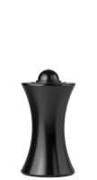Bollard [Designer’s Designation]:

Model: Reliance Foundry; **R-7611**.

Height: 23 inches (58.4 cm)

Diameter: 7 inches (17.8 cm) body; 12 inches (30.5 cm) base.

Weight: 65 lbs. (29.5 kg)

Design: Hourglass shape with rounded top.

Material: Ductile Cast Iron: ASTM A536, Grade 65-45-12; 30 percent recycled-material content.

Country of Origin: China.

Color Coating:

Type: [Polyester powder coat over epoxy primer.] [IronArmor protective coating.]

Color: [Black textured semi gloss.] [Dark green.] [Statuary bronze.] [Bengal silver.] [Anodized silver.] [Safety yellow.]

Installation:

Fixed, new concrete, anchor.

Fixed, existing concrete, insert.

Fixed, existing concrete, adhesive.

Fixed, new concrete, concrete form.

Security post cover, new post.

Security post cover, existing post, insert.

Security post cover, existing post, adhesive.

Security post cover, existing, anchor.

Removable, new concrete, anchor.

Removable, existing concrete, insert.

Removable, new concrete, premium retractable.

* + - * 1. 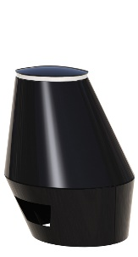Bollard [Designer’s Designation]:

Model: Reliance Foundry; **R-7651-EM** Martello Bollard™.

Height: 22 1/2 inches (57.2 cm)

Diameter: 13 1/2 inches (34.2 cm) top; 24 1/2 inches (62.2 cm) base.

Weight: 180 lbs. (81.6 kg)

Design: Sloped-sided oval designed by Billings Jackson.

Material: Steel: ASTM A36; 25 percent recycled-material content.

Country of Origin: United States.

Color Coating:

Type: [Polyester powder coat over epoxy primer.] [IronArmor protective coating.]

Color: [Black textured semi gloss.] [Dark green.] [Statuary bronze.] [Bengal silver.] [Anodized silver.] [Safety yellow.]

Installation: Fixed, new concrete, embedded.

* + - * 1. 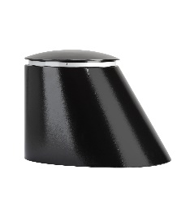Bollard [Designer’s Designation]:

Model: Reliance Foundry; **R-7661**.

Height: 22 3/4 inches (57.8 cm)

Diameter: 16 inches (40.6 cm) top; 28 1/2 inches (72.4 cm) base.

Weight: 210 lbs. (95.3 kg)

Design: Sloped-sided oval designed by Billings Jackson.

Material: Steel: ASTM A36; 25 percent recycled-material content.

Country of Origin: China.

Color Coating:

Type: [Polyester powder coat over epoxy primer.] [IronArmor protective coating.]

Color: [Black textured semi gloss.] [Dark green.] [Statuary bronze.] [Bengal silver.] [Anodized silver.] [Safety yellow.]

Installation:

Fixed, new concrete, embedded.

Fixed, existing concrete, bolt down.

* + - * 1. 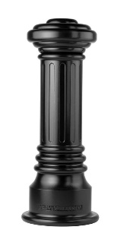Bollard [Designer’s Designation]:

Model: Reliance Foundry; **R-7691**.

Height: 39 inches (99 cm)

Diameter: 8 1/4 inches (21 cm) body; 15 inches (38 cm) base

Weight: 148 lbs. (67.1 kg)

Design: Tapered and fluted, with fluted base and flat disc top.

Material: Ductile Cast Iron: ASTM A536, Grade 65-45-12; 30 percent recycled-material content.

Country of Origin: China.

Color Coating:

Type: [Polyester powder coat over epoxy primer.] [IronArmor protective coating.]

Color: [Black textured semi gloss.] [Dark green.] [Statuary bronze.] [Bengal silver.] [Anodized silver.] [Safety yellow.]

Installation:

Fixed, new concrete, anchor.

Fixed, existing concrete, insert.

Fixed, existing concrete, adhesive.

Fixed, new concrete, concrete form.

Security post cover, new post.

Security post cover, existing post, insert.

Security post cover, existing post, adhesive.

Security post cover, existing, anchor.

* + - * 1. 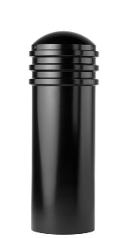Bollard [Designer’s Designation]:

Model: Reliance Foundry; **R-7736**.

Height: 36 inches (91.5 cm)

Diameter: 11 3/4 inches (29.8 cm) body; 11 3/4 inches (29.8 cm) base

Weight: 129 lbs. (58.5 kg)

Design: Cylindrical with segmented rings and rounded top.

Material: Steel: ASTM A36; 25 percent recycled-material content.

Country of Origin: China.

Color Coating:

Type: [Polyester powder coat over epoxy primer.] [IronArmor protective coating.]

Color: [Black textured semi gloss.] [Dark green.] [Statuary bronze.] [Bengal silver.] [Anodized silver.] [Safety yellow.]

Installation:

Fixed, new concrete, anchor.

Fixed, existing concrete, insert.

Fixed, existing concrete, adhesive.

Fixed, new concrete, concrete form.

Security post cover, new post.

Security post cover, existing post, insert.

Security post cover, existing post, adhesive.

Security post cover, existing, anchor.

Removable, new concrete, anchor.

Removable, existing concrete, insert.

Removable, new concrete, premium retractable.

* + - * 1. Bollard [Designer’s Designation]:

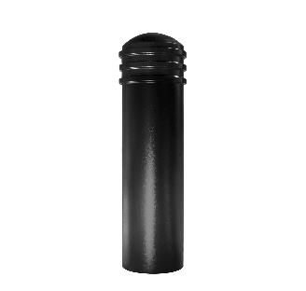Model: Reliance Foundry; **R-7743**

Height: 44 inches (111.8 cm)

Diameter: 11 3/4 inches (29.8 cm) body; 11 3/4 inches (29.8 cm) base

Weight: 154 lbs. (69.9 kg)

Design: Cylindrical with segmented rings and rounded top

Material: Steel body with ductile iron cap

Country of Origin: China

Color Coating:

Type: [Polyester powder coat over epoxy primer.] [IronArmor protective coating.]

Color: [Black textured semi gloss.] [Dark green.] [Statuary bronze.] [Bengal silver.] [Anodized silver.] [Safety yellow.]

Installation:

Fixed, new concrete, anchor.

Fixed, existing concrete, insert.

Fixed, existing concrete, adhesive.

Fixed, new concrete, concrete form.

Security post cover, new post.

Security post cover, existing post, insert.

Security post cover, existing post, adhesive.

Security post cover, existing, anchor.

* + - * 1. 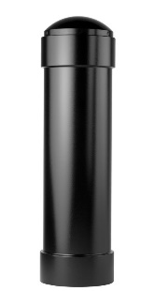Bollard [Designer’s Designation]:

Model: Reliance Foundry; **R-7744**.

Height: 44 1/2 inches (113 cm)

Diameter: 11 3/4 inches (29.8 cm) body; 13 inches (33 cm) base

Weight: 151 lbs. (68.5 kg)

Design: Cylindrical with rounded top.

Material: Steel: ASTM A36; 25 percent recycled-material content.

Country of Origin: China.

Color Coating:

Type: [Polyester powder coat over epoxy primer.] [IronArmor protective coating.]

Color: [Black textured semi gloss.] [Dark green.] [Statuary bronze.] [Bengal silver.] [Anodized silver.] [Safety yellow.]

Installation:

Fixed, new concrete, anchor.

Fixed, existing concrete, insert.

Fixed, existing concrete, adhesive.

Fixed, new concrete, concrete form.

Security post cover, new post.

Security post cover, existing post, insert.

Security post cover, existing post, adhesive.

Security post cover, existing, anchor.

* + - * 1. Bollard [Designer’s Designation]:

Model: Reliance Foundry; **R-7835**.

Height: 35 inches (88.9 cm)

Diameter: 9 1/2 inches (24.1 cm) body; 9 1/2 inches (24.1 cm) base

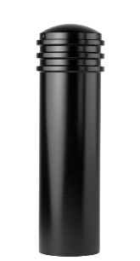Weight: 80 lbs. (36.3 kg)

Design: Cylindrical with segmented rings and rounded top.

Material: Steel: ASTM A36; 25 percent recycled-material content.

Country of Origin: China.

Color Coating:

Type: [Polyester powder coat over epoxy primer.] [IronArmor protective coating.]

Color: [Black textured semi gloss.] [Dark green.] [Statuary bronze.] [Bengal silver.] [Anodized silver.] [Safety yellow.]

Installation:

Fixed, new concrete, anchor.

Fixed, existing concrete, insert.

Fixed, existing concrete, adhesive.

Fixed, new concrete, concrete form.

Security post cover, new post.

Security post cover, existing post, insert.

Security post cover, existing post, adhesive.

Security post cover, existing, anchor.

Removable, new concrete, anchor.

Removable, existing concrete, insert.

Removable, new concrete, premium retractable.

* + - * 1. Bollard [Designer’s Designation]:

Model: Reliance Foundry; **8401-43AB**.

Height: 40 15/16 inches (104.0 cm)

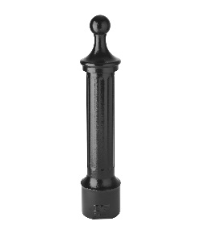Diameter: 8 inches (20.3 cm) base; 5 5/8 inches (14.3 cm) body

Weight: 91 lbs. (41.3 kg)

Design: Cylindrical body with round finial and ball top.

Material: Steel: ASTM A48; CLASS 35B.

Country of Origin: USA.

Color Coating:

Type: [Polyester powder coat over epoxy primer.]

Color: [Black textured semi gloss.]

Installation:

Fixed, new concrete, anchor.

Security post cover, new post.

* + - * 1. Bollard [Designer’s Designation]:

Model: Reliance Foundry; **8402-43AB**.

Height: 40 15/16 inches (104.0 cm)

Diameter: 8 inches (20.3 cm) base; 5 5/8 inches (14.3 cm) body

Weight: 99.3 lbs. (45.0 kg)

Design: Cylindrical body with round finial and ball top.

Material: Steel: ASTM A48; CLASS 35B.

Country of Origin: USA.

Color Coating:

Type: [Polyester powder coat over epoxy primer.]

Color: [Black textured semi gloss.]

Installation:

Fixed, new concrete, anchor.

Security post cover, new post.

* + - * 1. Bollard [Designer’s Designation]:

Model: Reliance Foundry; **8401-43AC**.

Height: 40 15/16 inches (104.0 cm)

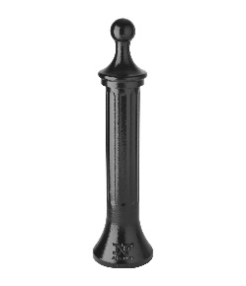Diameter: 10.5 inches (26.7 cm) base; 5 5/8 inches (14.3 cm) body

Weight: 95 lbs. (43.1 kg)

Design: Tapered cylindrical body with round finial and ball top.

Material: Steel: ASTM A48; CLASS 35B.

Country of Origin: USA.

Color Coating:

Type: [Polyester powder coat over epoxy primer.]

Color: [Black textured semi gloss.]

Installation:

Fixed, new concrete, anchor.

Security post cover, new post.

* + - * 1. Bollard [Designer’s Designation]:

Model: Reliance Foundry; **8402-43AC**.

Height: 40 15/16 inches (104.0 cm)

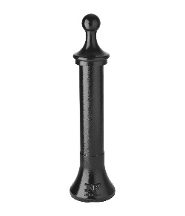Diameter: 10.5 inches (26.7 cm) base; 5 5/8 inches (14.3 cm) body

Weight: 88 lbs. (39.9 kg)

Design: Tapered cylindrical body with round finial and ball top.

Material: Steel: ASTM A48; CLASS 35B.

Country of Origin: USA.

Color Coating:

Type: [Polyester powder coat over epoxy primer.]

Color: [Black textured semi gloss.]

Installation:

Fixed, new concrete, anchor.

Security post cover, new post.

* + - * 1. Bollard [Designer’s Designation]:

Model: Reliance Foundry; **8401-43AA**.

Height: 40 15/16 inches (104.0 cm)

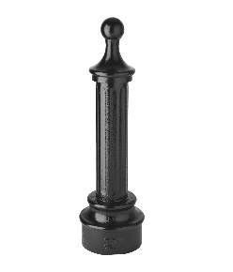Diameter: 11 inches (27.9 cm) base; 5 5/8 inches (14.3 cm) body

Weight: 128 lbs. (58.1 kg)

Design: Cylindrical body with round finial and ball top.

Material: Steel: ASTM A48; CLASS 35B.

Country of Origin: USA.

Color Coating:

Type: [Polyester powder coat over epoxy primer.]

Color: [Black textured semi gloss.]

Installation:

Fixed, new concrete, anchor.

Security post cover, new post.

* + - * 1. Bollard [Designer’s Designation]:

Model: Reliance Foundry; **8402-43AA**.

Height: 40-15/16 inches (104.0 cm)

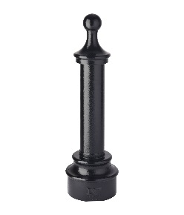 Diameter: 11 inches (27.9 cm) base; 5 3/8 inches (13.7 cm) base

Weight: 120 lbs. (54.4 kg)

Design: Cylindrical body with round finial and ball top.

Material: Steel: ASTM A48; CLASS 35B.

Country of Origin: USA.

Color Coating:

Type: [Polyester powder coat over epoxy primer.]

Color: [Black textured semi gloss.]

Installation:

Fixed, new concrete, anchor.

Security post cover, new post.

* + - * 1. Bollard [Designer’s Designation]:

Model: Reliance Foundry; **8401-43BA**.

Height: 38.1 inches (96.8 cm)

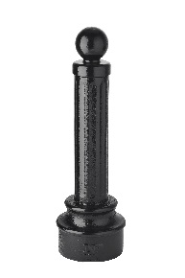Diameter: 5.6 inches (14.2 cm) body; 11 inches (27.9 cm) base

Weight: 119 lbs. (54 kg)

Design: Cylindrical body with spherical top casting.

Material: Steel: ASTM A48; CLASS 35B.

Country of Origin: USA.

Color Coating:

Type: [Polyester powder coat over epoxy primer.]

Color: [Black textured semi gloss.]

Installation:

Fixed, new concrete, anchor.

Security post cover, new post.

* + - * 1. Bollard [Designer’s Designation]:

Model: Reliance Foundry; **8401-43BB**.

Height: 38 inches (96.5 cm)

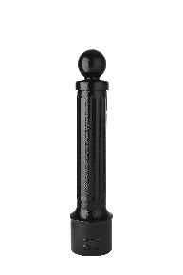Diameter: 5.6 inches (14.2 cm) body; 8 inches (20.3 cm) base

Weight: 97.5 lbs. (44.2 kg)

Design: Cylindrical body with spherical top casting.

Material: Steel: ASTM A48; CLASS 35B.

Country of Origin: USA.

Color Coating:

Type: [Polyester powder coat over epoxy primer.]

Color: [Black textured semi gloss.]

Installation:

Fixed, new concrete, anchor.

Security post cover, new post.

* + - * 1. Bollard [Designer’s Designation]:

Model: Reliance Foundry; **8401-43BC**.

Height: 38.1 inches (96.8 cm)

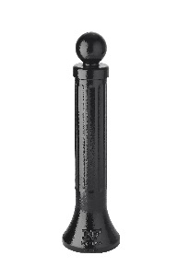Diameter: 5.6 inches (14.2 cm) body; 10.5 inches (26.7 cm) base

Weight: 86 lbs. (39 kg)

Design: Cylindrical body with spherical top casting.

Material: Steel: ASTM A48; CLASS 35B.

Country of Origin: USA.

Color Coating:

Type: [Polyester powder coat over epoxy primer.]

Color: [Black textured semi gloss.]

Installation:

Fixed, new concrete, anchor.

Security post cover, new post.

* + - * 1. Bollard [Designer’s Designation]:

Model: Reliance Foundry; **8402-43BA**.

Height: 38.1 inches (96.8 cm)

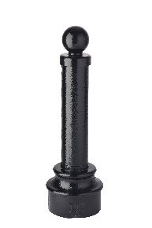Diameter: 5.4 (13.7 cm) body; 11 inches (27.9 cm) base

Weight: 111 lbs. (50.3 kg)

Design: Cylindrical body with spherical top casting.

Material: Steel: ASTM A48; CLASS 35B.

Country of Origin: USA.

Color Coating:

Type: [Polyester powder coat over epoxy primer.]

Color: [Black textured semi gloss.]

Installation:

Fixed, new concrete, anchor.

Security post cover, new post.

* + - * 1. Bollard [Designer’s Designation]:

Model: Reliance Foundry; **8402-43BB**.

Height: 38 inches (96.5 cm)

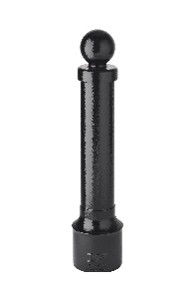Diameter: 5.6 inches (14.2 cm) body; 8 inches (20.3 cm) base

Weight: 91 lbs. (41.3 kg)

Design: Cylindrical body with spherical top casting.

Material: Steel: ASTM A48; CLASS 35B.

Country of Origin: USA.

Color Coating:

Type: [Polyester powder coat over epoxy primer.]

Color: [Black textured semi gloss.]

Installation:

Fixed, new concrete, anchor.

Security post cover, new post.

* + - * 1. Bollard [Designer’s Designation]:

Model: Reliance Foundry; **8402-43BC**.

Height: 38.1 inches (96.8 cm)

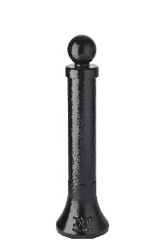Diameter: 5.6 inches (14.2 cm) body; 10.5 inches (26.7 cm) base

Weight: 80 lbs. (36.3 kg)

Design: Cylindrical body with spherical top casting.

Material: Steel: ASTM A48; CLASS 35B.

Country of Origin: USA.

Color Coating:

Type: [Polyester powder coat over epoxy primer.]

Color: [Black textured semi gloss.]

Installation:

Fixed, new concrete, anchor.

Security post cover, new post.

* + - * 1. Bollard [Designer’s Designation]:

Model: Reliance Foundry; **8401-43DA**.

Height: 36 inches (91.4 cm)

Diameter: 5.4 inches (13.7 cm) body; 11 inches (27.9 cm) base

Weight: 122 lbs. (55.3 kg)

Design: Cylindrical body with corniced top casting

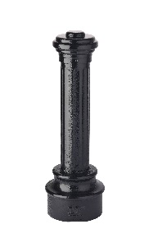Material: Steel: ASTM A48; CLASS 35B.

Country of Origin: USA.

Color Coating:

Type: [Polyester powder coat over epoxy primer.]

Color: [Black textured semi gloss.]

Installation:

Fixed, new concrete, anchor.

Security post cover, new post.

* + - * 1. Bollard [Designer’s Designation]:

Model: Reliance Foundry; **8401-43DB**.

Height: 36 inches (91.4 cm)

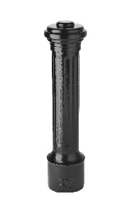Diameter: 5.4 inches (13.7 cm) body; 8 inches (20.3 cm) base

Weight: 101 lbs. (45.8 kg)

Design: Cylindrical body with corniced top casting.

Material: Steel: ASTM A48; CLASS 35B.

Country of Origin: USA.

Color Coating:

Type: [Polyester powder coat over epoxy primer.]

Color: [Black textured semi gloss.]

Installation:

Fixed, new concrete, anchor.

Security post cover, new post.

* + - * 1. Bollard [Designer’s Designation]:

Model: Reliance Foundry; **8401-43DC**.

Height: 36 inches (91.4 cm)

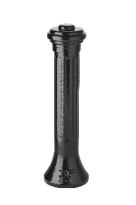Diameter: 5.4 inches (13.7 cm) body; 9.9 inches (25.1 cm) base

Weight: 89 lbs. (40.4 kg)

Design: Cylindrical body with corniced top casting.

Material: Steel: ASTM A48; CLASS 35B.

Country of Origin: USA.

Color Coating:

Type: [Polyester powder coat over epoxy primer.]

Color: [Black textured semi gloss.]

Installation:

Fixed, new concrete, anchor.

Security post cover, new post.

* + - * 1. Bollard [Designer’s Designation]:

Model: Reliance Foundry; **8402-43DA**.

Height: 36 inches (91.4 cm)

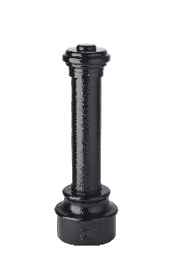Diameter: 5.4 inches (13.7 cm) body; 11 inches (27.9 cm) base

Weight: 114 lbs. (51.7 kg)

Design: Cylindrical body with corniced top casting.

Material: Steel: ASTM A48; CLASS 35B.

Country of Origin: USA.

Color Coating:

Type: [Polyester powder coat over epoxy primer.]

Color: [Black textured semi gloss.]

Installation:

Fixed, new concrete, anchor.

Security post cover, new post.

* + - * 1. Bollard [Designer’s Designation]:

Model: Reliance Foundry; **8402-43DB**.

Height: 36 inches (91.4 cm)

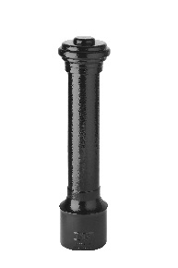Diameter: 5.4 inches (13.7 cm) body; 8 inches (20.3 cm) base

Weight: 94 lbs. (42.6 kg)

Design: Cylindrical body with corniced top casting.

Material: Steel: ASTM A48; CLASS 35B.

Country of Origin: USA.

Color Coating:

Type: [Polyester powder coat over epoxy primer.]

Color: [Black textured semi gloss.]

Installation:

Fixed, new concrete, anchor.

Security post cover, new post.

* + - * 1. Bollard [Designer’s Designation]:

Model: Reliance Foundry; **8402-43DC**.

Height: 36 inches (91.4 cm)

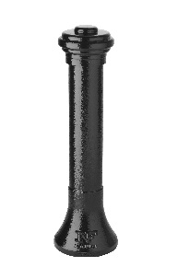Diameter: 5.4 inches (13.7 cm) body; 9.9 inches (25.1 cm) base

Weight: 83 lbs. (37.6 kg)

Design: Cylindrical body with corniced top casting.

Material: Steel: ASTM A48; CLASS 35B.

Country of Origin: USA.

Color Coating:

Type: [Polyester powder coat over epoxy primer.]

Color: [Black textured semi gloss.]

Installation:

Fixed, new concrete, anchor.

Security post cover, new post.

* + - * 1. Bollard [Designer’s Designation]:

Model: Reliance Foundry; **8403-43AA**.

Height: 40.9 inches (103.9 cm)

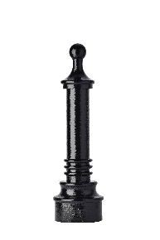Diameter: 5.4 inches (13.7 cm) body; 11 inches (27.9 cm) base

Weight: 127 lbs. (57.6 kg)

Design: Cylindrical body with round finial and ball top.

Material: Steel: ASTM A48; CLASS 35B.

Country of Origin: USA.

Color Coating:

Type: [Polyester powder coat over epoxy primer.]

Color: [Black textured semi gloss.]

Installation:

Fixed, new concrete, anchor.

Security post cover, new post.

* + - * 1. Bollard [Designer’s Designation]:

Model: Reliance Foundry; **8403-43AC**.

Height: 40.9 inches (103.9 cm)

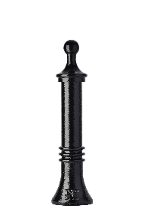Diameter: 5.6 inches (14.2 cm) body; 9.9 inches (25.1 cm) base

Weight: 95 lbs. (43.1 kg)

Design: Cylindrical body with round finial and ball top.

Material: Steel: ASTM A48; CLASS 35B.

Country of Origin: USA.

Color Coating:

Type: [Polyester powder coat over epoxy primer.]

Color: [Black textured semi gloss.]

Installation:

Fixed, new concrete, anchor.

Security post cover, new post.

* + - * 1. Bollard [Designer’s Designation]:

Model: Reliance Foundry; **8403-43BA**.

Height: 38 inches (96.5 cm)

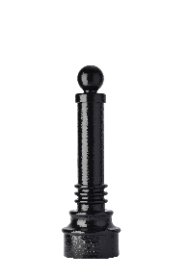Diameter: 5.4 inches (13.7 cm) body; 11 inches (27.9 cm) base

Weight: 118 lbs. (53.5 kg)

Design: Cylindrical body with round finial and ball top.

Material: Steel: ASTM A48; CLASS 35B.

Country of Origin: USA.

Color Coating:

Type: [Polyester powder coat over epoxy primer.]

Color: [Black textured semi gloss.]

Installation:

Fixed, new concrete, anchor.

Security post cover, new post.

* + - * 1. Bollard [Designer’s Designation]:

Model: Reliance Foundry; **8403-43BC**.

Height: 38 inches (96.5 cm)

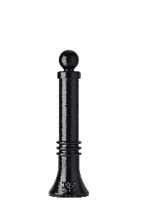Diameter: 5.6 inches (14.2 cm) body; 9.9 inches (25.1 cm) base

Weight: 86 lbs. (39 kg)

Design: Cylindrical body with round finial and ball top.

Material: Steel: ASTM A48; CLASS 35B.

Country of Origin: USA.

Color Coating:

Type: [Polyester powder coat over epoxy primer.]

Color: [Black textured semi gloss.]

Installation:

Fixed, new concrete, anchor.

Security post cover, new post.

* + - * 1. Bollard [Designer’s Designation]:

Model: Reliance Foundry; **8403-43DA**.

Height: 36 inches (91.4 cm)

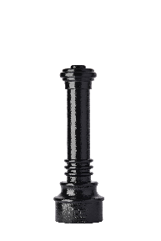Diameter: 5.4 inches (13.7 cm) body; 11 inches (27.9 cm) base

Weight: 121 lbs. (54.9 kg)

Design: Cylindrical body with round finial and ball top.

Material: Steel: ASTM A48; CLASS 35B.

Country of Origin: USA.

Color Coating:

Type: [Polyester powder coat over epoxy primer.]

Color: [Black textured semi gloss.]

Installation:

Fixed, new concrete, anchor.

Security post cover, new post.

* + - * 1. Bollard [Designer’s Designation]:

Model: Reliance Foundry; **8403-43DC**.

Height: 36 inches (91.4 cm)

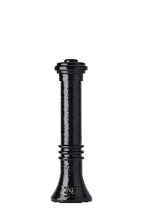Diameter: 5.6 inches (14.2 cm) body; 9.9 inches (25.1 cm) base

Weight: 90 lbs. (40.8 kg)

Design: Cylindrical body with round finial and ball top.

Material: Steel: ASTM A48; CLASS 35B.

Country of Origin: USA.

Color Coating:

Type: [Polyester powder coat over epoxy primer.]

Color: [Black textured semi gloss.]

Installation:

Fixed, new concrete, anchor.

Security post cover, new post.

* + - * 1. Bollard [Designer’s Designation]:

Model: Reliance Foundry; **R-8915**.

Height: 36 inches (91.4 cm)

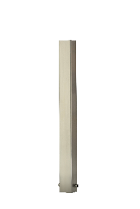Width: 4 inches (10.2 cm)

Weight: 23 lbs. (10.4 kg)

Design: Square body with flat top.

Material: Stainless steel: ASTM A312, Grade TP 316; 60 percent recycled-material content.

Country of Origin: Malaysia.

Color Coating:

Type: [Polyester powder coat over epoxy primer.]

Color: [Black textured semi gloss.]

Installation:

Fixed, new concrete, embedded.

Fixed, existing concrete, flange, surface mount.

* + - * 1. Bollard [Designer’s Designation]:

Model: Reliance Foundry; **R-7567**.

Height: 37 1/2 inches (95.25 cm)

Base Diameter: 15 inches (38.1 cm)

Planter Diameter: 14 3/8 inches (36.5 cm)

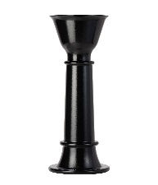Weight: 127 lbs. (57.6 kg)

Design: Tapered cylindrical body with planter top.

Material: Ductile Cast Iron: ASTM A536, Grade 65-45-12

Country of Origin: Vietnam.

Color Coating:

Type: [Polyester powder coat over epoxy primer.] [IronArmor protective coating.]

Color: [Black textured semi gloss.] [Dark green.] [Statuary bronze.] [Bengal silver.] [Anodized silver.] [Safety yellow.]

Installation:

Removable, new concrete, anchor.

Removable, existing concrete, insert.

Removable, new concrete, premium retractable.

* + - * 1. Bollard [Designer’s Designation]:

Model: Reliance Foundry; **R-7597**.

Height: 38 1/4 inches (97.2 cm)

Base Diameter: 10 1/4 inches (26 cm)

Planter Diameter: 14 3/8 inches (36.5 cm)

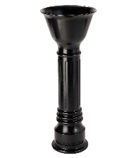Weight: 90 lbs. (40.8 kg)

Design: Fluted cylindrical body with round finial and planter top.

Material: Ductile Cast Iron: ASTM A536, Grade 65-45-12

Country of Origin: Vietnam.

Color Coating:

Type: [Polyester powder coat over epoxy primer.] [IronArmor protective coating.]

Color: [Black textured semi gloss.] [Dark green.] [Statuary bronze.] [Bengal silver.] [Anodized silver.] [Safety yellow.]

Installation:

Removable, new concrete, anchor.

Removable, existing concrete, insert.

Removable, new concrete, premium retractable.

* + - * 1. Bollard Cover [Designer’s Designation]:

Model: Reliance Foundry; **R-7322**.

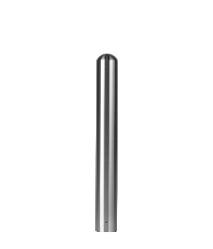Height: 36 inches (91.4 cm)

Diameter: 4 1/2 inches (11.4 cm)

Weight: 17 lbs. (7.7 kg)

Max interior post size:

Height: 34 inches (86.4 cm)

Diameter: 3-1/2 inches (8.9 cm)

Design: Cylindrical bollard cover with rounded top.

Material: Stainless steel: ASTM A312, Grade TP 316.

Country of Origin: China.

Finish: Satin No. 6, buffed.

Color coating over stainless is available at additional cost for this bollard. Delete if not required.

Color Coating:

Type: [Polyester powder coat over epoxy primer.] [IronArmor protective coating.]

Color: [Black textured semi gloss.] [Dark green.]

[Statuary bronze.] [Bengal silver.] [Anodized silver.] [Safety yellow.]

Installation:

Security post cover, [new][existing] post, set screws

Security post cover, [new][existing] post, adhesive foam

Security post cover, [existing] post, top hangers with adhesive

Security post cover, [new] post, top “J” hangers for new concrete

* + - * 1. 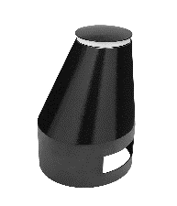Bollard [Designer’s Designation]:

Model: Reliance Foundry; **R-7652-EM** Martello Bollard™.

Height: 22 1/2 inches (57.2 cm)

Diameter: 13 1/2 inches (34.2 cm) top; 24 1/2 inches (62.2 cm) base.

Weight: 180 lbs. (81.6 kg)

Design: Sloped-sided oval designed by Billings Jackson.

Material: Steel: ASTM A36; 25 percent recycled-material content.

Country of Origin: United States.

Color Coating:

Type: [Polyester powder coat over epoxy primer.] [IronArmor protective coating.]

Color: [Black textured semi gloss.] [Dark green.] [Statuary bronze.] [Bengal silver.] [Anodized silver.] [Safety yellow.]

Installation: Fixed, new concrete, embedded.

* + - 1. ACCESSORIES

Retain following if specified bollards require security posts.

* + - * 1. Security Post:

Pipe: ASTM 500 B Structural Grade Steel

Manufacturer: Reliance Foundry Co. Ltd.

Country of Origin: United States.

Base Diameter: [4.5 inches] [6.25 inches] [8.625 inches] [10.75 inches]

Finish: [Red] [Grey] primer.

Installation:

Direct embed.

Footing and fill; Concrete or mortar, [3000 psi minimum.]

Retain the following for removable bollards with padlock hasps and for chains with padlocks

* + - * 1. Padlock:

[Brass] [Marine Grade], supplied [supplied by bollard manufacturer] [as specified in Section [__ __ __]]. [Key alike.]

Retain following if chains draped between bollards are required. In Drawings, show locations where chain is required, quick-release and padlock locations, and drape of chain.

* + - * 1. Chain:

5/16-inch galvanized steel chain, Grade 30, with quick-release type connections.] Provide sufficient lengths to provide drape [shown on Drawings.] [acceptable to Architect.]

Chain Eye: 5/16-inch diameter steel.

Quick Links: Powder coated chain links with barrel nut closures.

Finish: Powder coated to match bollard [_______________.]

See http://www.reliance-foundry.com/bike-storage/bike-bollard-stands

* + - * 1. Bollard Arms:

Curved rods attach to bollard body.

Material: Stainless steel: ASTM A312, Grade TP 316

Finish: [Powder coated to match bollard [_______________.]] [Satin No. 6, buffed].

1. EXECUTION
   * + 1. EXAMINATION
          1. Examine paving or other substrates for compliance with manufacturer’s requirements for placement and location of embedded items, condition of substrate, and other conditions affecting installation of bollards.
          2. Proceed with installation only after unsatisfactory conditions have been corrected.
       2. INSTALLATION
          1. General: Comply with manufacturer’s installation instructions and setting drawings.
          2. Do not install damaged, cracked, chipped, deformed or marred bollards. Field touch-up minor imperfections in accordance with manufacturer’s instructions. Replace bollards that cannot be field repaired.
       3. CLEANING & PROTECTION

Normal cleaning may be done with clean water and a soft cloth. Detailed cleaning and inspection instructions are available at [www.reliance-foundry.com/bollard/maintenance-bollards](http://www.reliance-foundry.com/bollard/maintenance-bollards).

* + - * 1. Protect bollards against damage.
        2. Immediately prior to Substantial Completion, clean bollards in accordance with manufacturer’s instructions to remove dust, dirt, adhesives, and other foreign materials.
        3. Touch up damaged finishes according to manufacturer’s instructions.
      1. CLOSEOUT ACTIVITIES
         1. Provide executed warranty.

END OF SECTION

Copyright 2021 by Reliance Foundry Co. Ltd.; qualified design and construction professionals may copy for preparation of construction specifications and purchase orders for Reliance Foundry products. Issued November 2021. Subject to change.

Issued July 2016. Subject to change.